|  |  |
| --- | --- |
| For Academic Affairs and Research Use Only | |
| Proposal Number | BU08 |
| CIP Code: |  |
| Degree Code: |  |

**Program Modification Form**

**[X] Undergraduate Curriculum Council**

**[ ] Graduate Council**

|  |
| --- |
| **Modification Type: [ ]Admissions, [ X]Curricular Sequence, or [ ]Other** |

Signed paper copies of proposals submitted for consideration are no longer required. Please type approver name and enter date of approval.

|  |  |  |  |  |  |
| --- | --- | --- | --- | --- | --- |
| |  |  | | --- | --- | | H. Steve Leslie | 2/21/2022 |   **Department Curriculum Committee Chair** | |  |  | | --- | --- | | __________________ | Enter date |   **COPE Chair (if applicable)** |
| |  |  | | --- | --- | | Bill Hu | 2/28/2022 |   **Department Chair** | |  |  | | --- | --- | | __________________ | Enter date |   **Head of Unit (if applicable)** |
| |  |  | | --- | --- | | John Robertson | 3/11/2022 |   **College Curriculum Committee Chair** | |  |  | | --- | --- | | __________________ | Enter date |   **Undergraduate Curriculum Council Chair** |
| |  |  | | --- | --- | | __________________ | Enter date |   **Director of Assessment** *(only for changes impacting assessment)* | |  |  | | --- | --- | | __________________ | Enter date |   **Graduate Curriculum Committee Chair** |
| |  |  | | --- | --- | | Jim Washam | 3/25/2022 |   **College Dean** | |  |  | | --- | --- | | __________________ | Enter date |   **Vice Chancellor for Academic Affairs** |
| |  |  | | --- | --- | | __________________ | Enter date |   **General Education Committee Chair (if applicable)** |  |

1. **Contact Person** (Name, Email Address, Phone Number)

Dr. John Mello; jmello@astate.edu;870-972-3515

1. **Proposed Change** (for undergraduate curricular changes please provide an 8-semester plan (appendix A), if applicable)

Replace MGMT 2003, Entrepreneurial Discovery, with GSCM 3163, Global Supply Chain Management in the business core.

1. **Effective Date**

8/2/2022

1. **Justification –** *Please provide details as to why this change is necessary.*

Supply chain management (SCM) is an integral part of for-profit and not-for-profit businesses, as well as government organizations.  Every function within an organization has a vested interest in how the organization’s supply chain is run; it is essential to company success and customer satisfaction. GSCM 3163 specifically addresses important topics such as sourcing, inventory analysis and management, transportation, distribution, intra-and inter-organizational collaboration, supply chain resiliency, and environmentally sustainable operations. The role of SCM in society and businesses has been greatly enhanced by the effects of COVID-19 on the movement and availability of all types of products throughout the world. An understanding of how supply chains operate, methods for improving the flow of goods and services throughout supply chains, and the most effective supply chain network designs is important to business students regardless of their major. This is because every organizational function affects and is affected by how well a company manages the flow of goods and services within its supply chain in order to service its customers. This is true regardless of whether the company is a manufacturer, retailer, or services company.

Reasons for our students to have a good exposure to supply chain management include the fact that a well-run supply chain can be a differentiator and competitive advantage among competing companies, current emphasis on analytics, collaboration and technology requires exposure to those concepts for all business students, and the effects of supply chain management on a company’s financials contributes to a company’s bottom line. Furthermore, societal roles for SCM include ensuring human survival, improve quality of life, and help protect cultural freedom and development.

MGMT 2003 Entrepreneurial Discovery has not been taught. This course was developed and included in the business core under prior leadership in 2020-21. The current strategic direction of the college is better supported by its substitution with GSCM 3163 Supply Chain Management.

**Bulletin Changes**

|  |
| --- |
| **Instructions** |
| **Please visit** **http://www.astate.edu/a/registrar/students/bulletins/index.dot** **and select the most recent version of the bulletin. Copy and paste all bulletin pages this proposal affects below. Please include a before (with changed areas highlighted) and after of all affected sections.**  **\*Please note: Courses are often listed in multiple sections of the bulletin. To ensure that all affected sections have been located, please search the bulletin (ctrl+F) for the appropriate courses before submission of this form.** |

BEFORE:



AFTER: (Reordered courses to reflect alpha-numeric ordering)

|  |  |
| --- | --- |
| **Neil Griffin College of Business Core Courses:**  Grade of “C” or better or 2.25 overall core GPA required | **Sem. Hrs.** |
| ACCT 2033, Introduction to Financial Accounting | 3 |
| ACCT 2133, Introduction to Managerial Accounting | 3 |
| BCOM 2563, Business Communication | 3 |
| GSCM 3163, Supply Chain Management | 3 |
| FIN 3713, Business Finance | 3 |
| ISBA 1503, Microcomputer Applications | 3 |
| ISBA 3013, Management Information Systems | 3 |
| ISBA 3553, Foundation of Business Analytics | 3 |
| LAW 2073, Legal Environment of Business | 3 |
| MGMT 3123, Principles of Management | 3 |
| MGMT 4813, Strategic Management | 3 |
| MKTG 3013, Marketing | 3 |
| STAT 3233, Applied Statistics | 3 |
| **Total Required Hours:** | **39** |

*The bulletin can be accessed at* *https://www.astate.edu/a/registrar/students/bulletins/*

125

BEFORE:

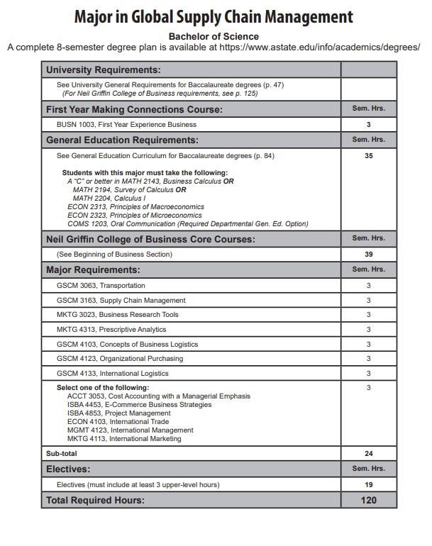

147

# Major in Global Supply Chain Management

**Bachelor of Science**

A complete 8-semester degree plan is available at https://www.astate.edu/info/academics/degrees/

|  |  |
| --- | --- |
| **University Requirements:** |  |
| See University General Requirements for Baccalaureate degrees (p. 47)  *(For Neil Griffin College of Business requirements, see p. 125)* |  |
| **First Year Making Connections Course:** | **Sem. Hrs.** |
| BUSN 1003, First Year Experience Business | **3** |
| **General Education Requirements:** | **Sem. Hrs.** |
| See General Education Curriculum for Baccalaureate degrees (p. 84)  **Students with this major must take the following:**  *A “C” or better in MATH 2143, Business Calculus* ***OR***  *MATH 2194, Survey of Calculus* ***OR***  *MATH 2204, Calculus I*  *ECON 2313, Principles of Macroeconomics ECON 2323, Principles of Microeconomics*  *COMS 1203, Oral Communication (Required Departmental Gen. Ed. Option)* | **35** |
| **Neil Griffin College of Business Core Courses:** | **Sem. Hrs.** |
| (See Beginning of Business Section) | **39** |
| **Major Requirements:** | **Sem. Hrs.** |
| GSCM 3063, Transportation | 3 |
|  |  |
| MKTG 3023, Business Research Tools | 3 |
| MKTG 4313, Prescriptive Analytics | 3 |
| GSCM 4103, Concepts of Business Logistics | 3 |
| GSCM 4123, Organizational Purchasing | 3 |
| GSCM 4133, International Logistics | 3 |
| **Select one of the following:**  ACCT 3053, Cost Accounting with a Managerial Emphasis  ISBA 4453, E-Commerce Business Strategies  ISBA 4853, Project Management ECON 4103, International Trade  MGMT 4123, International Management MKTG 4113, International Marketing | 3 |
| **Sub-total** | **21** |
| **Electives:** | **Sem. Hrs.** |
| Electives (must include at least 3 upper-level hours) | **22** |
| **Total Required Hours:** | **120** |

147

**Major In Management**

**Bachelor of Science**



150

**Major In Management**

**Bachelor of Science**



150

**Major In Marketing**

**Bachelor of Science**



152

**Major In Marketing**

**Bachelor of Science**

A complete 8-semester degree plan is available at https://www.astate.edu/info/academics/degrees/

|  |  |
| --- | --- |
| **University Requirements:** |  |
| See University General Requirements for Baccalaureate degrees (p. 47)  *(For Neil Griffin College of Business requirements, see p. 125)* |  |
| **First Year Making Connections Course:** | **Sem. Hrs.** |
| BUSN 1003, First Year Experience Business | **3** |
| **General Education Requirements:** | **Sem. Hrs.** |
| See General Education Curriculum for Baccalaureate degrees (p. 84)  **Students with this major must take the following:**  *A “C” or better in MATH 2143, Business Calculus* ***OR***  *MATH 2194, Survey of Calculus* ***OR***  *MATH 2204, Calculus I*  *ECON 2313, Principles of Macroeconomics ECON 2323, Principles of Microeconomics*  *COMS 1203, Oral Communication (Required Departmental Gen. Ed. Option)* | **35** |
| **Neil Griffin College of Business Core Courses:** | **Sem. Hrs.** |
| (See Beginning of Business Section) | **39** |
| **Major Requirements:** | **Sem. Hrs.** |
| MKTG 3023, Business Research Tools | 3 |
| MKTG 3033, Strategic Marketing Communications | 3 |
|  |  |
| MKTG 4043, Consumer Behavior | 3 |
| MKTG 4083, Marketing Research | 3 |
| MKTG 4223, Marketing Management | 3 |
| **Sub-total** | **15** |
| **Additional Requirements:** | **Sem. Hrs.** |
| **Select three of the following:** MKTG 3093, Professional Selling MKTG 4023, Services Marketing  MKTG 4113, International Marketing MKTG 4213, Marketing Analytics MKTG 428V, Marketing Internship | 9 |
| Select two additional upper level Marketing Electives | 6 |
| **Sub-total** | **15** |
| **Electives:** | **Sem. Hrs.** |
| Electives | **13** |
| **Total Required Hours:** | **120** |

152

**Appendix A, 8-Semester Plan**

(**Referenced in #2** - **Undergraduate Proposals Only)**

*Instructions: Please identify new courses in italics*.

|  |  |  |  |  |  |  |  |  |
| --- | --- | --- | --- | --- | --- | --- | --- | --- |
| **Arkansas State University-Jonesboro**  **Degree:**  **Major:**  **Year:** | | | | | | | | |
| Students requiring developmental course work based on low entrance exam scores (ACT, SAT, ASSET, COMPASS) may not be able to complete this program of study in eight (8) semesters. Developmental courses do not count toward total degree hours. **Students having completed college level courses prior to enrollment will be assisted by their advisor in making appropriate substitutions. In most cases, general education courses may be interchanged between semesters.** A minimum of 45 hours of upper division credit (3000-4000 level) is required for this degree. | | | | | | | | |
| **Year 1** | | | |  | **Year 1** | | | |
| **Fall Semester** | | | |  | **Spring Semester** | | | |
| **Course No.** | **Course Name** | **Hrs** | **Gen Ed** |  | **Course No.** | **Course Name** | **Hrs** | **Gen Ed** |
|  |  |  |  |  |  |  |  |  |
|  |  |  |  |  |  |  |  |  |
|  |  |  |  |  |  |  |  |  |
|  |  |  |  |  |  |  |  |  |
|  |  |  |  |  |  |  |  |  |
| **Total Hours** |  |  |  |  | **Total Hours** |  |  |  |
| **Year 2** | | | |  | **Year 2** | | | |
| **Fall Semester** | | | |  | **Spring Semester** | | | |
| **Course No.** | **Course Name** | **Hrs** | **Gen Ed** |  | **Course No.** | **Course Name** | **Hrs** | **Gen Ed** |
|  |  |  |  |  |  |  |  |  |
|  |  |  |  |  |  |  |  |  |
|  |  |  |  |  |  |  |  |  |
|  |  |  |  |  |  |  |  |  |
|  |  |  |  |  |  |  |  |  |
|  |  |  |  |  |  |  |  |  |
| **Total Hours** |  |  |  |  | **Total Hours** |  |  |  |
| **Year 3** | | | |  | **Year 3** | | | |
| **Fall Semester** | | | |  | **Spring Semester** | | | |
| **Course No.** | **Course Name** | **Hrs** | **Gen Ed** |  | **Course No.** | **Course Name** | **Hrs** | **Gen Ed** |
|  |  |  |  |  |  |  |  |  |
|  |  |  |  |  |  |  |  |  |
|  |  |  |  |  |  |  |  |  |
|  |  |  |  |  |  |  |  |  |
|  |  |  |  |  |  |  |  |  |
| **Total Hours** |  |  |  |  | **Total Hours** |  |  |  |
| **Year 4** | | | |  | **Year 4** | | | |
| **Fall Semester** | | | |  | **Spring Semester** | | | |
| **Course No.** | **Course Name** | **Hrs** | **Gen Ed** |  | **Course No.** | **Course Name** | **Hrs** | **Gen Ed** |
|  |  |  |  |  |  |  |  |  |
|  |  |  |  |  |  |  |  |  |
|  |  |  |  |  |  |  |  |  |
|  |  |  |  |  |  |  |  |  |
|  |  |  |  |  |  |  |  |  |
| **Total Hours** |  |  |  |  | **Total Hours** |  |  |  |
| **Total Jr/Sr Hours ___ Total Degree Hours ___** | | | | | | | | |
| **Graduation Requirements:** | | | | | | | | |

















































