For Academic Affairs and Research Use Only
Proposal Number
CIP Code:
Degree Code:

Program Modification Form
[X] Undergraduate Curriculum Council
[ ] Graduate Council
Modification Type: [ ]Admissions, [ X]Curricular Sequence, or []Other

Signed paper copies of proposals submitted for consideration are no longer required. Please type approver name and enter date of approval.

Tamara Glover 9/3/2020  Department Curriculum Committee Chair | __________________ Enter date  COPE Chair (if applicable)
Cheryl Knight 9/3/2020  Department Chair | __________________ Enter date  Head of Unit (if applicable)
Shanon Brantley 9/23/2020  College Curriculum Committee Chair | __________________ Enter date  Undergraduate Curriculum Council Chair
Susan Hanrahan 9/24/2020  College Dean | __________________ Enter date  Graduate Curriculum Committee Chair
__________________ Enter date  General Education Committee Chair (if applicable) | __________________ Enter date  Vice Chancellor for Academic Affairs

- Contact Person (Name, Email Address, Phone Number)
Cheryl L. Knight DSW, LCSW .
cknight@astate.edu
870-972-3984

- Proposed Change (for undergraduate curricular changes please provide an 8-semester plan (appendix A), if applicable)
To allow students to opportunity to enroll in either SW3373 or SOC 4293. The course will be offered in the Fall and Spring Semesters

- Effective Date
Fall 2020

- Justification – Please provide details as to why this change is necessary.
To provide social work students the flexibility to enroll in SW 3373 or SOC 4293 and eliminate scheduling conflicts.

Bulletin Changes

Instructions
Please visit http://www.astate.edu/a/registrar/students/bulletins/index.dot and select the most recent version of the bulletin. Copy and paste all bulletin pages this proposal affects below. Please include a before (with changed areas highlighted) and after of all affected sections.

*Please note: Courses are often listed in multiple sections of the bulletin. To ensure that all affected sections have been located, please search the bulletin (ctrl+F) for the appropriate courses before submission of this form.

Before
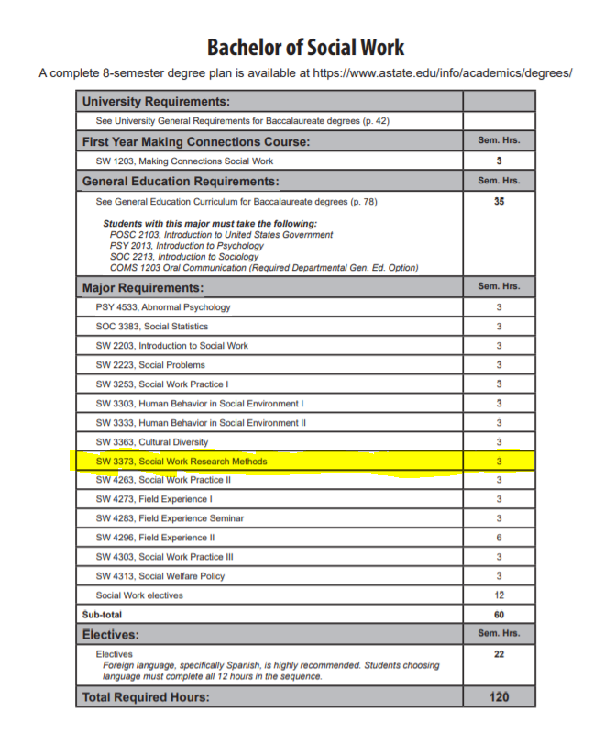

After

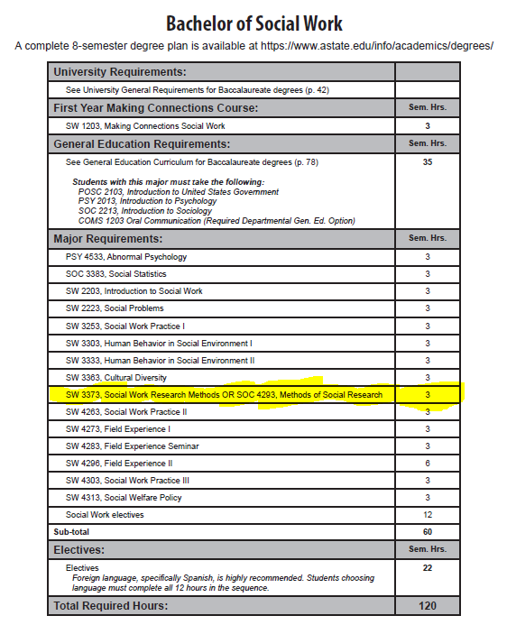

Appendix A, 8-Semester Plan
(Referenced in #2 - Undergraduate Proposals Only)
Instructions: Please identify new courses in italics.
Arkansas State University-Jonesboro
Degree:
Major:
Year:

Students requiring developmental course work based on low entrance exam scores (ACT, SAT, ASSET, COMPASS) may not be able to complete this program of study in eight (8) semesters. Developmental courses do not count toward total degree hours. Students having completed college level courses prior to enrollment will be assisted by their advisor in making appropriate substitutions. In most cases, general education courses may be interchanged between semesters. A minimum of 45 hours of upper division credit (3000-4000 level) is required for this degree.
Year 1 |  |  |  |  | Year 1
Fall Semester |  |  |  |  | Spring Semester
Course No. | Course Name | Hrs | Gen Ed |  | Course No. | Course Name | Hrs | Gen Ed
Total Hours |  |  |  |  | Total Hours
Year 2 |  |  |  |  | Year 2
Fall Semester |  |  |  |  | Spring Semester
Course No. | Course Name | Hrs | Gen Ed |  | Course No. | Course Name | Hrs | Gen Ed
Total Hours |  |  |  |  | Total Hours
Year 3 |  |  |  |  | Year 3
Fall Semester |  |  |  |  | Spring Semester
Course No. | Course Name | Hrs | Gen Ed |  | Course No. | Course Name | Hrs | Gen Ed
Total Hours |  |  |  |  | Total Hours
Year 4 |  |  |  |  | Year 4
Fall Semester |  |  |  |  | Spring Semester
Course No. | Course Name | Hrs | Gen Ed |  | Course No. | Course Name | Hrs | Gen Ed
Total Hours |  |  |  |  | Total Hours
Total Jr/Sr Hours ___ Total Degree Hours ___
Graduation Requirements:

