For Academic Affairs and Research Use Only
CIP Code:
Degree Code:

Bulletin / Banner Change Transmittal Form
[ ] Undergraduate Curriculum Council
[X] Graduate Council
Signed paper copies of proposals submitted for consideration are no longer required. Please type approver name and enter date of approval.
Email completed proposals to curriculum@astate.edu for inclusion in curriculum committee agenda.
Dr. Angela Schmidt, Interim 10/30/2017  Department Curriculum Committee Chair | __________________ Enter date  COPE Chair (if applicable)
Dr. Angela Schmidt, Interim 10/30/2017  Department Chair: | __________________ Enter date  Head of Unit (If applicable)
Deanna Barymon 11/3/2017  College Curriculum Committee Chair | __________________ Enter date  Undergraduate Curriculum Council Chair
Susan Hanrahan 11/6/2017  College Dean | __________________ Enter date  Graduate Curriculum Committee Chair
__________________ Enter date  General Education Committee Chair (If applicable) | __________________ Enter date  Vice Chancellor for Academic Affairs

1.Contact Person (Name, Email Address, Phone Number)
Dr. Angela Smith, asmith@astate.edu, 870-972-2403.

2.Proposed Change
There is an error on page 229 of the gradate bulletin. The program name was recently changed from Adult Health to Adult Gerontology Clinical Nurse Specialist. The plan of study text box was not corrected when this change was made. The correct number of hours for NURS 646V Advanced Adult Gerontology Nursing Practicum should be 6 rather than 0-6. The resultant sub-total should be 15. The Adult Health Program had different options allowing for variable clinical (practicum) hours. The AGCNS program requires 540 clinical hours (6 credit hours).

3.Effective Date
10/26/2017

4.Justification – Please provide details as to why this change is necessary.
See above.

Bulletin Changes

Instructions
Please visit http://www.astate.edu/a/registrar/students/bulletins/index.dot and select the most recent version of the bulletin. Copy and paste all bulletin pages this proposal affects below. Follow the following guidelines for indicating necessary changes.

*Please note: Courses are often listed in multiple sections of the bulletin. To ensure that all affected sections have been located, please search the bulletin (ctrl+F) for the appropriate courses before submission of this form.

- Deleted courses/credit hours should be marked with a red strike-through (red strikethrough)
- New credit hours and text changes should be listed in blue using enlarged font (blue using enlarged font).
- Any new courses should be listed in blue bold italics using enlarged font (blue bold italics using enlarged font)

You can easily apply any of these changes by selecting the example text in the instructions above, double-clicking the ‘format painter’ icon , and selecting the text you would like to apply the change to.
Please visit https://youtu.be/yjdL2n4lZm4 for more detailed instructions.

The change should be made on page 229- the Adult-Gerontology Clinical Nurse Specialist Plan of Study Table- see below
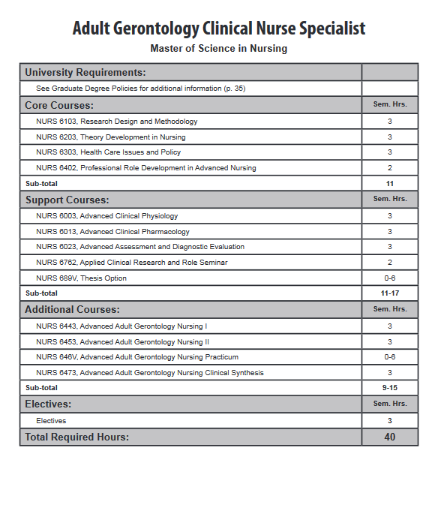
0--6 Should be “6”
9-15 Should be “15”

