For Academic Affairs and Research Use Only
Proposal Number | NHP59
CIP Code:
Degree Code:

NEW PROGRAM / CERTIFICATE PROPOSAL FORM
(More than 50% of the courses are new and created for this program)
(Also requires Arkansas Department of Higher Education (ADHE) approval)
[X] Undergraduate Curriculum Council
[ ] Graduate Council
Signed paper copies of proposals submitted for consideration are no longer required. Please type approver name and enter date of approval.
__________________ Enter date  Department Curriculum Committee Chair | __________________ Enter date  COPE Chair (if applicable)
__________________ Enter date  Department Chair | Amanda Carpenter 8/1/2022  Head of Unit (if applicable)
Mary Elizabeth Spence 8/3/2022  Office of Assessment | __________________ Enter date  Undergraduate Curriculum Council Chair
____Amy Hyman_________ 08/12/22  College Curriculum Committee Chair | __________________ Enter date  Graduate Curriculum Committee Chair
_________Scott E. Gordon__________ 8-20-22  College Dean | _____Alan Utter_____________ 9-12-22  Vice Chancellor for Academic Affairs
__________________ | Enter date
General Education Committee Chair (if applicable)

- Contact Person (Name, Email Address, Phone Number)
Amanda Carpenter
acarpenter@astate.edu
(870) 972-3894

- Proposed Program Title
Bachelor of Science in Public Health

- Proposed Starting Date
Summer 2023

- Is there differential tuition requested? If yes, please fill out the New Program/Tuition and Fees Change Form.
No

- Will this program be offered:
- Traditional/Face-to-face No
- Distance/Online Yes
- If yes, indicate mode of distance delivery, and the percentage of courses offered via this modality (<50%, 50-99%, or 100%).
100%
- If online, will it be offered through Global Initiatives/Academic Partnerships (AP)?
Yes
- Concurrent (High School Students) No

- Graduate programs only: Will this program require a comprehensive exam?
N/A

Program Justification
- Justification for the introduction of the new program. Must include:

- Academic rationale (how will this program fit into the mission established by the department for the curriculum?)

The Centers for Disease Control and Prevention (CDC) broadly define public health as “the science of protecting and improving the health of people and their communities.” Public Health is an interdisciplinary area of study with five core disciplines: (1) Epidemiology, (2) Biostatistics, (3) Health Policy and Management, (4) Environmental Health Sciences, and (5) Social and Behavioral Sciences. Public health focuses on three core functions: (1) Assessment, (2) Policy Development, and (3) Assurance. To achieve optimal health, Public Health focuses on policies, systems, and services, and equity to enhance health.

There is a need for a Bachelor of Science in Public Health to serve the northeast Arkansas region. There is both student demand and employment demand for an undergraduate Public Health program. Market research conducted on behalf of Arkansas State University indicated that Public Health ranked 2nd in demand among undergraduate healthcare programs in Arkansas. This research showed a 167% increase in undergraduate Public Health degree conferrals in the region. The average undergraduate Public Health degree conferrals per institution has increased 6.8% since 2015. Regional employment for Public Health occupations increased by 13% from 2016 to 2020, with continued projected growth of 13% by 2028. To that end, the College of Nursing & Health Professions (CNHP) is proposing the development of an online Bachelor of Science degree program in Public Health.

Arkansas is currently ranked #48 (out of 50 states) in public health, #50 in health care quality, and #40 in health care access. The Mississippi Delta region, one of the most rural and socioeconomically disadvantaged regions in the country, also experiences poorer health behaviors and overall health outcomes compared to the rest of the country. Thus, an undergraduate Public Health degree program would meet both the university mission to “educate leaders, enhance intellectual growth, and enrich lives” in the Delta and Mid-South region, and the CNHP mission to for graduates to contribute to “health and healthcare in the Delta region and beyond.”

- List program goals (faculty or curricular goals.)

The curriculum is designed using the CDC’s 10 Essential Public Health Services framework. Thus, the program goals align closely with this framework.
- Students will understand how to assess and monitor population health.
- Students will learn how to investigate, diagnose, and address health hazards and root causes.
- Students will develop effective public health communication strategies to inform and educate.
- Students will develop public health strategies to strengthen, support, and mobilize communities and partnerships.
- Students will learn how to create, champion, and implement public health policies, plans, and laws.
- Students will understand how to utilize public health legal and regulatory actions.
- Students will identify avenues to enabling equitable health access.
- Students will contribute to building a diverse and skilled public health workforce.
- Students will develop strategies to improve and innovate through public health evaluation, research, and quality improvement.
- Students will learn how to build and maintain a strong organizational infrastructure for public health.

- Will this program be accredited or certified? Yes
If Yes, name the accrediting or certifying agency. Council on Education for Public Health (CEPH)
What are the steps for candidacy or initial accreditation? Please include a timeline for each step:
Step | Timeline
Initial Accreditation
Contact CEPH Director of Accreditation Services | Spring 2026
Participate in CEPH’s Pre-Application Orientation Webinar | Spring 2026
Submit payment for initial application submission fee | Spring 2026
Submit first draft of initial application submission for CEPH review | Fall 2026
Receive feedback on the draft initial application submission | Fall 2026
Revise the initial application submission | Fall 2026
Submit the revised initial application submission for CEPH review | Fall 2026
Receive official notification from CEPH regarding the acceptance of the initial application submission | Spring 2027
Pay the applicant fee | Spring 2027
Self-Study and Site Visit
Schedule the self-study | Fall 2027
Self-study preliminary review | Spring 2029
Self-study final document | Summer 2029
Third-party commenting period | Fall 2029
Site visit planning | Spring 2030
Site visit | Spring 2030
CEPH site visit report from CEPH | Summer 2030
Site visit response | Summer 2030
Final accreditation report | Fall 2030

- Student population served.
The program will serve undergraduate students seeking a Bachelor of Science degree in Public Health. Because the program will be offered online, both traditional and nontraditional students may be admitted to the program.

Program Assessment
University Outcomes
2. Please indicate the university-level student learning outcomes for which this new program will contribute. Please complete the table by adding program level outcomes (PLO) to the first column, and indicating the alignment with the university learning outcomes (ULO). If you need more information about the ULOs, go to the University Level Outcomes Website.

 | ULO 1: Creative & Critical Thinking | ULO 2: Effective Communication | ULO 3: Civic & Social Responsibility | ULO 4: Globalization & Diversity
PLO 1:  Students will understand how to assess and monitor population health. | X
PLO 2:  Students will learn how to investigate, diagnose, and address health hazards and root causes. | X
PLO 3:  Students will develop effective public health communication strategies to inform and educate. | X | X | X
PLO 4:  Students will develop public health strategies to strengthen, support, and mobilize communities and partnerships. | X | X | X | X
PLO 5:  Students will learn how to create, champion, and implement public health policies, plans, and laws. | X | X | X
PLO 6:  Students will understand how to utilize public health legal and regulatory actions. | X | X | X
PLO 7:  Students will identify avenues to enabling equitable health access. | X |  | X | X
PLO 8:  Students will contribute to building a diverse and skilled public health workforce. | X |  |  | X
PLO 9:  Students will develop strategies to improve and innovate through public health evaluation, research, and quality improvement. | X
PLO 10:  Students will learn how to build and maintain a strong organizational infrastructure for public health. | X |  |  | X

Program Learning Outcomes
3. Provide outcomes that students will accomplish during or at completion of this program. Fill out the following table to develop a continuous improvement assessment process.
For further assistance, please see the ‘Expanded Instructions’ document available on the UCC - Forms website for guidance, or contact the Office of Assessment at 870-972-2989.
Note: Best practices suggest 4-7 outcomes per program; minors would have 1 to 4 outcomes.

Outcome 1 | Students will understand how to assess and monitor population health.
Assessment Measure | - Direct measure: Exam scores, homework assignment grades  - Indirect measure: Program exit surveys; Certified in Public Health exam pass rate (if data are available)
Which courses are responsible for this outcome? | OESH 3313 Epidemiology  PHLT 3203 Biostatistics for Public Health  PHLT 4513 Public Health Research Design and Methods
Assessment  Timetable | Annually
Who is responsible for assessing and reporting on the results? | Program director

Outcome 2 | Students will learn how to investigate, diagnose, and address health hazards and root causes.
Assessment Measure | - Direct measure: Exam scores, written assignment grades  - Indirect measure: Program exit surveys; Certified in Public Health exam pass rate (if data are available)
Which courses are responsible for this outcome? | BIO 2103/2101 Microbiology for Nursing and Allied Health/Lab  OESH 3313 Epidemiology  PHLT 3503 Public Health Interventions  PHLT 3513 Population Health  PHLT 3603 Rural Health
Assessment  Timetable | Annually
Who is responsible for assessing and reporting on the results? | Program director

Outcome 3 | Students will develop effective public health communication strategies to inform and educate.
Assessment Measure | - Direct measure: Exam scores, written assignment grades  - Indirect measure: Program exit surveys; Certified in Public Health exam pass rate (if data are available)
Which courses are responsible for this outcome? | COMS 2253 Introduction to Health Communication  PHLT 3503 Public Health Interventions
Assessment  Timetable | Annually
Who is responsible for assessing and reporting on the results? | Program director

Outcome 4 | Students will develop public health strategies to strengthen, support, and mobilize communities and partnerships.
Assessment Measure | - Direct measure: Exam scores, written assignment grades  - Indirect measure: Program exit surveys; Certified in Public Health exam pass rate (if data are available)
Which courses are responsible for this outcome? | PHLT 3023 Global Health  PHLT 3503 Public Health Interventions  PHLT 4503 Public Health Program Planning and Evaluation
Assessment  Timetable | Annually
Who is responsible for assessing and reporting on the results? | Program director

Outcome 5 | Students will learn how to create, champion, and implement public health policies, plans, and laws.
Assessment Measure | - Direct measure: Exam scores, written assignment grades  - Indirect measure: Program exit surveys; Certified in Public Health exam pass rate (if data are available)
Which courses are responsible for this outcome? | PHLT 3303 Health Policy
Assessment  Timetable | Annually
Who is responsible for assessing and reporting on the results? | Program director

Outcome 6 | Students will understand how to utilize public health legal and regulatory actions.
Assessment Measure | - Direct measure: Exam scores, written assignment grades  - Indirect measure: Program exit surveys; Certified in Public Health exam pass rate (if data are available)
Which courses are responsible for this outcome? | PHLT 3303 Health Policy  PHLT 3323 Public Health Practice and Management
Assessment  Timetable | Annually
Who is responsible for assessing and reporting on the results? | Program director

Outcome 7 | Students will identify avenues to enabling equitable health access.
Assessment Measure | - Direct measure: Exam scores, written assignment grades  - Indirect measure: Program exit surveys; Certified in Public Health exam pass rate (if data are available)
Which courses are responsible for this outcome? | PHLT 3303 Health Policy  PHLT 3313 Health Equity  PHLT 3503 Public Health Interventions  PHLT 3513 Population Health  PHLT 3603 Rural Health
Assessment  Timetable | Annually
Who is responsible for assessing and reporting on the results? | Program director

Outcome 8 | Students will contribute to building a diverse and skilled public health workforce.
Assessment Measure | - Direct measure: Exam scores, written assignment grades  - Indirect measure: Program exit surveys; Certified in Public Health exam pass rate (if data are available); post-graduation employment survey
Which courses are responsible for this outcome? | PHLT 1013 Introduction to Public Health  PHLT 3323 Public Health Practice and Management  PHLT 470V Public Health Internship
Assessment  Timetable | Annually
Who is responsible for assessing and reporting on the results? | Program director

Outcome 9 | Students will develop strategies to improve and innovate through public health evaluation, research, and quality improvement.
Assessment Measure | - Direct measure: Exam scores, homework assignment grades, written assignment grades  - Indirect measure: Program exit surveys; Certified in Public Health exam pass rate (if data are available)
Which courses are responsible for this outcome? | OESH 3313 Epidemiology  PHLT 3203 Biostatistics for Public Health  PHLT 4503 Public Health Program Planning and Evaluation  PHLT 4513 Public Health Research Design and Methods
Assessment  Timetable | Annually
Who is responsible for assessing and reporting on the results? | Program director

Outcome 10 | Students will learn how to build and maintain a strong organizational infrastructure for public health.
Assessment Measure | - Direct measure: Exam scores, written assignment grades  - Indirect measure: Program exit surveys; Certified in Public Health exam pass rate (if data are available)
Which courses are responsible for this outcome? | PHLT 3323 Public Health Practice and Management  PHLT 4503 Public Health Program Planning and Evaluation
Assessment  Timetable | Annually
Who is responsible for assessing and reporting on the results? | Program director
Please repeat as necessary.

LETTER OF INTENT – 1
(New Certificate or Degree Program)
- Institution submitting request:
Arkansas State University

- Education Program Contact person/title:
Dr. Amanda Carpenter, Assistant Professor of Public Health

- Telephone number/e-mail address:
(870) 972-3894
acarpenter@AState.edu

- Proposed Name of Certificate or Degree Program:
Bachelor of Science in Public Health

- Proposed Effective Date:
Summer 2023

- Requested CIP Code:
51.2201

- Program Description:

- Mode of Delivery (mark all that apply):

__X__On-Campus

_____Off-Campus Location

Provide address of off-campus location__________________________ _______________________________________________________________

Provide a copy of the e-mail notification to other institutions in the state notifying them of the proposed program. Please inform institutions not to send the response to “Reply All”. If you receive an objection/concern(s) from an institution, reply to the institution and copy ADHE on the email. That institution should respond and copy ADHE. If the objection/concern(s) cannot be resolved, ADHE may intervene.

Submit copy of written notification to Higher Learning Commission (HLC) if notification required by HLC for a program offered at an off-campus location.

______Indicate distance of proposed site from main campus.

___X__Distance Technology (50% of program offered by distance technology)

Submit copy of written notification to HLC if notification is required by HLC for a program offered by distance technology.

- List existing certificate or degree programs that support the proposed program:
- Bachelor of Science in Health Studies
- Bachelor of Science in Occupational and Environmental Safety and Health
- Bachelor of Science in Disaster Preparedness and Emergency Management
- Bachelor of Arts in Communication
- Bachelor of Arts in History
- Bachelor of Arts in Political Science
- Bachelor of Arts in Sociology
- Statistics, Minor

- President/Chancellor Approval Date:

- Academic Affairs Officer: Date:

PROPOSAL – 1

NEW DEGREE PROGRAM

- PROPOSED PROGRAM TITLE
Bachelor of Science in Public Health

- CIP CODE REQUESTED
51.2201
Link for CIP Codes: http://nces.ed.gov/ipeds/cipcode/resources.aspx?y=55.

- PROPOSED STARTING DATE
July 2023

- CONTACT PERSON
Name: Dr. Alan Utter
Title: Provost and Executive Vice Chancellor for Academic Affairs and Research
Name of Institution: Arkansas State University
E-mail Address: autter@AState.edu
Phone Number: (870) 972-2030

Name: Dr. Amanda Carpenter
Title: Assistant Professor of Public Health
E-mail Address: acarpenter@AState.edu
Phone Number: (870) 972-3894

- PROGRAM SUMMARY
Provide a general description of the proposed program. Include overview of any curriculum additions or modifications; program costs; faculty resources, library resources, facilities and equipment; purpose of the program; and any information that will serve as introduction to the program.

Curriculum Additions or Modifications
- The Bachelor of Science in Public Health curriculum will prepare students for employment in government, industry, and non-profit settings as epidemiologists, community health workers, health administrators and managers, health data scientists and analysts, and health educators. The program will require 50 required public health credit hours. The required coursework will focus on the five core public health disciplines: (1) Epidemiology, (2) Biostatistics, (3) Health Policy and Management, (4) Environmental Health Sciences, and (5) Social and Behavioral Sciences.

Program Costs
- See #10 New Program Costs (pg. 20).

Faculty Resources
- See #8 Faculty (pg. 19) and #10 New Program Costs (pg. 20).

Library Resources
- See Appendix B for Library Resources.

Facilities and Equipment
- Current facilities and equipment allow for facilitating an online undergraduate program. Smart classrooms can be used to record lectures. For faculty on campus, the A-State Center for Excellence and Teaching recently constructed a state-of-the-art recording studio with audio and video equipment to enhance lectures.

Purpose of the Program
- Arkansas State University is proposing an online undergraduate program, a Bachelor of Science in Public Health. The program will meet student demand and employment demand in Public Health, at the regional, state, and national levels.

List degree programs or emphasis areas currently offered at the institution that support the proposed program.
The following degree programs currently offered at Arkansas State University that support the proposed program include:
- Bachelor of Science in Health Studies
- Bachelor of Science in Occupational and Environmental Safety and Health
- Bachelor of Science in Disaster Preparedness and Emergency Management
- Bachelor of Arts in Communication
- Bachelor of Arts in History
- Bachelor of Arts in Political Science
- Bachelor of Arts in Sociology
- Statistics, Minor

These 8 programs have offered existing A-State courses to include as either required or elective courses. Emails documenting the approval from these programs to use their courses are in Appendix C.

- NEED FOR THE PROGRAM
Submit Workforce Analysis Form or Employer Needs Survey (only when workforce data is deficient for the academic discipline within the proposal)
- See Appendix D for Workforce Analysis.

Employer Needs Survey should include the following:
Submit numbers that show job availability, corporate demands and employment/wage projections, not student interest and anticipated enrollment. Focus mostly on state needs and less on regional and national needs, unless applicable to the program.
- N/A: Workforce Analysis is attached.

Survey data can be obtained by telephone, letters of interest, student inquiry, etc. Focus mostly on state needs for undergraduate programs; for graduate programs, focus on state, regional and national needs.
- N/A: Workforce Analysis is attached.

Provide names and types of organizations/businesses surveyed.
- N/A: Workforce Analysis is attached.

Letters of support should address the following when relevant: the number of current/anticipated job vacancies, whether the degree is desired or required for advancement, the increase in wages projected based on additional education, etc.
- See Appendix E for letters of support.
Indicate if employer tuition assistance is provided or if there are other enrollment incentives.
- N/A; no employer tuition assistance is provided

Describe what need the proposed program will address and how the institution became aware of this need.
- Market research conducted for Arkansas State University showed both student and employment demand in Public Health. Data suggest that Public Health ranked 2nd in demand among undergraduate healthcare programs in Arkansas. There was a 167% increase in undergraduate Public Health degree conferrals in the region. Regional employment for Public Health occupations increased by 13% from 2016 to 2020, with continued projected growth of 13% by 2028.

Indicate which employers contacted the institution about offering the proposed program.
- N/A

Indicate the composition of the program advisory committee, including the number of members, professional background of members, topics to be considered by the members, meeting schedule (annually, bi-annually, quarterly), institutional representative, etc.
- A program advisory committee will be developed following program approval. The program advisory committee will include approximately 10 members with public health professional and/or educational experience. Program advisory committee members will be identified using A-State networks and connections. The program advisory committee will be asked for input regarding the curriculum, internship opportunities for students, and employment opportunities for students. The program advisory committee will meet at least annually.

Indicate the projected number of program enrollments for Years 1 - 3.
- For Year 1, initial enrollment of 10–15 students is projected. In Year 2, an additional 20–30 students will be added to the program, resulting in 30–45 students matriculating through the program. In Year 3, an additional 20–30 students will be added to the program, resulting in 50–75 total students matriculating through the program.

Indicate the projected number of program graduates in 3-5 years.
- Following the previous response, assuming total program enrollment of 50–75 in Year 3 and a 50% graduation rate as reported by A-State Institutional Research, the estimated minimum number of program graduates is 25.

- CURRICULUM

Provide curriculum outline by semester (include course number and title).

(For bachelor’s degree program, submit the 8-semester degree plan.)
- See Appendix A for the 8-semester degree plan.

Give total number of semester credit hours required for the program, including prerequisite courses.
- The total number of credit hours required for completion of the program is 120.

Public Health Curriculum | Credit Hours
General Education | 35
Public Health Requirements | 50
Electives | 35
TOTAL | 120

Identify new courses (in italics) and provide course descriptions.

New Courses:
- PHLT 1013: Introduction to Public Health
Overview of foundational public health knowledge including key terms and concepts, the 10 Essential Public Health Services, and the five core disciplines (epidemiology, biostatistics, health policy and management, environmental health sciences, and social and behavioral sciences).

- PHLT 3023: Global Health
Explores important health challenges facing the world including the environmental, social, political, and economic factors that shape patterns and experiences of illness and healthcare across societies, cultures, and countries.

- PHLT 3203: Biostatistics for Public Health
Introduces the principles of biostatistics and application of statistical methods used in public health and medical research. Concepts include descriptive data, probability distributions, hypothesis testing, group comparisons, measures of association, and regression; focus is on interpretation, rather than calculation.

- PHLT 3303: Health Policy
Overview of public health institutions and systems, health policy and the policymaking process; application of policy analysis to population health, private insurance, Medicare, and Medicaid at the local, state, and federal levels.
Prerequisites: HP 2112

- PHLT 3313: Health Equity
Explores the concept of health equity and a broad overview of health disparities in the United States; examination of relevant historical issues and case studies, emphasizing critical analysis and application.

- PHLT 3323: Public Health Practice and Management
Introduces concepts of public health practice and management including professionalism, health care systems management, finance, strategic planning, surveillance, performance management, social marketing, and evidence-based practice.

- PHLT 3503: Public Health Interventions
Explores the process of developing, implementing, and assessing public health interventions, incorporating health behavior change theories and concepts, case studies, and application.

- PHLT 3513: Population Health
Examines the biological, genetic, behavioral, social, physical, and structural determinants of health, and how these factors impact individuals, communities, and populations.
- PHLT 3603: Rural Health
Explores issues specific to rural health including rural health systems and policies, rural health disparities, and advancing rural health.

- PHLT 4503: Public Health Program Planning and Evaluation
Provides a basic understanding about public health program planning, implementation, and evaluation; emphasis on application and development of public health programs.

- PHLT 4513: Public Health Research Design and Methods
Introduces fundamental principles of public health research design and methodology used for surveillance, monitoring, data collection, assessment, and reporting.

- PHLT 470V: Public Health Internship
Provides public health work experience, applying coursework concepts and knowledge through practical application in government, private sector, or nonprofit setting.
Prerequisites: PHLT 1013 and Instructor permission

Identify required general education courses, required courses, and public health major courses.

General Education Courses
- UC 1013 First Year Experience—Making Connections
- ENG 1003 Composition I
- ENG 1013 Composition II
- MATH 1023 College Algebra
- COMS 1203 Oral Communication
- Social Sciences (choose one):
  - HIST 2763 US History to 1876
  - HIST 2773 US History since 1876
  - POSC 2103 Intro to US Government
- Social Sciences (choose two):
  - ANTH 2233 Introduction to Cultural Anthropology
  - MDIA 1003 Mass Communications in Modern Society
  - ECON 2313 Principles of Macroeconomics
  - ECON 2323 Principles of Microeconomics
  - ECON 2333 Economic Issues & Concepts
  - GEOG 2613 Intro to Geography
  - HIST 1013 World History to 1500
  - HIST 1023 World History since 1500
  - SOC 2213 Intro to Sociology
  - PSY 2013 Intro to Psychology
  - POSC 1003 Intro to Politics
- Life Science (BIO 2103/2101 required):

  - BIO 2103/2101 Microbiology for Nursing and Allied Health/Laboratory
- Physical Science (choose one):
  - CHEM 1013/1001 General Chemistry I/Laboratory
  - CHEM 1043/1041 Fundamental Concepts of Chemistry/Laboratory
  - GEOL 1003/1001 Environmental Geology/Laboratory
  - PHSC 1203/1201 Physical Space/Laboratory
  - PHYS 1103/1101 Intro to Space Science/Laboratory
  - PHYS 2034 University Physics I
  - PHYS 2054 General Physics I
- Humanities (choose one):
  - ENG 2003 World Literature to 1660
  - ENG 2013 World Literature since 1660
  - PHIL 1103 Introduction to Philosophy
- Fine Arts and Humanities
  - ART 2503 Fine Arts—Visual
  - MUS 2503 Fine Arts—Musical
  - THEA 2503 Fine Arts—Theatre

Required Courses
- COMS 2253 Introduction to Health Communication
- HP 2112 Introduction to the United States Healthcare System
- HP 3233 Preventive Health
- HP 3353 Public Health Principles and Practice
- OESH 3023 Principles of Environmental Health
- OESH 3313 Epidemiology
- PHLT 1013 Introduction to Public Health
- PHLT 3023 Global Health
- PHLT 3203 Biostatistics for Public Health
- PHLT 3303 Health Policy
- PHLT 3313 Health Equity
- PHLT 3323 Public Health Practice and Management
- PHLT 3503 Public Health Interventions
- PHLT 3513 Population Health
- PHLT 4503 Public Health Program Planning and Evaluation
- PHLT 4513 Public Health Research Design and Methods
- STAT 3233, Applied Statistics I

Public Health Elective Courses
- PHLT 3603 Rural Health
- PHLT 470V Public Health Internship

For each program major/specialty area course, list the faculty member assigned to teach the course.
- Per the Council on Education for Public Health (CEPH) accreditation requirements, all faculty hired to teach in the Bachelor of Science in Public Health program will hold graduate degrees in one of the five core public health disciplines: (1) Epidemiology, (2) Biostatistics, (3) Health Policy and Management, (4) Environmental Health Sciences, or (5) Social and Behavioral Sciences.
Identify courses currently offered by distance technology (with an asterisk*) and endnote at the end of the document.
- See Appendix F for courses currently offered by distance technology.

Indicate the number of contact hours for internship/clinical courses.
- Students will complete 80–120 hours for the public health internship course, depending on the number of credit hours they choose (1–3 credit hours). They will be required to complete a written assignment reviewing their experience. Their onsite internship supervisor will complete an evaluation and verify that the student met the requirements to receive credit for the internship course.

State the program admission requirements.
- Students must be admitted to Arkansas State University.
- Overall grade point average of 2.75.

Describe specified learning outcomes and course examination procedures.
- The Bachelor of Science in Public Health will have 10 learning outcomes:
- Students will understand how to assess and monitor population health.
- Students will learn how to investigate, diagnose, and address health hazards and root causes.
- Students will develop effective public health communication strategies to inform and educate.
- Students will develop public health strategies to strengthen, support, and mobilize communities and partnerships.
- Students will learn how to create, champion, and implement public health policies, plans, and laws.
- Students will understand how to utilize public health legal and regulatory actions.
- Students will identify avenues to enabling equitable health access.
- Students will contribute to building a diverse and skilled public health workforce.
- Students will develop strategies to improve and innovate through public health evaluation, research, and quality improvement.
- Students will learn how to build and maintain a strong organizational infrastructure for public health.
- Course examinations will be used to evaluate student understanding and comprehension of the course material. Respondus LockDown Browser and Respondus Monitor technology will be used to facilitate online examinations. Respondus LockDown Browser is a web browser used within a learning management system that prevents cheating during exams. This tool prevents access to other applications (including messaging, screen-sharing, virtual machines, and remote desktops), disables printing and screen capture functions, prevents copying and pasting, and disables keyboard shortcuts and task switching. Respondus Monitor is a proctoring tool that allows for student identification verification, ensures that the test-taking environment is free of cheating, and flags suspicious behaviors during the exam. All public health faculty will use both Respondus LockDown Browser and Respondus Monitor for online exams.

Include a copy of the course evaluation to be completed by the student.
- See Appendix G for the course evaluation.

Include information received from potential employers about course content.
- N/A

Provide institutional curriculum committee review/approval date for proposed program.
- September 9, 2022

- FACULTY
List the names and credentials of all faculty teaching courses for the proposed program. Include college/university awarding degree; degree level; degree field; subject area of courses faculty currently teaching and/or will teach. (For associate degrees and above: A minimum of one full-time faculty member with appropriate academic credentials is required.)

Indicate lead faculty member or program coordinator for the proposed program.

- Lead Faculty Member/Program Director: Dr. Amanda Carpenter
College/University Awarding Degree: Rutgers, the State University of New Jersey
Degree Level: PhD
Degree Field: Health communication
Subject Area of Courses: Public health

Total number of faculty required for program implementation, including the number of existing faculty and number of new faculty. For new faculty, provide the expected credentials/experience and expected hire date.

- Total number of faculty required for program implementation: 3
# of Existing Faculty: 2
# of New Faculty: 1
- One assistant professor (non-tenure track) is hired to begin on October 1, 2022. This faculty member has a master’s of public health and is currently completing his Ph.D. in public health. This faculty member has experience teaching undergraduate courses in both face-to-face and online settings.
- One additional faculty member will be required for accreditation. The program will request approval to hire for this position within the first 3 years of the program before submitting the initial application for accreditation.

For proposed graduate programs: Provide the curriculum vita for faculty teaching in the program, and the expected credentials for new faculty and expected hire date. Also, provide the projected startup costs for faculty research laboratories, and the projected number of and costs for graduate teaching and research assistants.
- N/A

9. DESCRIPTION OF RESOURCES
Current library resources in the field
- See Appendix B for Library Resources.

Current instructional facilities including classrooms, instructional equipment and technology, laboratories (if applicable)
- Instructional facilities include classrooms with integrated learning technology including specialized software, audience response technology, and audiovisual capabilities. A-State faculty are provided with a computer including a camera and microphone when they are hired. This is the primary instructional equipment required for planning and preparing online courses. A-State is currently in the process of transitioning learning management systems to Canvas. Public health faculty will have access to Canvas to build their online courses. For faculty on campus, the A-State Center for Excellence and Teaching recently constructed a state-of-the-art recording studio with audio and video equipment to enhance lectures.

New instructional resources required, including costs and acquisition plan
- N/A

10. NEW PROGRAM COSTS – Expenditures for the first 3 years
New administrative costs (number and position titles of new administrators)
- Program Director: $90,000 + benefits/year

Number of new faculty (full-time and part-time) and costs
- Two full-time (9-month) faculty: $120,000 + benefits/year

New library resources and costs
- N/A

New/renovated facilities and costs
- N/A

New instructional equipment and costs
- Laptop computers, microphones, camera, and software: $10,000 for two new faculty

Distance delivery costs (if applicable)
- N/A

Other new costs (graduate assistants, secretarial support, supplies, faculty development, faculty/students research, program accreditation, etc.)
- Secretarial Support: An administrative assistant will be shared with another program in the College of Nursing & Health Professions.
- Supplies: Office supplies are estimated to be $5,000 annually.
- Faculty Development: A faculty development budget of $1,000 per fiscal year will be given to tenure-track and tenured faculty for travel to academic conferences or professional development.
- Program Accreditation: An initial accreditation fee of $1,000 will be paid in Year 3 of the program contingent upon having program graduates.

Budget Form

Resource Requirements:

 | Year 1 (in dollars) | Year 2 (in dollars) | Year 3 (in dollars)
Staffing
Program Director | $90,000 + benefits | $92,700 + benefits | $95,481 + benefits
Full-time faculty  (two 9-month starting in Year 3) | $60,000 + benefits | $61,800 + benefits | $123,654 + benefits
Clerical (1/2 administrative assistant) | $12,544 + benefits | $12,920 + benefits | $13,307 + benefits
Instructional equipment | $5,000 | $0 | $5,000
Other Support Services
Supplies/Printing | $5,000 | $5,000 | $5,000
Accreditation application fee | $0 | $0 | $1,000
Professional development | $3,000 | $3,000 | $3,000
Total | $175,544 + benefits | $175,420 + benefits | $246,442 + benefits

Planned Funding Sources:

 | Year 1 (in dollars) | Year 2 (in dollars) | Year 3 (in dollars)
New Student Tuition | $68,700 | $206,100 | $343,500
Student Fees | $12,000 | $36,000 | $60,000
Total | $80,700 | $242,100 | $403,500
Note: Year 1 assumes projected enrollment of 10 students taking 15 credit hours per semester; Year 2 assumes projected enrollment of 30 students taking 15 credit hours per semester; Year 3 assumes projected enrollment of 50 students taking 15 credit hours per semester

If no new costs required for program implementation, provide explanation.

11. SOURCE OF PROGRAM FUNDING – Income for the first 3 years of program operation
If there will be a reallocation of funds, indicate from which department, program, etc.
- A-State Online and the College of Nursing & Health Professions will cover the program funding until the program begins to generate revenue.
Provide the projected annual student enrollment, the amount of student tuition per credit hour, and the total cost of the program that includes tuition and fees.

Year | Projected Enrollment* | Tuition per Credit Hour | Fees per Credit Hour
1 | 10 | $229.00 | $40.00
2 | 30 | $229.00 | $40.00
3 | 50 | $229.00 | $40.00
*Note: See #6 Need for the Program (p. 13) for enrollment estimates

Indicate the projected annual state general revenues for the proposed program (Provide the amount of state general revenue per student).
- Tuition will be the primary source of income for the proposed program. A-State Online tuition and fees for U.S. residents are currently $229/credit hour with $40/credit hour. Projected revenue is listed below, assuming the minimum enrollment estimates listed in #6 Need for the Program (p. 13) and 15 credit hours per semester.
Year | Projected Enrollment* | Tuition per Credit Hour | Fees per Credit Hour | Total Revenue
1 | 10 | $229.00 | $40.00 | $80,700.00
2 | 30 | $229.00 | $40.00 | $242,100.00
3 | 50 | $229.00 | $40.00 | $403,500.00

Other (grants [list grant source & amount of grant], employers, special tuition rates, mandatory technology fees, program specific fees, etc.).
- N/A

12. ORGANIZATIONAL CHART REFLECTING NEW PROGRAM
Proposed program will be housed in (department/college)
- See Appendix H for the College of Nursing & Health Professions organizational chart.

13. SPECIALIZED REQUIREMENTS
If specialized accreditation is required for program, list the name of accrediting agency.
- N/A: There is no specialized accreditation is required for the program

Indicate the licensure/certification requirements for student entry into the field.
- There are no formal licensure/certification requirements for study entry into the field. There is an optional Certified in Public Health (CPH) examination offered by the National Board of Public Health Examiners. The regular fee for the CPH exam is $385.

Provide documentation of Agency/Board review/approvals (education, nursing--initial approval required, health-professions, counseling, etc.)
- N/A

14. BOARD OF TRUSTEES APPROVAL
Provide the date that the Board approved (or will consider) the proposed program.
- AAR will add following UCC approval.

Provide a copy of the Board meeting agenda that lists the proposed program, and written documentation of program/unit approval by the Board of Trustees prior to the Coordinating Board meeting that the proposal will be considered.
- AAR will add following UCC approval.

15. SIMILAR PROGRAMS

List institutions offering program:

Proposed undergraduate program – list institutions in Arkansas
- University of Arkansas: Bachelor of Science in Public Health

Proposed master’s program – list institutions in Arkansas and region
Proposed doctoral program – list institutions in Arkansas, region, and nation

State why proposed program needed if offered at other institutions in Arkansas or region.
- Arkansas State University’s mission is to serve the Mississippi Delta and Mid-South region. There is currently no undergraduate public health program serving this region in Arkansas. In state rankings, Arkansas is ranked toward the bottom in public health, health care quality, and health care access. Adding an undergraduate public health program will help to better serve this region and the state of Arkansas, in addition to meeting both student and employment demand for public health practitioners.

List institution(s) offering a similar program that the institution used as a model to develop the proposed program.
- N/A

Provide a copy of the e-mail notification to other institutions in the state notifying them of the proposed program. Please inform institutions not to send the response to “Reply All”. If you receive an objection/concern(s) from an institution, reply to the institution and copy ADHE on the email. That institution should respond and copy ADHE. If the objection/concern(s) cannot be resolved, ADHE may intervene.

Note: A written institutional objection/concern(s) to the proposed program/unit may delay Arkansas Higher Education Coordinating Board (AHECB) consideration of the proposal until the next quarterly AHECB meeting.

16. DESEGREGATION
State the total number of students, number of black students, and number of other minority students enrolled in related degree programs, if applicable.
- Demographic data is available at the university level. In 2020, total enrollment at A-State was 12,925. A-State demographic data in 2020 indicated that students self-reported their race/ethnicity as African American (13.4%; n = 1,733), Hispanic (4.0%; n = 516), multiracial (2.3%; n = 292), and Asian (1.0%; n = 124).

- INSTITUTIONAL AGREEMENTS/MEMORANDUM OF UNDERSTANDING (MOU)
If the courses or academic support services will be provided by other institutions or organizations, include a copy of the signed MOU that outlines the responsibilities of each party and the effective dates of the agreement.
- N/A

- ACADEMIC PROGRAM REVIEW
Provide scheduled program review date (within 10 years of program implementation date).
- The program will seek accreditation from the Council for Education on Public Health in the third year of the program, beginning in Spring 2026.

- PROVIDE ADDITIONAL INFORMATION IF REQUESTED BY ADHE STAFF

- INSTRUCTION BY DISTANCE TECHNOLOGY
If the proposed program will be offered by distance technology, provide the following information:
Summarize institutional policies on the establishment, organization, funding and management of distance courses/degrees.
- Arkansas State University (A-State) distance degree programs are established via consultation with the academic college and department that house the specific degree. The A-State Online office will meet with college and department faculty to lay out a plan and timeline for launch of the programs including marketing, stipends, course builds, rotation of courses, and state compliance. The courses are taught mostly by regular faculty members with the occasional adjunct instructor. The management and oversight, including selection of faculty, of the courses themselves is done by the academic department, however A-State Online does provide faculty support through instructional designers for assistance with Canvas, which is the learning management system used by A-State. Funding of the distance degree program is through the tuition generated by the program, and it is expected that the program will fund itself. For startup the initial funding will come from other sources of revenue that the academic department has until the program is on its feet and able to fund itself.

Describe the internal organizational structure that coordinates (development, technical support, oversight) distances courses/degrees.
- A-State has a team of faculty support specialists/instructional designers that are certified in Canvas, the institutional learning management system, to provide assistance to all faculty teaching online classes. Courses in the online programs are developed in a standardized module format and all are required to pass a Quality Matters (QM) review prior to launch to ensure they meet all essential standards as indicated by the QM rubric. All courses go through the rebuild/redevelopment process every two years to ensure the content remains current and always meet QM standards for accessibility, alignment, and overall best practices for online learning.
- Each academic college at A-State has an assigned faculty support specialist that provides continued support to the assigned course developer/instructor of the course. Instructors use development shells within Canvas to work on their course and that content is that transferred to the live shell at least one week prior to the course start date.

Summarize the policies and procedures to keep the technology infrastructure current.
- A-State staffs a full-time Information Technology Services (ITS) department that is responsible for the operation and upkeep of all online services for both faculty and students. The ITS department schedules maintenance and backups on a routine basis incorporating daily, weekly and monthly procedures that allow for 24/7 operation of all online systems with 99.97% uptime and availability.
- Enhancements and changes in software, hardware, and technical systems are communicated to both students and faculty by various channels. Several methods are used such as the university weekly online news bulletins where technology announcements can be made via email to both faculty and students. Faculty and staff are asked to inform students during class meetings and via their online course announcements.

Summarize the procedures that assure the security of personal information.
- To assure the protection of student identity and their personal information, A-State ensures the security and privacy through the institution’s identity management policy. Security Sensitive Information Qualifiers (SSIQ’s) are not released beyond the centralized server.
- For applications outside of the primary Enterprise Resource Planning (ERP) system, A-State assigns an alternate ID, which has no personal or information value beyond A-State applications. A-State employs multifactor authentication for all users that login to use the learning management system and the enterprise resource planning system.

Provide a list of services that will be outsourced to other organizations (course materials, course management and delivery, technical services, online payment, student privacy, etc.).
- Advising: Students in the online programs are initially advised via e-mail in which the advisor sends the student a degree plan and course recommendations along with all the information the student needs to register for the courses. If the student has questions they can contact the advisor via e-mail, phone, A-State Connect app or in person to get them answered. Advisors are required to connect with their students once a semester to see if they need any assistance and ensure that everything is going well with them.
- Course Registration: Students are provided step-by-step instructions on how to register for their courses via an online PowerPoint presentation. The link to the presentation is located in all advising and registration reminder e-mails, as well as the orientation class in Canvas. The students are given a schedule of courses with the correct course registration numbers to register so they will be enrolled in the proper section of the course for the online programs. If students have trouble with registration, they can contact one of the registration coordinators by e-mail or phone for assistance.
- Financial Aid: A-State Online has a full team of financial aid coordinators that are dedicated to the online programs. They are available to assist students through phone, e-mail, chat and through the A-State Connect app available on Android and iOS.
- Course Withdrawal: Students are allowed to withdraw from their courses through Banner Self-Service. The only exception is if they choose to drop all courses in a semester, and are required to have assistance in dropping the last course they are enrolled in for a semester. This allows for a review of their accounts to ensure everything is in order before dropping all classes. If a student wishes to drop the courses in a semester, but continue with the degree the following term, a withdrawal is not required—only dropping courses for that semester is required. If a student indicates they are leaving the program, the registration team processes the withdrawal in Banner.
- E-mail Accounts: Students are asked to activate their A-State student e-mail accounts as part of their admissions/registration process. The student e-mail is the main form of communication used by A-State. Students are required to use this email address when communicating with university faculty and staff.
- Access to Library Resources: Online access is available to students using their university login. Information for online students about how to access the library is posted at https://degree.astate.edu/student-services.aspx.
- ITS Help Desk: The ITS Help Desk offers services to our students 24/7 to accommodate the different schedules and time zones the students are located. They are able to help them with technical support, log in issues with Banner Self-Service, Canvas, e-mail, and other issues for which students may require technical assistance.
- Online Writing Center: Online students have access to tutoring and assistance to help develop their writing skills. The Online Writing Center staff consists of tutors from different writing backgrounds and assist with all stages of the writing process, from outlining and researching, to grammar and finalizing the paper. This resource is accessible through synchronous or asynchronous appointments.

Appendix A, 8-Semester Plan
(Referenced in #7 - Undergraduate Proposals Only)
Instructions: Please identify new courses in italics.
Arkansas State University-Jonesboro
Degree: Bachelor of Science
Major: Public Health
Year: 2023–2024

Students requiring developmental course work based on low entrance exam scores (ACT, SAT, ASSET, COMPASS) may not be able to complete this program of study in eight (8) semesters. Developmental courses do not count toward total degree hours. Students having completed college level courses prior to enrollment will be assisted by their advisor in making appropriate substitutions. In most cases, general education courses may be interchanged between semesters. A minimum of 45 hours of upper division credit (3000-4000 level) is required for this degree.
Year 1 |  |  |  |  | Year 1
Fall Semester |  |  |  |  | Spring Semester
Course No. | Course Name | Hrs | Gen Ed |  | Course No. | Course Name | Hrs | Gen Ed
ENG 1003 | Composition I | 3 | X |  | COMS 1203 | Oral Communication | 3 | X
MATH 1023 | College Algebra | 3 | X |  | ENG 1013 | Composition II | 3 | X
HIST 2763  HIST 2773  POSC 2103 | Choose one (Social Science):  US History to 1876  US History since 1876  Intro to US Government | 3 | X |  | ANTH 2233  ECON 2313  ECON 2323  ECON 2333  GEOG 2613  HIST 1013  HIST 1023  MDIA 1003  POSC 1003  PSY 2013  SOC 2213 | Choose one (Social Science):  Introduction to Cultural Anthropology  Principles of Macroeconomics  Principles of Microeconomics  Economic Issues & Concepts  Intro to Geography  World History to 1500  World History since 1500  Mass Communications in Modern Society  Intro to Politics  Intro to Psychology  Intro to Sociology | 3 | X
CHEM 1013/1001  CHEM 1043/1041  GEOL 1003/1001  PHSC 1203/1201  PHYS 1103/1101  PHYS 2034  PHYS 2054 | Choose one (Physical Science):  General Chemistry I/Laboratory  Fundamental Concepts of Chemistry/Laboratory  Environmental Geology/Laboratory  Physical Space/Laboratory  Intro to Space Science/Laboratory  University Physics I  General Physics I | 4 | X |  | ENG 2003  ENG 2013  PHIL 1103 | Choose one (Humanities):  World Literature to 1660  World Literature since 1660  Introduction to Philosophy | 3 | X
UC 1013 | First Year Experience – Making Connections | 3 | X |  | ART 2503  MUS 2503  THEA 2503 | Choose one (Fine Arts):  Fine Arts – Visual  Fine Arts – Music  Fine Arts – Theatre | 3 | X
Total Hours |  | 16 |  |  | Total Hours |  | 15
Year 2 |  |  |  |  | Year 2
Fall Semester |  |  |  |  | Spring Semester
Course No. | Course Name | Hrs | Gen Ed |  | Course No. | Course Name | Hrs | Gen Ed
BIO 2103/2101 | Life Science:  Microbiology for Nursing and Allied Health/Laboratory | 4 | X |  | ANTH 2233  ECON 2313  ECON 2323  ECON 2333  GEOG 2613  HIST 1013  HIST 1023  MDIA 1003  POSC 1003  PSY 2013  SOC 2213 | Choose one (Social Science):  Introduction to Cultural Anthropology  Principles of Macroeconomics  Principles of Microeconomics  Economic Issues & Concepts  Intro to Geography  World History to 1500  World History since 1500  Mass Communications in Modern Society  Intro to Politics  Intro to Psychology  Intro to Sociology | 3 | X
COMS 2253 | Introduction to Health Communication | 3 |  |  | PHLT 3303 | Health Policy | 3
PHLT 1013 | Introduction to Public Health | 3 |  |  | PHLT 3503 | Public Health Interventions | 3
SOC 2223 | Social Problems | 3 |  |  | PHLT 3513 | Population Health | 3
STAT 3233 | Applied Statistics I | 3 |  |  | PHLT 3313 | Health Equity | 3
Total Hours |  | 16 |  |  | Total Hours |  | 15
Year 3 |  |  |  |  | Year 3
Fall Semester |  |  |  |  | Spring Semester
Course No. | Course Name | Hrs | Gen Ed |  | Course No. | Course Name | Hrs | Gen Ed
HP 2112 | Introduction to the U.S. Healthcare System | 2 |  |  | OESH 3313 | Epidemiology | 3
HP 3233 | Preventive Health | 3 |  |  | PHLT 3323 | Public Health Practice and Management | 3
HP 3353 | Public Health Principles and Practice | 3 |  |  | HP 3673 | Critical Issues in Health | 3
OESH 3023 | Principles of Environmental Health | 3 |  |  | PHLT 3203 | Biostatistics for Public Health | 3
PHLT 3603 | Rural Health | 3 |  |  | POSC 3503 | Principles of Public Administration | 3
Total Hours |  | 14 |  |  | Total Hours |  | 15
Year 4 |  |  |  |  | Year 4
Fall Semester |  |  |  |  | Spring Semester
Course No. | Course Name | Hrs | Gen Ed |  | Course No. | Course Name | Hrs | Gen Ed
PHLT 4513 | Public Health Research Design and Methods | 3 |  |  | PHLT 3023 | Global Health | 3
DPEM 2303 | Environmental Health Training in Emergency Response | 3 |  |  | PHLT 4503 | Public Health Program Planning and Evaluation | 3
HIST 4553 | History of Medicine | 3 |  |  | HP 3783 | Issues in Mental Health | 3
HP 3413 | Cultural Competence in the Health Professions | 3 |  |  | HP 4443 | Healthcare Management | 3
SOC 3333 | Sociology of Health and Illness | 3 |  |  | PHLT 470V | Public Health Internship | 2
Total Hours |  | 15 |  |  | Total Hours |  | 14
Total Jr/Sr Hours ___ Total Degree Hours 120
Graduation Requirements:
Required course
Prerequisite & required course
Elective course
New Course
Bulletin Changes

Instructions
Please visit http://www.astate.edu/a/registrar/students/bulletins/index.dot and select the most recent version of the bulletin. Copy and paste all bulletin pages this proposal affects below. Please include a before (with changed areas highlighted) and after of all affected sections.

*Please note: Courses are often listed in multiple sections of the bulletin. To ensure that all affected sections have been located, please search the bulletin (ctrl+F) for the appropriate courses before submission of this form.

*For new programs, please insert copy of all sections where it will be referenced.*

From the 2022–2023 Online Undergraduate Bulletin
- Programs by Department
College of Nursing and Health Professions

Public Health Program
Go to information for Public Health Program
Bachelor of Science
• Public Health, BS

Public Health Program
Assistant Professors: Carpenter
The Bachelor of Science in Public Health degree will provide students with education and training in the five core public health disciplines: (1) Biostatistics, (2) Environmental Health Sciences, (3) Epidemiology, (4) Health Policy and Management, and (5) Social and Behavioral Sciences. Coursework is focused on public health practice and management, health policy, population health, global health, program planning, and research methods. This program will prepare students for careers in healthcare management, epidemiology, community health, health data science, and health education.

Program Prerequisites
- Admission to A-State
- Minimum cumulative GPA of 2.75
Programs
Major
- Public Health, BS

Public Health, BS
A complete degree plan is available at https://www.astate.edu/info/academics/degrees/

UNIVERSITY REQUIREMENTS:

See University General Requirements for Baccalaureate degrees

FIRST YEAR MAKING CONNECTIONS COURSE:

GENERAL EDUCATION REQUIREMENTS:
- BIO 2101/2103 Microbiology for Nursing and Allied Health Laboratory Sem. Hrs: 3
- COMS 1203 - Oral Communication Sem. Hrs: 3 (Required Departmental Gen. Ed. Option)
- MATH 1023 - College Algebra Sem. Hrs: 3 or MATH course that requires MATH 1023 as a prerequisite
- UC 1013 - First Year Experience—Making Connections Sem. Hrs: 3

See General Education Curriculum for Baccalaureate degrees Sem. Hrs: 35

Students with this major must take the following:

- STAT 3233 – Applied Statistics I Sem. Hrs: 3

MAJOR REQUIREMENTS:
- COMS 2253 - Introduction to Health Communication Sem. Hrs: 3
- HP 2112 - Introduction to the United States Healthcare System Sem. Hrs: 2
- HP 3233 - Preventive Health Sem. Hrs: 3
- HP 3353 - Public Health Principles and Practice Sem. Hrs: 3
- OESH 3023 - Principles of Environmental Health Sem. Hrs: 3
- OESH 3313 - Epidemiology Sem. Hrs: 3
- PHLT 1013 - Introduction to Public Health Sem. Hrs: 3
- PHLT 3023 - Global Health Sem. Hrs: 3
- PHLT 3203 – Biostatistics for Public Health Sem. Hrs: 3
- PHLT 3303 - Health Policy Sem. Hrs: 3
- PHLT 3313 - Health Equity Sem. Hrs: 3
- PHLT 3323 - Public Health Practice and Management Sem. Hrs: 3
- PHLT 3503 - Public Health Interventions Sem. Hrs: 3
- PHLT 3513 - Population Health Sem. Hrs: 3
- PHLT 4503 - Public Health Program Planning and Evaluation Sem. Hrs: 3
- PHLT 4513 - Public Health Research Design and Methods Sem. Hrs: 3

ELECTIVES:

Electives Sem. Hrs: 35

TOTAL REQUIRED HOURS: 120

Programs A-Z
• Public Health, BS

Course Descriptions
Public Health
PHLT 1013 - Introduction to Public Health Sem. Hrs: 3
Overview of foundational public health knowledge including key terms and concepts, the 10 Essential Public Health Services, and the five core disciplines (epidemiology, biostatistics, health policy and management, environmental health sciences, and social and behavioral sciences).
Fall, Spring

PHLT 3023 - Global Health Sem. Hrs: 3
Important health challenges facing the world including the environmental, social, political, and economic factors that shape patterns and experiences of illness and healthcare across societies, cultures, and countries.
Spring, Summer
Prerequisites: PHLT 1013

PHLT 3203 - Biostatistics for Public Health Sem. Hrs: 3
Principles of biostatistics and application of statistical methods used in public health and medical research. Concepts include descriptive data, probability distributions, hypothesis testing, group comparisons, measures of association, and regression; focus is on interpretation, rather than calculation.
Fall, Spring
Prerequisites: PHLT 1013 and STAT 3233

PHLT 3303 - Health Policy Sem. Hrs: 3
Overview of public health institutions and systems, health policy and the policymaking process; application of policy analysis to population health, private insurance, Medicare, and Medicaid at the local, state, and federal levels.
Fall, Spring
Prerequisites: HP 2112 and PHLT 1013

PHLT 3313 - Health Equity Sem. Hrs: 3
The concept of health equity and a broad overview of health disparities in the United States; examination of relevant historical issues and case studies, emphasizing critical analysis and application.
Spring, Summer
Prerequisites: PHLT 1013

PHLT 3323 - Public Health Practice and Management Sem. Hrs: 3
Concepts of public health practice and management including professionalism, health care systems management, finance, strategic planning, surveillance, performance management, social marketing, and evidence-based practice.
Fall, Spring
Prerequisites: PHLT 1013

PHLT 3503 - Public Health Interventions Sem. Hrs: 3
The process of developing, implementing, and assessing public health interventions, incorporating health behavior change theories and concepts, case studies, and application.
Spring, Summer
Prerequisites: PHLT 1013

PHLT 3513 - Population Health Sem. Hrs: 3
The biological, genetic, behavioral, social, physical, and structural determinants of health, and how these factors impact individuals, communities, and populations.
Spring, Summer
Prerequisites: PHLT 1013

PHLT 3603 - Rural Health Sem. Hrs: 3
Issues specific to rural health including rural health systems and policies, rural health disparities, and advancing rural health.
Fall
Prerequisites: PHLT 1013

PHLT 4503 - Public Health Program Planning and Evaluation Sem. Hrs: 3
Public health program planning, implementation, and evaluation; emphasis on application and development of public health programs.
Spring, Summer
Prerequisites: PHLT 1013

PHLT 4513 - Public Health Research Design and Methods Sem. Hrs: 3
Fundamental principles of public health research design and methodology used for surveillance, monitoring, data collection, assessment, and reporting.
Fall, Spring
Prerequisites: PHLT 1013 and STAT 3233

PHLT 470V - Public Health Internship Sem. Hrs: Variable
Practical application of public health concepts and knowledge in a government, private sector, or nonprofit setting.
Fall, Spring, Summer
Prerequisites: PHLT 1013 and Instructor permission

Appendix B: Library Resources
(Referenced in #5 on pg. 12 and #9 on pg. 20)

2020 Report of the Dean B. Ellis Library, Arkansas State University

Public Health
1. Library Holdings
The Dean B. Ellis Library has over 320,000 print books in the online public access catalog available for faculty, staff, and student checkout. In addition, the Library’s print collection contains over 106,000 government documents, 20,000 microfilm, 8,000 CDs, and 5,100 DVDs. Additionally, over 450,000 eBooks, 40,000 streaming academic videos, and 380,000 streaming albums are readily available in all disciplines. Archives & Special Collections house an additional 15,000 items, many with local and regional significance that cannot be found in any other library. Journals and other periodicals can be accessed through the Library’s online A to Z journals list. Between 95% to 99% of all 1995 to present journal content is available online. Most journals can also be accessed through one of over 300 databases in a wide variety of disciplines.

1a. Library Holdings in Public Health
As of July 19, 2022, there are more than 7,500 print book records in the online public access catalog with subject headings directly related to Public Health and more than 800 records for video, audio, and other media. Resources can be found through the library’s discovery service, OneSearch; the online public access catalog; the online A to Z journals list; or one of 53 online research databases relating to Nursing & Health Professions (http://libguides.astate.edu/az.php?s=6718). The library also maintains late hours and has more than 80 computers and 45 study rooms for in-library use.

The Library’s online A to Z journals list (http://ds7av9ek5z.search.serialssolutions.com/ejp/?libHash=DS7AV9EK5Z#/?language=en-US&titleType=JOURNALS) reports journal holdings in the following subject areas:

Periodical titles in the broad category of “Public Health”:
Total titles: 1,318 serials

Between 97% to 99% of all 1995 to present journal content is available online and readily accessible off-campus. Students, staff, and faculty may request digital copies of articles and book chapters from our physical collection through our Document Delivery Department (http://libguides.astate.edu/docdel).

2. Library Staffing
Library services at Arkansas State University are provided through a single central library – the Dean B. Ellis Library. Thus, all students in all programs are referred to the Dean B. Ellis Library, at the center of the campus, for access to all library collections, equipment, and services. The library is a full service library and provides all of the services expected of a university library.

The library is administered/staffed by 31 full time employees:
A Director of Library Services
One Assistant Director
Eight (8) MLS Library Faculty
One Archivists
Seventeen (17) Classified Staff

3. Library Hours
Library collections, services, and facilities are open to all students and faculty on a uniform schedule throughout the year. The schedules during these periods are:

Library hours while classes are in session are:
Monday – Thursday - 7:00 am – 1:00 am
Friday - 7:00 am – 6:00 pm
Saturday - 12:00 pm – 6:00 pm
Sunday - 12:00 pm – 1:00 am
Special extended library hours during pre/exam weeks are:
Monday – Thursday - 7:00 am – 2:00 am
Friday - 7:00 am – 8:00 pm
Saturday - 12:00 am – 8:00 pm
Sunday - 12:00 pm – 2:00 am

Library hours between sessions are:
Monday – Thursday - 7:30 am – 5:00 pm
Friday - 7:30 am – 5:00 pm
Saturday - Closed
Sunday - Closed

Online resources and chat assistance are available 24 hours a day, 7 days a week. In addition, over 100 research guides in 27 subject areas are available online through the library’s home page to assist patrons with research, finding information by subject areas, and writing papers.

4. Library Allocations
Library collection development funds are distributed by direct allocation to academic departments based on an established formula that includes such weighted factors as: lower level, upper level and graduate credit hour production; numbers of courses offered at these levels; total degrees awarded per department; the number of FTE faculty in the department; and the national average costs of books and periodical titles for the disciplines. These elements, with appropriate weights applied, provide the basis for objectivity and equity in the awarding of funds.

Through its departmental allocation program, the library encourages all faculty in academic departments to actively participate in the selection of both current and retrospective materials that are appropriate to support student and faculty research and study at all levels of instruction at Arkansas State University.
Additional subscriptions, plus book and media purchases, are made upon selection by librarians to ensure currency of resources.

4a. Library Allocations to Public Health
Library collection development funds are distributed by direct allocation to academic colleges, departments, or programs based on an established formula that includes such weighted factors as: lower level, upper level and graduate credit hour production; the number of courses offered at these levels; total degrees awarded per department; the number of FTE faculty in the department; and the national average costs of books and periodical titles for the disciplines. These elements, with appropriate weights applied, provide the basis for objectivity and equity in the awarding of funds to support A-State programs and scholarship.

Beginning with the 2014–2015 academic year, the College of Nursing & Health Professions elected to forego specific allocations to individual departments and programs in favor of a single allocation for the entire college, with funds being distributed internally to support the college’s departments and programs. This includes funding resources to support Public Health.

Departmental faculty liaisons to the Library are responsible for the development of the Library’s collections for the College of Nursing & Health Professions. Although individual faculty members and students may recommend books and periodicals for acquisition, faculty members from within the college have served as the Library collection development liaisons for many years, and requests for book purchases and changes in journal subscriptions are usually submitted to the Library’s Collection Management Librarian by these faculty liaisons.

Over the past several years, numerous periodical and journal subscriptions in relevant fields have been added or made available through broad content databases or open access. Any new individual journal subscriptions paid from the college allocation were added as result of specific requests from departmental faculty. The Library requests that the list of subscriptions acquired from the funds allocated to the College of Nursing & Health Professions be reviewed on an annual basis.
The 2020–2021 fiscal year collection development allocation for the College of Nursing &Health Professions is $241,800, which is 13.29% of the total Library acquisitions budget of $1,820,000. The college’s allocation has been unchanged for the last three fiscal years. The allocation for the College of Nursing & Health Professions represents 21.05% of the collection development funds that are allocated to all A-State academic colleges, departments, and programs.

Of the total $1.82 million Library acquisitions budget, approximately $670,000 is not allocated to any department or program, and is used by the Library for purchases and subscriptions that apply to the campus as a whole, including a variety of interdisciplinary article and eBook databases from EBSCO, Gale, and ProQuest, plus specific interdisciplinary databases including Academic Video Online, Digital Dissertations and Theses, Web of Science, WestLaw, and the journals and eBooks of JSTOR and Project Muse. Additionally, some funds are used by the Library to fill in gaps in the collection that may not be covered by faculty requests.

5. Equipment and Technology Available
Approximately 80 fully networked workstations are available to students and faculty inside the Dean B. Ellis Library. All student workstations inside the library are networked to three print release stations. Students may also print from other computers on campus, their laptop, and their mobile device to the release stations. Students are awarded a free print allocation each semester based on their classification and can add additional funds to their account if needed. A public access photocopier and several microforms reader/printers are also available for duplicating services at a cost of 10 cents per page. A digital microform scanner is also available free of charge.

Additionally, two self-service scanners are available for student use at no charge. Scans may be printed, emailed, or saved to a USB flash drive.

6. Circulation Policies and Procedures
The borrowing of library materials is permitted for currently enrolled students, currently employed faculty and staff, and other individuals who have been approved with affiliate status for circulation privileges. All patrons must present a valid A-State photo identification card in order to borrow library materials. The patron is responsible for all material borrowed against their ID. Circulation privileges are not transferable from one person to another. The Service Desk is staffed and open for services during all library hours of operation.

Circulation Policies
There is a 30 day loan period for undergraduates for most books and a 45 day load period for graduate students, with 2 online renewals available per item. Undergraduate students may borrow a maximum of 20 items and graduate students a maximum of 40 items at any given time.

Students are charged for lost items, but not charged overdue fines for items from the library’s physical collection. Faculty have an end of semester due date with no limit on number of items borrowed at any given time and 2 online renewals available per item.

7. Library’s Online Catalog, Interlibrary Loan, and Document Delivery
Students and faculty have full access to the library’s Voyager catalog and full-text online resources from both on and off-campus via the library proxy server. The Dean B. Ellis Library utilizes ProQuest’s Summon as a discovery search platform. Interlibrary loan and document delivery services are available to students and faculty at no cost, with over 99% of all journal articles requested through Interlibrary Loan being delivered digitally. In addition, digital copies of book chapters and journal articles may be scanned and delivered digitally at no cost. All students are entitled to comparable borrowing privileges at over 40 academic libraries in the State of Arkansas if they obtain an ARKLink borrower’s card (at no cost) from the Dean B. Ellis Library. Participating libraries include all of the major academic libraries in Arkansas, including the University of Arkansas, the University of Central Arkansas and the University of Arkansas at Little Rock.

8. Reference Coverage
Reference coverage is available 24 hours a day, 365 days a year. Dean B. Ellis Library personnel provide more than 70 hours per week of coverage for face-to-face, telephone, or email consultation, instruction and assistance. After hours assistance is available via Chatstaff reference services.

9. Library Liaisons
Four librarians are assigned selected responsibilities to departments as liaisons in coordinating related library reference, collection development, bibliographic instruction, and the preparation of department/course-specific library literature and resource guides. However, all library faculty may provide basic reference services, library orientation, personal research assistance, and other general library services to all students and faculty in all departments as a result of their availability during a 100-plus schedule of library hours.

Library resources are frequently embedded into course modules in course management platform software. Support for these programs and any issues involving Blackboard and other course management platforms, Respondus, technology development, curriculum revisions, and professional development are provided by a variety of campus services, including the Faculty Center, Information and Technology Services, and the Office of the Provost. Library faculty may, however, assist with library orientation and instruction for any A-State student groups upon request.

10. Selection of Library Resources
The library relies heavily on departmental faculty to make selections of new materials to be added to the library collections. All faculty requests are channeled to the Collection Management Department in the library via the departmental faculty liaison to the library. When requests are received from the department liaison, library staff then order and process the materials and they are made available for use.

Additionally, under a unique A-State library program, any student enrolled at Arkansas State University may select and recommend a maximum of three (3) books (per semester) for purchase by the library to supplement library holdings for their research and study. Library faculty are available to assist students in identifying the titles to be purchased. After the books are purchased and processed, the requesting student is notified when the titles are available.

11. Reporting New Acquisitions
New acquisitions, if any, are reported on a monthly basis to the faculty liaison from the department. All newly-acquired print books are displayed on the New Books shelves near the Circulation Desk prior to being shelved in the general stacks. Additionally, there is a “New Titles” feature on the library catalog that allows all new materials to be searched by different time frames (within the last 30, 60, or 90 days), by collection, and by call number range.

12. Library Traffic and User Counts
Library services at Arkansas State University are provided in and through a single, central library – the Dean B. Ellis Library. Thus, as all students and faculty are referred to the Dean B. Ellis Library for access to collections and resources. Counts for the number of users for specific subject areas are not available. The exit door count for the Dean B. Ellis Library academic year 2018 was 316,248.

13. Instructional Sessions
Individual instruction sessions covering basic or specific library resources and skills are available to classes upon instructor request. In the 2018-2019, there were approximately 331 individual library instruction sessions conducted that reached some 6,500 students. Additionally, nine sections of a one credit hour course in basic library and information literacy skills (Introduction to Academic Research) are offered by the Dean B. Ellis Library as an elective in the fall and spring semesters, respectively. An additional three sections of Intro to Academic Research – Biology are also offered each fall and spring semester. Courses and instructors are subject to regular student evaluation in a wide variety of areas and overall evaluations are consistently near or above 4.5 on a 0 – 5 scale, with 5 being the highest ranking possible. Students in the Library’s Introduction to Academic Research and Intro to Academic Research Biology classes are given an information literacy skills pre-test at the beginning and end of the course. During the last cohort of students, post-test averages were 20.39% higher than pre-test averages.
Appendix C: Approval to Use Existing A-State Courses in Public Health Program
(Referenced in #5 on pg. 13)

The following programs have offered existing A-State courses to include as either core or elective courses. Emails documenting the approval to use their courses from the department chair or program director are below.
- Bachelor of Science in Health Studies
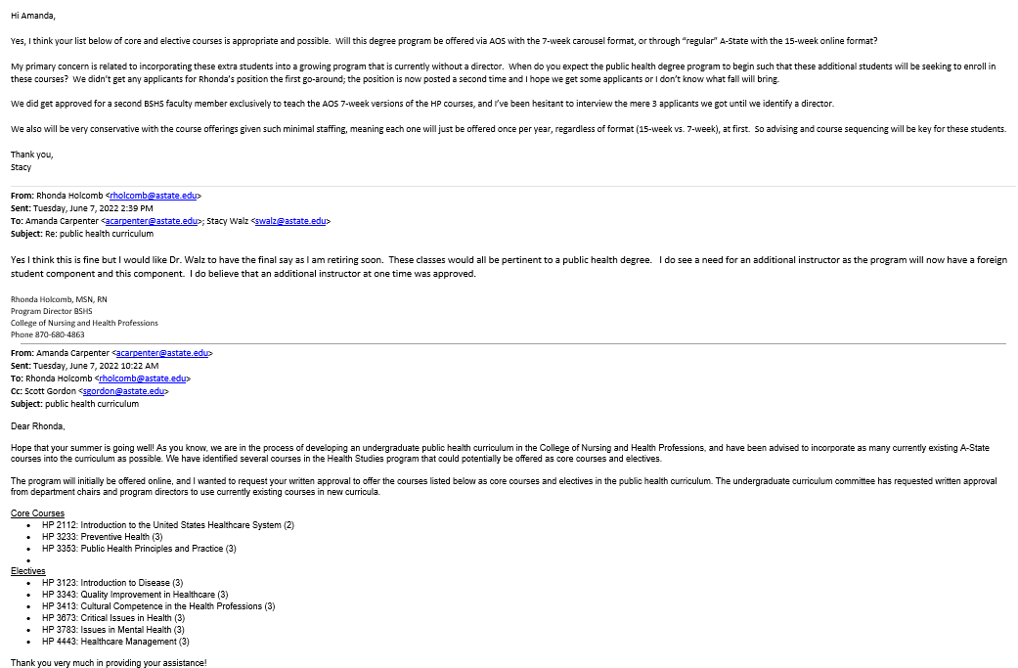

- Bachelor of Science in Occupational and Environmental Safety and Health
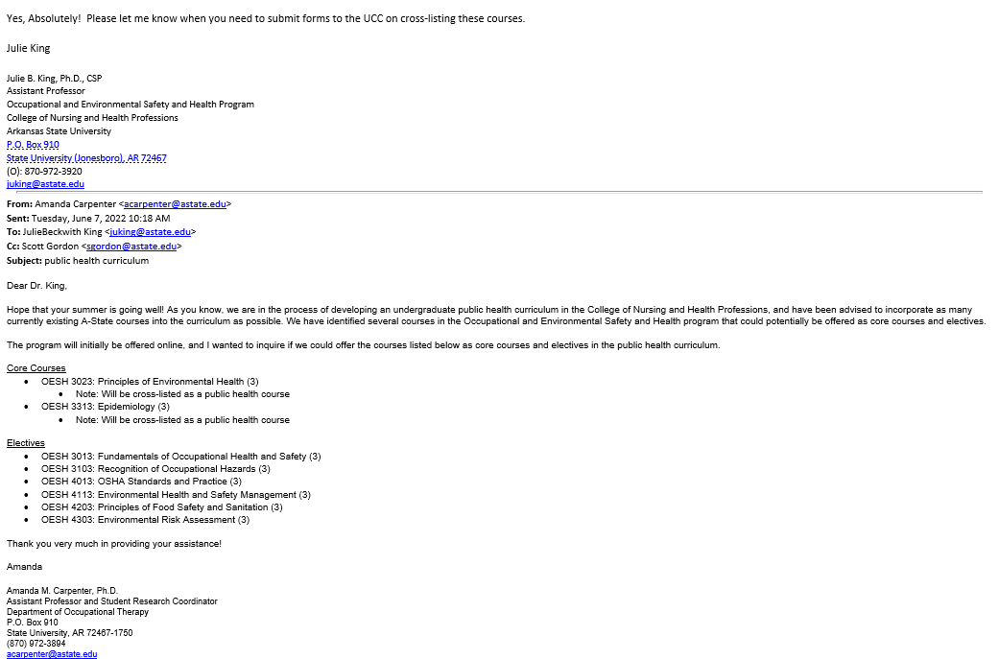

- Bachelor of Science in Disaster Preparedness and Emergency Management
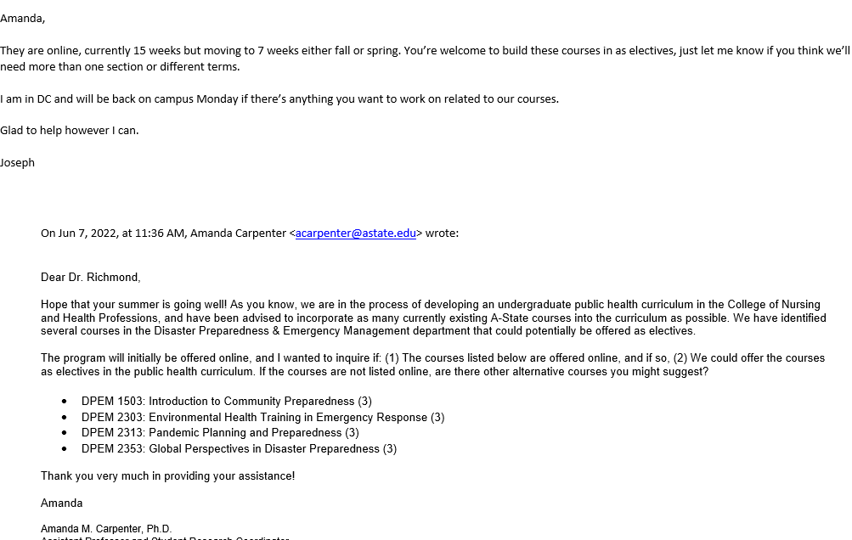

- Bachelor of Arts in Communication
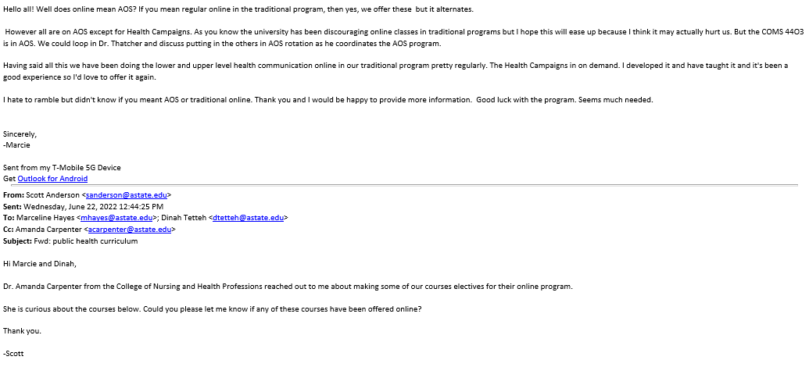
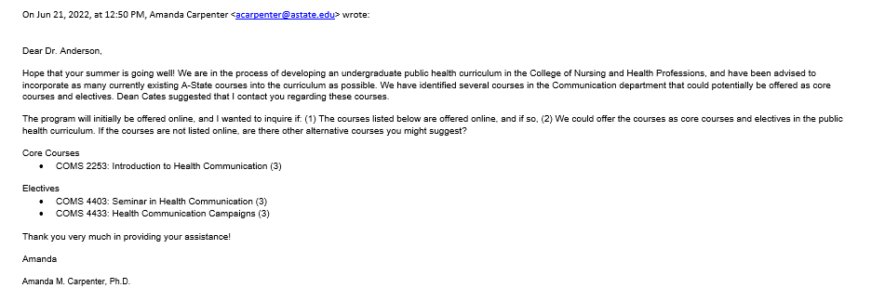

- Bachelor of Arts in Political Science
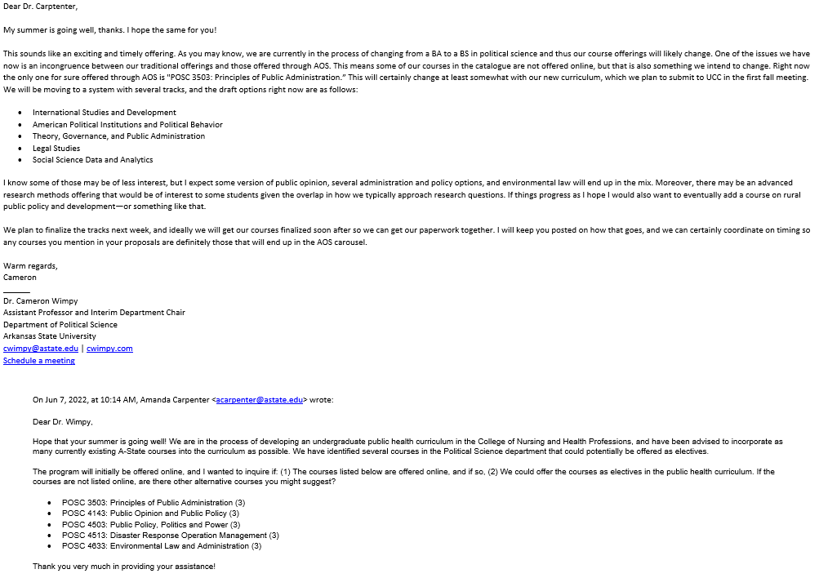

- Bachelor of Arts in Sociology
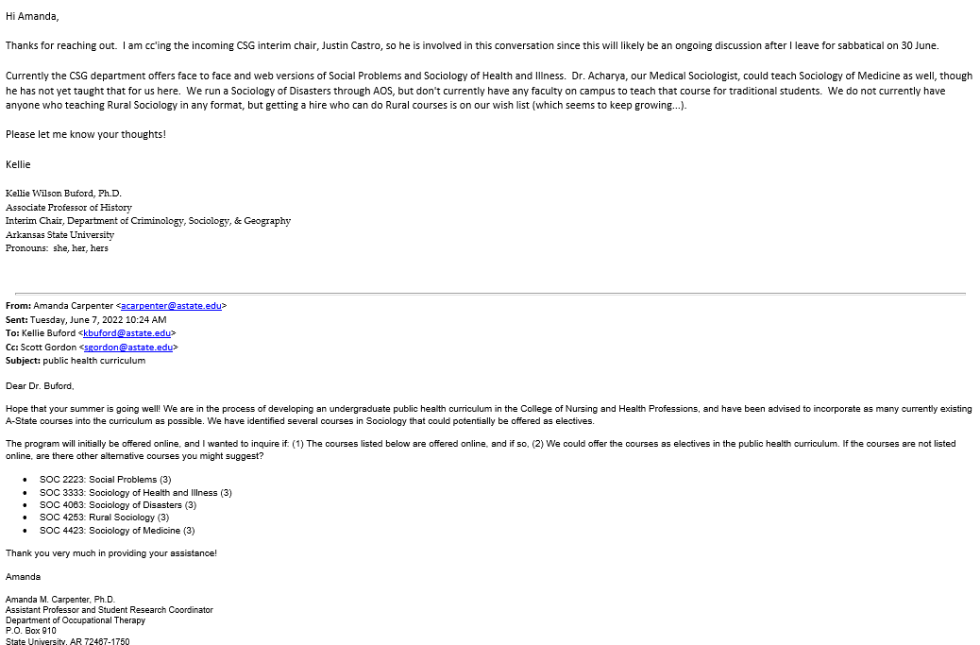

- Bachelor of Arts in History
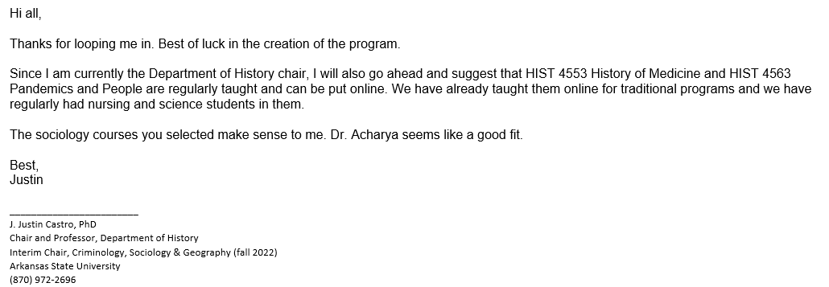

- Statistics, Minor
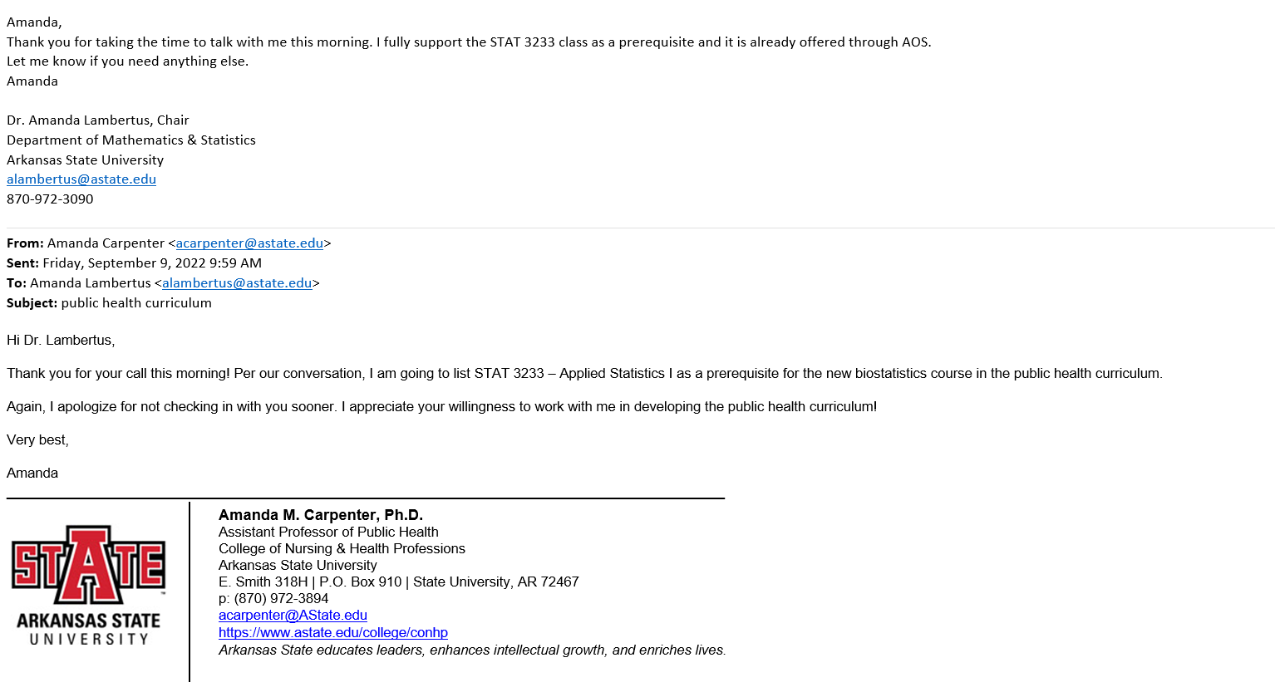

Appendix D: Workforce Analysis (Referenced in #6 on pg. 13)

Workforce Analysis

Institution: | Arkansas State University – Jonesboro
Program Name: | Bachelor of Science in Public Health
Proposed CIP Code: | 51.2201
By: | ADFA Economic Policy Division
Date: | July 14th, 2022
Introduction

Arkansas State University – Jonesboro proposes a Bachelor of Science in Public Health program. This program is described in the following way:
“The proposed A-State Bachelor’s of Science in Public Health incorporates the five core disciplines of public health into the curriculum: (1) epidemiology, (2) biostatistics, (3) health and policy management, (4) environmental health sciences, and (5) social and behavioral sciences. The curriculum is designed using the Centers for Disease Control and Prevention (CDC) 10 Essential Public Health Services as a framework. Students will complete 35 credits of general education requirements, 50 credits of public health core requirements, and 35 credits of elective courses, for a total of 120 credit hours.”
Degrees in Public Health are much less common than generally expected. Only about half of such degrees are at the bachelors level. There aren’t occupations specifically related to public health. They include typically diverse educational backgrounds. For example, for healthcare administrators with a bachelor’s degree, the most common major of study is nursing, with almost 20% followed by business (and business-related) degrees. Still, only 1.6% have a BS in Public Health. This is because they serve different purposes., either managing a team of nurses or running a healthcare business, but organizations or teams dedicated to health policy are because the number of establishments aimed at healthcare policy is relatively small.¹
At the same time, when observing job ads, the list of occupations demanding a bachelor’s degree in Public Health is vast and includes positions such as analysts and public relations. Moreover, most of such demand comes from state government agencies, which is not surprising since they are most interested in health policies. Therefore, most of the enrollees in this program should expect a career in public service.
One question worth raising but can’t be answered by the data is if general degrees in public health might prepare graduates to become competent in different areas of study but not enough to master each of them, limiting how far they can reach in each subfield. This is partly why Public Health degrees are so popular at the graduate level, complementing their specialization (for example, a degree in Epidemiology) with a general knowledge of public health policy.

¹ But probably way higher than 1.6% since the number of workers with a BS in political science who work as healthcare administrators is 1.5%. Also, the estimations in Table 5 only use individuals with a bachelor’s degree but not higher, as the data source didn’t have details on majors for graduate degrees.
Analysis

Public health degrees are not particularly popular in Arkansas, where less than 100 degrees at the bachelors level are awarded in the state. Nationally it’s only slightly better in terms of bachelors diplomas per population. However, the most popular type of degree in this field is at masters degree level.

Table 1: Awards by type in Academic year 2018-2019 (Source: Chmura Analytics)
CIP Code | Major | Area | Total | % Certificates | % Assoc. Degrees | % Bacc. Degrees | % Masters and Post-  Bacc. | % Doctorate
51.2201 | Public Health, General | Arkansas | 129 | 0% | 0% | 68% | 29% | 3%
 |  | United States | 20,608 | 0% | 1% | 46% | 50% | 3%

There are four occupations associated with this degree. The workforce analysis also includes Epidemiologists. Except for Postsecondary teachers, all the rest have a substantial percentage of workers with a bachelor's degree. Table 3 shows an educational breakdown for Managers that is across the board. This is because this occupation is vaguely defined and includes a diverse set of types of managers within healthcare. We will see this in more detail in Table 5.

Table 2: Education, Experience, Training (Source: Bureau of Labor Statistics)
SOC Code | Occupation | Typical Entry-Level Education | Previous Work Experience | Typical On-the-Job Training
11-9111 | Medical and Health Services Managers | Bachelor's degree | Less than 5 years | None
19-1041 | Epidemiologists | Master's degree | None | None
21-1091 | Health Education Specialists | Bachelor's degree | None | None
21-1094 | Community Health Workers | High school diploma or equivalent | None | Short-term on-the-job training
25-1071 | Health Specialties Teachers, Postsecondary | Doctoral or professional degree | Less than 5 years | None

Table 3: Education attainment in matched occupations (Source: Chmura Analytics)
Occupation | % Less Than High  School | % High School | % Some College | % 2 Year Degree | % Bachelors Degree | % Masters | % Doctorate
Medical and Health Services Managers | 1% | 11% | 14% | 12% | 32% | 23% | 7%
Epidemiologists | 1% | 1% | 1% | 1% | 29% | 23% | 44%
Health Education Specialists | 2% | 15% | 14% | 8% | 41% | 18% | 4%
Community Health Workers | 2% | 15% | 14% | 8% | 41% | 17% | 3%
Health Specialties Teachers, Postsecondary | 1% | 2% | 3% | 2% | 18% | 31% | 44%

The most popular associated occupations are managers, which has been growing steadily in the past five years, and it’s expected to keep that growth rate, even when the Location Quotient shows that its proportion over the whole workforce is way higher than the national average. However, the rest of the occupations have LQ values below one. Note that more than 800 employees work as postsecondary teachers, but this occupation is usually reserved for people with a graduate degree. While it is expected that almost 300 new healthcare managers will be hired over the next year (either because of employment growth or to replace exiting workers), public health specialists will fill only a small number of these positions. Table 5 uses Census microdata to break down healthcare managers according to their major of study.² Less than 2% of such managers have a degree in public health. The most popular is nursing, followed by business degrees, psychology, biology, and healthcare administration. Note also that if we consider this and add that postsecondary teaching is not a destination for recent graduates, the expected number of new positions is smaller than the current number of graduates. This means that many of them either become employed in different occupations or pursue a higher degree.
Table 4: Occupation Snapshot (Source: Chmura Analytics)
Occupation | Empl | % Self Employed | % Private | LQ | Unemp. Rate | Prev 5 Years Empl. Change | Prev 5 Years % Annual Change | 1 Year Forecast Total Demand | 1 Year Forecast Exits | 1 Year Forecast Net Empl. Growth | 1 Year Forecast  % Net Empl.  Growth
Medical and Health Services Managers | 5,295 | 3% | 78% | 1.46 | 1.0% | 596 | 2.4% | 573 | 144 | 135 | 2.5%
Epidemiologists | 41 | 0% | 32% | 0.65 |  | 2 | 0.9% | 4 | 1 | 1 | 2.1%
Health Education Specialists | 295 | 0% | 69% | 0.59 | 1.6% | 3 | 0.2% | 35 | 10 | 3 | 1.2%
Community Health Workers | 390 | 0% | 67% | 0.74 | 1.6% | 66 | 3.8% | 51 | 14 | 8 | 2.0%
Health Specialties Teachers, Postsecondary | 826 | 0% | 26% | 0.51 | 1.3% | -6 | -0.2% | 99 | 40 | 18 | 2.1%

² This table is at the national level and only includes surveyed individuals with bachelor degrees.
Table 5: Medical and Health Services Managers by first major among workers only holding bachelor’s degree, United States (Source: Census ACS Microdata 2015-19)
Major | Pct Major
Nursing | 17.2%
Business Management And Administration | 7.6%
Psychology | 7.4%
Health And Medical Administrative Services | 5.3%
Biology | 4.3%
General Business | 3.9%
Communications | 3.0%
Physical Fitness Parks Recreation And Leisure | 2.7%
Sociology | 2.4%
General Medical And Health Services | 1.9%
Criminal Justice And Fire Protection | 1.8%
Marketing And Marketing Research | 1.8%
Community And Public Health | 1.6%
Political Science And Government | 1.5%
Accounting | 1.4%
Treatment Therapy Professions | 1.4%
English Language And Literature | 1.4%
Finance | 1.3%
Medical Technologies Technicians | 1.3%
General Education | 1.3%
Multi-Disciplinary Or General Science | 1.1%
Social Work | 1.1%
History | 1.0%
All Other | 26.5%

Salaries in these occupations are relatively high. However, since the distribution of educational attainment includes, in some cases, large percentages of workers with degrees higher and lower than a bachelor's, the values in Table 6 are not an accurate outlook of what graduates of this degree should expect if they embark in careers on any of these occupations.
Table 6: Wage distribution for matched occupations (Source: Chmura Analytics)
Occupation | Entry Level | Experienced | 10%  Percentile | 25%  Percentile | 50%  Percentile | 75%  Percentile | 90%  Percentile | Mean Arkansas | Mean Country
Medical and Health Services Managers | $56,200 | $106,400 | $52,600 | $64,300 | $78,800 | $100,400 | $133,900 | $89,700 | $118,800
Epidemiologists | $51,800 | $74,800 | $51,800 | $53,200 | $60,900 | $80,000 | $96,200 | $67,100 | $83,600
Health Education Specialists | $32,700 | $57,900 | $29,300 | $38,300 | $46,400 | $61,000 | $75,300 | $49,500 | $62,100
Community Health Workers | $31,900 | $52,500 | $29,400 | $36,300 | $43,000 | $56,500 | $64,200 | $45,600 | $46,000
Health Specialties Teachers, Postsecondary | $38,600 | $88,300 | $33,400 | $47,200 | $63,400 | $82,200 | $114,500 | $71,700 | $124,900

Table 7a shows, surprisingly, that the number of ads for healthcare managers is higher than the actual number of workers employed as such. This is probably because a search for these positions is hardly ever local, so some jobs might be advertised in many places simultaneously. Some of these employers might be out of state but doing regional or national searches for candidates. We can say a similar story about postsecondary teachers. However, as we mentioned, these occupations are not explicitly related to public health. In table 7b, we used the same database to look for Job ads over the past 12 months that included the term “public health” (and also required a bachelor’s degree). Note that the list of occupations looking for workers is way more extensive than the one in 7a, with Social and Human Service Assistants at the top, followed by healthcare managers (note that the proportion of such positions is similar to the one in table 5). There is also a large number of posts related to analysts and research coordinators, which makes sense given the types of skills earned with a bachelors degree in public health.
However, Figure 1 shows a drop in the number of ads containing this term.
Table 7a: Online job Advertisement in Arkansas for matched occupations, May 2021 - April 2022 (Source: Chmura Analytics)
SOC-8 | Occupation | Total Ads
11-9111.00 | Medical and Health Services Managers | 6,217
25-1071.00 | Health Specialties Teachers, Postsecondary | 586
21-1094.00 | Community Health Workers | 115
19-1041.00 | Epidemiologists | 43
21-1091.00 | Health Education Specialists | 29

Table 7b: Online job Advertisement in Arkansas having “Public Health” in it and requiring a Bachelor’s degree, July 2021 - June 2022 (Source: Chmura Analytics)
SOC | Occupation | Active Job Ads |  | Top Employers | Active Job Ads
21-1093.00 | Social and Human Service Assistants | 135 |  | State of Arkansas | 157
11-9111.00 | Medical and Health Services Managers | 90 |  | UAMS Medical Center | 42
13-1111.00 | Management Analysts | 21 |  | Molina Healthcare | 30
11-1011.00 | Chief Executives | 13 |  | General Dynamics - Information Technology | 17
11-3021.00 | Computer and Information Systems Managers | 13 |  | ICF | 10
15-2031.00 | Operations Research Analysts | 11 |  | Highmark Health | 9
13-1151.00 | Training and Development Specialists | 9 |  | Humana | 8
13-1199.00 | Business Operations Specialists, All Other | 9 |  | Anthem, Inc. | 6
43-6013.00 | Medical Secretaries and Administrative Assistants | 9 |  | Centene Corporation | 5
11-9121.01 | Clinical Research Coordinators | 5 |  | University of Arkansas for Medical Sciences | 5
13-1071.00 | Human Resources Specialists | 5
19-1041.00 | Epidemiologists | 5
27-3031.00 | Public Relations Specialists | 5
19-1042.00 | Medical Scientists, Except Epidemiologists | 4
21-1021.00 | Child, Family, and School Social Workers | 4
11-9151.00 | Social and Community Service Managers | 3
15-1221.00 | Computer and Information Research Scientists | 3
21-1091.00 | Health Education Specialists | 3
29-9021.00 | Health Information Technologists and Medical Registrars | 3
31-9099.00 | Healthcare Support Workers, All Other | 3
 | All others | 25

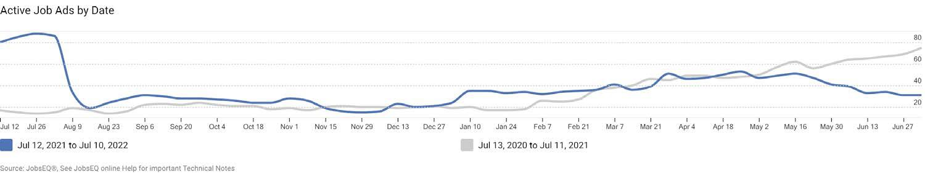
Figure 1: Total Online job Advertisement in Arkansas Arkansas having “Public Health” in it and requiring a Bachelor’s degree, July 2020 - June 2022 (Source: Chmura Analytics)

The following table shows the job placement one year after graduation for Arkansas’ 2016-17 cohorts. Note that low values of full employment and full-time wages don’t mean that graduates struggled in the job market. The data only includes those employed and receiving a salary within Arkansas. Those who continue their studies, leave the state, or become self-employed would not be counted as employed. Unfortunately, we don’t have access to more detailed information to know the cause of this.
Table 8: Job Placement Track Record, degrees in Public Health, 2016 & 2017 cohorts (Source: ARC 2019 Economic Security Report)
Institution | Degree Abbr. | Graduates | Share graduates in state | Employed % | Avg First Year Wages | Full-Time  % | Avg First Year Full- Time Wages
University of Arkansas Fayetteville | Bacc. | 141 | 100% | 52% | $20,651 | 23% | $33,750
University of Arkansas for Medical Sciences | Masters | 58 | 100% | 67% | $42,068 | 47% | $51,589

The final table lists the performance in the job market for graduates of ASU – Jonesboro, 12 months after finishing the program. For most of the programs, the university has values similar to those in the rest of the state (last two columns).
Table 9: Job Placement Track Record, Arkansas State University - Jonesboro, 2016 & 2017 cohorts (Source: ARC 2019 Economic Security Report)
Degree Abbr. | CIP Category | CIP Detail | Grads | Share graduates in state | Employed  % | Avg First Year Wages | Full- Time  % | State Avg Full Time Emp | Avg First Year Full- Time  Wages | State Avg Full Time Wage
Assoc. Deg. | Liberal Arts & Sci., Gen. Studies | Liberal Arts and Sciences/Liberal Studies | 524 | 12% | 76% | $14,777 | 5% | 18% | $32,364 | $30,279
Assoc. Deg. | Liberal Arts & Sci., Gen. Studies | General Studies | 40 | 2% | 78% | $29,341 | 40% | 20% | $37,740 | $33,142
Assoc. Deg. | Health Professions | Occupational Therapist Assistant | 26 | 18% | 96% | $40,380 | 69% | 53% | $45,120 | $49,549
Assoc. Deg. | Health Professions | Physical Therapy Technician/Assistant | 48 | 39% | 92% | $41,310 | 65% | 70% | $45,007 | $46,022
Assoc. Deg. | Health Professions | Registered Nursing/Registered Nurse | 171 | 10% | 69% | $48,082 | 40% | 57% | $52,399 | $53,863
Assoc. Deg. | ALL AREAS OF STUDY |  | 834 | 6% | 76% | $25,144 | 20% | 31% | $45,008 | $38,777
Bacc. | Agriculture | Agribusiness/Agricultural Business  Operations | 102 | 28% | 75% | $36,001 | 59% | 53% | $41,634 | $40,121
Bacc. | Agriculture | Animal Sciences, General | 37 | 29% | 70% | $22,150 | 35% | 34% | $31,887 | $32,078
Bacc. | Agriculture | Plant Sciences, General | 43 | 100% | 70% | $29,661 | 47% | 47% | $36,594 | $36,594
Bacc. | Communication &  Journalism | Communication and Media Studies | 42 | 44% | 67% | $18,234 | 33% | 34% | $25,569 | $33,233
Bacc. | Communication & Journalism | Journalism | 16 | 3% | 56% | $21,822 | 38% | 32% | $30,866 | $33,386
Bacc. | Communication & Journalism | Journalism, Other | 18 | 100% | 56% | $13,969 | 22% | 22% | $26,193 | $26,193
Bacc. | Communication &  Journalism | Radio and Television | 13 | 100% | 69% | $28,196 | 62% | 62% | $31,634 | $31,634
Bacc. | Communication & Journalism | Radio, Television, and Digital Communication, Other | 32 | 100% | 53% | $19,659 | 34% | 34% | $25,201 | $25,201
Bacc. | Communication &  Journalism | Public Relations, Advertising, and Applied  Communication, Other | 29 | 100% | 59% | $15,766 | 24% | 24% | $28,525 | $28,525
Bacc. | Computer & Information Sciences | Computer and Information Sciences, General | 32 | 8% | 66% | $36,272 | 44% | 51% | $47,004 | $53,446
Bacc. | Computer & Information  Sciences | Data Processing and Data Processing Technology/Technician | 41 | 100% | 71% | $37,088 | 59% | 59% | $42,495 | $42,495
Bacc. | Education | Junior High/Intermediate/Middle School Education and Teaching | 93 | 40% | 88% | $33,328 | 70% | 63% | $34,471 | $34,916
Bacc. | Education | Early Childhood Education and Teaching | 192 | 38% | 92% | $32,478 | 72% | 69% | $34,073 | $34,080
Bacc. | Education | English/Language Arts Teacher Education | 23 | 38% | 91% | $30,912 | 39% | 54% | $34,388 | $34,096
Bacc. | Education | Music Teacher Education | 31 | 45% | 84% | $36,434 | 77% | 71% | $38,590 | $36,429
Bacc. | Education | Physical Education Teaching and Coaching | 51 | 18% | 86% | $33,887 | 65% | 54% | $38,170 | $36,510
Bacc. | Education | Social Science Teacher Education | 25 | 100% | 84% | $31,474 | 52% | 52% | $38,156 | $38,156
Bacc. | Engineering | Civil Engineering, General | 34 | 22% | 71% | $49,193 | 62% | 42% | $53,655 | $54,138
Bacc. | Engineering | Electrical and Electronics Engineering | 24 | 14% | 58% | $54,810 | 33% | 33% | $65,985 | $60,012
Bacc. | Engineering | Mechanical Engineering | 45 | 11% | 62% | $57,496 | 56% | 43% | $62,257 | $58,845
Bacc. | Engineering Technology | Engineering Technologies and Engineering- Related Fields, Other | 28 | 100% | 79% | $52,050 | 64% | 64% | $53,512 | $53,512
Bacc. | Foreign Languages  & Linguistics | Foreign Languages and Literatures, General | 12 | 16% | 75% | $15,944 | 33% | 42% | $26,278 | $29,541
Bacc. | English Language & Literature | English Language and Literature, General | 40 | 8% | 75% | $15,089 | 22% | 33% | $23,275 | $29,011
Bacc. | Liberal Arts & Sci., Gen. Studies | General Studies | 405 | 52% | 69% | $23,680 | 34% | 33% | $31,731 | $31,150
Bacc. | Biological & Biomedical  Sciences | Biology/Biological Sciences, General | 127 | 11% | 57% | $16,836 | 19% | 21% | $28,799 | $31,241
Bacc. | Mathematics & Statistics | Mathematics, General | 25 | 13% | 72% | $25,101 | 16% | 35% | $30,336 | $40,351
Bacc. | Parks, Recreation,  Leisure & Fitness | Health and Physical Education/Fitness,  General | 33 | 6% | 64% | $19,266 | 18% | 21% | $36,471 | $36,575
Bacc. | Parks, Recreation, Leisure & Fitness | Sport and Fitness Administration/Management | 44 | 100% | 68% | $18,686 | 23% | 23% | $34,084 | $34,084
Bacc. | Parks, Recreation,  Leisure & Fitness | Kinesiology and Exercise Science | 110 | 46% | 63% | $24,344 | 25% | 30% | $36,989 | $33,997
Bacc. | Physical Sciences | Chemistry, General | 44 | 15% | 52% | $15,053 | 16% | 20% | $30,027 | $34,033
Bacc. | Psychology | Psychology, General | 130 | 11% | 72% | $17,802 | 35% | 34% | $26,090 | $28,431
Bacc. | Public Admin. &  Social Service | Social Work | 69 | 19% | 80% | $19,097 | 23% | 37% | $31,271 | $29,964
Bacc. | Social Sciences | Criminology | 127 | 91% | 76% | $24,972 | 46% | 49% | $31,470 | $32,360
Bacc. | Social Sciences | Political Science and Government, General | 19 | 7% | 79% | $12,026 | 16% | 18% | $27,944 | $36,176
Bacc. | Social Sciences | Sociology | 44 | 16% | 73% | $22,906 | 41% | 41% | $28,364 | $30,685
Bacc. | Visual & Performing Arts | Commercial and Advertising Art | 28 | 100% | 64% | $26,910 | 50% | 50% | $31,586 | $31,586
Bacc. | Visual &  Performing Arts | Drama and Dramatics/Theatre Arts, General | 16 | 18% | 31% | $25,825 | 25% | 34% | $32,210 | $23,340
Bacc. | Visual & Performing Arts | Art/Art Studies, General | 19 | 6% | 68% | $23,017 | 47% | 43% | $27,901 | $27,627
Bacc. | Health Professions | Health and Wellness, General | 30 | 100% | 63% | $19,472 | 17% | 17% | $37,077 | $37,077
Bacc. | Health Professions | Audiology/Audiologist and Speech-Language Pathology/Pathologist | 64 | 22% | 69% | $12,247 | 20% | 12% | $30,060 | $28,075
Bacc. | Health Professions | Medical Radiologic Technology/Science -  Radiation Therapist | 75 | 51% | 55% | $41,784 | 41% | 56% | $45,834 | $50,530
Bacc. | Health Professions | Clinical Laboratory Science/Medical Technology/Technologist | 23 | 27% | 78% | $34,996 | 57% | 60% | $42,532 | $47,138
Bacc. | Health Professions | Dietetics/Dietitian | 17 | 100% | 53% | $26,493 | 18% | 18% | $42,468 | $42,468
Bacc. | Health Professions | Registered Nursing/Registered Nurse | 281 | 12% | 79% | $52,335 | 57% | 59% | $57,462 | $59,537
Bacc. | Business, Management & Marketing | Business Administration and Management, General | 224 | 18% | 65% | $30,038 | 40% | 46% | $37,681 | $39,595
Bacc. | Business, Management &  Marketing | Accounting | 103 | 16% | 74% | $32,145 | 46% | 43% | $35,580 | $42,929
Bacc. | Business, Management &  Marketing | Finance, General | 113 | 16% | 52% | $31,174 | 35% | 29% | $38,970 | $45,268
Bacc. | Business, Management & Marketing | International Business/Trade/Commerce | 31 | 28% | 23% | $25,594 | 16% | 31% | $32,228 | $50,603
Bacc. | Business,  Management & Marketing | Marketing/Marketing Management, General | 65 | 9% | 58% | $29,044 | 34% | 34% | $34,282 | $43,774
Bacc. | History | History, General | 22 | 6% | 86% | $16,681 | 36% | 35% | $26,060 | $31,837
Bacc. | ALL AREAS OF STUDY |  | 3409 | 13% | 70% | $29,676 | 41% | 39% | $38,349 | $41,190
Masters | Agriculture | Agribusiness/Agricultural Business  Operations | 43 | 100% | 72% | $36,719 | 47% | 47% | $46,850 | $46,850
Masters | Communication & Journalism | Communication and Media Studies, Other | 12 | 100% | 67% | $26,913 | 42% | 42% | $36,999 | $36,999
Masters | Computer & Information  Sciences | Computer and Information Sciences, General | 71 | 7% | 20% | $42,305 | 11% | 3% | $55,412 | $57,608
Masters | Education | Curriculum and Instruction | 651 | 96% | 46% | $46,015 | 35% | 36% | $46,861 | $46,918
Masters | Education | Elementary and Middle School Administration/Principalship | 699 | 95% | 37% | $52,889 | 29% | 30% | $53,954 | $53,836
Masters | Education | Special Education and Teaching, General | 192 | 82% | 52% | $45,037 | 42% | 47% | $44,727 | $45,637
Masters | Education | Education/Teaching of the Gifted and Talented | 197 | 94% | 56% | $47,193 | 41% | 43% | $47,939 | $48,041
Masters | Education | Special Education and Teaching, Other | 64 | 100% | 67% | $44,705 | 44% | 44% | $45,808 | $45,808
Masters | Education | Counselor Education/School Counseling and Guidance Services | 15 | 6% | 93% | $42,357 | 87% | 64% | $43,304 | $47,061
Masters | Education | College Student Counseling and Personnel  Services | 33 | 20% | 52% | $38,657 | 33% | 30% | $41,320 | $38,108
Masters | Education | Teacher Education and Professional Development, Specific Levels and Methods, Other | 20 | 7% | 100% | $36,416 | 50% | 69% | $40,051 | $41,983
Masters | Engineering | Engineering, General | 11 | 100% | 36% | $37,006 | 27% | 27% | $48,021 | $48,021
Masters | Family &  Consumer Sciences | Child Care and Support Services  Management | 15 | 100% | 67% | $36,258 | 47% | 47% | $37,385 | $37,385
Masters | English Language & Literature | English Language and Literature, General | 15 | 23% | 47% | $22,036 | 27% | 40% | $32,938 | $32,474
Masters | Biological & Biomedical  Sciences | Biology/Biological Sciences, General | 16 | 46% | 56% | $27,966 | 38% | 35% | $36,429 | $38,303
Masters | Mathematics & Statistics | Mathematics, General | 12 | 48% | 67% | $37,508 | 50% | 36% | $45,587 | $51,522
Masters | Parks, Recreation, Leisure & Fitness | Sport and Fitness Administration/Management | 52 | 55% | 35% | $33,572 | 17% | 26% | $44,565 | $40,146
Masters | Parks, Recreation,  Leisure & Fitness | Kinesiology and Exercise Science | 21 | 44% | 48% | $23,021 | 19% | 17% | $37,510 | $40,305
Masters | Law Enforcement & Protective Serv. | Crisis/Emergency/Disaster Management | 27 | 45% | 52% | $47,110 | 30% | 22% | $63,061 | $51,591
Masters | Public Admin. &  Social Service | Public Administration | 195 | 85% | 33% | $37,951 | 24% | 29% | $44,694 | $48,434
Masters | Public Admin. & Social Service | Social Work | 79 | 31% | 94% | $43,062 | 84% | 81% | $45,765 | $46,151
Masters | Health Professions | Speech-Language Pathology/Pathologist | 51 | 100% | 73% | $52,579 | 69% | 69% | $55,016 | $55,016
Masters | Health Professions | Registered Nursing/Registered Nurse | 69 | 39% | 78% | $89,280 | 71% | 72% | $92,175 | $87,401
Masters | Health Professions | Nurse Anesthetist | 78 | 100% | 33% | $144,216 | 29% | 29% | $152,415 | $152,415
Masters | Health Professions | Health Professions and Related Clinical  Sciences, Other | 11 | 100% | 64% | $43,697 | 45% | 45% | $45,717 | $45,717
Masters | Business, Management &  Marketing | Business Administration and Management, General | 109 | 18% | 35% | $52,273 | 25% | 46% | $60,951 | $94,597
Masters | Business, Management & Marketing | Accounting | 14 | 10% | 36% | $34,279 | 29% | 26% | $42,200 | $52,433
Masters | History | History, General | 13 | 25% | 62% | $28,507 | 46% | 47% | $34,728 | $36,687
Masters | ALL AREAS OF STUDY |  | 2925 | 29% | 47% | $48,733 | 35% | 40% | $52,584 | $56,175
Post- Masters | Education | Elementary and Middle School Administration/Principalship | 709 | 100% | 37% | $61,930 | 29% | 29% | $64,512 | $64,512
Post-  Masters | Education | Counselor Education/School Counseling and  Guidance Services | 27 | 100% | 89% | $40,391 | 74% | 74% | $44,709 | $44,709
Post- Masters | ALL AREAS OF STUDY |  | 743 | 87% | 39% | $60,014 | 30% | 35% | $62,610 | $63,838
Prof. Doct. | Health Professions | Physical Therapy/Therapist | 59 | 35% | 76% | $65,734 | 69% | 61% | $69,346 | $70,141
Prof. Doct. | Health Professions | Nursing Practice | 15 | 19% | 73% | $111,168 | 60% | 53% | $110,914 | $110,470
Prof. Doct. | ALL AREAS OF STUDY |  | 74 | 6% | 76% | $74,658 | 68% | 49% | $76,828 | $75,469
Ph.D | Education | Educational Leadership and Administration,  General | 18 | 60% | 56% | $60,691 | 44% | 40% | $64,304 | $80,211
Ph.D | ALL AREAS OF STUDY |  | 40 | 7% | 57% | $53,260 | 42% | 32% | $60,181 | $71,973

Appendix E: Letters of Support (Referenced in #6 on pg. 13)

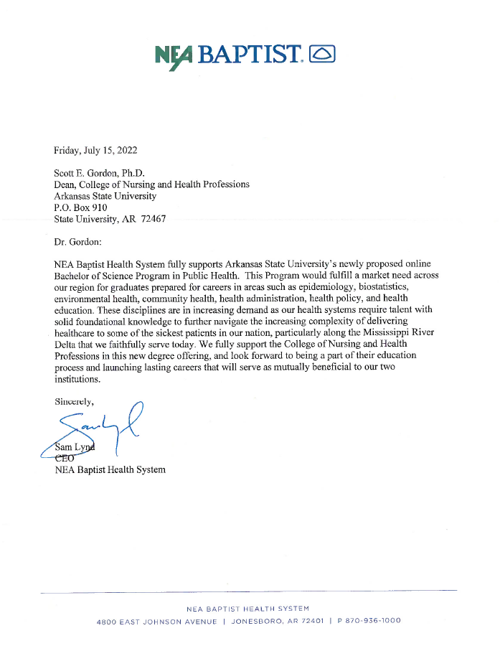

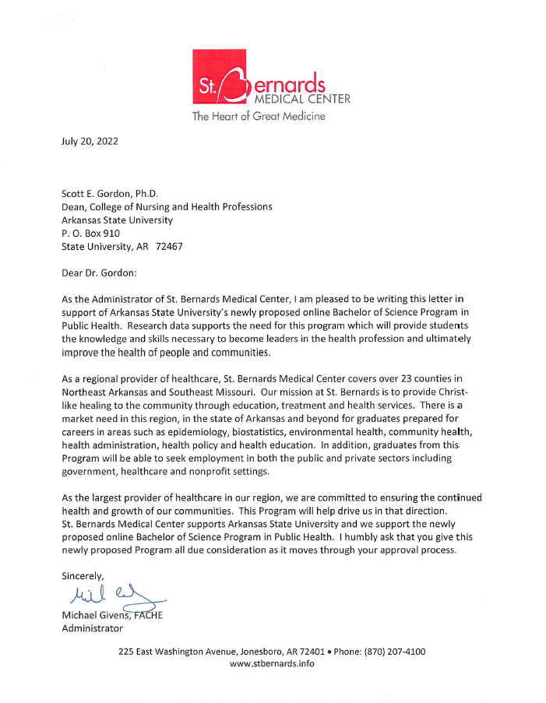
Appendix F: Courses Offered by Distance Technology
(Referenced in #7 on pg. 18)

General Education Requirements
*Note: All general education requirements are offered by distance technology.
  - BIO 2101/2103 Microbiology for Nursing and Allied Health Laboratory*
  - UC 1013: First Year Experience—Making Connections*

Required Courses
- COMS 2253 Introduction to Health Communication*
- HP 2112 Introduction to the United States Healthcare System+
- HP 3233 Preventive Health+
- HP 3353 Public Health Principles and Practice+
- OESH 3023 Principles of Environmental Health*
- OESH 3313 Epidemiology*
- PHLT 1013 Introduction to Public Health*
- PHLT 3023 Global Health*
- PHLT 3203 Biostatistics for Public Health*
- PHLT 3303 Health Policy*
- PHLT 3313 Health Equity*
- PHLT 3323 Public Health Practice and Management*
- PHLT 3503 Public Health Interventions*
- PHLT 3513 Population Health*
- PHLT 4503 Public Health Program Planning and Evaluation*
- PHLT 4513 Public Health Research Design and Methods*
- STAT 3233 Applied Statistics I*

Elective Courses
- COMS 4403 Seminar in Health Communication*
- DPEM 1503 Introduction to Community Preparedness*
- DPEM 2303 Environmental Health Training in Emergency Response*
- DPEM 2313 Pandemic Planning and Preparedness*
- DPEM 2353 Global Perspectives in Disaster Preparedness*
- HIST 4553 History of Medicine*
- HIST 4563 Pandemics and People*
- HP 3123 Introduction to Disease+
- HP 3343 Quality Improvement in Healthcare+
- HP 3413 Cultural Competence in the Health Professions+
- HP 3673 Critical Issues in Health+
- HP 3783 Issues in Mental Health+
- HP 4443 Healthcare Management+
- OESH 3013 Fundamentals of Occupational Health and Safety*
- OESH 3103 Recognition of Occupational Hazards*
- OESH 4013 OSHA Standards and Practice*
- OESH 4113 Environmental Health and Safety Management*
- OESH 4203 Principles of Food Safety and Sanitation*
- OESH 4303 Environmental Risk Assessment*
- PHLT 3603 Rural Health*
- PHLT 470V Public Health Internship*
- POSC 3503 Principles of Public Administration*
- SOC 2223 Social Problems*
- SOC 3333 Sociology of Health and Illness*

+Note: Health Studies courses (with “HP” prefix) will be offered online by the time the Bachelor of Science in Public Health launches. The paperwork to offer all of the Health Studies courses will be completed in the 2023–2024 academic year.

Appendix G: Course Evaluation (Referenced in #7 on pg. 19)

Student evaluations of courses and faculty are conducted through Watermark Course Evaluations & Surveys in the Blackboard learning management system. The following response options are used for each of the course evaluation items:

0 | 1 | 2 | 3 | 4 | 5
Did not have this instructor | Strongly Disagree | Disagree | Agree Somewhat | Agree | Strongly Agree

From my perspective, the Professor/Instructor:
- Was organized and prepared for this course.
- Feedback given to student was appropriate in relation to assignments and performance.
- Communicated well in English.
- Demonstrated impartial and fair evaluation.
- Provided a positive student-teacher interaction.
- Activities contributed to understanding and skill development.
- Demonstrated punctuality.
- Demonstrated knowledge and understanding of the subject matter.
- Provided learning techniques appropriate for course and laboratory.
- Interacted with students in a professional manner.
- Provided opportunities for problem solving, multiple viewpoints, and critical thinking.
- Provided adequate explanation of course material.
- Provided an atmosphere in which students felt comfortable asking questions.
- Comments regarding this instructor.

From my perspective, the Course:
- Reading level of the textbook was appropriate.
- Equipment was functional and represented appropriate technology.
- Format for the course facilitated accomplishment of course objectives and goals.
- Course material was sequenced and structured to facilitate the achievement of goals and
Objectives.
- Textbook covered the topic.
- Library had adequate resources for this course.
- Media used added to my learning experience.
- Format for this course (compressed video, we/asynchronous, web-assisted, lecture/discussion,
laboratory, etc.…) was help in learning the material and related concepts.
- Additional reading assignments provided opportunities to expand knowledge.
- Comments regarding this course.

Appendix H: College of Nursing & Health Professions Organizational Chart
(Referenced in #12 on pg. 22)
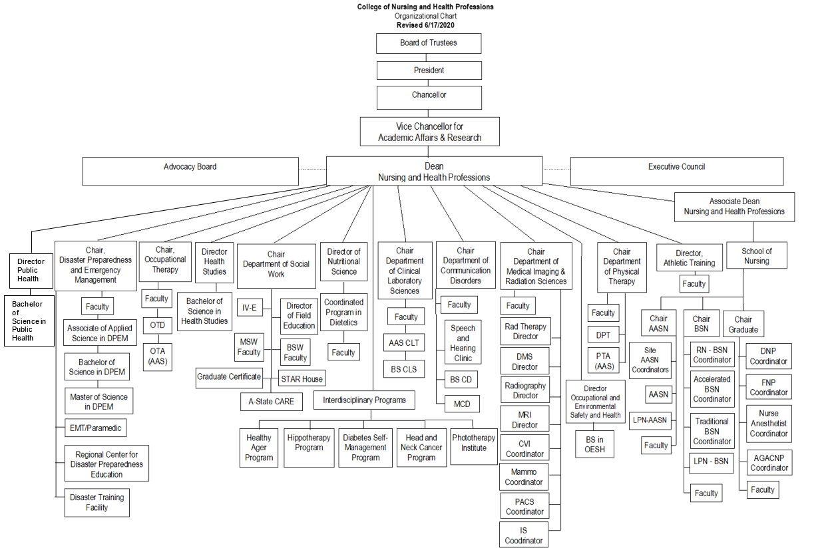

CDC Foundation. (2022). What is public health? https://www.cdcfoundation.org/what-public-health
U.S. News & World Report. (2019). Arkansas. https://www.usnews.com/news/best-states/arkansas#state-rankings
Gennuso KP, Jovaag A, Catlin BB, Rodock M, Park H. Assessment of factors contributing to health outcomes in the eight states of the Mississippi Delta region. Preventing Chronic Disease: Public Health Research, Practice, and Policy. 2016;13, 1–13. doi: 10.5888/pcd13.150440
Arkansas State University. (n.d.) About Arkansas State. https://www.astate.edu/info/about-asu/
Arkansas State University. (n.d.) College of Nursing & Health Professions. https://www.astate.edu/college/conhp/
CDC. (2021). 10 Essential Public Health Services. https://www.cdc.gov/publichealthgateway/publichealthservices/essentialhealthservices.html

