|  |  |
| --- | --- |
| For Academic Affairs and Research Use Only | |
| Proposal Number | BU10 |
| CIP Code: |  |
| Degree Code: |  |

**Program Modification Form**

**[ X] Undergraduate Curriculum Council**

**[ ] Graduate Council**

|  |
| --- |
| **Modification Type: [ ]Admissions, [ X]Curricular Sequence, or [ ]Other** |

Signed paper copies of proposals submitted for consideration are no longer required. Please type approver name and enter date of approval.

|  |  |  |  |  |  |
| --- | --- | --- | --- | --- | --- |
| |  |  | | --- | --- | | H. Steve Lelsie | 2/21/2022 |   **Department Curriculum Committee Chair** | |  |  | | --- | --- | | __________________ | Enter date |   **COPE Chair (if applicable)** |
| |  |  | | --- | --- | | Bill Hu | 2/28/2022 |   **Department Chair** | |  |  | | --- | --- | | __________________ | Enter date |   **Head of Unit (if applicable)** |
| |  |  | | --- | --- | | John Robertson | 3/11/2022 |   **College Curriculum Committee Chair** | |  |  | | --- | --- | | __________________ | Enter date |   **Undergraduate Curriculum Council Chair** |
| |  |  | | --- | --- | | __________________ | Enter date |   **Director of Assessment** *(only for changes impacting assessment)* | |  |  | | --- | --- | | __________________ | Enter date |   **Graduate Curriculum Committee Chair** |
| |  |  | | --- | --- | | Jim Washam | 3/25/2022 |   **College Dean** | |  |  | | --- | --- | | __________________ | Enter date |   **Vice Chancellor for Academic Affairs** |
| |  |  | | --- | --- | | __________________ | Enter date |   **General Education Committee Chair (if applicable)** |  |

1. **Contact Person** (Name, Email Address, Phone Number)

Dr. Melodie Philhours

mphil@astate.edu

870-680-8148

1. **Proposed Change** (for undergraduate curricular changes please provide an 8-semester plan (appendix A), if applicable)

Remove GSCM 3163 Supply Chain Management from BS Global Supply Chain Management core requirements and add 3 hours free elective.

1. **Effective Date**

Fall 2022

1. **Justification –** *Please provide details as to why this change is necessary.*

GSCM 3163 Supply Chain Management is moving to the NGCOB core requirements. All students, including GSCM majors, take the core and thus GSCM 3163 becomes redundant in the core GSCM requirements.

**Bulletin Changes**

|  |
| --- |
| **Instructions** |
| **Please visit** **http://www.astate.edu/a/registrar/students/bulletins/index.dot** **and select the most recent version of the bulletin. Copy and paste all bulletin pages this proposal affects below. Please include a before (with changed areas highlighted) and after of all affected sections.**  **\*Please note: Courses are often listed in multiple sections of the bulletin. To ensure that all affected sections have been located, please search the bulletin (ctrl+F) for the appropriate courses before submission of this form.** |

Page 147: Before

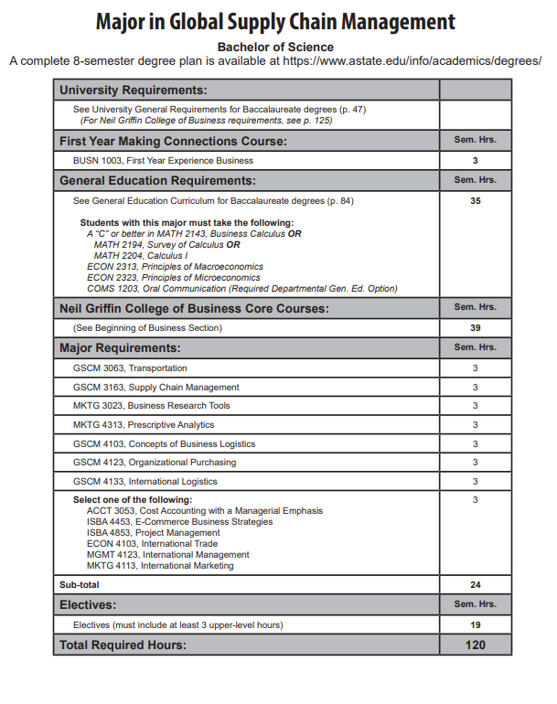

**Page 147 AFTER: (Reordered Major Requirements Following Page)**



**22**

**21**

|  |  |
| --- | --- |
| **Major Requirements:** | **Sem. Hrs.** |
| **GSCM 3063, Transportation** | **3** |
| **GSCM 4103, Concepts of Business Logistics** | **3** |
| **GSCM 4123, Organizational Purchasing** | **3** |
| **GSCM 4133, International Logistics** | **3** |
| **MKTG 3023, Business Research Tools** | **3** |
| **MKTG 4313, Prescriptive Analytics** | **3** |
| **Select One of the Following:**  **ACCT 3053, Cost Accounting with Managerial Emphasis**  **ECON 4103, International Trade**  **ISBA 4453, E-Commerce Business Strategies**  **ISBA 4853, Project Management**  **MGMT 4123, International Management**  **MKTG 4113, International Marketing** | **3** |
| **Sub-Total** | **21** |
| **Electives (must include at least 3 upper level hours)** | **22** |
| **Total Required Hours** | **120** |

**Appendix A, 8-Semester Plan**

(**Referenced in #2** - **Undergraduate Proposals Only)**

