For Academic Affairs and Research Use Only
Proposal Number | NHP59
CIP Code:
Degree Code:

NEW OR MODIFIED COURSE PROPOSAL FORM
[ ] Undergraduate Curriculum Council
[ ] Graduate Council
[ ]New Course, [ ]Experimental Course (1-time offering), or [x ]Modified Course (Check one box)
Signed paper copies of proposals submitted for consideration are no longer required. Please type approver name and enter date of approval.

Kacie Altom 10-18/21  Department Curriculum Committee Chair | ___________________ Enter date…  COPE Chair (if applicable)
Sarah Davidson, CNHP Associate Dean 8/23/2021  Department Chair | Sarah Dearing 8/23/2021  Head of Unit (if applicable)
Shanon Brantley 10/19/2021  College Curriculum Committee Chair | ___________________ Enter date…  Undergraduate Curriculum Council Chair
___________________ Enter date…  Director of Assessment (new courses only) | ___________________ Enter date…  Graduate Curriculum Committee Chair
__Scott E. Gordon_______ 10-28-21  College Dean | __ Alan Utter __________ 11/16/21  Vice Chancellor for Academic Affairs
___________________ Enter date…
General Education Committee Chair (if applicable)

- Contact Person (Name, Email Address, Phone Number)
Sarah Davidson, Associate Dean, CNHP Sarah Dearing, AASN Program Chair
sarahdavidson@astate.edu sdearing@astate.edu
870-972-2748

- Proposed starting term and Bulletin year for new course or modification to take effect
Spring 2022

Instructions:
Please complete all sections unless otherwise noted. For course modifications, sections with a “Modification requested?” prompt need not be completed if the answer is “No.”

 | Current (Course Modifications Only) | Proposed (New or Modified)  (Indicate “N/A” if no modification)
Prefix | NRSP | N/A
Number* | 2382 | N/A
Title | Capstone: Online LPN to AASN | AASN Capstone
Description** | Focus on synthesis of patient care. The graduating student will integrate the knowledge and skills of the registered nurse, validate leadership skills, and transition toward becoming a member of the profession. Corequisites, NRS 2333, and NRSP 2371. Summer. | N/A

* (Confirm with the Registrar’s Office that number chosen has not been used before and is available for use. For variable credit courses, indicate variable range. Proposed number for experimental course is 9. )
**Forty words or fewer as it should appear in the Bulletin.

- Proposed prerequisites and major restrictions [Modification requested? No]
(Indicate all prerequisites. If this course is restricted to a specific major, which major. If a student does not have the prerequisites or does not have the appropriate major, the student will not be allowed to register).

- Proposed course frequency [Modification requested? No]
(e.g. Fall, Spring, Summer; if irregularly offered, please indicate, “irregular.”) Not applicable to Graduate courses.

Enter text...

- Proposed course type [Modification requested? No]
Will this course be lecture only, lab only, lecture and lab, activity (e.g., physical education), dissertation/thesis, capstone, independent study, internship/practicum, seminar, special topics, or studio? Please choose one.
Enter text...

- Proposed grade type [Modification requested? No]
What is the grade type (i.e. standard letter, credit/no credit, pass/fail, no grade, developmental, or other [please elaborate])
Enter text...

- NO Is this course dual-listed (undergraduate/graduate)?

- NO Is this course cross-listed?
(If it is, all course entries must be identical including course descriptions. Submit appropriate documentation for requested changes. It is important to check the course description of an existing course when adding a new cross-listed course.)

a. – If yes, please list the prefix and course number of the cross-listed course.
Enter text...
b. – NO Can the cross-listed course be used to satisfy the prerequisite or degree requirements this course satisfies?
Enter text...

- NO Is this course in support of a new program?
a. If yes, what program?
Enter text...

- NO Will this course be a one-to-one equivalent to a deleted course or previous version of this course (please check with the Registrar if unsure)?
a. If yes, which course?

Course Details

- Proposed outline [Modification requested? No]
(The course outline should be topical by weeks and should be sufficient in detail to allow for judgment of the content of the course.)
Enter text...

- Proposed special features [Modification requested? No]
(e.g. labs, exhibits, site visitations, etc.)
Enter text...

- Department staffing and classroom/lab resources
No change in department staffing and classroom/lab resources.
- Will this require additional faculty, supplies, etc.? No
Enter text...

- Yes Does this course require course fees? This is not a new program/course. Existing Differential Tuition and Fees will be used for NRSP 2382
If yes: please attach the New Program Tuition and Fees form, which is available from the UCC website.

Justification

Modification Justification (Course Modifications Only)
- Justification for Modification(s)
A course name change is requested to be more inclusive and accessible for future expansion for the School of Nursing undergraduate program tracks.

New Course Justification (New Courses Only)
- Justification for course. Must include:
a. Academic rationale and goals for the course (skills or level of knowledge students can be expected to attain)
Enter text...

b. How does the course fit with the mission of the department? If course is mandated by an accrediting or certifying agency, include the directive.
Enter text...

c. Student population served.
Enter text...

d. Rationale for the level of the course (lower, upper, or graduate).
Enter text...

Assessment

Assessment Plan Modifications (Course Modifications Only)
- No Do the proposed modifications result in a change to the assessment plan?
If yes, please complete the Assessment section of the proposal

Relationship with Current Program-Level Assessment Process (Course modifications skip this section unless the answer to #18 is “Yes”)
- What is/are the intended program-level learning outcome/s for students enrolled in this course? Where will this course fit into an already existing program assessment process?
Enter text...

- Considering the indicated program-level learning outcome/s (from question #19), please fill out the following table to show how and where this course fits into the program’s continuous improvement assessment process.

For further assistance, please see the ‘Expanded Instructions’ document available on the UCC - Forms website for guidance, or contact the Office of Assessment at 870-972-2989.

Program-Level Outcome 1 (from question #19) | Type outcome here. What do you want students to think, know, or do when they have completed the course?
Assessment Measure | Please include direct and indirect assessment measure for outcome.
Assessment  Timetable | What semesters, and how often, is the outcome assessed?
Who is responsible for assessing and reporting on the results? | Who (person, position title, or internal committee) is responsible for assessing, evaluating, and analyzing results, and developing action plans?
(Repeat if this new course will support additional program-level outcomes)

Course-Level Outcomes
- What are the course-level outcomes for students enrolled in this course and the associated assessment measures?

Outcome 1 | Type outcome here. What do you want students to think, know, or do when they have completed the course?
Which learning activities are responsible for this outcome? | List learning activities.
Assessment Measure | What will be your assessment measure for this outcome?

Bulletin Changes

Instructions
Please visit http://www.astate.edu/a/registrar/students/bulletins/index.dot and select the most recent version of the bulletin. Copy and paste all bulletin pages this proposal affects below. Please include a before (with changed areas highlighted) and after of all affected sections.

*Please note: Courses are often listed in multiple sections of the bulletin. To ensure that all affected sections have been located, please search the bulletin (ctrl+F) for the appropriate courses before submission of this form.

BEFORE - Bulletin Table Page 394

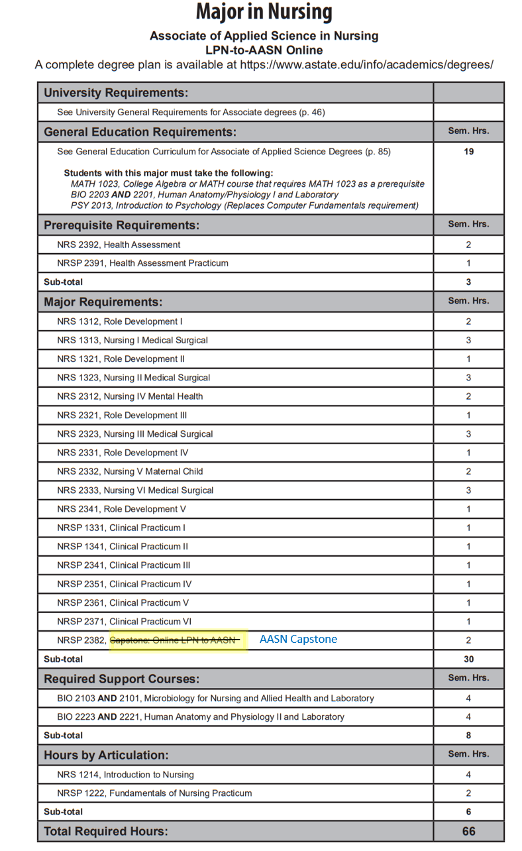

Course Description Page 570:

NRSP 2382. Capstone: Online LPN to AASN AASN Capstone Focus on synthesis of patient care. The graduating student will integrate the knowledge and skills of the registered nurse, validate leadership skills, and transition toward becoming a member of the profession. Corequisites, NRS 2333, and NRSP 2371. Summer.

AFTER
Bulletin table Page 394

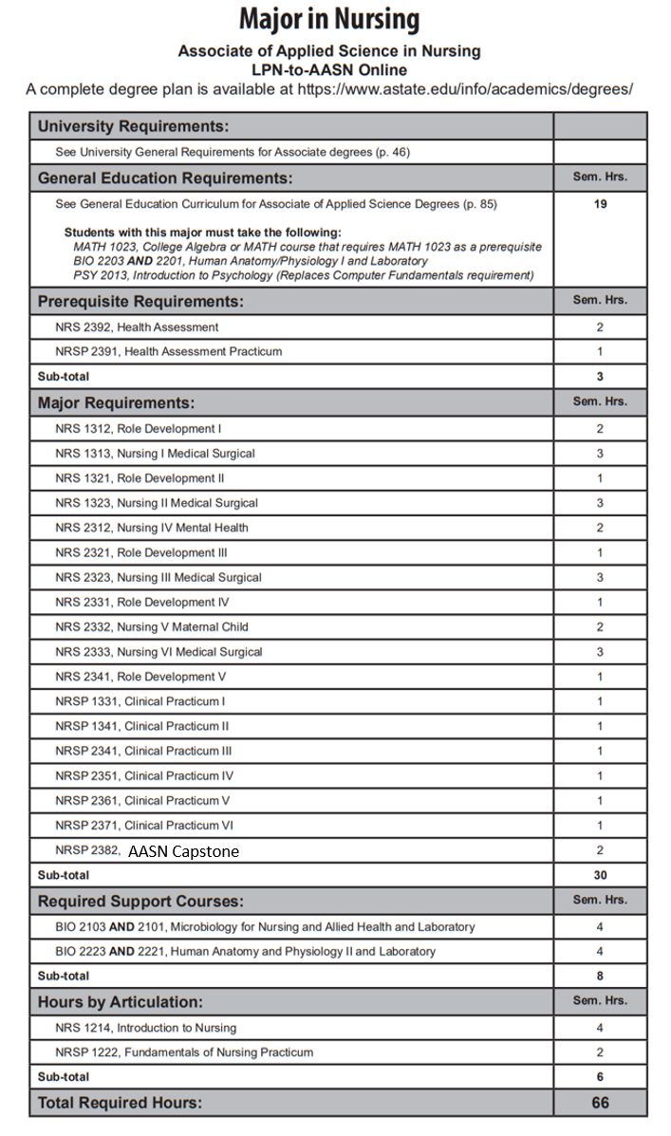

Course Description PAGE 570

NRSP 2382. AASN Capstone Focus on synthesis of patient care. The graduating student will integrate the knowledge and skills of the registered nurse, validate leadership skills, and transition toward becoming a member of the profession. Corequisites, NRS 2333, and NRSP 2371. Summer.

