For Academic Affairs and Research Use Only
Proposal Number
CIP Code:
Degree Code:

NEW OR MODIFIED COURSE PROPOSAL FORM
[x ] Undergraduate Curriculum Council
[ ] Graduate Council
[ ]New Course, [ ]Experimental Course (1-time offering), or [x ]Modified Course (Check one box)
Signed paper copies of proposals submitted for consideration are no longer required. Please type approver name and enter date of approval.

Dr. Cheryl Knight 1/13/21  Department Curriculum Committee Chair | ___________________ Enter date…  COPE Chair (if applicable)
Dr. Cheryl Knight 1/13/2021  Department Chair | ___________________ Enter date…  Head of Unit (if applicable)
Shanon Brantley 01/26/2021  College Curriculum Committee Chair | ___________________ Enter date…  Undergraduate Curriculum Council Chair
___________________ Enter date…  Director of Assessment (new courses only) | ___________________ Enter date…  Graduate Curriculum Committee Chair
__Susan Hanrahan (TK)______ 1/29/21  College Dean | ___________________ Enter date…  Vice Chancellor for Academic Affairs
___________________ Enter date…
General Education Committee Chair (if applicable)

- Contact Person (Name, Email Address, Phone Number)
Dr. Cheryl Knight, cknight@astate.edu, 870-219-4333

- Proposed starting term and Bulletin year for new course or modification to take effect
Fall 2021.

Instructions:
Please complete all sections unless otherwise noted. For course modifications, sections with a “Modification requested?” prompt need not be completed if the answer is “No.”

 | Current (Course Modifications Only) | Proposed (New or Modified)  (Indicate “N/A” if no modification)
Prefix | SW | SW
Number* | 3363 | 3363
Title | Cultural Diversity | Cultural Humility
Description** | Application of social diversity concepts from the Human Behavior and the Social Environment sequence to practice situations will be incorporated into the study of ethical practice of social work with minority populations. Prerequisites, SW 3303 and SW 3333. | No change

* (Confirm with the Registrar’s Office that number chosen has not been used before and is available for use. For variable credit courses, indicate variable range. Proposed number for experimental course is 9. )
**Forty words or fewer as it should appear in the Bulletin.

- Proposed prerequisites and major restrictions [Modification requested? NO
(Indicate all prerequisites. If this course is restricted to a specific major, which major. If a student does not have the prerequisites or does not have the appropriate major, the student will not be allowed to register).
- Yes / No Are there any prerequisites?
  - If yes, which ones?
Enter text...
  - Why or why not?
Enter text...

- Yes / No Is this course restricted to a specific major?
  - If yes, which major?

- Proposed course frequency [Modification requested? NO
(e.g. Fall, Spring, Summer; if irregularly offered, please indicate, “irregular.”) Not applicable to Graduate courses.

- Proposed course type [Modification requested? NO

- Proposed grade type [Modification requested? NO
What is the grade type (i.e. standard letter, credit/no credit, pass/fail, no grade, developmental, or other [please elaborate])
Standard Letter Grade

- NO Is this course dual-listed (undergraduate/graduate)?

- NO Is this course cross-listed?
(If it is, all course entries must be identical including course descriptions. Submit appropriate documentation for requested changes. It is important to check the course description of an existing course when adding a new cross-listed course.)

a. – If yes, please list the prefix and course number of the cross-listed course.
Enter text...
b. – Yes / No Can the cross-listed course be used to satisfy the prerequisite or degree requirements this course satisfies?
Enter text...

- NO Is this course in support of a new program?
a. If yes, what program?

- YES Will this course be a one-to-one equivalent to a deleted course or previous version of this course (please check with the Registrar if unsure)?
a. If yes, which course?
Course Name Change Only

Course Details

- Proposed outline [Modification requested? NO
(The course outline should be topical by weeks and should be sufficient in detail to allow for judgment of the content of the course.)

- Proposed special features [Modification requested? NO
(e.g. labs, exhibits, site visitations, etc.)

- Department staffing and classroom/lab resources NO
Course name change
- Will this require additional faculty, supplies, etc.?

- Yes / No Does this course require course fees? NO
If yes: please attach the New Program Tuition and Fees form, which is available from the UCC website.
Justification

Modification Justification (Course Modifications Only)
- Justification for Modification(s)
The Social Work Department is requesting the name of SW 3363 Cultural Diversity be changed to Cultural Humility. The justification for this modification is based in current research and terminology. There is a push in Social Work to move aware from terms likes cultural diversity, cultural competence and cultural awareness and move toward the concept of cultural humility. The content of this course will not change just terminology and areas of focus

New Course Justification (New Courses Only)
- Justification for course. Must include:
a. Academic rationale and goals for the course (skills or level of knowledge students can be expected to attain)
Enter text...

b. How does the course fit with the mission of the department? If course is mandated by an accrediting or certifying agency, include the directive.
Enter text...

c. Student population served.
Enter text...

d. Rationale for the level of the course (lower, upper, or graduate).
Enter text...

Assessment

Assessment Plan Modifications (Course Modifications Only)
- NO Do the proposed modifications result in a change to the assessment plan?
If yes, please complete the Assessment section of the proposal

Relationship with Current Program-Level Assessment Process (Course modifications skip this section unless the answer to #18 is “Yes”)
- What is/are the intended program-level learning outcome/s for students enrolled in this course? Where will this course fit into an already existing program assessment process?
Enter text...

- Considering the indicated program-level learning outcome/s (from question #19), please fill out the following table to show how and where this course fits into the program’s continuous improvement assessment process.

For further assistance, please see the ‘Expanded Instructions’ document available on the UCC - Forms website for guidance, or contact the Office of Assessment at 870-972-2989.

Program-Level Outcome 1 (from question #19) | Type outcome here. What do you want students to think, know, or do when they have completed the course?
Assessment Measure | Please include direct and indirect assessment measure for outcome.
Assessment  Timetable | What semesters, and how often, is the outcome assessed?
Who is responsible for assessing and reporting on the results? | Who (person, position title, or internal committee) is responsible for assessing, evaluating, and analyzing results, and developing action plans?
(Repeat if this new course will support additional program-level outcomes)

Course-Level Outcomes
- What are the course-level outcomes for students enrolled in this course and the associated assessment measures?

Outcome 1 | Type outcome here. What do you want students to think, know, or do when they have completed the course?
Which learning activities are responsible for this outcome? | List learning activities.
Assessment Measure | What will be your assessment measure for this outcome?
(Repeat if needed for additional outcomes)

Bulletin Changes
Instructions
Please visit http://www.astate.edu/a/registrar/students/bulletins/index.dot and select the most recent version of the bulletin. Copy and paste all bulletin pages this proposal affects below. Please include a before (with changed areas highlighted) and after of all affected sections.

*Please note: Courses are often listed in multiple sections of the bulletin. To ensure that all affected sections have been located, please search the bulletin (ctrl+F) for the appropriate courses before submission of this form.

BEFORE: Pg. 380
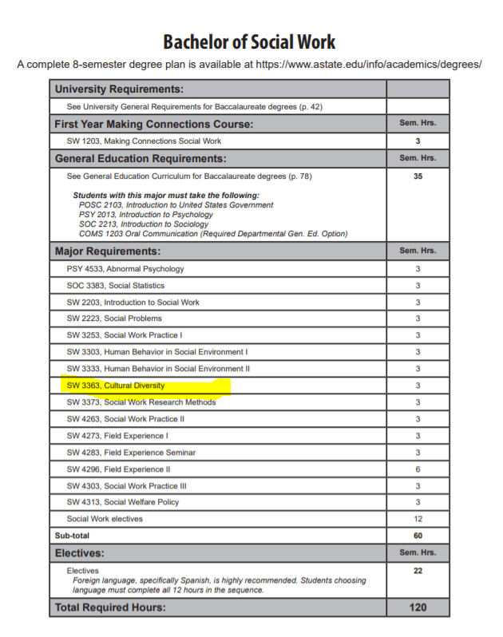

BEFORE: Pg. 573

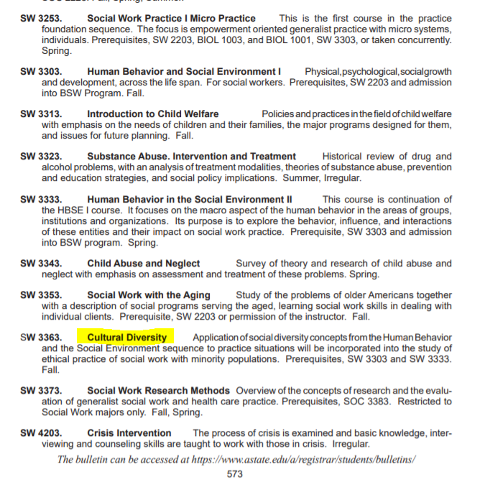

AFTER: Pg 380

Cultural Humility

AFTER: Pg. 573

Cultural Humility

