For Academic Affairs and Research Use Only
Proposal Number
CIP Code:
Degree Code:

NEW CERTIFICATE PROGRAM FORM
(Also requires Arkansas Department of Higher Education (ADHE) approval)
[X ] Undergraduate Curriculum Council
[ ] Graduate Council
Signed paper copies of proposals submitted for consideration are no longer required. Please type approver name and enter date of approval.
Dr. Shubha Kher 11/12/2020  Department Curriculum Committee Chair | __________________ Enter date  COPE Chair (if applicable)
Yeonsang Hwang 11/12/2020  Department Chair | __________________ Enter date  Head of Unit (if applicable)
Jason Stewart 11/12/2020  College Curriculum Committee Chair | __________________ Enter date  Undergraduate Curriculum Council Chair
Abhijit Bhattacharyya 11/12/2020  College Dean | __________________ Enter date  Graduate Curriculum Committee Chair
__________________ Enter date  General Education Committee Chair (if applicable) | __________________ Enter date  Vice Chancellor for Academic Affairs

- Contact Person (Name, Email Address, Phone Number)
Dr. Yeonsang Hwang, yhwang@astate.edu, 870 972 3581
- Name of proposed Certificate Program (Program must consist of 6-21 semester credit hours):
Controls and Automation

- Proposed effective date:
Fall 2021

- Reason for proposed program implementation:
Industrial automation has been in a state of rapid growth the last few decades. With industries aiming to keep costs down by implementing more automation, there is a strong desire to hire engineering professionals with a background in controls and automation. The proposed Certificate in Controls and Automation will be typically pursued by undergraduates majoring in Mechanical Engineering or Electrical engineering, and by industry professionals with the appropriate background in these disciplines. The objectives are to expose students and industry professionals to the breadth of knowledge required by the modern practice of control and automation, and enhance the skillset and capabilities within their discipline-specific field, which will supplement the BSEE and BSME degrees. With this in mind, the certificate includes not only courses in controls addressing underlying theory, but a hands-on approach in design and programming based on applications. Additional background offered includes electronics and circuits, instrumentation, data acquisition and signal analysis, with applications. This certificate is designed to help students specialize in this area and advance in their profession. Furthermore, it will be useful to students intending to pursue graduate studies in controls and/or automation.

- Provide the following:
    - Curriculum outline - List of courses in new program – Underline required courses

Certificate (19 -21 Credit Hours *)

Core (13 Credit Hours)

EE 4313 Control Systems Theory
MATH 3243 Linear Algebra
ME 3504 Process Monitoring and Control
ME 3613 Control Systems for Mechanical Engineers

Electives (Any two) (6-8 Credit Hours)

EE 4344 Embedded Systems
EE 4354 Intelligent Control Systems
EE 479V Special Problems in Electrical Engineering (minimum: 3 credit hours)
ME 3523 Introduction to Robotics Laboratory
ME 4613 Introduction to Mechatronics
ME 469V Special Problems in Mechanical Engineering (minimum: 3 credit hours)

* Additional requirement: Must include at least 10 credit hours outside of the major.

    - Total semester credit hours required for proposed program
19-21 Credit Hours
    - New courses and new course descriptions
There are no new courses.

    - Program goals and objectives
Goal: Package a marketable product for BSEE and BSME students to accentuate a desired industry driven skillset. The objectives are to expose students and industry professionals to the breadth of knowledge required by the modern practice of control and automation, and enhance the skillset and capabilities within their discipline-specific field, which will supplement the BSEE and BSME degrees.

    - Expected student learning outcomes
Expose students to underlying theory in controls and automation and train students with a hands-on approach to design and programming based on applications
    - Documentation that program meets employer needs
The EE and ME program directors have solicited input from employers in the area (Hytrol, Big River Steel, Nucor, Automation Outfitters etc.) as well as graduates of the EE and ME programs. There is a big need among employers for engineers to be trained in the principles and applications of control systems. In that context, the proposal to develop the certificate was very well received by both employers and alums of the EE, ME programs.
    - Student demand (projected enrollment) for proposed program
10 -12 students a year.
    - Program approval letter from licensure/certification entity, if required (attach): n/a
    - Name of institutions offering similar programs and the institution(s) used as model to develop proposed program
None known
    - Proposed program review date (within 10 years of program implementation)
Fall 2031

- Will this program be offered:
  - Traditional/Face-to-face Yes
  - Distance/Online No
    - If yes, indicate mode of distance delivery, and the percentage of courses offered via this modality (<50%, 50-99%, or 100%).
Enter text...
    - If online, will it be offered through Global Initiatives/Academic Partnerships (AP)?
Enter text...

- Will this program be offered off-campus? No
  - If yes, identify the off-campus location
Enter text...

Bulletin Changes
Instructions
Please visit http://www.astate.edu/a/registrar/students/bulletins/index.dot and select the most recent version of the bulletin. Copy and paste all bulletin pages this proposal affects below. Please include a before (with changed areas highlighted) and after of all affected sections.

*Please note: Courses are often listed in multiple sections of the bulletin. To ensure that all affected sections have been located, please search the bulletin (ctrl+F) for the appropriate courses before submission of this form.

Page 64 Before

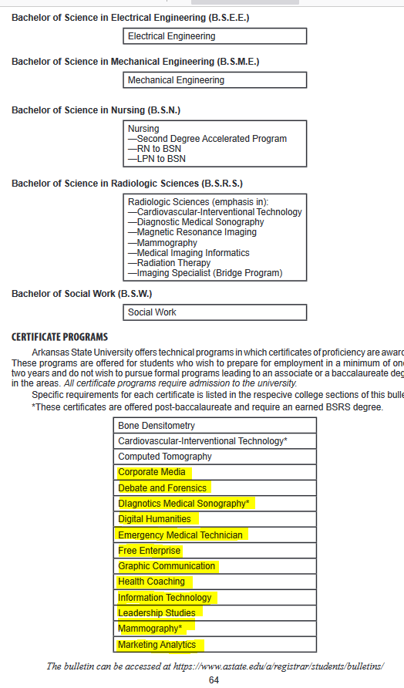

Page 64 After
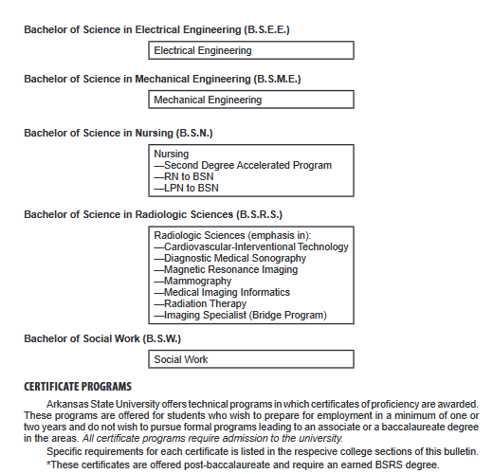
Bone densitometry
Cardiovascular-Interventional Technology*
Computer Tomography
Controls and Automation
Corporate Media
Debate and Forensics
Diagnostics Medical Technician
Free enterprise
Graphic Communication
Health Coaching
Information technology
Leadership Studies
Mammography*
Marketing Analytics

Page 201
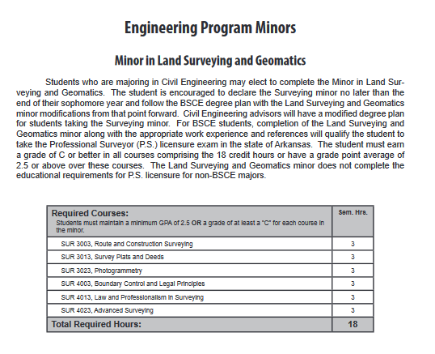

Page 202 Before

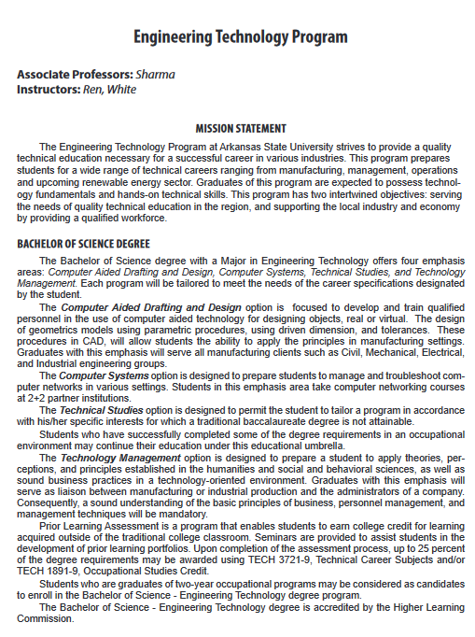

Page 202 After
Following description to be added immediately after Page 201

Engineering Program Certificates

Certificate in Controls and Automation
The Certificate in Controls and Automation will be typically pursued by undergraduates majoring in Mechanical Engineering or Electrical Engineering and by industry professionals with the appropriate background in these disciplines. The objectives are to expose students and industry professionals to the breadth of knowledge required by the modern practice of control and automation and enhance the skillset and capabilities within their discipline-specific field which will supplement the BSEE and BSME degrees. With this in mind, the certificate includes not only courses in controls addressing underlying theory, but a hands-on approach in design and programming based on applications. Additional background offered includes electronics and circuits, instrumentation, data acquisition, and signal analysis with applications.
Required courses * | Sem. Hrs.
EE 4313, Control Systems Theory | 3
MATH 3243, Linear Algebra | 3
ME 3504, Process Monitoring and Control | 4
ME 3613, Control Systems for Mechanical Engineering | 3
Any two electives:  EE 4344, Embedded Systems  EE 4354, Intelligent Control Systems  EE 479V, Special Problems in Electrical Engineering  ME 3523, Introduction to Robotics Laboratory  ME 4613, Introduction to Mechatronics  ME 469V, Special Problems in Mechanical Engineering  * Additional requirement: Must include at least 10 credit hours outside of the major. | 6-8
Total Required Hours: | 19-21

