For Academic Affairs and Research Use Only
Proposal Number
CIP Code:
Degree Code:

NEW CERTIFICATE PROGRAM FORM
(Also requires Arkansas Department of Higher Education (ADHE) approval)
[X] Undergraduate Curriculum Council
[ ] Graduate Council
Signed paper copies of proposals submitted for consideration are no longer required. Please type approver name and enter date of approval.
Shelley Gipson 2/16/2021  Department Curriculum Committee Chair | __________________ Enter date  COPE Chair (if applicable)
Temma Balducci 2/16/2021  Department Chair | __________________ Enter date  Head of Unit (if applicable)
Warren Johnson 2/24/2021  College Curriculum Committee Chair | __________________ Enter date  Undergraduate Curriculum Council Chair
Gina Hogue 2/25/2021  College Dean | __________________ Enter date  Graduate Curriculum Committee Chair
__________________ Enter date  General Education Committee Chair (if applicable) | Alan Utter 3/15/2021  Vice Chancellor for Academic Affairs

- Contact Person (Name, Email Address, Phone Number)
Mindy Fulcher, Dept. of Art + Design, mfulcher@astate.edu, 870-761-2121
- Name of proposed Certificate Program (Program must consist of 6-21 semester credit hours):
Data Visualization and Information Design

- Proposed effective date:
Fall 2021

- Reason for proposed program implementation:
This new certificate will provide students with specialized skills, knowledge specific to Visual Information Design, Presentation and Communication.

- Provide the following:
    - Curriculum outline - List of courses in new program – Underline required courses
    - GRFX 3613 Information Design
    - GRFX 4213 Interactive Infographics
    - MDIA 3323 Media Analytics and Data Visualization
    - Total semester credit hours required for proposed program
9
    - New courses and new course descriptions
Certificate consists of existing courses.
    - Program goals and objectives
PSLO:
- Students will learn to design custom information graphics using industry standard software.

    - Program goals and objectives
- Student will be able to create custom infographics in Adobe Illustrator.
- Student will be able to analyze and interpret data to effective communicate to an audience.
- Student will be able to create animated and interactive content.

    - Documentation that program meets employer needs
    - Marketing data/regional need provided by Academic Partnerships for Information Design: Design conferrals were flat from 2015-2019, with 1790 conferrals in the region in 2019.
- Employment in Graphic Design/ Desktop Publishing is expected to grow at a 12.4% growth rate from 2020-2030
- In the last 12 months, there were 1,662 Graphic Design related job openings posted in the region.
- Top 5 employers: Kalo, FastSigns, CBRE, Magellan Health and University of Arkansas
    - Student demand (projected enrollment) for proposed program
25-100 per year
    - Program approval letter from licensure/certification entity, if required (attach)
    - Name of institutions offering similar programs and the institution(s) used as model to develop proposed program
    - Proposed program review date (within 10 years of program implementation)
Fall 2029

- Will this program be offered:
  - Traditional/Face-to-face No
  - Distance/Online Yes
    - If yes, indicate mode of distance delivery, and the percentage of courses offered via this modality (<50%, 50-99%, or 100%).
100% online
    - If online, will it be offered through Global Initiatives/Academic Partnerships (AP)?
AOS

- Will this program be offered off-campus? No
  - If yes, identify the off-campus location
Enter text...

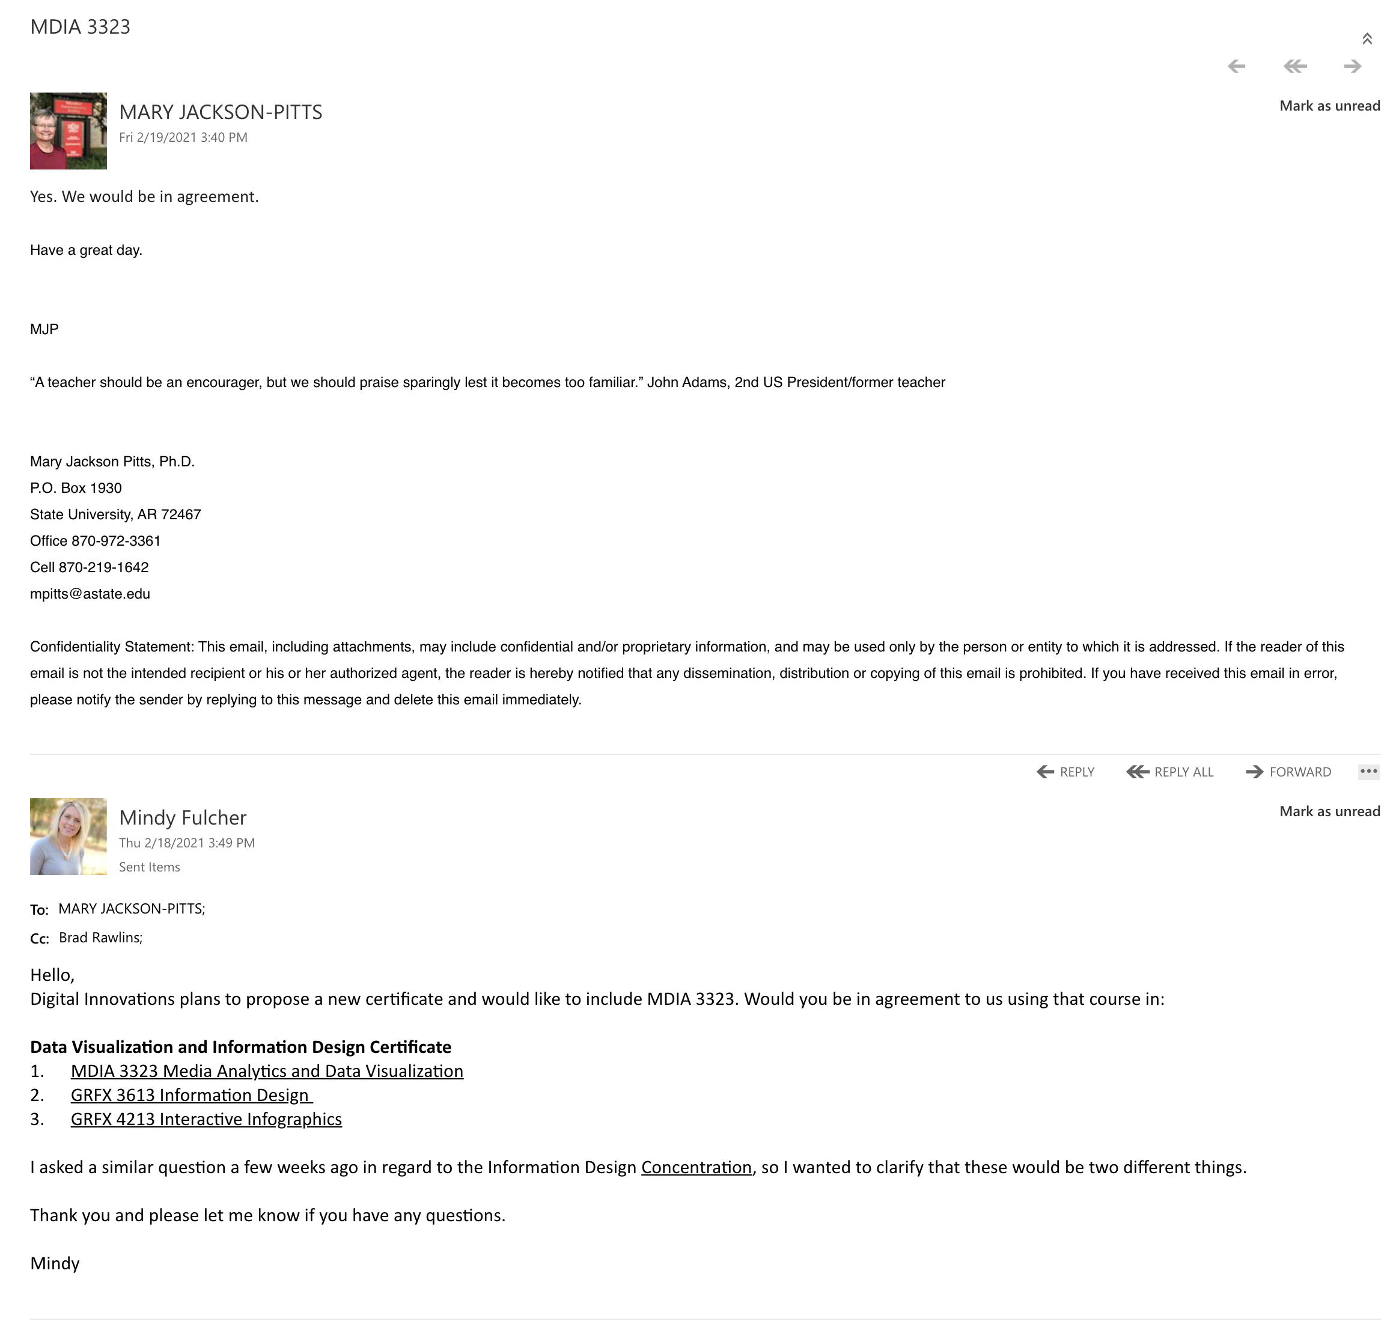

Bulletin Changes

Instructions
Please visit http://www.astate.edu/a/registrar/students/bulletins/index.dot and select the most recent version of the bulletin. Copy and paste all bulletin pages this proposal affects below. Please include a before (with changed areas highlighted) and after of all affected sections.

*Please note: Courses are often listed in multiple sections of the bulletin. To ensure that all affected sections have been located, please search the bulletin (ctrl+F) for the appropriate courses before submission of this form.

Undergraduate Bulletin 2020-2021

CURRENT
p. 64

CERTIFICATE PROGRAMS
Arkansas State University offers technical programs in which certificates of proficiency are awarded. These programs are offered for students who wish to prepare for employment in a minimum of one or two years and do not wish to pursue formal programs leading to an associate or a baccalaureate degree in the areas. All certificate programs require admission to the university.
Specific requirements for each certificate is listed in the respecive college sections of this bulletin.
*These certificates are offered post-baccalaureate and require an earned BSRS degree.
Bone Densitometry
Cardiovascular-Interventional Technology*
Computed Tomography
Corporate Media
Debate and Forensics
Data Visualization and Information Design
Diagnotics Medical Sonography*
Digital Humanities
Emergency Medical Technician
Free Enterprise
Graphic Communication
Health Coaching
Information Technology

p. 213
College of Liberal Arts and Communication
Professor Carl M. Cates, Dean
Associate Professor Gina Hogue, Associate Dean
MISSION STATEMENT
The mission of the College of Liberal Arts and Communication is to provide students and the region with innovative educational opportunities that will enable lifelong learning, professional leadership, and engaged lives.
Encompassing the areas of fine arts, humanities, media and communication, and social sciences, the College of Liberal Arts and Communication aims to:
- Provide excellent instruction to all students in the essential skills of oral communication, writing, critical thinking, and appreciation of their cultural heritage through the general education components of degree requirements;
- Create a dynamic transformative education experience to prepare students for their professional careers or further study and their roles as leaders in a global society;
- Promote an understanding and appreciation of diversity in all its various forms and the ways it can contribute to the enrichment of society;
- Expand diversity and global awareness by encouraging the study of languages and participation in international exchange programs;
- Enhance and promote faculty scholarly, creative, and professional development;
- Encourage interdisciplinary programs and collaborative research;
- Facilitate and develop outreach activities to enrich the minds and hearts of pre-collegiate students, alumni, and diverse communities of the Mississippi Delta Region and greater Arkansas.
The College of Liberal Arts and Communication offers a wide range of undergraduate degree programs including a Bachelor of Arts in Art (emphasis in Art History), Communication Studies (and emphases in Interpersonal, Organizational, and Public Communication), Criminology, Digital Innovations, English, History, Music (and concentration in Jazz Studies), Philosophy, Political Science,
Sociology, Theatre (and emphases in Acting, Design and Technology, and Musical Theatre), and World Languages and Cultures (emphases in French, Global Studies, and Spanish); a Bachelor of Fine Arts in Art (emphases in Art Education and Studio Art) and Graphic Design (and emphasis in Digital Design); a Bachelor of Music (concentrations in Composition as well as Voice, Keyboard, and Instrumental Performance); a Bachelor of Music Education (concentrations in Instrumental and Vocal Music Education); a Bachelor of Science in Creative Media Production (emphases in Corporate Media, Graphic Communication, and Sports Media), Multimedia Journalism, and Strategic Communication; and a Bachelor of Science in Education in English, Social Science, and World Languages and Cultures (emphases in French and Spanish). Most degree programs offer minors. Minors are also available in the following fields: African-American Studies, Children’s Advocacy Studies, Cognitive Science, Folklore Studies, French, German, History and Philosophy of Science and Technology, Interdisciplinary Family Studies, International Studies, Medieval Studies, Modern European Studies, Religious Studies, Spanish, Women and Gender Studies, and Writing Studies. A minor in Homeland Security and Disaster Preparedness is offered in partnership with the College of Nursing and Health Professions. The College provides an Associate of Applied Science degree in Law Enforcement and certificates in Data Visualization and Information Design, Digital Humanities, Museum Studies, Nonprofit Communication, Social Media Management, Spanish for the Professions, and Swift Coding. It also provides pre-professional advisement for law school as part of its Political Science, Philosophy, History, and Criminology majors.
The College of Liberal Arts and Communication grants a full range of masters’ degree (M.A., M.M., M.M.E., M.P.A., and M.S.E.) programs, several Educational Specialist degree (Ed.S.) programs, and an interdisciplinary doctoral degree (Ph.D.) program (Heritage Studies). For further information, see A-State’s Graduate Bulletin.

p. 215
Department of Art + Design
Professor Temma Balducci, Chair
Professors: Gipson, Rowe, Salvest, Vickrey
Associate Professors: Arnell, Ford, Whiteland, Wilkinson
Assistant Professors: Baker, Parker
Instructors: Buckley, Fulcher, Long, McCarroll, Sullivan

MISSION STATEMENT
The Department of Art + Design is dedicated to the creative, aesthetic and cultural development of visual art students that builds upon a well-rounded liberal arts education. The faculty prepares its stu- dents to assume leadership positions in their professional lives while maintaining a commitment to the conceptual and aesthetic standards of their chosen discipline. The department develops and supports a nurturing creative community that builds confidence through academic rigor and provides an environ- ment in which students can build and refine their craft, develop critical thinking skills, and realize their full potential. Graduates of the Department of Art + Design join the community as socially responsible artists, designers, educators and historians ready to contribute to diverse and changing creative fields.
The Bachelor of Arts degree provides a liberal arts-fine arts education in art history. Art history provides practice in analysis, interpretation, critical thinking, and writing skills. This degree is good preparation for a student planning to work toward an advanced degree in art history. A certificate in Museum Studies is also available to help students prepare for a job in a variety of museum fields. The Department also offers a certificates in Data Visualization and Information Designand Swift Coding.
No grade below C in courses with an ART/ARTH/ARED/ARTM prefix may be applied to the Bachelor of Arts with an Emphasis in Art History Degree. A cumulative 2.75 GPA (or higher) in all courses with an ART/ARTH/ARED/ARTM prefix is required for the Bachelor of Arts with an Emphasis in Art History Degree.
The Bachelor of Fine Arts degree programs are designed to prepare students for professional careers as a classroom art teacher, graphic designer, or studio artist. The BFA in Graphic Design, the BFA in Graphic Design (with emphasis in Digital Design) or the BFA in Art (with emphasis in Studio Art or Art Education) is the initial professional degree, and it is the requisite degree for the student who plans to pursue a studio-oriented post-baccalaureate degree.
No grade below C in courses with an ART/ARTH/ARED/ARTM/GRFX prefix may be applied to the Bachelor of Fine Arts Degree. A cumulative 2.75 GPA (or higher) in all courses with an ART/ARTH/ ARED/ARTM/GRFX prefix is required for the BFA degree.

p. 228

Certificate in Swift Coding
This certificate is not available to majors in BFA Graphic Design, Emphasis in Digital Design
Required Courses: | Sem. Hrs.
DIGI 2003, Introduction to Coding with Swift | 3
DIGI 3003, Intermediate Coding with Swift | 3
DIGI 4003, Advanced Studio in Swift Coding | 3
Total Required Hours: | 9
Total Required Hours: | 9

Certificate in Data Visualization and Information Design
Required Courses: | Sem. Hrs.
GRFX 3613, Information Design | 3
GRFX 4213, Interactive Infographics | 3
MDIA 3323, Media Analytics and Data Visualization | 3
Total Required Hours: | 9

PROPOSD
p. 64

CERTIFICATE PROGRAMS
Arkansas State University offers technical programs in which certificates of proficiency are awarded. These programs are offered for students who wish to prepare for employment in a minimum of one or two years and do not wish to pursue formal programs leading to an associate or a baccalaureate degree in the areas. All certificate programs require admission to the university.
Specific requirements for each certificate is listed in the respecive college sections of this bulletin.
*These certificates are offered post-baccalaureate and require an earned BSRS degree.
Bone Densitometry
Cardiovascular-Interventional Technology*
Computed Tomography
Corporate Media
Debate and Forensics
Data Visualization and Information Design
Diagnotics Medical Sonography*
Digital Humanities
Emergency Medical Technician
Free Enterprise
Graphic Communication
Health Coaching
Information Technology

p. 213
College of Liberal Arts and Communication
Professor Carl M. Cates, Dean
Associate Professor Gina Hogue, Associate Dean
MISSION STATEMENT
The mission of the College of Liberal Arts and Communication is to provide students and the region with innovative educational opportunities that will enable lifelong learning, professional leadership, and engaged lives.
Encompassing the areas of fine arts, humanities, media and communication, and social sciences, the College of Liberal Arts and Communication aims to:
- Provide excellent instruction to all students in the essential skills of oral communication, writing, critical thinking, and appreciation of their cultural heritage through the general education components of degree requirements;
- Create a dynamic transformative education experience to prepare students for their professional careers or further study and their roles as leaders in a global society;
- Promote an understanding and appreciation of diversity in all its various forms and the ways it can contribute to the enrichment of society;
- Expand diversity and global awareness by encouraging the study of languages and participation in international exchange programs;
- Enhance and promote faculty scholarly, creative, and professional development;
- Encourage interdisciplinary programs and collaborative research;
- Facilitate and develop outreach activities to enrich the minds and hearts of pre-collegiate students, alumni, and diverse communities of the Mississippi Delta Region and greater Arkansas.
The College of Liberal Arts and Communication offers a wide range of undergraduate degree programs including a Bachelor of Arts in Art (emphasis in Art History), Communication Studies (and emphases in Interpersonal, Organizational, and Public Communication), Criminology, Digital Innovations, English, History, Music (and concentration in Jazz Studies), Philosophy, Political Science,
Sociology, Theatre (and emphases in Acting, Design and Technology, and Musical Theatre), and World Languages and Cultures (emphases in French, Global Studies, and Spanish); a Bachelor of Fine Arts in Art (emphases in Art Education and Studio Art) and Graphic Design (and emphasis in Digital Design); a Bachelor of Music (concentrations in Composition as well as Voice, Keyboard, and Instrumental Performance); a Bachelor of Music Education (concentrations in Instrumental and Vocal Music Education); a Bachelor of Science in Creative Media Production (emphases in Corporate Media, Graphic Communication, and Sports Media), Multimedia Journalism, and Strategic Communication; and a Bachelor of Science in Education in English, Social Science, and World Languages and Cultures (emphases in French and Spanish). Most degree programs offer minors. Minors are also available in the following fields: African-American Studies, Children’s Advocacy Studies, Cognitive Science, Folklore Studies, French, German, History and Philosophy of Science and Technology, Interdisciplinary Family Studies, International Studies, Medieval Studies, Modern European Studies, Religious Studies, Spanish, Women and Gender Studies, and Writing Studies. A minor in Homeland Security and Disaster Preparedness is offered in partnership with the College of Nursing and Health Professions. The College provides an Associate of Applied Science degree in Law Enforcement and certificates in Data Visualization and Information Design, Digital Humanities, Museum Studies, Nonprofit Communication, Social Media Management, Spanish for the Professions, and Swift Coding. It also provides pre-professional advisement for law school as part of its Political Science, Philosophy, History, and Criminology majors.
The College of Liberal Arts and Communication grants a full range of masters’ degree (M.A., M.M., M.M.E., M.P.A., and M.S.E.) programs, several Educational Specialist degree (Ed.S.) programs, and an interdisciplinary doctoral degree (Ph.D.) program (Heritage Studies). For further information, see A-State’s Graduate Bulletin.

p. 215
Department of Art + Design
Professor Temma Balducci, Chair
Professors: Gipson, Rowe, Salvest, Vickrey
Associate Professors: Arnell, Ford, Whiteland, Wilkinson
Assistant Professors: Baker, Parker
Instructors: Buckley, Fulcher, Long, McCarroll, Sullivan

MISSION STATEMENT
The Department of Art + Design is dedicated to the creative, aesthetic and cultural development of visual art students that builds upon a well-rounded liberal arts education. The faculty prepares its stu- dents to assume leadership positions in their professional lives while maintaining a commitment to the conceptual and aesthetic standards of their chosen discipline. The department develops and supports a nurturing creative community that builds confidence through academic rigor and provides an environ- ment in which students can build and refine their craft, develop critical thinking skills, and realize their full potential. Graduates of the Department of Art + Design join the community as socially responsible artists, designers, educators and historians ready to contribute to diverse and changing creative fields.
The Bachelor of Arts degree provides a liberal arts-fine arts education in art history. Art history provides practice in analysis, interpretation, critical thinking, and writing skills. This degree is good preparation for a student planning to work toward an advanced degree in art history. A certificate in Museum Studies is also available to help students prepare for a job in a variety of museum fields. The Department also offers certificates in Data Visualization and Information Design and Swift Coding.
No grade below C in courses with an ART/ARTH/ARED/ARTM prefix may be applied to the Bachelor of Arts with an Emphasis in Art History Degree. A cumulative 2.75 GPA (or higher) in all courses with an ART/ARTH/ARED/ARTM prefix is required for the Bachelor of Arts with an Emphasis in Art History Degree.
The Bachelor of Fine Arts degree programs are designed to prepare students for professional careers as a classroom art teacher, graphic designer, or studio artist. The BFA in Graphic Design, the BFA in Graphic Design (with emphasis in Digital Design) or the BFA in Art (with emphasis in Studio Art or Art Education) is the initial professional degree, and it is the requisite degree for the student who plans to pursue a studio-oriented post-baccalaureate degree.
No grade below C in courses with an ART/ARTH/ARED/ARTM/GRFX prefix may be applied to the Bachelor of Fine Arts Degree. A cumulative 2.75 GPA (or higher) in all courses with an ART/ARTH/ ARED/ARTM/GRFX prefix is required for the BFA degree.

p. 228

Certificate in Swift Coding
This certificate is not available to majors in BFA Graphic Design, Emphasis in Digital Design
Required Courses: | Sem. Hrs.
DIGI 2003, Introduction to Coding with Swift | 3
DIGI 3003, Intermediate Coding with Swift | 3
DIGI 4003, Advanced Studio in Swift Coding | 3
Total Required Hours: | 9
Certificate in Data Visualization and Information Design
Required Courses: | Sem. Hrs.
GRFX 3613, Information Design | 3
GRFX 4213, Interactive Infographics | 3
MDIA 3323, Media Analytics and Data Visualization | 3
Total Required Hours: | 9

