For Academic Affairs and Research Use Only
Proposal Number | NHP57
CIP Code:
Degree Code:

PROGRAM MODIFICATION FORM
[ ] Undergraduate Curriculum Council
[ ] Graduate Council
Modification Type: [ ]Admissions, [ ]Curricular Sequence, or [x ]Other

Signed paper copies of proposals submitted for consideration are no longer required. Please type approver name and enter date of approval.
_Kacie Altom 10/27/2021  Department Curriculum Committee Chair | __________________ Enter date  COPE Chair (if applicable)
Sarah Davidson, CNHP Associate Dean 8/23/2021  Department Chair | Sarah Dearing 8/23/2021  Head of Unit (if applicable)
Shanon Brantley 10/28/2021  College Curriculum Committee Chair | __________________ Enter date  Undergraduate Curriculum Council Chair
__________________ Enter date  Director of Assessment (only for changes impacting assessment) | __________________ Enter date  Graduate Curriculum Committee Chair
Scott E. Gordon 10/29/2021  College Dean | Alan Utter ____________ 11/16/21  Vice Chancellor for Academic Affairs
__________________ | Enter date
General Education Committee Chair (if applicable)

- Contact Person (Name, Email Address, Phone Number)
Sarah Davidson, Associate Dean, CNHP Sarah Dearing, AASN Program Chair
sarahdavidson@astate.edu sdearing@astate.edu
3074 3074

- Proposed Change (for undergraduate curricular changes please provide an 8-semester plan (appendix A), if applicable)
Addition of the Paramedic to AASN Program track

- Effective Date
1/1/2022

- Justification – Please provide details as to why this change is necessary.
According to the Bureau of Labor Statistics’ Employment Projections 2019-2929, Registered Nursing is listed among the top occupations in terms of job growth through 2029. The Bureau projects 175,900 openings for RNs each year through 2029 when nurse retirements and workforce exits are factored into the number of nurses needed across the United States. Additionally, according to the US Registered Nurse Workforce Report Card and Shortage Forecast: A Revisit, a shortage of registered nurses is projected to spread across the country between 2016 and 2030.
To combat the registered nursing shortage, the School of Nursing currently provides multiple pathways for individuals to access our program options, but none for the Paramedic. We wish to provide an additional opportunity for individuals who have completed a Paramedic Certificate and are eligible to sit for the National Registry Certification Exam, and Paramedics who have an unencumbered Paramedic License to complete our registered nursing (AASN) program.
Therefore, we are seeking an additional pathway to access the AASN program, and a new plan of study was created using the courses which are currently in place.

Bulletin Changes

Instructions
Please visit http://www.astate.edu/a/registrar/students/bulletins/index.dot and select the most recent version of the bulletin. Copy and paste all bulletin pages this proposal affects below. Please include a before (with changed areas highlighted) and after of all affected sections.

*Please note: Courses are often listed in multiple sections of the bulletin. To ensure that all affected sections have been located, please search the bulletin (ctrl+F) for the appropriate courses before submission of this form.

BEFORE - Pg: 336

Associate of Applied Science in Nursing

June 7 for admission to the Fall semester for LPN to AASN students at campus site and distance learning sites; October 1 and June 7 for transfer/readmission for subsequent semester. Deadline for traditional AASN program at the Mountain Home and West Memphis campuses is October 1st. Deadline for the Paramedic to AASN program at the Jonesboro campus is October 1st. Applicants must complete required prerequisite support courses with a cumulative GPA of 2.0 or better. A “C” or better must be earned in ALL required courses. Applicants for admission will be ranked based upon prerequisites, admission testing scores, and overall GPA. All LPN to AASN applicants must have an unencumbered nursing license. All Paramedic applicants must be eligible to sit for the National Registry Certification Exam or have an unencumbered Paramedic License.

BEFORE - Pg. 380:

SCHOOL OF NURSING
SECTION - EDUCATIONAL MOBILITY:

The nursing faculty is committed to the concept of educational mobility, and has provided a variety of approaches to Paramedics, Licensed Practical Nurses, to Licensed Psychiatric Technician Nurses, and to Registered Nurses prepared at the associate degree and diploma levels. Paramedics, LPNs, LPTNs, and RNs must work closely with their advisors. Paramedics, LPNs and LPTNs must be admitted to the desired program prior to enrolling in any nursing courses (except NS 2203, NRS 3353, NRS 2392, and NRSP 2391). The BSN program has a specially designed RN track to facilitate RNs’ movement through the BSN. The track includes a reduction in nursing clinical hours, and clinical experiences designed to accommodate individual learning goals. Detailed information may be obtained from the nursing office (972-3074) relative to earning credit by articulation or examinations.

Prospective students who are LPNs, LPTNs, or RNs applying for admission to any nursing program must have a current unencumbered license to practice nursing. Prospective students who are Paramedics applying for admission into the AASN program must be eligible to sit for the National Registry Certification Exam or have an unencumbered Paramedic License.

BEFORE - Pg 391

PARAMEDIC TO AASN OPTION
Students must maintain a minimum grade of “C” in all degree-required courses for an Associate of Applied Science in Nursing degree to continue progression.

PREREQUISITES
The following courses must be completed prior to acceptance into the program:

- BIO 2203 AND 2201, Human Anatomy and Physiology I and Laboratory
- ENG 1003, Composition I
- MATH 1023, College Algebra (or MATH course that requires MATH 1023 as a prerequisite)

REQUIRED PROGRESSION OF COURSES
The following courses must be completed prior to taking NRS 1313 and NRSP 1331:
- BIO 2223 AND 2221, Anatomy and Physiology II and Laboratory
- PSY 2013, Introduction to Psychology
- NRS 2392, Health Assessment
- NRSP 2391, Health Assessment Practicum

The following courses must be completed prior to NRSP 2361:
  - BIO 2103 AND 2101, Microbiology for Nursing and Allied Health and Laboratory The following course must be completed prior to NRSP 2341:
  - ENG 1013, Composition II

The following course must be completed prior to NRSP 2371:
  - HIST 2763, The United States To 1876 OR
  - HIST 2773, The United States Since 1876 OR
  - POSC 2103, Introduction to United States Government

LPN-TO-AASN OPTION

Students must maintain a minimum grade of “C” in all degree-required courses for an Associate of Applied Science in Nursing degree to continue progression.
A-State participates in the statewide articulation program for licensed practical nurses (LPNs) seeking the AASN degree. Applicants who completed their LPN/LPTN programs greater than 12 months prior to applying to the AASN program must provide proof of work experience.
ARTICULATION….

Add Bulletin Page 393 (highlighted): (LPN to AASN Online moved to pg 394)

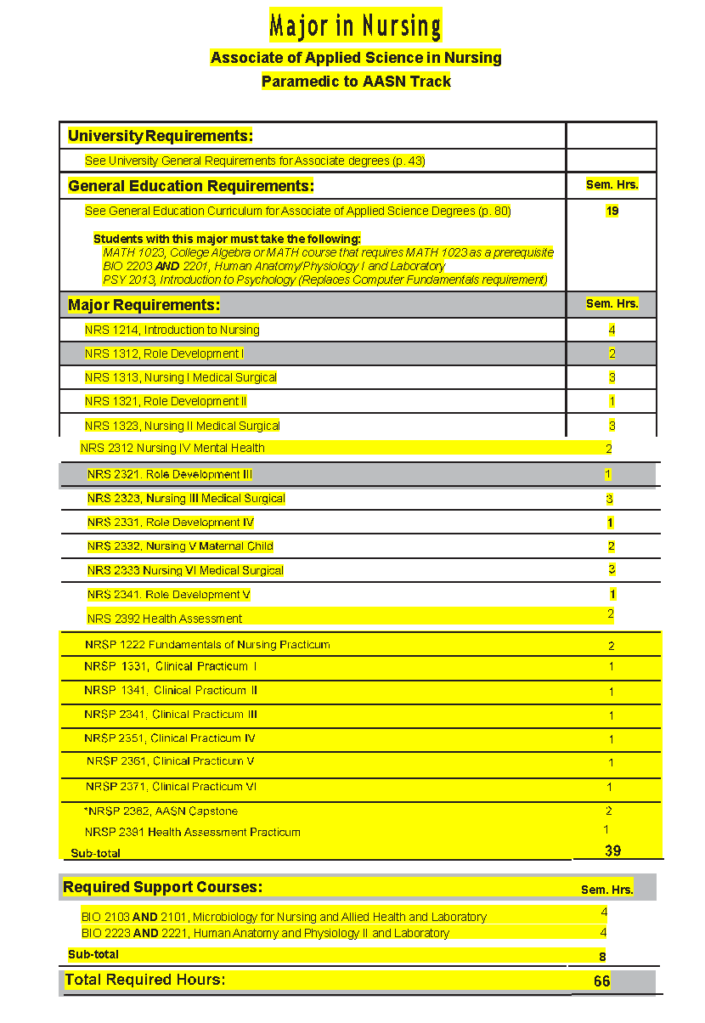

Appendix A, 8-Semester Plan
(Referenced in #2 - Undergraduate Proposals Only)
Instructions: Please identify new courses in italics.
Arkansas State University-Jonesboro
Degree: AASN
Major: Nursing
Year: 2021-2022

Students requiring developmental course work based on low entrance exam scores (ACT, SAT, ASSET, COMPASS) may not be able to complete this program of study in eight (8) semesters. Developmental courses do not count toward total degree hours. Students having completed college level courses prior to enrollment will be assisted by their advisor in making appropriate substitutions. In most cases, general education courses may be interchanged between semesters. A minimum of 45 hours of upper division credit (3000-4000 level) is required for this degree.
Year 1 |  |  |  |  | Year 1
Fall Semester |  |  |  |  | Spring Semester
Course No. | Course Name | Hrs | Gen Ed |  | Course No. | Course Name | Hrs | Gen Ed
BIO 2203 | Human Anatomy and Physiology I | 3 | X |  | NRS 1214 | Introduction to Nursing | 4
BIO 2201 | Human Anatomy and Physiology Laboratory | 1 | x |  | NRSP 1222 | Fundamentals of Nursing Practicum | 2
ENG 1003 | Composition I | 3 | X |  | NRS 2392 | Health Assessment | 2
MATH 1023 | College Algebra (or MATH course that requires MATH 1023 as prereq) | 3 | x |  | NRSP 2391 | Health Assessment Practicum | 1
PSY 2013 | Introduction to Psychology | 3 | x |  | BIO 2223 | Human Anatomy and Physiology II | 3
 |  |  |  |  | BIO 2221 | Human Anatomy and Physiology II | 1
Total Hours |  | 13 |  |  | Total Hours |  | 13
Year 2 |  |  |  |  | Year 2
Fall Semester |  |  |  |  | Spring Semester
Course No. | Course Name | Hrs | Gen Ed |  | Course No. | Course Name | Hrs | Gen Ed
NRS 1313 | Nursing I Medical Surgical | 3 |  |  | NRS 2323 | Nursing III Medical Surgical | 3
NRS 1312 | Role Development I | 2 |  |  | NRS 2321 | Role Development III | 1
NRSP 1331 | Clinical Practicum I | 1 |  |  | NRSP 2341 | Clinical Practicum III | 1
NRS 1323 | Nursing II Medical Surgical | 3 |  |  | NRS 2312 | Nursing IV Mental Health | 2
NRSP 1341 | Clinical Practicum II | 1 |  |  | NRS 2331 | Role Development IV | 1
NRS 1321 | Role Development II | 1 |  |  | NRSP 2351 | Clinical Practicum IV | 1
ENG 1013 | Composition II | 3 | x |  | BIO 2103 | Microbiology for Nursing and Allied Health | 3
 |  |  |  |  | BIO 2101 | Microbiology for Nursing and Allied Health Lab | 1
Total Hours |  | 14 |  |  | Total Hours |  | 13
Year 3 |  |  |  |  | Year 3
Summer Semester Semester |  |  |  |  | Spring Semester
Course No. | Course Name | Hrs | Gen Ed |  | Course No. | Course Name | Hrs | Gen Ed
HIST 2763 (OR HIST 2773 OR POSC 2103) | US Hist to 1876 (OR US Hist since 1876 OR Intro to US Govt) | 3 | x
NRS 2332 | Nursing V Maternal Child | 2
NRS 2341 | Role Development V | 1
NRSP 2361 | Clinical Practicum V | 1
NRS 2333 | Nursing VI Medical Surgical | 3
NRSP 2371 | Clinical Practicum VI | 1
NRSP 2382 | AASN Capstone * | 2
Total Hours |  | 13 |  |  | Total Hours
Year 4 |  |  |  |  | Year 4
Fall Semester |  |  |  |  | Spring Semester
Course No. | Course Name | Hrs | Gen Ed |  | Course No. | Course Name | Hrs | Gen Ed
Total Hours |  |  |  |  | Total Hours
Total Jr/Sr Hours _NA__ Total Degree Hours _66__
Graduation Requirements:
Students must maintain a minimum grade of “C” in all degree-required courses for an Associate of Applied Science in Nursing degree to continue progression.

After
Bulletin Pg: 336

Associate of Applied Science in Nursing

June 7 for admission to the Fall semester for LPN to AASN students at campus site and distance learning sites; October 1 and June 7 for transfer/readmission for subsequent semester. Deadline for traditional AASN program at the Mountain Home and West Memphis campuses is October 1st. Deadline for the Paramedic to AASN program at the Jonesboro campus is October 1st. Applicants must complete required prerequisite support courses with a cumulative GPA of 2.0 or better. A “C” or better must be earned in ALL required courses. Applicants for admission will be ranked based upon prerequisites, admission testing scores, and overall GPA. All LPN to AASN applicants must have an unencumbered nursing license. All Paramedic applicants must be eligible to sit for the National Registry Certification Exam or have an unencumbered Paramedic License.

After - Pg. 380

SCHOOL OF NURSING
SECTION - EDUCATIONAL MOBILITY:

The nursing faculty is committed to the concept of educational mobility, and has provided a variety of approaches to Paramedics, Licensed Practical Nurses, to Licensed Psychiatric Technician Nurses, and to Registered Nurses prepared at the associate degree and diploma levels. Paramedics, LPNs, LPTNs, and RNs must work closely with their advisors. Paramedics, LPNs and LPTNs must be admitted to the desired program prior to enrolling in any nursing courses (except NS 2203, NRS 3353, NRS 2392, and NRSP 2391). The BSN program has a specially designed RN track to facilitate RNs’ movement through the BSN. The track includes a reduction in nursing clinical hours, and clinical experiences designed to accommodate individual learning goals. Detailed information may be obtained from the nursing office (972-3074) relative to earning credit by articulation or examinations.

Prospective students who are LPNs, LPTNs, or RNs applying for admission to any nursing program must have a current unencumbered license to practice nursing. Prospective students who are Paramedics applying for admission into the AASN program must be eligible to sit for the National Registry Certification Exam or have an unencumbered Paramedic License.

After - Pg 391

PARAMEDIC TO AASN OPTION
Students must maintain a minimum grade of “C” in all degree-required courses for an Associate of Applied Science in Nursing degree to continue progression.

PREREQUISITES
The following courses must be completed prior to acceptance into the program:

- BIO 2203 AND 2201, Human Anatomy and Physiology I and Laboratory
- ENG 1003, Composition I
- MATH 1023, College Algebra (or MATH course that requires MATH 1023 as a prerequisite)

REQUIRED PROGRESSION OF COURSES
The following courses must be completed prior to taking NRS 1313 and NRSP 1331:
- BIO 2223 AND 2221, Anatomy and Physiology II and Laboratory
- PSY 2013, Introduction to Psychology
- NRS 2392, Health Assessment
- NRSP 2391, Health Assessment Practicum

The following courses must be completed prior to NRSP 2361:
  - BIO 2103 AND 2101, Microbiology for Nursing and Allied Health and Laboratory The following course must be completed prior to NRSP 2341:
  - ENG 1013, Composition II

The following course must be completed prior to NRSP 2371:
  - HIST 2763, The United States To 1876 OR
  - HIST 2773, The United States Since 1876 OR
  - POSC 2103, Introduction to United States Government

LPN-TO-AASN OPTION

Students must maintain a minimum grade of “C” in all degree-required courses for an Associate of Applied Science in Nursing degree to continue progression.
A-State participates in the statewide articulation program for licensed practical nurses (LPNs) seeking the AASN degree. Applicants who completed their LPN/LPTN programs greater than 12 months prior to applying to the AASN program must provide proof of work experience.
ARTICULATION….

