For Academic Affairs and Research Use Only
Proposal Number | NHP61
CIP Code:
Degree Code:

NEW OR MODIFIED COURSE PROPOSAL FORM
[X] Undergraduate Curriculum Council
[ ] Graduate Council
[]New Course, [ ]Experimental Course (1-time offering), or [X]Modified Course (Check one box)
Signed paper copies of proposals submitted for consideration are no longer required. Please type approver name and enter date of approval.

Kacie Altom 10/18/2021  Department Curriculum Committee Chair | ___________________ Enter date…  COPE Chair (if applicable)
Sarah Davidson, Associate Dean 10/18/2021  Department Chair | Elizabeth Nix 10/18/2021  Head of Unit (if applicable)
Shanon Brantley 10/27/2021  College Curriculum Committee Chair | ___________________ Enter date…  Undergraduate Curriculum Council Chair
___________________ Enter date…  Director of Assessment (new courses only) | ___________________ Enter date…  Graduate Curriculum Committee Chair
__Scott E. Gordon_______ 10-28-21  College Dean | ____ Alan Utter _________ 11/16/21  Vice Chancellor for Academic Affairs
___________________ Enter date…
General Education Committee Chair (if applicable)

- Contact Person (Name, Email Address, Phone Number)
Sarah Davidson, DNP, RN, CNE
sarahdavidson@astate.edu
870-972-2748

- Proposed starting term and Bulletin year for new course or modification to take effect
Spring 2022

Instructions:
Please complete all sections unless otherwise noted. For course modifications, sections with a “Modification requested?” prompt need not be completed if the answer is “No.”

 | Current (Course Modifications Only) | Proposed (New or Modified)  (Indicate “N/A” if no modification)
Prefix | NRS | N/A
Number* | 4733 | N/A
Title | Nursing Management | Nursing Leadership
Description** | Nursing Management Managerial and leadership aspects of the nurse manager in various healthcare environments are discussed. Prerequisite, Admission to the RN-BSN Program, C or better in Statistics, NRS 3713. Fall, Spring, Summer. | N/A

* (Confirm with the Registrar’s Office that number chosen has not been used before and is available for use. For variable credit courses, indicate variable range. Proposed number for experimental course is 9. )
**Forty words or fewer as it should appear in the Bulletin.

- Proposed prerequisites and major restrictions [Modification requested? No]
(Indicate all prerequisites. If this course is restricted to a specific major, which major. If a student does not have the prerequisites or does not have the appropriate major, the student will not be allowed to register).
- Yes Are there any prerequisites?
  - If yes, which ones?
Admission to the RN-BSN Program, C or better in Statistics, NRS 3713
  - Why or why not?
Enter text...

- Yes Is this course restricted to a specific major?
  - If yes, which major? RN-BSN Program

- Proposed course frequency [Modification requested? No]
(e.g. Fall, Spring, Summer; if irregularly offered, please indicate, “irregular.”) Not applicable to Graduate courses.

No.

- Proposed course type [Modification requested?No]
Will this course be lecture only, lab only, lecture and lab, activity (e.g., physical education), dissertation/thesis, capstone, independent study, internship/practicum, seminar, special topics, or studio? Please choose one.

No.

- Proposed grade type [Modification requested?No]
What is the grade type (i.e. standard letter, credit/no credit, pass/fail, no grade, developmental, or other [please elaborate])
No.

- No Is this course dual-listed (undergraduate/graduate)?

No.

- No Is this course cross-listed?
(If it is, all course entries must be identical including course descriptions. Submit appropriate documentation for requested changes. It is important to check the course description of an existing course when adding a new cross-listed course.)

No.

a. – If yes, please list the prefix and course number of the cross-listed course.
Enter text...
b. – N/A Can the cross-listed course be used to satisfy the prerequisite or degree requirements this course satisfies?
Enter text...

- No Is this course in support of a new program? No.
a. If yes, what program?
Enter text...

- No Will this course be a one-to-one equivalent to a deleted course or previous version of this course (please check with the Registrar if unsure)? No.
a. If yes, which course?
Enter text...

Course Details

- Proposed outline [Modification requested? No]
(The course outline should be topical by weeks and should be sufficient in detail to allow for judgment of the content of the course.)
No.

- Proposed special features [Modification requested? No]
(e.g. labs, exhibits, site visitations, etc.)
No.

- Department staffing and classroom/lab resources
No change in department staffing and classroom/lab resources.

- Will this require additional faculty, supplies, etc.?
No change in department staffing and classroom/lab resources.

- No Does this course require course fees?
If yes: please attach the New Program Tuition and Fees form, which is available from the UCC website.

Justification

Modification Justification (Course Modifications Only)
- Justification for Modification(s)
The change in course title will better correlate with course content. The course is not just about management but also about leadership within the profession as a whole. Not every nurse will become a manager, but every nurse can apply principles of leadership to their everyday practice within the profession.

New Course Justification (New Courses Only)
- Justification for course. Must include:
a. Academic rationale and goals for the course (skills or level of knowledge students can be expected to attain)
Enter text...

b. How does the course fit with the mission of the department? If course is mandated by an accrediting or certifying agency, include the directive.
Enter text...

c. Student population served.
Enter text...

d. Rationale for the level of the course (lower, upper, or graduate).
Enter text...

Assessment

Assessment Plan Modifications (Course Modifications Only)
- No Do the proposed modifications result in a change to the assessment plan? No.
If yes, please complete the Assessment section of the proposal

Relationship with Current Program-Level Assessment Process (Course modifications skip this section unless the answer to #18 is “Yes”)
- What is/are the intended program-level learning outcome/s for students enrolled in this course? Where will this course fit into an already existing program assessment process?
Enter text...

- Considering the indicated program-level learning outcome/s (from question #19), please fill out the following table to show how and where this course fits into the program’s continuous improvement assessment process.

For further assistance, please see the ‘Expanded Instructions’ document available on the UCC - Forms website for guidance, or contact the Office of Assessment at 870-972-2989.

Program-Level Outcome 1 (from question #19) | Type outcome here. What do you want students to think, know, or do when they have completed the course?
Assessment Measure | Please include direct and indirect assessment measure for outcome.
Assessment  Timetable | What semesters, and how often, is the outcome assessed?
Who is responsible for assessing and reporting on the results? | Who (person, position title, or internal committee) is responsible for assessing, evaluating, and analyzing results, and developing action plans?
(Repeat if this new course will support additional program-level outcomes)

Course-Level Outcomes
- What are the course-level outcomes for students enrolled in this course and the associated assessment measures?

Outcome 1 | Type outcome here. What do you want students to think, know, or do when they have completed the course?
Which learning activities are responsible for this outcome? | List learning activities.
Assessment Measure | What will be your assessment measure for this outcome?
(Repeat if needed for additional outcomes)

Bulletin Changes

Instructions
Please visit http://www.astate.edu/a/registrar/students/bulletins/index.dot and select the most recent version of the bulletin. Copy and paste all bulletin pages this proposal affects below. Please include a before (with changed areas highlighted) and after of all affected sections.

*Please note: Courses are often listed in multiple sections of the bulletin. To ensure that all affected sections have been located, please search the bulletin (ctrl+F) for the appropriate courses before submission of this form.

BEFORE
Bulletin Table Pg. 390
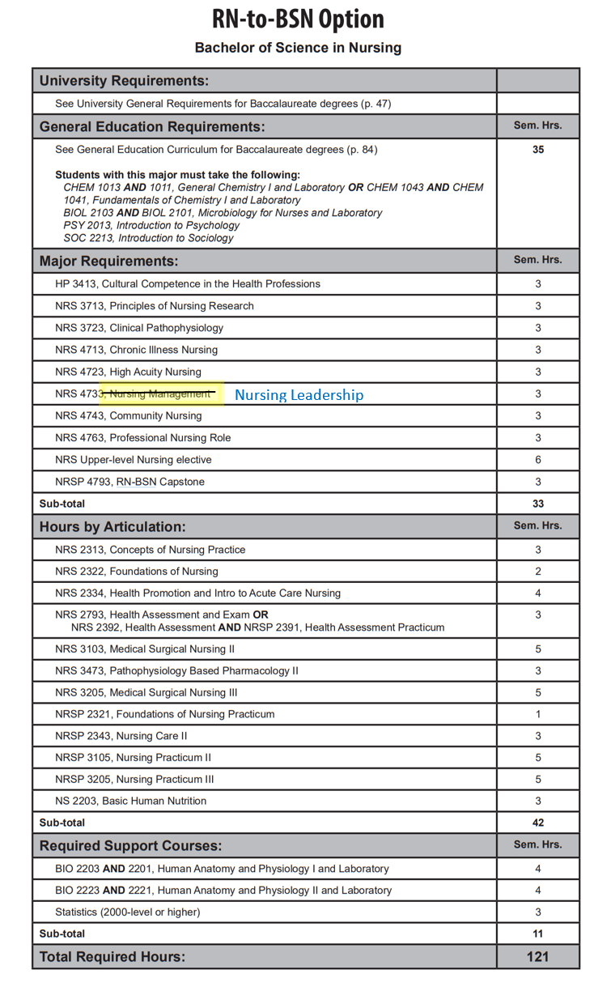

Course Descriptions Page 568
NRS 4223. Forensic Nursing This course will introduce the beginning nurse to the field of forensic nursing. Content includes the recognition and management of forensic patients, both living and dead, and includes information on detection, collection, and preservation of evidence. Restricted to students who have completed 1 year of nursing coursework in either the AASN or BSN program, RN licensure, or instructor permission. Summer, odd.
NRS 4312. Chronic Illness and Rehabilitation Nursing Focus on clients with chronic illness throughout the lifespan. Concepts of gerontology and rehabilitation are integrated. Corequisites, NRS 4343, NRS 4362, and NRSP 4336. Fall, Spring.
NRS 4343. Professional Nursing Community Concepts of professional nursing practice expanded to the care of families and groups of clients in the community setting. Focuses also on change theory, group process strategies and professional and health care issues. Fall, Spring.
NRS 4393. Advanced Nutritional Concepts and Therapeutic Interventions Principles of nutritional support utilized in healthcare, including nutritional assessment, nutrient delivery and implications of disease. Prerequisites, completion of one year of nursing coursework, BSN junior level status, RN licensure, or instructor permission. Spring.
NRS 4424. Essentials of Medical Surgical Nursing III Continuation of concepts introduced in NRS 3345 Essentials of Medical Surgical Nursing II. Registration restricted to students who have been accepted to accelerated BSN option. Corequisites, NRS 3422, NRSP 3453. Spring.
NRS 4443. Essentials of High Acuity Nursing Focuses on patients with acute episodic health deviations which require ongoing diagnosis, immediate intervention or intensive nursing observation and care. Registration restricted to Students who are accepted to accelerated BSN option. Corequisites, NRS 4012, and NRSP 4433. Spring.
NRS 4481. Critical Decision Making and Testing Competencies in Nursing Further assists nursing students to identify areas for improving critical thinking skills and test taking skills. Will enhance the students ability to problem solve in providing complex care to individuals, groups, communities and populations. Prerequisites, senior nursing student status or instructor permission. Spring.
NRS 4542. Health Care Administration Introduction to the organization, operations and administration of a modern health care environment. Includes an introduction to health care delivery systems, decision making, and the management functions. Prerequisite, Admission to BSN program or graduate student enrolled in a CNHP program or any health related major. Fall, Spring.
NRS 4713. Chronic Illness Nursing Focus on clients with chronic illness throughout the lifespan. Concepts of gerontology, rehabilitation and spirituality are integrated. Prerequisites, Admission to the RN-BSN program, C or better in NRS 3723 and NRS 3713. Fall, Spring, Summer.
NRS 4723. High Acuity Nursing Focuses on patients with high acuity episodic or traumatic health deviations which require immediate intensive ongoing nursing diagnosis and interventions. Prerequisites, Admission to the RN-BSN program, C or better in NRS 3713 and NRS 3723. Fall, Spring, Summer.
NRS 4733. Nursing Management: Nursing Leadership Managerial and leadership aspects of the nurse manager in various healthcare environments are discussed. Prerequisite, Admission to the RN-BSN Program, C or better in Statistics, NRS 3713. Fall, Spring, Summer.
NRS 4743. Public Health Nursing Concepts of professional nursing practice expanded to the care of families and groups of clients in the community setting. Focuses also on change theory, group process strategies and professional and health care issues. Prerequisites, Admission to the RN-BSN program, NRS 3723 and NRS 3713. Fall, Spring, Summer.

AFTER

Bulletin Table Pg. 390
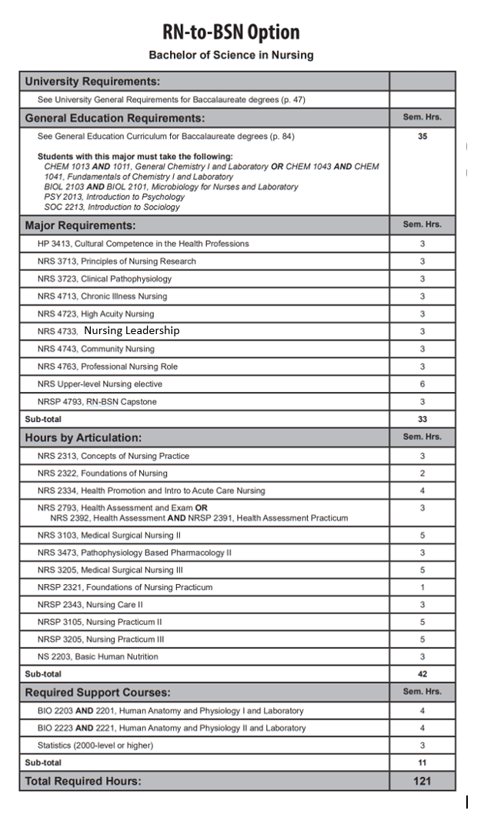

Course Descriptions Page 568
NRS 4223. Forensic Nursing This course will introduce the beginning nurse to the field of forensic nursing. Content includes the recognition and management of forensic patients, both living and dead, and includes information on detection, collection, and preservation of evidence. Restricted to students who have completed 1 year of nursing coursework in either the AASN or BSN program, RN licensure, or instructor permission. Summer, odd.
NRS 4312. Chronic Illness and Rehabilitation Nursing Focus on clients with chronic illness throughout the lifespan. Concepts of gerontology and rehabilitation are integrated. Corequisites, NRS 4343, NRS 4362, and NRSP 4336. Fall, Spring.
NRS 4343. Professional Nursing Community Concepts of professional nursing practice expanded to the care of families and groups of clients in the community setting. Focuses also on change theory, group process strategies and professional and health care issues. Fall, Spring.
NRS 4393. Advanced Nutritional Concepts and Therapeutic Interventions Principles of nutritional support utilized in healthcare, including nutritional assessment, nutrient delivery and implications of disease. Prerequisites, completion of one year of nursing coursework, BSN junior level status, RN licensure, or instructor permission. Spring.
NRS 4424. Essentials of Medical Surgical Nursing III Continuation of concepts introduced in NRS 3345 Essentials of Medical Surgical Nursing II. Registration restricted to students who have been accepted to accelerated BSN option. Corequisites, NRS 3422, NRSP 3453. Spring.
NRS 4443. Essentials of High Acuity Nursing Focuses on patients with acute episodic health deviations which require ongoing diagnosis, immediate intervention or intensive nursing observation and care. Registration restricted to Students who are accepted to accelerated BSN option. Corequisites, NRS 4012, and NRSP 4433. Spring.
NRS 4481. Critical Decision Making and Testing Competencies in Nursing Further assists nursing students to identify areas for improving critical thinking skills and test taking skills. Will enhance the students ability to problem solve in providing complex care to individuals, groups, communities and populations. Prerequisites, senior nursing student status or instructor permission. Spring.
NRS 4542. Health Care Administration Introduction to the organization, operations and administration of a modern health care environment. Includes an introduction to health care delivery systems, decision making, and the management functions. Prerequisite, Admission to BSN program or graduate student enrolled in a CNHP program or any health related major. Fall, Spring.
NRS 4713. Chronic Illness Nursing Focus on clients with chronic illness throughout the lifespan. Concepts of gerontology, rehabilitation and spirituality are integrated. Prerequisites, Admission to the RN-BSN program, C or better in NRS 3723 and NRS 3713. Fall, Spring, Summer.
NRS 4723. High Acuity Nursing Focuses on patients with high acuity episodic or traumatic health deviations which require immediate intensive ongoing nursing diagnosis and interventions. Prerequisites, Admission to the RN-BSN program, C or better in NRS 3713 and NRS 3723. Fall, Spring, Summer.
NRS 4733. Nursing Leadership Managerial and leadership aspects of the nurse manager in various healthcare environments are discussed. Prerequisite, Admission to the RN-BSN Program, C or better in Statistics, NRS 3713. Fall, Spring, Summer.
NRS 4743. Public Health Nursing Concepts of professional nursing practice expanded to the care of families and groups of clients in the community setting. Focuses also on change theory, group process strategies and professional and health care issues. Prerequisites, Admission to the RN-BSN program, NRS 3723 and NRS 3713. Fall, Spring, Summer.

