For Academic Affairs and Research Use Only
Proposal Number | EBS25
CIP Code:
Degree Code:

New or Modified Course Proposal Form
[x] Undergraduate Curriculum Council
[ ] Graduate Council
[x]New Course, [ ]Experimental Course (1-time offering), or [ ]Modified Course (Check one box)
Signed paper copies of proposals submitted for consideration are no longer required. Please type approver name and enter date of approval.

Amanda Wheeler Gryffin 9/22/2021  Department Curriculum Committee Chair | ___________________ Enter date…  COPE Chair (if applicable)
Paul Finnicum 9/22/2021  Department Chair | ___________________ Enter date…  Head of Unit (if applicable)
Wayne Wilkinson 10/8/2021  College Curriculum Committee Chair | ___________________ Enter date…  Undergraduate Curriculum Council Chair
Mary Elizabeth Spence 10/12/2021  Office of Assessment (new courses only) | ___________________ Enter date…  Graduate Curriculum Committee Chair
Lance G Bryant 10/13/2021  College Dean | Alan Utter 11/16/2021  Vice Chancellor for Academic Affairs
___________________ Enter date…
General Education Committee Chair (if applicable)

- Contact Person (Name, Email Address, Phone Number)
Neal Ternes
nteres@astate.edu
227 PE Ext. 8108

- Proposed starting term and Bulletin year for new course or modification to take effect
Fall/Spring term course to start in bulletin year 2021-2022

Instructions:
Please complete all sections unless otherwise noted. For course modifications, sections with a “Modification requested?” prompt need not be completed if the answer is “No.”

 | Current (Course Modifications Only) | Proposed (New or Modified)  (Indicate “N/A” if no modification)
Prefix |  | PE
Number* |  | 4103
Title |  | Sport, Globalization, and Nationalism  Short Title: Sport, Global, and National
Description** |  | An exploration of historical and present issues relating to the development of global sporting identities

* (Confirm with the Registrar’s Office that number chosen has not been used before and is available for use. For variable credit courses, indicate variable range. Proposed number for experimental course is 9. )
**Forty words or fewer as it should appear in the Bulletin.

- Proposed prerequisites and major restrictions [Modification requested? Yes/No]
(Indicate all prerequisites. If this course is restricted to a specific major, which major. If a student does not have the prerequisites or does not have the appropriate major, the student will not be allowed to register).
- No Are there any prerequisites?
  - If yes, which ones?
No
  - Why or why not?
Course follows the same non-restriction format of other Sport Management courses

- No Is this course restricted to a specific major?
  - If yes, which major?
Enter text...
- Proposed course frequency [Modification requested? Yes/No]
(e.g. Fall, Spring, Summer; if irregularly offered, please indicate, “irregular.”) Not applicable to Graduate courses.

Fall and Spring

- Proposed course type [Modification requested? Yes/No]
Will this course be lecture only, lab only, lecture and lab, activity (e.g., physical education), dissertation/thesis, capstone, independent study, internship/practicum, seminar, special topics, or studio? Please choose one.
Lecture

- Proposed grade type [Modification requested? Yes/No]
What is the grade type (i.e. standard letter, credit/no credit, pass/fail, no grade, developmental, or other [please elaborate])
Standard Letter

- No Is this course dual-listed (undergraduate/graduate)?

- No Is this course cross-listed?

- No Is this course in support of a new program?

- No Will this course be a one-to-one equivalent to a deleted course or previous version of this course (please check with the Registrar if unsure)?

Course Details

- Proposed outline [Modification requested? Yes/No]
(The course outline should be topical by weeks and should be sufficient in detail to allow for judgment of the content of the course.)

Week | Date | Topic | Readings & Assignments
1 | January 12 | Course Overview and Introduction | Review Course Syllabus
 | January 14 | Nationalism & Globalization | Seippel (2017)
2 | January 19 | Sport, Identity, &  Nation-States | Bairner (2015)  Selections from Anderson & Putnam
 | January 21
3 | January 26 | Sporting Nationalism in Ancient History | Kilby (1979)  Wooyeal & Bell (2004)
 | January 28
4 | February 2 | Sport & Orientalism | Khodadadi & O’Donnell (2015)  Williams (2003)  Article Review #1 Due
 | February 4
5 | February 9 | Sport & Colonial Identities | Bell, Somerville, & Hargie (2020)  Woodward (2020)
 | February 11
6 | February 16 | The (Sporting) Body Politic | Selections from Forth (2014)  Selections from Strings (2019)
 | February 18
7 | February 23 | Sport & Fascism | Martin (2011)
 | February 25
8 | March 2 | Midterm Exam Review | Midterm Exam
 | March 4 | Midterm Exam
9 | March 9 | Globalization & Economies of Sporting Nationalism | Selections from  Gratton et. al (2012)
 | March 11
10 | March 16 | Nationalism & Global Sport Mega-Events | Jansen & Skey (2020)  Trubina (2017)
 | March 18
 | March 23 | NO CLASS: SPRING BREAK
 | March 25
11 | March 30 | Sport & Post-Colonialism  Part I | Burdsey (2006)  Cleophas (2020)  Article Review #2 Due
 | April 1
12 | April 6 | Sport & Post Colonialism  Part II | Darnell, et. al (2018)  Hwang & Jarvie (2003)
 | April 8
13 | April 13 | Labor & Nationalism in Globalized Sporting Economies | Excerpts from Klein (2005)
 | April 15
14 | April 20 | Globalization, Sport Media, & Sporting Celebrity | Pu, Newman, & Giardina (2019)  Term Paper Due
 | April 22
15 | April 27 | Term Paper Presentations & Discussion | Term Paper Presentation Due
 | April 29 | Final Exam Review
Final Exam Week | Final Exam

Important Note: Class would be organized to include discussion activities as part or all of each class session.

- Proposed special features [Modification requested? Yes/No]
(e.g. labs, exhibits, site visitations, etc.)
None

- Department staffing and classroom/lab resources
Will require one faculty member and classroom in semesters offered
- Will this require additional faculty, supplies, etc.?
No

- No Does this course require course fees?

Justification

Modification Justification (Course Modifications Only)
- Justification for Modification(s)

New Course Justification (New Courses Only)
- Justification for course. Must include:
a. Academic rationale and goals for the course (skills or level of knowledge students can be expected to attain)
Course will fulfill a need to provide students the opportunity to explore the increasingly globalized nature of the sport industry and discover the contexts in which sport is used to reproduce cultural identities in various global contexts. As the industry that our students seek to gain entry to has become increasingly active in geopolitical entanglements, it has become imperative to prepare our students by providing exposure to the various roles sport plays in shaping global and national identities. Students completing this course would be expected to gain a broader appreciation for the utility of sport in varied geopolitical contexts and be able to better identify their role within the global sporting environment.

b. How does the course fit with the mission of the department? If course is mandated by an accrediting or certifying agency, include the directive.
This course furthers our mission to prepare future professionals for the sport management field by expanding their exposure to the issues and contexts in which sport management is engaged with. Developing literacy in understanding and identifying cultural differences in engagement with the sport management field will better equip our students for a broader array of opportunities in the industry. Furthermore, the Commission for Sport Management Accreditation (COSMA) which accredits our Sport Management program includes international sport as one of their components under Foundations of Sport Management, and to date one of our programs’ lowest scoring components. The options of courses added to the curriculum will increase the number of contact hours students spend learning about globalization and internationalization components in support of COSMAS’ statement that “a global perspective is critical for a complete understanding of sport management” and its requirements.

c. Student population served.
This will serve all students in the SM program as they look to better prepare themselves for employment in the sport industry by raising their awareness of global movements in the sport industry.

d. Rationale for the level of the course (lower, upper, or graduate).
This course is predicated on entry into the SM major and requires significant reading and writing commitments. Students would have the option of completing either this course or PE 4823 which is only offered through the study abroad program.

Assessment

Assessment Plan Modifications (Course Modifications Only)
- No Do the proposed modifications result in a change to the assessment plan?
If yes, please complete the Assessment section of the proposal

Relationship with Current Program-Level Assessment Process (Course modifications skip this section unless the answer to #18 is “Yes”)
- What is/are the intended program-level learning outcome/s for students enrolled in this course? Where will this course fit into an already existing program assessment process?
This course will emphasize two of the already existing outcomes for the Sport Management program:
Outcome 1: Demonstrate knowledge of fundamental sport management research principles, strategies, and practices
Outcome 2: Effectively apply a variety of oral and written business and professional communication skills

- Considering the indicated program-level learning outcome/s (from question #19), please fill out the following table to show how and where this course fits into the program’s continuous improvement assessment process.

Program-Level Outcome 1 (from question #19) | Demonstrate knowledge of fundamental sport management research principles, strategies, and practices
Assessment Measure | - Assessed in ESS 3743 – 80% of the class will score a C or better  1.2a Assessed in PE 4743 Legal Issues in Sport – 80% of the class will score a C or better  1.2b Assessed in PE 4843 - 80% of the class will receive high scores (3 or 4) in the knowledge and understanding item as scored by their volunteer activity supervisor.
Assessment  Timetable | Measures 1.1 and 1.2a measured in the Fall, 1.2b measured in the Spring
Who is responsible for assessing and reporting on the results? | - – Dr. Hoyeol Yu  1.2a – Mitch Mathis  1.2b – Dr. Neal Ternes

Program-Level Outcome 2 (from question #19) | Effectively apply a variety of oral and written business and professional communication skills
Assessment Measure | 2.1 PE 4843 – 80% of students will score a B or higher on the final volunteer project.  2.2 PE 4843 – At least 90% of students will be scored a 3 or above in their Oral Communications ability by their volunteer supervisors.
Assessment  Timetable | Spring
Who is responsible for assessing and reporting on the results? | SM faculty, Dr. Benavides

Course-Level Outcomes
- What are the course-level outcomes for students enrolled in this course and the associated assessment measures?

Outcome 1 | Students will be able to assemble research on approaches to sport management outside of the United States
Which learning activities are responsible for this outcome? | In-class reviews of research papers and discussion of assigned readings will give students initial exposure to academic discourse on different approaches to sport management. Through discussion, students will learn to identify important elements of research and discussions of sport in various cultures that would be useful in a sport management setting. For evaluation, students will be asked to create a term paper where they are expected to synthesize academic literature on another culture’s approach to sport management and provide a written and oral presentation.
Assessment Measure | Term paper
Outcome 2 | Students will understand the historical roots of nationalism and globalization in the sport industry
Which learning activities are responsible for this outcome? | Readings provided to students each week and in-class discussions will outline these concepts.
Assessment Measure | Exams
Outcome 3 | Students will apply their knowledge of globalization and nationalism to analyze issues in the management of sporting events
Which learning activities are responsible for this outcome? | Readings and in-class discussion will give students their first contact with critically thinking through issues related to globalization and nationalism in sport management. Students will then apply lessons learned from class sessions through review of articles discussing similar issues.
Assessment Measure | Article review assignments
Outcome 4 | Students will be able to discuss how issues related to nationalism and globalization in sport affect people in different socio-cultural environments.
Which learning activities are responsible for this outcome? | Class discussions will recall material from lectures and the readings for students to synthesize the multiple conceptualizations of the sporting industry into issues relating to current events. Questions related to this material will also be included on exams to further measure student understanding.
Assessment Measure | In-class discussion and exams

Bulletin Changes

Instructions
Please visit http://www.astate.edu/a/registrar/students/bulletins/index.dot and select the most recent version of the bulletin. Copy and paste all bulletin pages this proposal affects below. Please include a before (with changed areas highlighted) and after of all affected sections.

*Please note: Courses are often listed in multiple sections of the bulletin. To ensure that all affected sections have been located, please search the bulletin (ctrl+F) for the appropriate courses before submission of this form.

Add: PE 4103 Sport, Globalization, and Nationalism:
An exploration of historical and present issues relating to the development of global sporting identities. Fall and Spring (p. 542)

Update Sport Management Major Requirements (p. 164)
See highlighted sections below

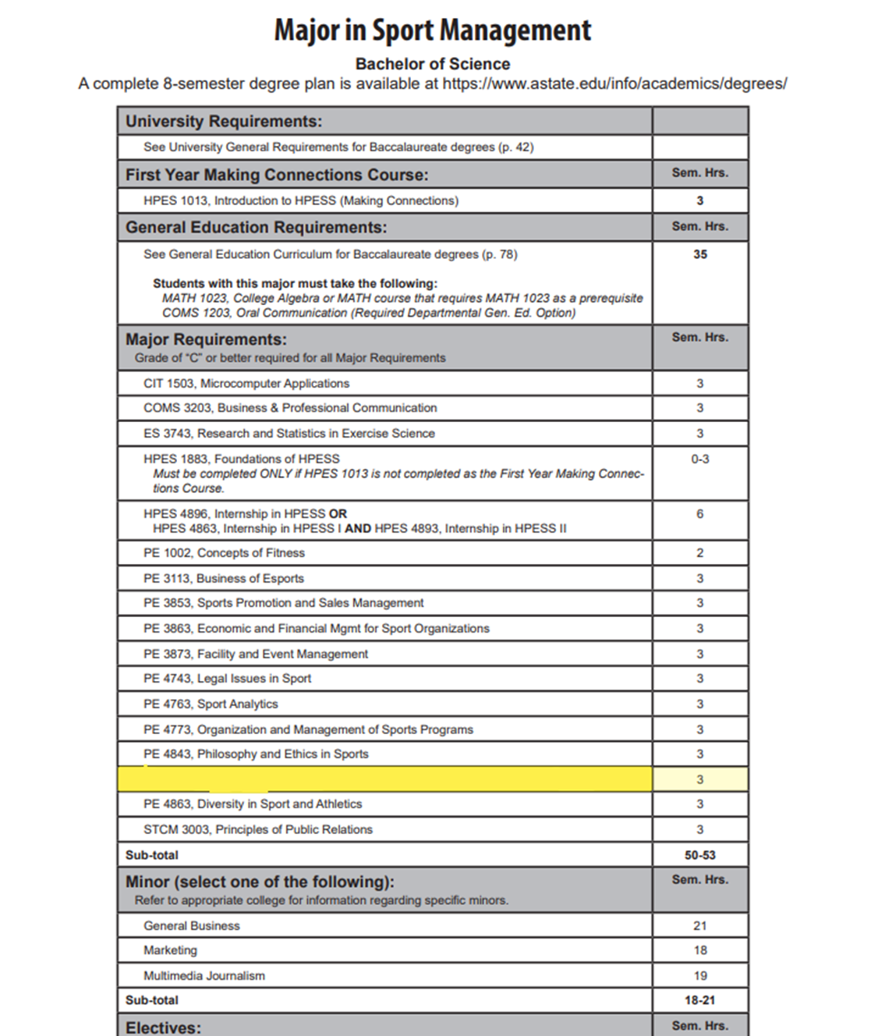
PE 4103 Sport, Globalization, and Nationalism OR PE 4823 International Sport Venues

Degree: Bachelor of Science in Sport Management (21 credit certificate)
Students requiring developmental coursework based on low entrance exam scores (ACT, SAT, ASSET, COMPASS) may not be able to complete this program of study in eight (8) semesters. Students having completed college level courses prior to enrollment will be assisted by their advisor in making appropriate substitutions. A minimum of 120 credit hours, of which 45 hours must be upper division credit (3000-4000 level), is required for this degree (developmental courses are excluded). Mandatory state and institutional assessment exams will be required during your degree program.
Year 1 - Fall |  |  |  |  |  |  | Year 1 - Spring
Course No. | Course Name | Hrs | GE | Cer | Maj |  | Course No. | Course Name | Hrs | GE | Cer | Maj
ENG 1003 | Composition I | 3 | x |  |  |  | ENG 1013 | Composition II | 3 | x
MATH 1023 | College Algebra | 3 | x |  |  |  | ISBA 1503 | Microcomputer Applications | 3 | x
COMS 1203 | Oral Comm | 3 | x |  |  |  | Social Sci | Choose 3 credits from: ANTH 2233; CMAC 1003; ECON 2313, 2323, OR 2333; GEOG 2613; HIST 1013, 1023, 2763, OR 2773; POSC 1003 OR 2103; PSY 2013; OR SOC 2213 | 3 | x
Fine arts | Choose 3 credits from: ART 2503, MUS 2503, or THEA 2503 | 3 | x |  |  |  | CMAC 1001 | Media Grammar & Style | 3 |  | x
HPES 1013 | Introduction to PE | 3 | x |  |  |  | Physical science | Pick 4 credits from CHEM 1013 & 1011, CHEM 1043 & 1041, GEOL 1003 & 1001, PHSC 1203 & 1201, PHYS 1103 & 1101, PHYS 2034, or PHYS 2054. | 4 | x
Total hrs |  | 15 |  |  |  |  | Total hrs |  | 16

Year 2 - Fall |  |  |  |  |  |  | Year 2 - Spring
Course No. | Course Name | Hrs | GE | Cer | Maj |  | Course No. | Course Name | Hrs | GE | Cer | Maj
certificate | Certificate credit hours (cumulative 3) | 3 |  | x |  |  | certificate | Certificate credit hours (cumulative 6) | 3 |  | x
Social Sci | Choose 3 credits from: ANTH 2233; CMAC 1003; ECON 2313, 2323, OR 2333; GEOG 2613; HIST 1013, 1023, 2763, OR 2773; POSC 1003 OR 2103; PSY 2013; OR SOC 2213 | 3 | x |  |  |  | Humanities | Choose 3 credits from: ENG 2003, ENG 2013, or PHIL 1103 | 3 | x
Life science | Pick 4 credits from BIOL 1003 & 1001, BIOL 1063 & 1001, BIO 1503 & 1501, BIO 2013 & 2011, BIO 2103 & 2101, or BIO 2203 & 2201 | 4 | x |  |  |  | STCM 4073 | Strategic communication law & ethics | 3 |  |  | x
ENG 2003 | Intro to Lit WWI | 3 | x |  |  |  | certificate | Certificate credit hours (cumulative 9) | 3 |  | x
PE 1002 | Concepts of Fitness | 2 |  |  | x |  | Social Sci | Choose 3 credits from: ANTH 2233; CMAC 1003; ECON 2313, 2323, OR 2333; GEOG 2613; HIST 1013, 1023, 2763, OR 2773; POSC 1003 OR 2103; PSY 2013; OR SOC 2213 | 3 | x
Total hrs |  | 15 |  |  |  |  | Total hrs |  | 15

Year 3 - Fall |  |  |  |  |  |  | Year 3 - Spring
Course No. | Course Name | Hrs | GE | Cer | Maj |  | Course No. | Course Name | Hrs | GE | Cer | Maj
PE 4863 | Diversity in Sport & Athletics | 3 |  |  | x |  | PE 3853 | Sport Promotion & Sales Mgtm | 3 |  |  | x
PE 3113 | Business of Esport | 3 |  |  | x |  | PE 3873 | Facility & Event Mgmt in Sport | 3 |  |  | x
PE 3863 | Econ & Fin Mgmt in Sport | 3 |  |  | x |  | certificate | Certificate credit hours (cumulative 15) | 3 |  | x
PE 4773 | Org & Mgmt of Sport Progms | 3 |  |  | x |  | COMS 3203 | Business & Professional Speech | 3 |  |  | x
certificate | Certificate credit hours (cumulative 12) | 3 |  | x |  |  | ES 3743 | Research & Stats | 3 |  |  | x
Total hrs |  | 15 |  |  |  |  | Total hrs |  | 15

Year 4 - Fall |  |  |  |  |  |  | Year 4 - Spring
Course No. | Course Name | Hrs | GE | Cer | Maj |  | Course No. | Course Name | Hrs | GE | Cer | Maj
PE 4743 | Legal Issues in Sport | 3 |  |  | x |  | PE 4843 | Philosophy & Ethics in Sport | 3 |  |  | x
PE 4103 | Sport, Globalization & Nationalism (or PE4823) | 3 |  |  | x |  | certificate | Certificate credit hours (cumulative 21) | 3 |  | x
PE 4763 | Sport Analytics | 3 |  |  | x |  | Elective | Any course | 2
certificate | Certificate credit hours (cumulative 18) | 3 |  | x |  |  | HPES 4896 | Internship | 6 |  |  | x
Eelective | Any upper level course | 3 |  |  | x
Total hrs |  | 15 |  |  |  |  | Total hrs |  | 14

