For Academic Affairs and Research Use Only
Proposal Number | NHP40
CIP Code:
Degree Code:

PROGRAM MODIFICATION FORM
[x] Undergraduate Curriculum Council
[ ] Graduate Council
Modification Type: []Admissions, []Curricular Sequence, or [x]Other

Signed paper copies of proposals submitted for consideration are no longer required. Please type approver name and enter date of approval.

Kacie Altom 3/28/2022  Department Curriculum Committee Chair | __________________ Enter date  COPE Chair (if applicable)
ElizabethNixBSN Chair  3/28/22  Department Chair | Sarah Davidson, Associate Dean, CNHP 3/28/2022  Head of Unit (if applicable)
Shanon Brantley 3/28/2022  College Curriculum Committee Chair | __________________ Enter date  Undergraduate Curriculum Council Chair
__________________ Enter date  Director of Assessment (only for changes impacting assessment) | __________________ Enter date  Graduate Curriculum Committee Chair
___________Scott E. Gordon_______ 3/28/22  College Dean | __________________ Enter date  Vice Chancellor for Academic Affairs
__________________ | Enter date
General Education Committee Chair (if applicable)

- Contact Person (Name, Email Address, Phone Number)
Kacie Altom
kaltom@astate.edu
Office: (870)972-2935
Cell: (870)615-4039

- Proposed Change (for undergraduate curricular changes please provide an 8-semester plan (appendix A), if applicable)
In order to verify that the bulletin accurately reflects traditional BSN program admission criteria, and required progression of courses, it is necessary to update the bulletin. These are not changes made recently but rather criteria that have never been reflected adequately in the bulletin and there is uncertainty as to where UCC approval documentation exists due to faculty changes. Bulletin changes are outlined below and summarized here.

Admission requirements already listed on page 335 need to be reflected on page 382. Additionally, the English proficiency requirement should be added along with the consideration for Spanish Proficiency. English proficiency requirements are listed on the website as well as here for convenience.

ENGLISH LANGUAGE PROFICIENCY REQUIREMENTS
The College of Nursing and Health Professions requires a high level of proficiency in English so that all students will be able to fully meet academic and clinical objectives as well as meet criteria for professional licensure/certification.
International Students
Students from non-English speaking countries or for whom English is not a native language must take one of the following tests:
- Test of English as a Foreign Language (TOEFL) with a score of 83 on the preferred internet-based test (iBT), 570 on the paper-based test, or 213 on the computer-based test.
- International English Language Testing System (IELTS) with a score of at least 6.5 and a spoken band score of 7.
- Pearson Test of English Academic (PTE) with a score of 56.
The term foreign born refers to people residing in the United States who were not U.S. citizens at birth. The foreign-born population includes naturalized citizens, lawful permanent immigrants, refugees and asylees, legal non-immigrants (including those on student, work, or other temporary visas), and persons residing in the country without authorization. In contrast, the term native born refers to people residing in the United States who were U.S. citizens in one of three categories: 1) born in one of the 50 states or the District of Columbia; 2) born in United States Insular areas such as Puerto Rico or Guam; 3) born abroad to at least one U. S. citizen parent.
Exemption
You may be exempt for the English proficiency testing if you are foreign born but attended school in the United States since kindergarten. For the exemption you must provide official school records showing continuous enrollment in U. S. schools since kindergarten.
TOEFL Information
The TOEFL is available at the ASU Testing Center. When taking the exam off campus, the report code for ASU is 6011.
English as a Second Language Program
Students who do not meet the required English language proficiency may enroll in ASU’s English as a Second Language (ESL) program in the International Center for English. Potential students enrolled in the ESL program must maintain an average of 85 or higher in levels 0 through 4. In the final or 5th level of the ESL program an average of 90 or higher must be maintained. Upon completion of the ESL program, the potential student must take the internet based Test of English as a Foreign Language (TOEFL). Upon successfully meeting the proficiency requirement, potential students are eligible to apply to the BSN Program.

For required progression of courses, students must earn a “C” or higher in all required nursing courses in order to progress, students are required to complete all science courses prior to the start of junior year with a “C” or higher, and students are required to complete a 3 credit-hour statistics course (2000 level or higher) with a “C” or higher by the end of the first semester of junior year. 2022-2023 plan of study is included below for convenience.

The section labeled expenses on page 382 can be removed as this information is included in the student handbook.

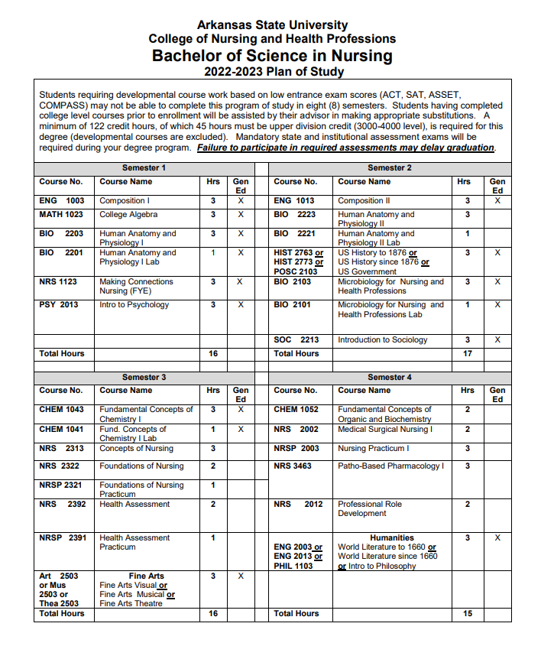

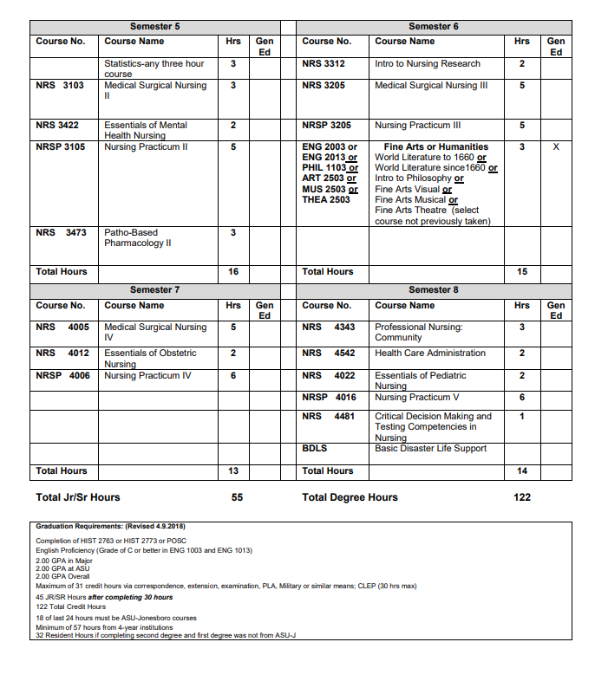

- Effective Date
These have already been in effect. If a date is required, Summer 2022 should be listed as it is the next semester start date.

- Justification – Please provide details as to why this change is necessary.
In order to verify that the bulletin accurately reflects traditional BSN program admission criteria, and required progression of courses, it is necessary to update the bulletin. These are not changes faculty made recently but rather criteria that have never been reflected adequately in the bulletin and there is uncertainty as to where UCC approval documentation exists due to faculty turnover. Bulletin changes are outlined below and summarized here.

Admission requirements already listed on page 335 need to be reflected on page 382. Additionally, the English proficiency requirement should be added along with the consideration for Spanish Proficiency. It is important for students entering the nursing program to be proficient in English as that is the primary language used for communication between faculty and students, students and patients, and on testing materials. The licensing exam will also be administered in English. Therefore, students must be proficient in English to be successful.

For required progression of courses, students must earn a “C” or higher in all required nursing courses in order to progress. Nursing courses are arranged in a specific order prior to the senior year. Each course builds on the one prior to it in the program. A “C” is required due to the professional nature of the program, and the high stakes environment in which students are practicing as they take care of real patients in the clinical setting. This standard is common among nursing programs nation-wide. Students are required to complete all science courses prior to the start of junior year with a “C” or higher to complete a 3 credit-hour statistics course (2000 level or higher) with a “C” or higher by the end of the first semester of junior year. Because of the professional nature of the program and because the program builds on previous knowledge, it is vital that students demonstrate proficiency in the sciences prior to the start of junior year. In the second semester of junior year, nursing students are required to take nursing research. Having a completed a statistics course with a “C” or better prior to taking Nursing Research ensures that students have the background knowledge needed to be successful in that course.

Bulletin Changes

Instructions
Please visit http://www.astate.edu/a/registrar/students/bulletins/index.dot and select the most recent version of the bulletin. Copy and paste all bulletin pages this proposal affects below. Please include a before (with changed areas highlighted) and after of all affected sections.

*Please note: Courses are often listed in multiple sections of the bulletin. To ensure that all affected sections have been located, please search the bulletin (ctrl+F) for the appropriate courses before submission of this form.

Before Page 335
Radiography Component (Junior Year) of Bachelor of Science in Radiologic Sciences
October 31 for admission to the Spring semester. Students are accepted based on 1) Prerequisite course GPA; 2) Entrance Exam scores; 3) interview scores. NOTE: Students completing prerequisite work or a Medical Imaging and Radiation Sciences program at A-State receive extra points toward admission score.
Cardiovascular-Interventional Technology – Bachelor of Science in Radiologic Sciences
April 1 for Fall enrollment. Students are accepted based on 1) cumulative GPA, 2) selected course grades, 3) interview, and 4) modality clinical evaluations. All categories are converted to a point system. Students wishing to apply must have completed all core requirements and an accredited radiography program. A-State radiography program students receive extra points when calculating total scores.
Mammography/Breast Sonography – Bachelor of Science in Radiologic Sciences
April 1 for Summer I enrollment. Students are accepted based on 1) cumulative GPA, 2) selected course grades, 3) interview, and 4) modality clinical evaluations. All categories are converted to a point system. Students wishing to apply to the Mammography/Breast Sonography program must have completed all core requirements and the Radiography component prior to fall semester. Breast sonography is included in this track for a Women’s Health approach to patient care. A-State radiography program students receive extra points when calculating total scores.
Medical Imaging Informatics – Bachelor of Science in Radiologic Sciences
April 1 for Fall enrollment. Students are accepted based on 1) cumulative GPA, 2) selected course grades, 3) interview, and 4) modality clinical evaluations. All categories are converted to a point system. Students wishing to apply to the Informatics program must have completed all core requirements and the Radiography component prior to fall semester. A-State radiography program students receive extra points when calculating total scores.
Magnetic Resonance Imaging - Bachelor of Science in Radiologic Sciences
April 1 for Summer I enrollment. Students are accepted based on 1) cumulative GPA, 2) selected course grades, 3) interview, and 4) modality clinical evaluations. All categories are converted to a point system. Students wishing to apply to the MRI program must have completed all core requirements and the Radiography component prior to fall semester. A-State radiography program students receive extra points when calculating total scores.
Diagnostic Medical Sonography - Bachelor of Science in Radiologic Sciences
April 1 for Summer I enrollment. Students are accepted based on 1) cumulative grade point average, 2) selected course grades, 3) interview, and 4) modality clinical evaluations. All categories are converted to a point system. Students wishing to apply to the Sonography program must have completed all core requirements and the Radiography component prior to fall semester. A-State radiography program students receive extra points when calculating total scores.
Radiation Therapy - Bachelor of Science in Radiologic Sciences
April 1 for Fall enrollment. Students are accepted based on 1) cumulative GPA, 2) selected course grades, 3) interview, and 4) modality clinical evaluations. All categories are converted to a point system. Students wishing to apply to the Radiation Therapy program must be enrolled or have completed an accredited school of Radiologic Technology. A-State graduates receive extra points when calculating total scores.
Imaging Specialist (Bridge Program) - Bachelor of Science in Radiologic Sciences
The “Bridge Program” offers the Imaging Specialist track of the BSRS in General Radiography. Admission is granted at the beginning of each semester. Only applicants who have 1) completed the associate degree in Radiologic Technology from a school approved by the American Registry of Radiologic Technologists OR 2) passed the national certification boards through the American Registry of Radiologic Technologists OR 3) completed curriculum reviewed and accepted by Dept. Chair will be considered.
Bachelor of Science in Nursing
June 7 for Fall enrollment in sophomore nursing courses and the LPN to BSN track. November 15 and June 7 for transfer/admission/readmissions for subsequent semester.
Applicants into the sophomore level must have at least 30 semester hours with a cumulative GPA of 3.0 or above completed by application deadline (June 7). Required prerequisite courses must be completed with a “C” or better by application deadline. Due to space availability, applicants for admission will be ranked based on the the GPA, successful completion of pre-requisites, and preadmission test scores. English Proficiency is required (see website for more detailed information). Consideration is given for Spanish Proficiency.

Before Page 382
TRADITIONAL BSN OPTION
ADMISSION REQUIREMENTS
- Completion of at least 30 semester hours
- Overall GPA of 3.0
- Pre-req GPA of 3.0 completed by application deadline
- Preadmission testing
- The following courses must be completed with a “C” or higher prior to the application deadline:
  - ENG 1003 Composition I
  - ENG 1013 Composition II
  - MATH 1023 College Algebra
  - PSY 2013 Intro to Psychology
  - BIO 2201/2203 Human Anatomy and Physiology I & Laboratory
  - At least one of the following courses/labs:
    - BIO 2221/2223 Human Anatomy and Physiology II & Laboratory
    - BIO 2101/2103 Microbiology for Nursing and Allied Health & Laboratory
    - CHEM 1041/1043 Fundamental Concepts of Chemistry & Laboratory
  - At least one of the following courses:
    - HIST 2763 U.S. History to 1876
    - HIST 2773 U.S. History since 1876
    - POSC 2103 U.S. Government
- English Proficiency Requirements (see website for details)
- Consideration will be given for Spanish Proficiency

REQUIRED PROGRESSION OF COURSES
Students must maintain a “C” or higher in all required nursing courses in order to progress. See Nursing Student Handbook for BSN grading scale.

Prior to beginning the junior year, students must complete the following courses with a “C” or higher in addition to all nursing courses required during sophomore year as listed on the degree plan:
- BIO 2101 AND 2103, Microbiology for Nursing and Laboratory
- BIO 2201 AND 2203, Anatomy and Physiology I and Laboratory
- BIO 2221 AND 2223, Anatomy and Physiology II and Laboratory
- CHEM 1041 AND 1043, Fundamental Concepts of Chemistry I and Laboratory
- CHEM 1052, Fundamental Concepts of Organic and Biochemistry

By the end of the first semester of junior year, students must have completed a 3 credit hour statistics course (2000 level or higher) with a grade of “C” or higher in addition to all nursing courses required as listed on the degree plan.

EXPENSES
In addition to tuition and costs, nursing students will incur the following expenses:
1. The cost of textbooks will vary each semester, with a majority of the total cost occurring in the first year of the professional program. These texts are used throughout the program.
2. Students will be required to purchase uniforms and equipment. Approximately $250 should be estimated in the first year of the program.
3. CPR certification is required. Some classes are free, while others may charge a nominal fee.
4. Students are required to pay a prorated standardized testing expense each semester. A contract is provided during the first semester with detailed costs.
5. During NRS 4481, an additional expense will occur for an NCLEX-RN preparation software.

After Page 335
Radiography Component (Junior Year) of Bachelor of Science in Radiologic Sciences
October 31 for admission to the Spring semester. Students are accepted based on 1) Prerequisite course GPA; 2) Entrance Exam scores; 3) interview scores. NOTE: Students completing prerequisite work or a Medical Imaging and Radiation Sciences program at A-State receive extra points toward admission score.
Cardiovascular-Interventional Technology – Bachelor of Science in Radiologic Sciences
April 1 for Fall enrollment. Students are accepted based on 1) cumulative GPA, 2) selected course grades, 3) interview, and 4) modality clinical evaluations. All categories are converted to a point system. Students wishing to apply must have completed all core requirements and an accredited radiography program. A-State radiography program students receive extra points when calculating total scores.
Mammography/Breast Sonography – Bachelor of Science in Radiologic Sciences
April 1 for Summer I enrollment. Students are accepted based on 1) cumulative GPA, 2) selected course grades, 3) interview, and 4) modality clinical evaluations. All categories are converted to a point system. Students wishing to apply to the Mammography/Breast Sonography program must have completed all core requirements and the Radiography component prior to fall semester. Breast sonography is included in this track for a Women’s Health approach to patient care. A-State radiography program students receive extra points when calculating total scores.
Medical Imaging Informatics – Bachelor of Science in Radiologic Sciences
April 1 for Fall enrollment. Students are accepted based on 1) cumulative GPA, 2) selected course grades, 3) interview, and 4) modality clinical evaluations. All categories are converted to a point system. Students wishing to apply to the Informatics program must have completed all core requirements and the Radiography component prior to fall semester. A-State radiography program students receive extra points when calculating total scores.
Magnetic Resonance Imaging - Bachelor of Science in Radiologic Sciences
April 1 for Summer I enrollment. Students are accepted based on 1) cumulative GPA, 2) selected course grades, 3) interview, and 4) modality clinical evaluations. All categories are converted to a point system. Students wishing to apply to the MRI program must have completed all core requirements and the Radiography component prior to fall semester. A-State radiography program students receive extra points when calculating total scores.
Diagnostic Medical Sonography - Bachelor of Science in Radiologic Sciences
April 1 for Summer I enrollment. Students are accepted based on 1) cumulative grade point average, 2) selected course grades, 3) interview, and 4) modality clinical evaluations. All categories are converted to a point system. Students wishing to apply to the Sonography program must have completed all core requirements and the Radiography component prior to fall semester. A-State radiography program students receive extra points when calculating total scores.
Radiation Therapy - Bachelor of Science in Radiologic Sciences
April 1 for Fall enrollment. Students are accepted based on 1) cumulative GPA, 2) selected course grades, 3) interview, and 4) modality clinical evaluations. All categories are converted to a point system. Students wishing to apply to the Radiation Therapy program must be enrolled or have completed an accredited school of Radiologic Technology. A-State graduates receive extra points when calculating total scores.
Imaging Specialist (Bridge Program) - Bachelor of Science in Radiologic Sciences
The “Bridge Program” offers the Imaging Specialist track of the BSRS in General Radiography. Admission is granted at the beginning of each semester. Only applicants who have 1) completed the associate degree in Radiologic Technology from a school approved by the American Registry of Radiologic Technologists OR 2) passed the national certification boards through the American Registry of Radiologic Technologists OR 3) completed curriculum reviewed and accepted by Dept. Chair will be considered.
Bachelor of Science in Nursing
June 7 for Fall enrollment in sophomore nursing courses and the LPN to BSN track. November 15 and June 7 for transfer/admission/readmissions for subsequent semester.
Applicants into the sophomore level must have at least 30 semester hours with a cumulative GPA of 3.0 or above completed by application deadline (June 7). Required prerequisite courses must be completed with a “C” or better by application deadline. Due to space availability, applicants for admission will be ranked based on GPA, successful completion of pre-requisites, and preadmission test scores. English Proficiency is required (see website for more detailed information). Consideration is given for Spanish Proficiency.

After Page 382

TRADITIONAL BSN OPTION
ADMISSION REQUIREMENTS
- Completion of at least 30 semester hours
- Overall GPA of 3.0
- Pre-req GPA of 3.0 completed by application deadline
- Preadmission testing
- The following courses must be completed with a “C” or higher prior to the application deadline:
  - ENG 1003 Composition I
  - ENG 1013 Composition II
  - MATH 1023 College Algebra
  - PSY 2013 Intro to Psychology
  - BIO 2201/2203 Human Anatomy and Physiology I & Laboratory
  - At least one of the following courses/labs:
    - BIO 2221/2223 Human Anatomy and Physiology II & Laboratory
    - BIO 2101/2103 Microbiology for Nursing and Allied Health & Laboratory
    - CHEM 1041/1043 Fundamental Concepts of Chemistry & Laboratory
  - At least one of the following courses:
    - HIST 2763 U.S. History to 1876
    - HIST 2773 U.S. History since 1876
    - POSC 2103 U.S. Government
- English Proficiency Requirements (see website for details)
- Consideration will be given for Spanish Proficiency

REQUIRED PROGRESSION OF COURSES
Students must maintain a “C” or higher in all required nursing courses in order to progress. See Nursing Student Handbook for BSN grading scale.

Prior to beginning the junior year, students must complete the following courses with a “C” or higher in addition to all nursing courses required during sophomore year as listed on the degree plan:
- BIO 2101 AND 2103, Microbiology for Nursing and Laboratory
- BIO 2201 AND 2203, Anatomy and Physiology I and Laboratory
- BIO 2221 AND 2223, Anatomy and Physiology II and Laboratory
- CHEM 1041 AND 1043, Fundamental Concepts of Chemistry I and Laboratory
- CHEM 1052, Fundamental Concepts of Organic and Biochemistry

By the end of the first semester of junior year, students must have completed a 3-credit hour statistics course (2000 level or higher) with a grade of “C” or higher in addition to all nursing courses required as listed on the degree plan.

Appendix A, 8-Semester Plan
(Referenced in #2 - Undergraduate Proposals Only)
Instructions: Please identify new courses in italics.
Arkansas State University-Jonesboro
Degree:
Major:
Year:

Students requiring developmental course work based on low entrance exam scores (ACT, SAT, ASSET, COMPASS) may not be able to complete this program of study in eight (8) semesters. Developmental courses do not count toward total degree hours. Students having completed college level courses prior to enrollment will be assisted by their advisor in making appropriate substitutions. In most cases, general education courses may be interchanged between semesters. A minimum of 45 hours of upper division credit (3000-4000 level) is required for this degree.
Year 1 |  |  |  |  | Year 1
Fall Semester |  |  |  |  | Spring Semester
Course No. | Course Name | Hrs | Gen Ed |  | Course No. | Course Name | Hrs | Gen Ed
Total Hours |  |  |  |  | Total Hours
Year 2 |  |  |  |  | Year 2
Fall Semester |  |  |  |  | Spring Semester
Course No. | Course Name | Hrs | Gen Ed |  | Course No. | Course Name | Hrs | Gen Ed
Total Hours |  |  |  |  | Total Hours
Year 3 |  |  |  |  | Year 3
Fall Semester |  |  |  |  | Spring Semester
Course No. | Course Name | Hrs | Gen Ed |  | Course No. | Course Name | Hrs | Gen Ed
Total Hours |  |  |  |  | Total Hours
Year 4 |  |  |  |  | Year 4
Fall Semester |  |  |  |  | Spring Semester
Course No. | Course Name | Hrs | Gen Ed |  | Course No. | Course Name | Hrs | Gen Ed
Total Hours |  |  |  |  | Total Hours
Total Jr/Sr Hours ___ Total Degree Hours ___
Graduation Requirements:

