For Academic Affairs and Research Use Only
Proposal Number: | NHP20
CIP Code:
Degree Code:

EXISTING CERTIFICATE, DEGREE, MAJOR

OR ORGANIZATIONAL UNIT: Name Change Only FORM

(No change in program curriculum, option/emphasis/concentration or organizational structure)

(Also requires Arkansas Department of Higher Education (ADHE) approval)
[X] Undergraduate Curriculum Council
[ ] Graduate Council
Signed paper copies of proposals submitted for consideration are no longer required. Please type approver name and enter date of approval.
Tiffany Sterling 2/8/2023  Department Curriculum Committee Chair | __________________ Enter date  COPE Chair (if applicable)
Tiffany Sterling 2/8/2023  Department Chair | __________________ Enter date  Head of Unit (if applicable)
Amy Hyman 2/16/2023  College Curriculum Committee Chair | __________________ Enter date  Undergraduate Curriculum Council Chair
Scott E. Gordon 2/16/2023  College Dean | __________________ Enter date  Graduate Curriculum Committee Chair
__________________ Enter date  General Education Committee Chair (if applicable) | Len Frey 3/22/2023  Vice Chancellor for Academic Affairs

- Contact Person (Name, Email Address, Phone Number)
Tiffany Sterling, rsterling@astate.edu, 4684

- Proposed effective date:
Spring 2024

- Justification:
The current name of the degree is Bachelor of Science in Dietetics. Traditionally, students were able to take the registration exam to become a registered dietitian after completing this degree. However, our accreditation is now requiring a minimum of a graduate degree for those wanting to become a registered dietitian. Since this degree no longer leads to the ability to become a dietitian, changing the name to a Bachelor of Science in Nutrition and Dietetics encompasses the degree program better. Students will still learn information related to dietetics, and the work of a dietitian, but the degree has a large nutrition focus.

 | Current Name | Proposed Name (if changed)
Degree/certificate program | Bachelor of Science in Nutrition and Dietetics | Bachelor of Science in Nutrition and Dietetics
Major or option/emphasis/concentration | Dietetics | Nutrition and Dietetics
Organizational unit | Dietetics Program/CNHP | Dietetics Program/CNHP

- Provide the curriculum/credit hours for the certificate/degree/major listed above.

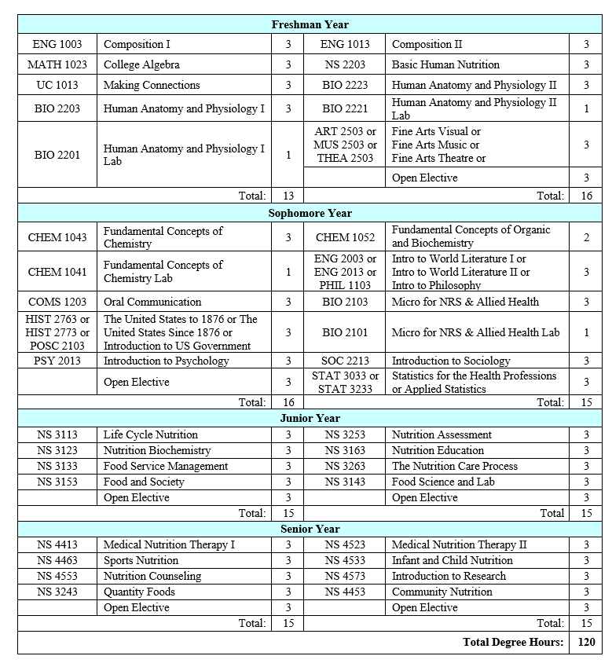

Bulletin Changes

Instructions
Please visit http://www.astate.edu/a/registrar/students/bulletins/index.dot and select the most recent version of the bulletin. Copy and paste all bulletin pages this proposal affects below. Please include a before (with changed areas highlighted) and after of all affected sections.

*Please note: Courses are often listed in multiple sections of the bulletin. To ensure that all affected sections have been located, please search the bulletin (ctrl+F) for the appropriate courses before submission of this form.

https://catalog.astate.edu/preview_program.php?catoid=3&poid=691&returnto=75
Before:
• Criminology, Minor
• Crop Consulting and Agronomic Services, Minor
• Data Analytics, Certificate
• Data Science and Data Analytics, Emphasis in Data Analytics, BS
• Data Science and Data Analytics, Emphasis in Data Analytics, Domain in Business, BS
• Data Science and Data Analytics, Emphasis in Data Science, BS
• Data Science and Data Analytics, Emphasis in Data Science, Domain
• Data Visualization and Information Design, Certificate
• Debate and Forensics, Certificate
• Nutrition & Dietetics, BS
• Digital Design, Minor
• Digital Humanities, Certificate
• Digital Technology and Design, Emphasis in Digital Animation, BS
• Digital Technology and Design, Emphasis in Game Design, BS
• Digital Technology and Design, Emphasis in Graphic Communications, BS
• Digital Technology and Design, Emphasis in Information Design, BS
• Digital Technology and Design, Emphasis in Mobile Application Development, BS
• Digital Technology and Design, Emphasis in Social Media Management, BS
• Digital Technology and Design, Emphasis in Virtual Reality Production, BS
• Digital Technology and Design, Emphasis in Web Design, BS
• Disaster Preparedness and Emergency Management, AAS

After:

Criminology, Minor
• Crop Consulting and Agronomic Services, Minor
• Data Analytics, Certificate
• Data Science and Data Analytics, Emphasis in Data Analytics, BS
• Data Science and Data Analytics, Emphasis in Data Analytics, Domain in Business, BS
• Data Science and Data Analytics, Emphasis in Data Science, BS
• Data Science and Data Analytics, Emphasis in Data Science, Domain
• Data Visualization and Information Design, Certificate
• Debate and Forensics, Certificate
• Nutrition & Dietetics, BS
• Digital Design, Minor
• Digital Humanities, Certificate
• Digital Technology and Design, Emphasis in Digital Animation, BS
• Digital Technology and Design, Emphasis in Game Design, BS
• Digital Technology and Design, Emphasis in Graphic Communications, BS
• Digital Technology and Design, Emphasis in Information Design, BS
• Digital Technology and Design, Emphasis in Mobile Application Development, BS
• Digital Technology and Design, Emphasis in Social Media Management, BS
• Digital Technology and Design, Emphasis in Virtual Reality Production, BS
• Digital Technology and Design, Emphasis in Web Design, BS
• Disaster Preparedness and Emergency Management, AAS

https://catalog.astate.edu/preview_program.php?catoid=3&poid=691&returnto=75

Before:

Nutrition & Dietetics, BS
Return to: Programs A-Z
A complete 8-semester degree plan is available at https://www.astate.edu/info/academics/degrees/

University Requirements:

See University General Requirements for Baccalaureate degrees

After:

Nutrition & Dietetics, BS
Return to: Programs A-Z
A complete 8-semester degree plan is available at https://www.astate.edu/info/academics/degrees/

University Requirements:

See University General Requirements for Baccalaureate degrees

https://catalog.astate.edu/content.php?catoid=3&navoid=77

Before:

Dietetics Program
Go to information for Dietetics Program.
Bachelor of Science
• Nutrition & Dietetics, BS

After:

Dietetics Program
Go to information for Dietetics Program.
Bachelor of Science
• Nutrition & Dietetics, BS

https://catalog.astate.edu/preview_program.php?catoid=3&poid=691&returnto=77

Before:

Nutrition & Dietetics, BS
Return to: Programs by Department
A complete 8-semester degree plan is available at https://www.astate.edu/info/academics/degrees/

University Requirements:

See University General Requirements for Baccalaureate degrees

After:

Nutrition & Dietetics, BS
Return to: Programs by Department
A complete 8-semester degree plan is available at https://www.astate.edu/info/academics/degrees/

University Requirements:

See University General Requirements for Baccalaureate degrees

