For Academic Affairs and Research Use Only
Proposal Number | BU24
CIP Code:
Degree Code:

Program Modification Form
[x] Undergraduate Curriculum Council
[ ] Graduate Council
Modification Type: [ ]Admissions, [X]Curricular Sequence, or [ ]Other

Signed paper copies of proposals submitted for consideration are no longer required. Please type approver name and enter date of approval.

H. Steve Leslie 9/1/2021  Department Curriculum Committee Chair | __________________ Enter date  COPE Chair (if applicable)
Bill Hu 9/9/21  Department Chair | __________________ Enter date  Head of Unit (if applicable)
John Robertson 9/13/21  College Curriculum Committee Chair | __________________ Enter date  Undergraduate Curriculum Council Chair
__________________ Enter date  Director of Assessment (only for changes impacting assessment) | __________________ Enter date  Graduate Curriculum Committee Chair
Jim Washam 10/29/2021  College Dean | Alan Utter 11/16/2021  Vice Chancellor for Academic Affairs
__________________ | Enter date
General Education Committee Chair (if applicable)

- Contact Person (Name, Email Address, Phone Number)
Dr. Melodie Philhours, mphil@astate.edu, 870-680-8148

- Proposed Change (for undergraduate curricular changes please provide an 8-semester plan (appendix A), if applicable)

Add MKTG 3023 Business Research Tools and GSCM 3163 Supply Chain Management to the marketing core for all BS Marketing degrees in the Neil Griffin College of Business (NGCOB) and to adjust the number of elective hours to reflect this change. Correspondingly, the number of electives is decreased from 16 to 10.

- Effective Date
8/15/2021

- Justification – Please provide details as to why this change is necessary.
The marketing faculty, given adequate time to reconsider sweeping curriculum change implemented in September/October 2020, seek to add these essential courses back to the marketing core curriculum. Adding these courses to the core reduced the number of electives from 16 hours to 10, as reflected in this document.

Bulletin Changes

Instructions
Please visit http://www.astate.edu/a/registrar/students/bulletins/index.dot and select the most recent version of the bulletin. Copy and paste all bulletin pages this proposal affects below. Please include a before (with changed areas highlighted) and after of all affected sections.

*Please note: Courses are often listed in multiple sections of the bulletin. To ensure that all affected sections have been located, please search the bulletin (ctrl+F) for the appropriate courses before submission of this form.

This is page 152 of the 2021-22 Bulletin. The bulletin page was proactively changed in May 2021 to avoid a year of curriculum that the marketing faculty did not support. Thus no bulletin change is necessary at this point. This proposal provides the appropriate shared governance documentation to support this curriculum and bulletin page.

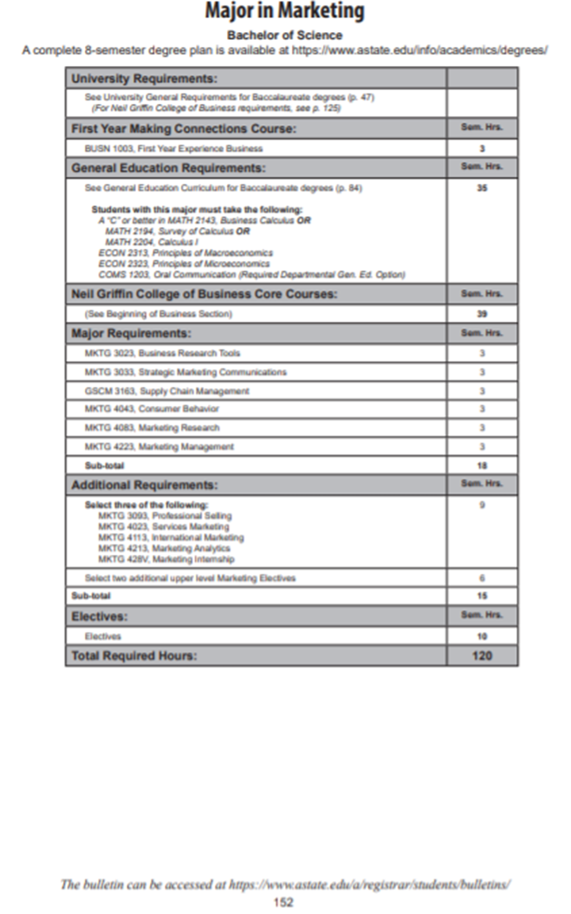

Appendix A, 8-Semester Plan
(Referenced in #2 - Undergraduate Proposals Only)
Instructions: Please identify new courses in italics.
Arkansas State University-Jonesboro
Degree: B.S.
Major: Marketing
Year: 2021-2022

Students requiring developmental course work based on low entrance exam scores (ACT, SAT, ASSET, COMPASS) may not be able to complete this program of study in eight (8) semesters. Developmental courses do not count toward total degree hours. Students having completed college level courses prior to enrollment will be assisted by their advisor in making appropriate substitutions. In most cases, general education courses may be interchanged between semesters. A minimum of 45 hours of upper division credit (3000-4000 level) is required for this degree.
Year 1 |  |  |  |  | Year 1
Fall Semester |  |  |  |  | Spring Semester
Course No. | Course Name | Hrs | Gen Ed |  | Course No. | Course Name | Hrs | Gen Ed
BIOL 1003 | Biology | 3 | x |  | ART or MUS or THEA 2503 | Fine Arts Visual, Musical, or Theatre | 3 | x
BIOL 1001 | Biology Lab | 1  333 | x |  | ENG 1013 | Composition II | 3 | x
BUSN 1003 | Freshman Year Experience | 3 | x |  | MATH 2143 | Business Calculus | 3 | x
CIT 1503 | Microcomputer Applications | 3 |  |  | PHSC 1203 | Physical Science | 3 | x
ENG 1003 | Composition I | 3 | x |  | PHSC 1201 | Physical Science Lab | 1 | x
MATH 1023 or Elective  Elective | College Algebra or Elective | 3 |  |  | Social Science Course | Pick one of the following: ANTH 2233, CMAC 1003, ECON 2333, GEOG 2613, HIST 1013, HIST 1023, POSC 1003, PSY 2013, SOC 2213 | 3 | x
Total Hours |  | 15 |  |  | Total Hours |  | 16
Year 2 |  |  |  |  | Year 2
Fall Semester |  |  |  |  | Spring Semester
Course No. | Course Name | Hrs | Gen Ed |  | Course No. | Course Name | Hrs | Gen Ed
ACCT 2033 | Intro to Financial Accounting | 3 |  |  | ACCT 2133 | Intro to Managerial Accounting | 3
COMS 1203 | Oral Communications | 3 | x |  | BCOM 2563 | Business Communications | 3
ECON 2313 | Principles of Macroeconomics | 3 | x |  | ECON 2323 | Principles of Microeconomics | 3
ENG 2003 or  ENG 2013 or  PHIL 1103 | World Literature I, World Literature II, or Intro to Philosophy | 3 | x |  | ECON 2113 or  STAT 3233 | Business Statistics or Applied Statistics | 3
HIST 2763 or  HIST 2773 or  POSC 2103 | US History to 1876, US History from 1876, or Intro to US Gov. | 3 | x |  | LAW 2023 | Legal Environment Business | 3
Total Hours |  | 15 |  |  | Total Hours |  | 15
Year 3 |  |  |  |  | Year 3
Fall Semester |  |  |  |  | Spring Semester
Course No. | Course Name | Hrs | Gen Ed |  | Course No. | Course Name | Hrs | Gen Ed
CIT 3013 | Management Information Systems | 3 |  |  | CIT 3523 | Operations Management | 3
Elective | Any Elective | 3 |  |  | Elective | Any Elective | 3
FIN 3713 | Business Finance | 3 |  |  | MKTG 3033 | Strategic Marketing Communications | 3
MGMT 3123 | Principles of Management | 3 |  |  | GSCM 3163 | Global Supply Chain Management | 3
MKTG 3013 | Marketing | 3 |  |  | MKTG 3023 | Business Research Tools | 3
Total Hours |  | 15 |  |  | Total Hours |  | 15
Year 4 |  |  |  |  | Year 4
Fall Semester |  |  |  |  | Spring Semester
Course No. | Course Name | Hrs | Gen Ed |  | Course No. | Course Name | Hrs | Gen Ed
MKTG Elective | Select One of the Following, MKTG 3043, MKTG 3093, MKTG 3173, MKTG 4023, MKTG 4113, MKTG 4213, or MTKG 428V | 3 |  |  | MGMT 4813 | Strategic Management | 3
Elective | Any Elective | 3 |  |  | 3000/4000 Level MKTG Elective | Any Upper Level Marketing Elective | 3
MKTG 4083 | Marketing Research | 3 |  |  | MKTG 4223 | Marketing Management | 3
MKTG 4043 | Consumer Behavior | 3 |  |  | MKTG Elective | Select One of the Following, MKTG 3043, MKTG 3093, MKTG 3173, MKTG 4023, MKTG 4113, MKTG 4213, or MTKG 428V | 3
MKTG elective | Select One of the Following, MKTG 3043, MKTG 3093, MKTG 3173, MKTG 4023, MKTG 4113, MKTG 4213, or MTKG 428V | 3 |  |  | 3000/4000 Level MKTG Elective | Any Upper Level Marketing Elective | 3
Total Hours |  | 15 |  |  | Total Hours |  | 15
Total Jr/Sr Hours 45 Total Degree Hours 120
Graduation Requirements:
Completion of HIST 2763 or HIST 2773 or POSC 2103
English Proficiency (Grade of C or better in ENG 1003 and ENG 1013)
2.25 in major or at least a "C" in each course in major
2.25 overall and at least 2.00 GPA at ASU
2.25 in business core or at least a "C" in each core course
50 % of business requirements completed at ASU-Jonesboro
Maximum of 30 credit hours via correspondence, extension, examination, PLA, Military or similar means; CLEP (30 hrs max)
45 JR/SR Hours after completing 30 hours
120 Total Credit Hours
30 of last 36 hours at ASU-Jonesboro
32 ASU residence hours
Must have grade of C or better in MATH 2143, ACCT 2033, and CIT 1503.

beasdf

