|  |  |
| --- | --- |
| For Academic Affairs and Research Use Only | |
| Proposal Number |  |
| CIP Code: |  |
| Degree Code: |  |

**NEW CERTIFICATE PROGRAM FORM**

(Also requires Arkansas Department of Higher Education (ADHE) approval)

**[X] Undergraduate Curriculum Council**

**[ ] Graduate Council**

Signed paper copies of proposals submitted for consideration are no longer required. Please type approver name and enter date of approval.

|  |  |  |  |  |  |
| --- | --- | --- | --- | --- | --- |
| |  |  | | --- | --- | | Kelly Fish | 9/17/2020 |   **Department Curriculum Committee Chair** | |  |  | | --- | --- | | __________________ | Enter date |   **COPE Chair (if applicable)** |
| |  |  | | --- | --- | | James Doering | 9/17/2020 |   **Department Chair** | |  |  | | --- | --- | | __________________ | Enter date |   **Head of Unit (if applicable)** |
| |  |  | | --- | --- | | Melodie Philhours | 9/24/2020 |   **College Curriculum Committee Chair** | |  |  | | --- | --- | | __________________ | Enter date |   **Undergraduate Curriculum Council Chair** |
| |  |  | | --- | --- | | Melody Lo | 9/24/2020 |   **College Dean** | |  |  | | --- | --- | | __________________ | Enter date |   **Graduate Curriculum Committee Chair** |
| |  |  | | --- | --- | | __________________ | Enter date |   **General Education Committee Chair (if applicable)** | |  |  | | --- | --- | | __________________ | Enter date |   **Vice Chancellor for Academic Affairs** |

1. **Contact Person** (Name, Email Address, Phone Number)

Dr. Richard Segall, Professor [E-mail: [rsegall@astate.edu](mailto:rsegall@astate.edu), Phone: 870-972-3989]

A-STATE

Neil Griffin College of Business

Department of Computer & Information Technology

State University, AR 72467-0130

1. **Name of proposed Certificate Program (Program must consist of 6-21 semester credit hours):**

Business Analytics Certificate

1. **Proposed effective date:**

Fall 2021

1. **Reason for proposed program implementation:**

Provide the opportunity of completing four of the essential courses in Business Analytics (plus MATH 1023) to the working professional or those wanting to acquire some of essential skills to become more marketable in Business Analytics.

1. **Provide the following:**
   * 1. Curriculum outline - List of courses in new program – Underline required courses

MATH 1023 or equivalent

STAT 3233 Applied Statistics I

CIT 3413 Big Data for Business OR CIT 3553 Foundation of Business Analytics

CIT 3423 Data Visualization for Business

CIT 3663 Data Mining for Business

* + 1. Total semester credit hours required for proposed program

15

* + 1. New courses and new course descriptions

**CIT 3553 Foundation of Business Analytics** Provides an understanding of contemporary processes, methods, techniques, tools and datasets that organizations use to implement knowledge discovery projects; focus on development of critical thinking through use of in-depth assignments that utilize project management fundamentals.

**CIT 3423 Data Visualization for Business** This course presents strategies and methods for visualization and communication of data. Data visualization software is used to answer business questions, drive decisions, and provide persuasive evidence. The course is for students interested in using visualization to better understand data.

* + 1. Program goals and objectives

Program goals – 1) Students will become comfortable in approaching decision making led by business analytics 2) Students will learn how to handle large data and glean information from them 3) Students will acquire business skills that are attractive to employers

Program objectives – 1) Students will learn fundamental descriptive statistical analysis 2) Students will learn how to communicate business intelligence through data visualization 3) Students will learn predictive and prescriptive data analytic techniques

* + 1. Expected student learning outcomes

1. Students will have developed knowledge, analytical skills and understanding around a range of subjects in the area of Business Analytics.
2. Students will understand how to effectively interpret and communicate their ideas through written and oral reports on the area of Business Analytics.
3. Students will learn the Business Analytics principles and techniques for decision-making for organizations.
4. Students will acquire Business Analytics skills to make efficient organizations.
5. Students will be able to provide leadership to teams or groups in an organization with Business Analytics skills.
   * 1. Documentation that program meets employer needs

The best-fit position titles for students with Business Analytics Certificate Program include “Management Analysts”, “Market Research Analyst”, and “Computer and Information Systems Managers”. Based on US Labor Department, the job outlook for these positions for 2019-2029 is much faster than average (Source: https://www.bls.gov/ooh/):

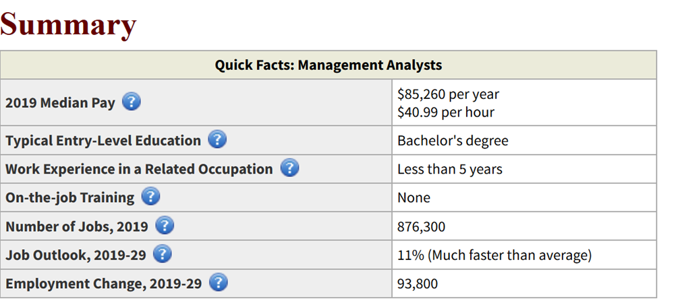

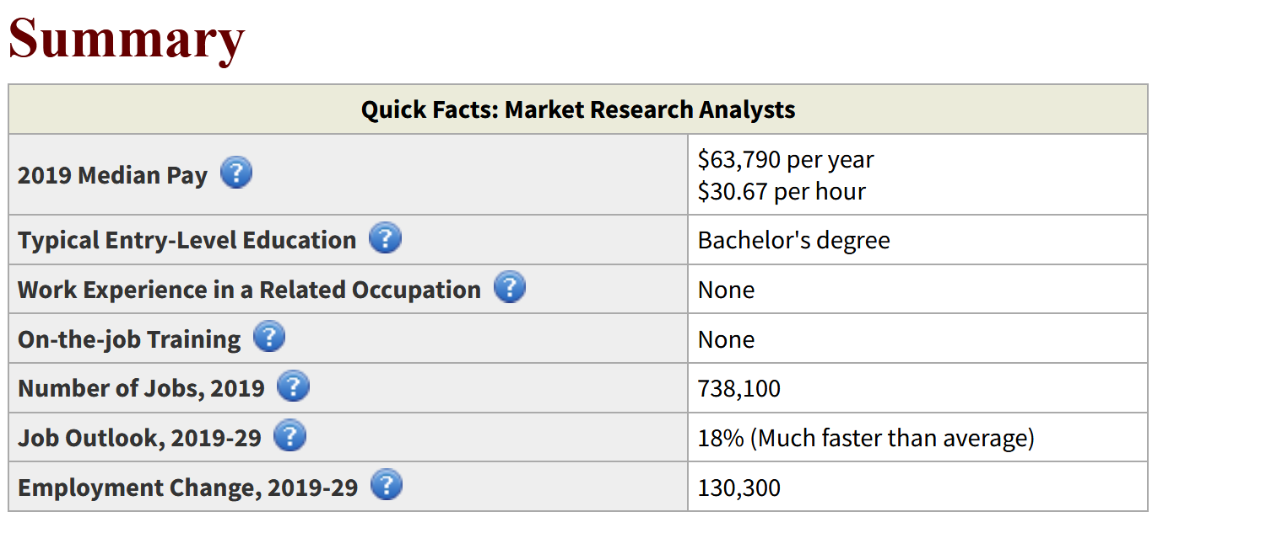

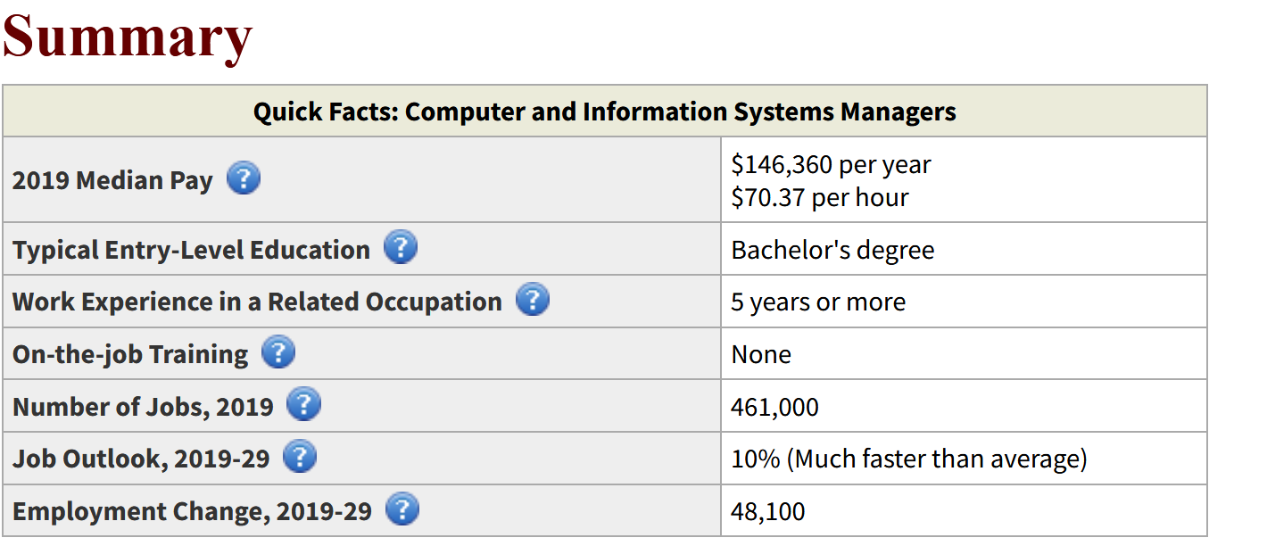

* + 1. Student demand (projected enrollment) for proposed program

20

* + 1. Program approval letter from licensure/certification entity, if required (attach)
    2. Name of institutions offering similar programs and the institution(s) used as model to develop proposed program

Enter text...

* + 1. Proposed program review date (within 10 years of program implementation)

2026

1. **Will this program be offered:**
   1. **Traditional/Face-to-face** Yes
   2. **Distance/Online** No
      1. **If yes, indicate mode of distance delivery, and the percentage of courses offered via this modality (<50%, 50-99%, or 100%).**

Enter text...

* + 1. **If online, will it be offered through Global Initiatives/Academic Partnerships (AP)?**

Enter text...

1. **Will this program be offered off-campus? No**
   1. **If yes, identify the off-campus location**

Enter text...

**Bulletin Changes**

|  |
| --- |
| **Instructions** |
| **Please visit** [**http://www.astate.edu/a/registrar/students/bulletins/index.dot**](http://www.astate.edu/a/registrar/students/bulletins/index.dot) **and select the most recent version of the bulletin. Copy and paste all bulletin pages this proposal affects below. Please include a before (with changed areas highlighted) and after of all affected sections.**  **\*Please note: Courses are often listed in multiple sections of the bulletin. To ensure that all affected sections have been located, please search the bulletin (ctrl+F) for the appropriate courses before submission of this form.** |

Page 122, changes in red

In additional to offering the four-year programs described above, the ISBA department offers an Associate of Science in Information Systems and Business Analytics, Certificates in Information Technology, Business Analytics and minors

Top of page 126, changes in red

**Certificate in Business Analytics (BA)**

Provides the opportunity of completing four of the essential courses in Business Analytics (plus MATH 1023) to the working professional or those wanting to acquire some of essential skills to become more marketable in BA. Students will become comfortable in approaching decision making led by BA and will learn how to handle large data sets and glean information from them. The resulting certificate is independent of any degree program and can be used either to enhance whatever degree is being pursued by the student or to demonstrate BA accomplishments of the non-degree-seeking student.

|  |  |
| --- | --- |
| **Requirements:** |  |
| **Required courses** | **Sem. Hrs.** |
| MATH 1023 College Algebra or equivalent | 3 |
| STAT 3233 Applied Statistics I | 3 |
| CIT 3423 Data Visualization for Business | 3 |
| CIT 3663 Data Mining for Business | 3 |
| **Choose one of the following courses** | **Sem. Hrs.** |
| CIT 3413 Big Data for Business | 3 |
| CIT 3553 Foundation of Business Analytics |
| **Total Required Hours:** | **15** |