For Academic Affairs and Research Use Only
Proposal Number
CIP Code:
Degree Code:
2+2/MOUs:

Emphasis, Concentration, Option, or Minor Deletion Proposal Form
[x] Undergraduate Curriculum Council
[ ] Graduate Council
Signed paper copies of proposals submitted for consideration are no longer required. Please type approver name and enter date of approval.

Kelly Fish 11/1/2020  Department Curriculum Committee Chair | __________________ Enter date  COPE Chair (if applicable)
James Doering 11/1/2020  Department Chair | __________________ Enter date  Head of Unit (if applicable)
Melodie Philhours 11/2/2020  College Curriculum Committee Chair | __________________ Enter date  Undergraduate Curriculum Council Chair
Melody Lo 11/3/2020  College Dean | __________________ Enter date  Graduate Curriculum Committee Chair
__________________ Enter date  General Education Committee Chair (if applicable) | __________________ Enter date  Vice Chancellor for Academic Affairs

- Contact Person (Name, Email Address, Phone Number)
Kelly Fish, kfish@astate.edu, 870-972-3986

- Type of deletion request:
- [ ] Emphasis
- [ ] Concentration
- [ ] Option
- [X] Minor

- Title of emphasis, concentration, option, or minor
Minor in Electronic Commerce

- Number of students still enrolled in emphasis, concentration, option, or minor:
0

- How will students in the deleted emphasis, concentration, option, or minor be accommodated?
N/A there are presently no students enrolled in the minor program

- Last semester and year for graduation.
Spring 2021

- Last semester for new admissions?
Fall 2020

- When will written notification providing deletion information be sent to enrolled students? (In the notification, include semester and year of the last award and how student will be accommodated.)
N/A There are presently no students enrolled in the minor program. No new students will be enrolled into the minor.

- Provide documentation of written notification to students currently enrolled in emphasis, concentration, option, or minor.

N/A There are presently no students enrolled in the minor program. No new students will be enrolled into the minor.

- Please provide a short justification for why this emphasis, concentration, option, or minor is being deleted.
Student and industry demands do not support this minor. The faculty resources are being utilized for other areas in the Computer & Information Technology curriculum.

Bulletin Changes

Instructions
Please visit http://www.astate.edu/a/registrar/students/bulletins/index.dot and select the most recent version of the bulletin. Copy and paste all bulletin pages this proposal affects below. Please include a before (with changed areas highlighted) and after of all affected sections.

*Please note: Courses are often listed in multiple sections of the bulletin. To ensure that all affected sections have been located, please search the bulletin (ctrl+F) for the appropriate courses before submission of this form.

Before - page 122
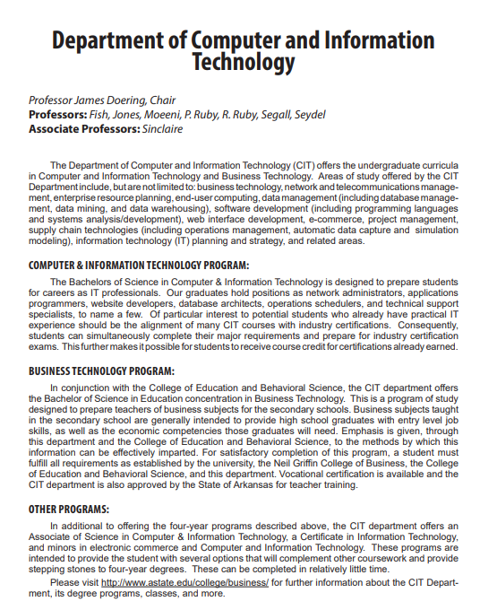

Before - page 127

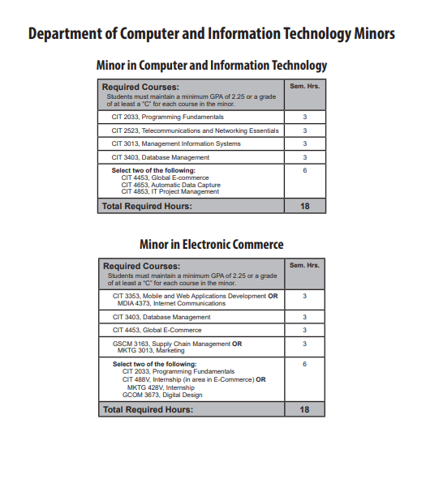

After - page 122

Department of Computer and Information Technology
Professor James Doering, Chair
Professors: Fish, Jones, Moeeni, P. Ruby, R. Ruby, Segall, Seydel
Associate Professors: Sinclaire

The Department of Computer and Information Technology (CIT) offers the undergraduate curricula
in Computer and Information Technology and Business Technology. Areas of study offered by the CIT
Department include, but are not limited to: business technology, network and telecommunications management, enterprise resource planning, end-user computing, data management (including database management, data mining, and data warehousing), software development (including programming languages
and systems analysis/development), web interface development, e-commerce, project management,
supply chain technologies (including operations management, automatic data capture and simulation
modeling), information technology (IT) planning and strategy, and related areas.
COMPUTER & INFORMATION TECHNOLOGY PROGRAM:

The Bachelors of Science in Computer & Information Technology is designed to prepare students
for careers as IT professionals. Our graduates hold positions as network administrators, applications
programmers, website developers, database architects, operations schedulers, and technical support
specialists, to name a few. Of particular interest to potential students who already have practical IT
experience should be the alignment of many CIT courses with industry certifications. Consequently,
students can simultaneously complete their major requirements and prepare for industry certification
exams. This further makes it possible for students to receive course credit for certifications already earned.
BUSINESS TECHNOLOGY PROGRAM:

In conjunction with the College of Education and Behavioral Science, the CIT department offers
the Bachelor of Science in Education concentration in Business Technology. This is a program of study
designed to prepare teachers of business subjects for the secondary schools. Business subjects taught
in the secondary school are generally intended to provide high school graduates with entry level job
skills, as well as the economic competencies those graduates will need. Emphasis is given, through
this department and the College of Education and Behavioral Science, to the methods by which this
information can be effectively imparted. For satisfactory completion of this program, a student must
fulfill all requirements as established by the university, the Neil Griffin College of Business, the College
of Education and Behavioral Science, and this department. Vocational certification is available and the
CIT department is also approved by the State of Arkansas for teacher training.
OTHER PROGRAMS:

In additional to offering the four-year programs described above, the CIT department offers an
Associate of Science in Computer & Information Technology, a Certificate in Information Technology,
and a minor(s) in electronic commerce and Computer and Information Technology. These programs are
intended to provide the student with several options that will complement other coursework and provide
stepping stones to four-year degrees. These can be completed in relatively little time.
Please visit http://www.astate.edu/college/business/ for further information about the CIT Depart
its degree programs, classes, and more.

After - page 127

