For Academic Affairs and Research Use Only
Proposal Number | NHP63
CIP Code:
Degree Code:

NEW OR MODIFIED COURSE PROPOSAL FORM
[X] Undergraduate Curriculum Council
[ ] Graduate Council
[]New Course, [ ]Experimental Course (1-time offering), or [X]Modified Course (Check one box)
Signed paper copies of proposals submitted for consideration are no longer required. Please type approver name and enter date of approval.
Kacie Altom MSN, RN, CNE, CMSRN 10/18/2021  Department Curriculum Committee Chair | ___________________ Enter date…  COPE Chair (if applicable)
Sarah Davidson, Associate Dean 10/18/2021  Department Chair | Elizabeth Nix, BSN Chair 10/18/2021  Head of Unit (if applicable)
Shanon Brantley 10/27/2021  College Curriculum Committee Chair | ___________________ Enter date…  Undergraduate Curriculum Council Chair
___________________ Enter date…  Director of Assessment (new courses only) | ___________________ Enter date…  Graduate Curriculum Committee Chair
__Scott E. Gordon_______ 10-28-21  College Dean | __ Alan Utter ___________ 11/16/21  Vice Chancellor for Academic Affairs
___________________ Enter date…
General Education Committee Chair (if applicable)

- Contact Person (Name, Email Address, Phone Number)
Sarah Davidson, DNP, RN, CNE
sarahdavidson@astate.edu
870-972-2748

- Proposed starting term and Bulletin year for new course or modification to take effect
Spring 2022

Instructions:
Please complete all sections unless otherwise noted. For course modifications, sections with a “Modification requested?” prompt need not be completed if the answer is “No.”

 | Current (Course Modifications Only) | Proposed (New or Modified)  (Indicate “N/A” if no modification)
Prefix | NRS | N/A
Number* | 4763 | N/A
Title | Professional Nursing Role | Professional Nursing Practice
Description** | Concepts of professional RN-BSN socialization, accountability, advocacy, issues and trends which affect the role of the nurse are analyzed and discussed. Prerequisite, Admission to the RN-BSN program. Fall, Spring, Summer | N/A

* (Confirm with the Registrar’s Office that number chosen has not been used before and is available for use. For variable credit courses, indicate variable range. Proposed number for experimental course is 9. )
**Forty words or fewer as it should appear in the Bulletin.

- Proposed prerequisites and major restrictions [Modification requested? No]
(Indicate all prerequisites. If this course is restricted to a specific major, which major. If a student does not have the prerequisites or does not have the appropriate major, the student will not be allowed to register).
- Yes Are there any prerequisites?
  - If yes, which ones?
Prerequisite, Admission to the RN-BSN program
  - Why or why not?
Enter text...

- Yes Is this course restricted to a specific major?
  - If yes, which major? RN-BSN Program

- Proposed course frequency [Modification requested? No]
(e.g. Fall, Spring, Summer; if irregularly offered, please indicate, “irregular.”) Not applicable to Graduate courses.

No

- Proposed course type [Modification requested? No]
Will this course be lecture only, lab only, lecture and lab, activity (e.g., physical education), dissertation/thesis, capstone, independent study, internship/practicum, seminar, special topics, or studio? Please choose one.

No.

- Proposed grade type [Modification requested? No]
What is the grade type (i.e. standard letter, credit/no credit, pass/fail, no grade, developmental, or other [please elaborate])
No.

- No Is this course dual-listed (undergraduate/graduate)?

No.

- No Is this course cross-listed?
(If it is, all course entries must be identical including course descriptions. Submit appropriate documentation for requested changes. It is important to check the course description of an existing course when adding a new cross-listed course.)

No.

a. – If yes, please list the prefix and course number of the cross-listed course.
Enter text...
b. – N/a Can the cross-listed course be used to satisfy the prerequisite or degree requirements this course satisfies?
Enter text...

- No Is this course in support of a new program? No.
a. If yes, what program?
Enter text...

- No Will this course be a one-to-one equivalent to a deleted course or previous version of this course (please check with the Registrar if unsure)? No.
a. If yes, which course?
Enter text...

Course Details

- Proposed outline [Modification requested? No]
(The course outline should be topical by weeks and should be sufficient in detail to allow for judgment of the content of the course.)
No.

- Proposed special features [Modification requested? No]
(e.g. labs, exhibits, site visitations, etc.)
No.

- Department staffing and classroom/lab resources
No change in department staffing and classroom/lab resources.

- Will this require additional faculty, supplies, etc.?
No change in department staffing and classroom/lab resources.
- No Does this course require course fees?
If yes: please attach the New Program Tuition and Fees form, which is available from the UCC website.

Justification

Modification Justification (Course Modifications Only)
- Justification for Modification(s)
Changing the name of this course is necessary to convey the purpose of the course within the curriculum. This course is not just about the role of the nurse but also about the concepts that affect their role within their practice. Thus, changing the name of the course from Professional Nursing Role to Professional Nursing Practice provides a better representation of the course.

New Course Justification (New Courses Only)
- Justification for course. Must include:
a. Academic rationale and goals for the course (skills or level of knowledge students can be expected to attain)
Enter text...

b. How does the course fit with the mission of the department? If course is mandated by an accrediting or certifying agency, include the directive.
Enter text...

c. Student population served.
Enter text...

d. Rationale for the level of the course (lower, upper, or graduate).
Enter text...

Assessment

Assessment Plan Modifications (Course Modifications Only)
- No Do the proposed modifications result in a change to the assessment plan? No.
If yes, please complete the Assessment section of the proposal

Relationship with Current Program-Level Assessment Process (Course modifications skip this section unless the answer to #18 is “Yes”)
- What is/are the intended program-level learning outcome/s for students enrolled in this course? Where will this course fit into an already existing program assessment process?
Enter text...

- Considering the indicated program-level learning outcome/s (from question #19), please fill out the following table to show how and where this course fits into the program’s continuous improvement assessment process.

For further assistance, please see the ‘Expanded Instructions’ document available on the UCC - Forms website for guidance, or contact the Office of Assessment at 870-972-2989.

Program-Level Outcome 1 (from question #19) | Type outcome here. What do you want students to think, know, or do when they have completed the course?
Assessment Measure | Please include direct and indirect assessment measure for outcome.
Assessment  Timetable | What semesters, and how often, is the outcome assessed?
Who is responsible for assessing and reporting on the results? | Who (person, position title, or internal committee) is responsible for assessing, evaluating, and analyzing results, and developing action plans?
(Repeat if this new course will support additional program-level outcomes)

Course-Level Outcomes
- What are the course-level outcomes for students enrolled in this course and the associated assessment measures?

Outcome 1 | Type outcome here. What do you want students to think, know, or do when they have completed the course?
Which learning activities are responsible for this outcome? | List learning activities.
Assessment Measure | What will be your assessment measure for this outcome?
(Repeat if needed for additional outcomes)

Bulletin Changes

Instructions
Please visit http://www.astate.edu/a/registrar/students/bulletins/index.dot and select the most recent version of the bulletin. Copy and paste all bulletin pages this proposal affects below. Please include a before (with changed areas highlighted) and after of all affected sections.

*Please note: Courses are often listed in multiple sections of the bulletin. To ensure that all affected sections have been located, please search the bulletin (ctrl+F) for the appropriate courses before submission of this form.

BEFORE - Bulletin Table Page 390
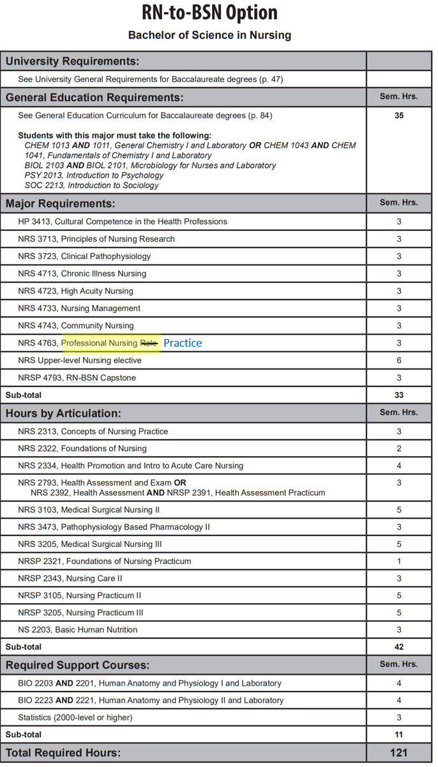

Course Descriptions Page 569
NRS 4763. Professional Nursing Role Practice Concepts of professional RN-BSN socialization, accountability, advocacy, issues and trends which affect the role of the nurse are analyzed and discussed. Prerequisite, Admission to the RN-BSN program. Fall, Spring, Summer.
NRSP 1222. Fundamentals of Nursing Practicum Practicum emphasizes the fundamental skills of nursing as utilized in maintaining activities of daily living. A clinical laboratory fee will be assessed. Prerequisites, “C” or better in MATH 1023, BIO 2203, BIO 2201, and ENG 1003. Corequisites, NRS 1214, NRS 2392, and NRSP 2391. Spring.
NRSP 1243. Clinical Practicum I Initial medical, surgical, maternal, and child health clinical experience for the student making the transition to the RN role. Nursing concepts from Nursing Agency I and Role Development I are applied to clinical practice. A clinical laboratory fee will be assessed. Corequisites, NRS 1235 and NRS 1252. Fall.
NRSP 1331. Clinical Practicum I Initial medical-surgical clinical experience for the student making the transition to the registered nurse role. Concepts from Nursing I and Role Development I are applied. Prerequisite, Admission to the Online LPN to AASN program. Fall.
NRSP 1341. Clinical Practicum II Medical-surgical clinical experience for the student making the transition to the registered nurse role. Concepts from Nursing II and Role Development II are applied. Corequisites, NRS 1321, and NRS 1323. Fall.
NRSP 1422. Foundations of Nursing Practice Practicum emphasizes the fundamental skills of nursing as utilized in maintaining activities of daily living. A clinical laboratory fee will be assessed. Prerequisite, Admission to the BSN Program. Summer.
NRSP 2003. Nursing Practicum I Practicum in which the clinical skills associated with medical surgical and perioperative nursing care are developed. A clinical laboratory fee will be assessed. Registration is restricted to the BSN program. Prerequisites, NRS 2313, NRS 2322, NRSP 2321, NRS 2393, and NRSP 2391.
NRSP 220V. Clinical Practicum Independent Study Practicum experience in specific clinical areas determined by student and instructor. Review of clinical nursing care with emphasis on the performance of specific nursing procedures. A clinical laboratory fee will be assessed. Irregular.
NRSP 2223. Clinical Practicum II Application of the nursing process in the care of individuals and families in all Stages of the life cycle. A clinical laboratory fee will be assessed. An additional fee is assessed for this course for the comprehensive assessment test. Corequsisites, NRS 2212, NRS 2213, and NRS 2251. Spring.
NRSP 2244. Clinical Practicum III Refinement of the nursing process in providing care for selected clients. A clinical laboratory fee will be assessed. An additional fee is assessed for this course for the comprehensive assessment examination given to all graduating nursing students. Corequisites, NRS 2232, NRS 2233, and NRSP 2272. Fall.
NRSP 2272. Role Development Practicum Course assists the graduating student to integrate the Associate Degree Nurse roles, including provider of care, manager of care and member of the profession. A clinical laboratory fee will be assessed. Fall.
NRSP 2321. Foundations of Nursing Practicum Application of nursing skills related to physiologic health processes, mobility, comfort, infection control, protection, oxygenation, medication administration, nutrition and elimination. Prerequisite, Admission to the BSN Program. Corequisites, NRS 2322, NRS 2423, and NRSP 2391 (Accelerated BSN); NRS 2313, NRS 2322, NRSP 2391, and NRS 2392 (Traditional BSN). Fall, Summer.
AFTER
Bulletin Table Page 390

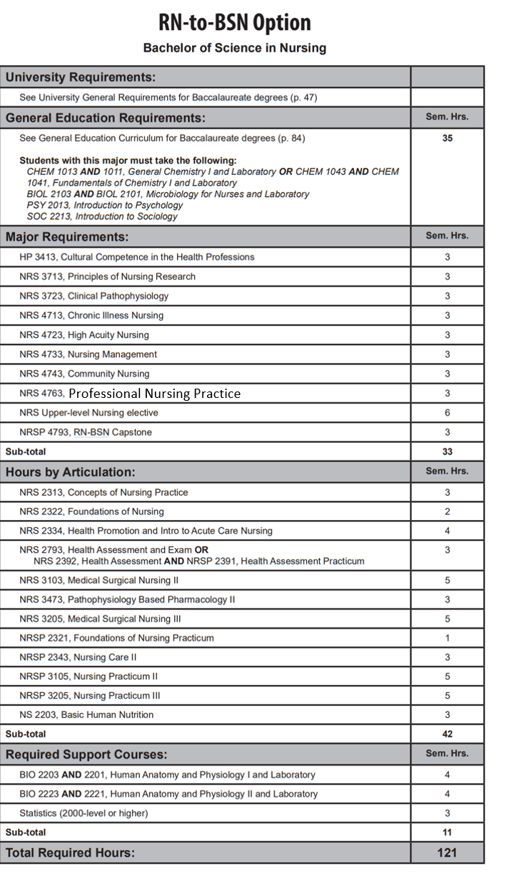

Course Descriptions Page 569

NRS 4763. Professional Nursing Practice Concepts of professional RN-BSN socialization, accountability, advocacy, issues and trends which affect the role of the nurse are analyzed and discussed. Prerequisite, Admission to the RN-BSN program. Fall, Spring, Summer. Nursing Practicum (NRSP) NRSP 1222. Fundamentals of Nursing Practicum
NRSP 1222. Fundamentals of Nursing Practicum Practicum emphasizes the fundamental skills of nursing as utilized in maintaining activities of daily living. A clinical laboratory fee will be assessed. Prerequisites, “C” or better in MATH 1023, BIO 2203, BIO 2201, and ENG 1003. Corequisites, NRS 1214, NRS 2392, and NRSP 2391. Spring.
NRSP 1243. Clinical Practicum I Initial medical, surgical, maternal, and child health clinical experience for the student making the transition to the RN role. Nursing concepts from Nursing Agency I and Role Development I are applied to clinical practice. A clinical laboratory fee will be assessed. Corequisites, NRS 1235 and NRS 1252. Fall.
NRSP 1331. Clinical Practicum I Initial medical-surgical clinical experience for the student making the transition to the registered nurse role. Concepts from Nursing I and Role Development I are applied. Prerequisite, Admission to the Online LPN to AASN program. Fall.
NRSP 1341. Clinical Practicum II Medical-surgical clinical experience for the student making the transition to the registered nurse role. Concepts from Nursing II and Role Development II are applied. Corequisites, NRS 1321, and NRS 1323. Fall.
NRSP 1422. Foundations of Nursing Practice Practicum emphasizes the fundamental skills of nursing as utilized in maintaining activities of daily living. A clinical laboratory fee will be assessed. Prerequisite, Admission to the BSN Program. Summer.
NRSP 2003. Nursing Practicum I Practicum in which the clinical skills associated with medical surgical and perioperative nursing care are developed. A clinical laboratory fee will be assessed. Registration is restricted to the BSN program. Prerequisites, NRS 2313, NRS 2322, NRSP 2321, NRS 2393, and NRSP 2391.
NRSP 220V. Clinical Practicum Independent Study Practicum experience in specific clinical areas determined by student and instructor. Review of clinical nursing care with emphasis on the performance of specific nursing procedures. A clinical laboratory fee will be assessed. Irregular.
NRSP 2223. Clinical Practicum II Application of the nursing process in the care of individuals and families in all Stages of the life cycle. A clinical laboratory fee will be assessed. An additional fee is assessed for this course for the comprehensive assessment test. Corequsisites, NRS 2212, NRS 2213, and NRS 2251. Spring.
NRSP 2244. Clinical Practicum III Refinement of the nursing process in providing care for selected clients. A clinical laboratory fee will be assessed. An additional fee is assessed for this course for the comprehensive assessment examination given to all graduating nursing students. Corequisites, NRS 2232, NRS 2233, and NRSP 2272. Fall.
NRSP 2272. Role Development Practicum Course assists the graduating student to integrate the Associate Degree Nurse roles, including provider of care, manager of care and member of the profession. A clinical laboratory fee will be assessed. Fall.
NRSP 2321. Foundations of Nursing Practicum Application of nursing skills related to physiologic health processes, mobility, comfort, infection control, protection, oxygenation, medication administration, nutrition and elimination. Prerequisite, Admission to the BSN Program. Corequisites, NRS 2322, NRS 2423, and NRSP 2391 (Accelerated BSN); NRS 2313, NRS 2322, NRSP 2391, and NRS 2392 (Traditional BSN). Fall, Summer.

