For Academic Affairs and Research Use Only
Proposal Number
CIP Code:
Degree Code:

NEW OR MODIFIED COURSE PROPOSAL FORM
[X] Undergraduate Curriculum Council
[ ] Graduate Council
[X]New Course, [ ]Experimental Course (1-time offering), or [ ]Modified Course (Check one box)
Signed paper copies of proposals submitted for consideration are no longer required. Please type approver name and enter date of approval.

Kacie Altom 10/18/2021  Department Curriculum Committee Chair | ___________________ Enter date…  COPE Chair (if applicable)
Sarah Davidson, Associate Dean 10/18/2021  Department Chair | Elizabeth Nix, BSN Chair 10/18/2021  Head of Unit (if applicable)
Shanon Brantley 10/28/2021  College Curriculum Committee Chair | ___________________ Enter date…  Undergraduate Curriculum Council Chair
Mary Elizabeth Spence 10/19/2021  Office of Assessment (new courses only) | ___________________ Enter date…  Graduate Curriculum Committee Chair
_____Scott E. Gordon___________ 11/2/2021  College Dean | ___ Alan Utter ___________ 11/16/21  Vice Chancellor for Academic Affairs
___________________ Enter date…
General Education Committee Chair (if applicable)

- Contact Person (Name, Email Address, Phone Number)
Sarah Davidson, DNP, RN, CNE
sarahdavidson@astate.edu
870-972-274

- Proposed starting term and Bulletin year for new course or modification to take effect
Spring 2022

Instructions:
Please complete all sections unless otherwise noted. For course modifications, sections with a “Modification requested?” prompt need not be completed if the answer is “No.”

 | Current (Course Modifications Only) | Proposed (New or Modified)  (Indicate “N/A” if no modification)
Prefix |  | NRS
Number* |  | 4003
Title |  | Issues in Healthcare Policy
Description** |  | Introduction to the importance of healthcare policy and its influence on nursing practice while examining the nurse’s role in developing, implementing and improving health policy at all levels.

* (Confirm with the Registrar’s Office that number chosen has not been used before and is available for use. For variable credit courses, indicate variable range. Proposed number for experimental course is 9.)
**Forty words or fewer as it should appear in the Bulletin.

- Proposed prerequisites and major restrictions [Modification requested? Yes/No]
(Indicate all prerequisites. If this course is restricted to a specific major, which major. If a student does not have the prerequisites or does not have the appropriate major, the student will not be allowed to register).
- Yes Are there any prerequisites?
  - If yes, which ones?
Prerequisites, Admission to the RN-BSN program, C or better in NRS 3713 and NRS 3723.

  - Why or why not?
Program plan of study sequence

- Yes Is this course restricted to a specific major?
  - If yes, which major? Nursing

- Proposed course frequency [Modification requested? Yes/No]
(e.g. Fall, Spring, Summer; if irregularly offered, please indicate, “irregular.”) Not applicable to Graduate courses.

Fall, Spring, Summer

- Proposed course type [Modification requested? Yes/No]
Will this course be lecture only, lab only, lecture and lab, activity (e.g., physical education), dissertation/thesis, capstone, independent study, internship/practicum, seminar, special topics, or studio? Please choose one.
Lecture

- Proposed grade type [Modification requested? Yes/No]
What is the grade type (i.e. standard letter, credit/no credit, pass/fail, no grade, developmental, or other [please elaborate])
Standard

- No Is this course dual-listed (undergraduate/graduate)?

- No Is this course cross-listed?
(If it is, all course entries must be identical including course descriptions. Submit appropriate documentation for requested changes. It is important to check the course description of an existing course when adding a new cross-listed course.)

- No Is this course in support of a new program?
a. If yes, what program?
Enter text...

- No Will this course be a one-to-one equivalent to a deleted course or previous version of this course (please check with the Registrar if unsure)?
a. If yes, which course?
Enter text...

Course Details

- Proposed outline [Modification requested? Yes/No]
(The course outline should be topical by weeks and should be sufficient in detail to allow for judgment of the content of the course.)

Date | Topics | Activities
Week 1 | Informing Public Policy: An Important Role for Registered Nurses | - PowerPoint Slides  - Readings, Chapter 1  - Introduction  - Discussion Board – Policy Process vs Nursing Process
Week 2 | Agenda Setting: What Rises to a Policymaker’s Attention? | - PowerPoint Slides  - Readings, Chapter 2  - Professional Nursing Organization Paper Due
Week 3 | Government Response: Legislation | - PowerPoint Slides  - Readings, Chapter 3  - Discussion Board – NCNR legislation  - Exam #1
Week 4 | Government Regulation: Parallel and Powerful | - PowerPoint Slides  - Chapter 4,  - Healthcare Issue Paper Due
Week 5 | Public Policy Design  Policy Implementation | - PowerPoint Slides  - Readings, Chapters 5 & 6  - Discussion Board – Proposed Health Policy  - Exam #2
Week 6 | Health Policy and Social Program Evaluation  Overview: The Economics and Finance of Healthcare | - PowerPoint Slides  - Readings, Chapters 7 & 10  - Policy Critique Paper Due
Week 7 | The Impact of Globalization & An Insider’s Guide to Engaging in Policy Activities | - Discussion Board – Global activism and Policy course value  - Exam #3 Due by noon Friday of Week 7  - The course closes at NOON

- Proposed special features [Modification requested? Yes/No]
(e.g. labs, exhibits, site visitations, etc.)
None

- Department staffing and classroom/lab resources
RN-BSN faculty will teach this course. No additional lab/classrooms are needed for this online course.
- Will this require additional faculty, supplies, etc.?
No

- No Does this course require course fees?
If yes: please attach the New Program Tuition and Fees form, which is available from the UCC website.

Justification

Modification Justification (Course Modifications Only)
- Justification for Modification(s)

New Course Justification (New Courses Only)
- Justification for course. Must include:
a. Academic rationale and goals for the course (skills or level of knowledge students can be expected to attain)
To meet changing needs for effective patient care and to prepare nurses for career growth and enhanced opportunities within the field of healthcare. “Preparing nursing students to engage in health policy is critical to ensuring the nursing workforce can influence the structure and financing of health care” (Thomas et al., 2020, p. 12). In NRSP 4793 RN to BSN Capstone, the only clinical course in this program, students complete a process improvement project. Instructors for this course must take time to explain that these are most often related to policy issues (creation, modification, education, management). The students in this program are all registered nurses but few are aware of how policies are managed in their facility, much less at the local, state, and national levels. With this course, we can better prepare our students to use life experience to be active participants in policy at these multiple levels. “Nurses who are knowledgeable in health policy at the local, state, and national level are capable of shaping the health policies of the United States (Thomas et al., 2020, p. 19). Thomas, T., Martsolf, G., $ Puskar, K. (2020). How to engage nursing students in health policy: Results of a survey assessing students’ competencies, experiences, interests, and values. Policy, Politics, & Nursing Practice, (21)1, 12-20.

b. How does the course fit with the mission of the department? If course is mandated by an accrediting or certifying agency, include the directive.
This course aligns with the School of Nursing mission to educate, enhance and enrich students for evolving nursing practice by expanding knowledge of current healthcare policy creation and implementation. This course will serve to educate students regarding the creation, modification, and management of health policy at the facility, local, state, and national level. Their current competencies, experiences, interests, and values will be enhanced by exposure to the new information presented in this course. Students will be enriched as they are challenged with new insights in this course to become more active participants in the healthcare policies that affect them as persons, citizens and professional nurses.

c. Student population served.
RN-BSN students

d. Rationale for the level of the course (lower, upper, or graduate).
This course replaces course NRS 4713 Chronic Illness Nursing in the degree plan. After a review of NRS 4713 Chronic Illness Nursing and a review of Associate Degree Nursing curriculum, the faculty in the RN to BSN Program found that much of the information was repetitive. It was felt that information regarding healthcare policy was lacking. Students need foundational knowledge of healthcare practice to understand the creation and management of healthcare policy. This new policy course will expose students to a higher level of nursing function inside and outside of the clinical arena and enhance patient student and patient outcomes through the knowledge they acquire in this course.

.

Assessment

Assessment Plan Modifications (Course Modifications Only)
- Yes / No Do the proposed modifications result in a change to the assessment plan?
If yes, please complete the Assessment section of the proposal

Relationship with Current Program-Level Assessment Process (Course modifications skip this section unless the answer to #18 is “Yes”)
- What is/are the intended program-level learning outcome/s for students enrolled in this course? Where will this course fit into an already existing program assessment process?
I. Create a culture of safety in all aspects of professional practice.
II. Integrate the nursing process and concepts from sciences, liberal arts, research, and evidence-based practice into patient-centered care.
III. Formulate verbal, nonverbal, and written communication with emerging technologies while teaching and collaborating with the patient, their support system, and the health care team.
IV. Integrate principles of leadership and management into professional nursing practice to deliver patient-centered healthcare.
V. Exemplify professional standards and ethics at all times.
This course will be assessed at the conclusion of each semester by the RN-BSN Faculty, RN-BSN Program Coordinator, BSN Chair, and the Associate Dean of the College of Nursing and Health Professions utilizing the standard process approved by the Accreditation Commission for Education in Nursing. Central record keeping is maintained within the School of Nursing repository accessible to all faculty and administrators.

- Considering the indicated program-level learning outcome/s (from question #19), please fill out the following table to show how and where this course fits into the program’s continuous improvement assessment process.

For further assistance, please see the ‘Expanded Instructions’ document available on the UCC - Forms website for guidance, or contact the Office of Assessment at 870-972-2989.

Program-Level Outcome 1 (from question #19) | Create a culture of safety in all aspects of professional practice.
Assessment Measure | End of Program Survey, Completion of NRSP 4793 RN - BSN Capstone
Assessment  Timetable | Fall, Spring, Summer at the end of each course  Each course is assessed at the end of each academic year by the BSN Faculty
Who is responsible for assessing and reporting on the results? | RN-BSN Faculty, RN-BSN Program Coordinator, BSN Chair, and the Associate Dean of the College of Nursing and Health Professions
(Repeat if this new course will support additional program-level outcomes)
Program-Level Outcome 2 (from question #19) | Integrate the nursing process and concepts from sciences, liberal arts, research, and evidence-based practice into patient-centered care.
Assessment Measure | End of Program Survey, Completion of NRSP 4793 RN - BSN Capstone
Assessment  Timetable | Fall, Spring, Summer at the end of each course  Each course is assessed at the end of each academic year by the BSN Faculty
Who is responsible for assessing and reporting on the results? | RN-BSN Faculty, RN-BSN Program Coordinator, BSN Chair, and the Associate Dean of the College of Nursing and Health Professions

Program-Level Outcome 3 (from question #19) | Formulate verbal, nonverbal, and written communication with emerging technologies while teaching and collaborating with the patient, their support system, and the health care team.
Assessment Measure | End of Program Survey, Completion of NRSP 4793 RN - BSN Capstone
Assessment  Timetable | Fall, Spring, Summer at the end of each course  Each course is assessed at the end of each academic year by the BSN Faculty
Who is responsible for assessing and reporting on the results? | RN-BSN Faculty, RN-BSN Program Coordinator, BSN Chair, and the Associate Dean of the College of Nursing and Health Professions

Program-Level Outcome 4 (from question #19) | Integrate principles of leadership and management into professional nursing practice to deliver patient-centered healthcare.
Assessment Measure | End of Program Survey, Completion of NRSP 4793 RN - BSN Capstone
Assessment  Timetable | Fall, Spring, Summer at the end of each course  Each course is assessed at the end of each academic year by the BSN Faculty
Who is responsible for assessing and reporting on the results? | RN-BSN Faculty, RN-BSN Program Coordinator, BSN Chair, and the Associate Dean of the College of Nursing and Health Professions

Program-Level Outcome 5 (from question #19) | Exemplify professional standards and ethics at all times.
Assessment Measure | End of Program Survey, Completion of NRSP 4793 RN - BSN Capstone
Assessment  Timetable | Fall, Spring, Summer at the end of each course  Each course is assessed at the end of each academic year by the BSN Faculty
Who is responsible for assessing and reporting on the results? | RN-BSN Faculty, RN-BSN Program Coordinator, BSN Chair, and the Associate Dean of the College of Nursing and Health Professions

Course-Level Outcomes
- What are the course-level outcomes for students enrolled in this course and the associated assessment measures?

Outcome 1 | Explore the principles of safety utilized in public policy formation and implementation.
Which learning activities are responsible for this outcome? | Policy Critique Paper
Assessment Measure | The average score for students will be 80% or higher.
(Repeat if needed for additional outcomes)
Outcome 2 | Discuss the policy development process and how it compares with the nursing process used for patient-centered care.
Which learning activities are responsible for this outcome? | Week 1 Discussion Board - Policy Process vs Nursing Process
Assessment Measure | The average student score for this Discussion Board will be 20/24 or higher

Outcome 3 | Analyze the impact of politics, culture, economics, technology, and social variables for the development of health policy.
Which learning activities are responsible for this outcome? | Healthcare Issue Paper
Assessment Measure | The average score for students will be 80% or higher.

Outcome 4 | Review the role of nurses in engaging in health policy at the local, state, and federal level.
Which learning activities are responsible for this outcome? | Professional Nursing Organization Paper
Assessment Measure | The average score for students will be 80% or higher.

Outcome 5 | Examine the impact of health policy ethics on the nursing profession and the health care delivery system.
Which learning activities are responsible for this outcome? | Discussion Board – NCNR Legislation (National Center for Nursing Research)
Assessment Measure | The average student score for this Discussion Board will be 20/24 or higher.

Bulletin Changes

Instructions
Please visit http://www.astate.edu/a/registrar/students/bulletins/index.dot and select the most recent version of the bulletin. Copy and paste all bulletin pages this proposal affects below. Please include a before (with changed areas highlighted) and after of all affected sections.

*Please note: Courses are often listed in multiple sections of the bulletin. To ensure that all affected sections have been located, please search the bulletin (ctrl+F) for the appropriate courses before submission of this form.

BEFORE - Page 390
Please see following page
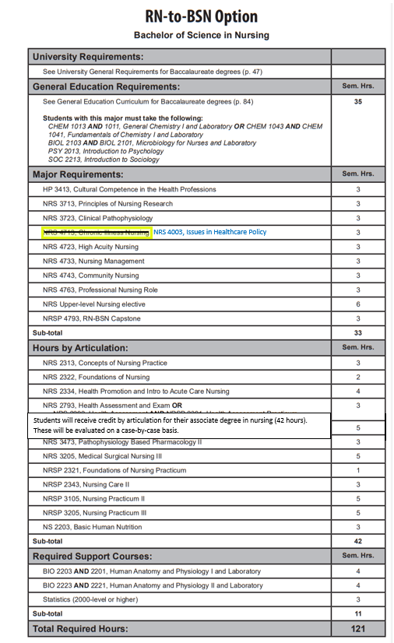

Course Descriptions Pg 568

NRS 4003. Issues in Healthcare Policy Introduction to the importance of healthcare policy and its influence on nursing practice while examining the nurse’s role in developing, implementing and improving health policy at all levels. Prerequisites, Admission to the RN-BSN program, C or better in NRS 3713 and NRS 3723. Fall, Spring, Summer.
NRS 4223. Forensic Nursing This course will introduce the beginning nurse to the field of forensic nursing. Content includes the recognition and management of forensic patients, both living and dead, and includes information on detection, collection, and preservation of evidence. Restricted to students who have completed 1 year of nursing coursework in either the AASN or BSN program, RN licensure, or instructor permission. Summer, odd.

NRS 4312. Chronic Illness and Rehabilitation Nursing Focus on clients with chronic illness throughout the lifespan. Concepts of gerontology and rehabilitation are integrated. Corequisites, NRS 4343, NRS 4362, and NRSP 4336. Fall, Spring.

NRS 4343. Professional Nursing Community Concepts of professional nursing practice expanded to the care of families and groups of clients in the community setting. Focuses also on change theory, group process strategies and professional and health care issues. Fall, Spring.
NRS 4393. Advanced Nutritional Concepts and Therapeutic Interventions Principles of nutritional support utilized in healthcare, including nutritional assessment, nutrient delivery and implications of disease. Prerequisites, completion of one year of nursing coursework, BSN junior level status, RN licensure, or instructor permission. Spring.

NRS 4424. Essentials of Medical Surgical Nursing III Continuation of concepts introduced in NRS 3345 Essentials of Medical Surgical Nursing II. Registration restricted to students who have been accepted to accelerated BSN option. Corequisites, NRS 3422, NRSP 3453. Spring.

NRS 4443. Essentials of High Acuity Nursing Focuses on patients with acute episodic health deviations which require ongoing diagnosis, immediate intervention or intensive nursing observation and care. Registration restricted to Students who are accepted to accelerated BSN option. Corequisites, NRS 4012, and NRSP 4433. Spring.

NRS 4481. Critical Decision Making and Testing Competencies in Nursing Further assists nursing students to identify areas for improving critical thinking skills and test taking skills. Will enhance the students ability to problem solve in providing complex care to individuals, groups, communities and populations. Prerequisites, senior nursing student status or instructor permission. Spring.

NRS 4542. Health Care Administration Introduction to the organization, operations and administration of a modern health care environment. Includes an introduction to health care delivery systems, decision making, and the management functions. Prerequisite, Admission to BSN program or graduate student enrolled in a CNHP program or any health related major. Fall, Spring.

NRS 4713. Chronic Illness Nursing Focus on clients with chronic illness throughout the lifespan. Concepts of gerontology, rehabilitation and spirituality are integrated. Prerequisites, Admission to the RN-BSN program, C or better in NRS 3723 and NRS 3713. Fall, Spring, Summer.

NRS 4723. High Acuity Nursing Focuses on patients with high acuity episodic or traumatic health deviations which require immediate intensive ongoing nursing diagnosis and interventions. Prerequisites, Admission to the RN-BSN program, C or better in NRS 3713 and NRS 3723. Fall, Spring, Summer.

NRS 4733. Nursing Leadership Managerial and leadership aspects of the nurse manager in various healthcare environments are discussed. Prerequisite, Admission to the RN-BSN Program, C or better in Statistics, NRS 3713. Fall, Spring, Summer.

NRS 4743. Public Health Nursing Concepts of professional nursing practice expanded to the care of families and groups of clients in the community setting. Focuses also on change theory, group process strategies and professional and health care issues. Prerequisites, Admission to the RN-BSN program, NRS 3723 and NRS 3713. Fall, Spring, Summer.

AFTER - Bulletin Table Page 390
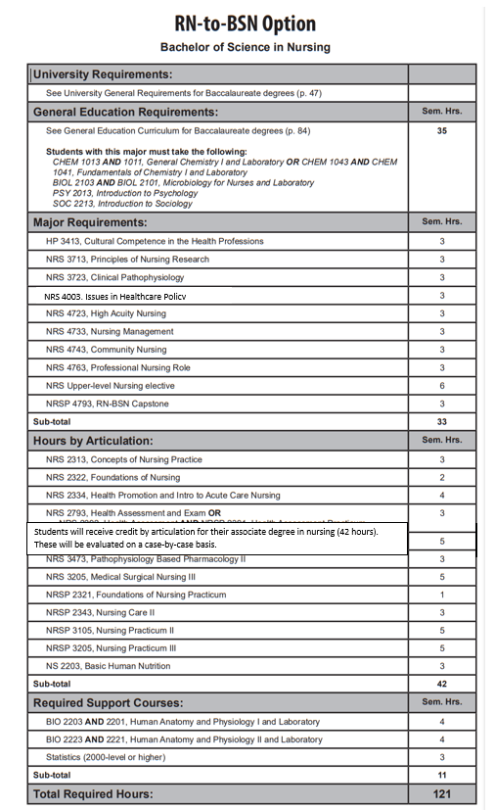

Course Descriptions Pg 568

NRS 4003. Issues in Healthcare Policy Introduction to the importance of healthcare policy and its influence on nursing practice while examining the nurse’s role in developing, implementing and improving health policy at all levels. Prerequisites, Admission to the RN-BSN program, C or better in NRS 3723 and NRS 3713. Fall, Spring, Summer.
NRS 4223. Forensic Nursing This course will introduce the beginning nurse to the field of forensic nursing. Content includes the recognition and management of forensic patients, both living and dead, and includes information on detection, collection, and preservation of evidence. Restricted to students who have completed 1 year of nursing coursework in either the AASN or BSN program, RN licensure, or instructor permission. Summer, odd.

NRS 4312. Chronic Illness and Rehabilitation Nursing Focus on clients with chronic illness throughout the lifespan. Concepts of gerontology and rehabilitation are integrated. Corequisites, NRS 4343, NRS 4362, and NRSP 4336. Fall, Spring.

NRS 4343. Professional Nursing Community Concepts of professional nursing practice expanded to the care of families and groups of clients in the community setting. Focuses also on change theory, group process strategies and professional and health care issues. Fall, Spring.
NRS 4393. Advanced Nutritional Concepts and Therapeutic Interventions Principles of nutritional support utilized in healthcare, including nutritional assessment, nutrient delivery and implications of disease. Prerequisites, completion of one year of nursing coursework, BSN junior level status, RN licensure, or instructor permission. Spring.

NRS 4424. Essentials of Medical Surgical Nursing III Continuation of concepts introduced in NRS 3345 Essentials of Medical Surgical Nursing II. Registration restricted to students who have been accepted to accelerated BSN option. Corequisites, NRS 3422, NRSP 3453. Spring.

NRS 4443. Essentials of High Acuity Nursing Focuses on patients with acute episodic health deviations which require ongoing diagnosis, immediate intervention or intensive nursing observation and care. Registration restricted to Students who are accepted to accelerated BSN option. Corequisites, NRS 4012, and NRSP 4433. Spring.

NRS 4481. Critical Decision Making and Testing Competencies in Nursing Further assists nursing students to identify areas for improving critical thinking skills and test taking skills. Will enhance the students ability to problem solve in providing complex care to individuals, groups, communities and populations. Prerequisites, senior nursing student status or instructor permission. Spring.

NRS 4542. Health Care Administration Introduction to the organization, operations and administration of a modern health care environment. Includes an introduction to health care delivery systems, decision making, and the management functions. Prerequisite, Admission to BSN program or graduate student enrolled in a CNHP program or any health related major. Fall, Spring.

NRS 4723. High Acuity Nursing Focuses on patients with high acuity episodic or traumatic health deviations which require immediate intensive ongoing nursing diagnosis and interventions. Prerequisites, Admission to the RN-BSN program, C or better in NRS 3713 and NRS 3723. Fall, Spring, Summer.

NRS 4733. Nursing Leadership Managerial and leadership aspects of the nurse manager in various healthcare environments are discussed. Prerequisite, Admission to the RN-BSN Program, C or better in Statistics, NRS 3713. Fall, Spring, Summer.

NRS 4743. Public Health Nursing Concepts of professional nursing practice expanded to the care of families and groups of clients in the community setting. Focuses also on change theory, group process strategies and professional and health care issues. Prerequisites, Admission to the RN-BSN program, NRS 3723 and NRS 3713. Fall, Spring, Summer.

