For Academic Affairs and Research Use Only
Proposal Number
CIP Code:
Degree Code:

New or Modified Course Proposal Form
[X ] Undergraduate Curriculum Council
[ ] Graduate Council
[ ]New Course, [ ]Experimental Course (1-time offering), or [X ]Modified Course (Check one box)
Signed paper copies of proposals submitted for consideration are no longer required. Please type approver name and enter date of approval.
Kelly Fish 9/17/2020  Department Curriculum Committee Chair | ___________________ Enter date…  COPE Chair (if applicable)
James Doering 9/17/2020  Department Chair | ___________________ Enter date…  Head of Unit (if applicable)
Melodie Philhours 9/24/2020  College Curriculum Committee Chair | ___________________ Enter date…  Undergraduate Curriculum Council Chair
___________________ Enter date…  Director of Assessment (new courses only) | ___________________ Enter date…  Graduate Curriculum Committee Chair
Melody Lo 9/24/2020  College Dean | ___________________ Enter date…  Vice Chancellor for Academic Affairs
___________________ Enter date…
General Education Committee Chair (if applicable)

- Contact Person (Name, Email Address, Phone Number)
Farhad Moeeni; moeeni@astate.edu; 870-680-8442
Arkansas State University
Neil Griffin College of Business
Department of Computer & Information Technology
State University, AR 72467-0130

- Proposed starting term and Bulletin year for new course or modification to take effect
Fall 2021.

Instructions:
Please complete all sections unless otherwise noted. For course modifications, sections with a “Modification requested?” prompt need not be completed if the answer is “No.”

 | Current (Course Modifications Only) | Proposed (New or Modified)  (Indicate “N/A” if no modification)
Prefix | CIT | N/A
Number* | 4653 | N/A
Title | Automatic Data Capture | IoT and Blockchain Business Strategies
Description** | Methods, technologies, systems, and standards used in supply chain information systems and e-business for automatically identifying objects, and collecting and transferring data. Technologies such as bar coding, RFID, smart cards, magnetic striping, biometrics, GPS, real time locating, and voice data entry, as well as their business applications are addressed. | Empirical study of the Internet of Things (IoT) for automated, secure data sharing through Blockchain among smart connected assets equipped with RFID, sensors for integration with organizational and supply chain information systems for analysis to create enhanced, real-time business intelligence.

* (Confirm with the Registrar’s Office that number chosen has not been used before and is available for use. For variable credit courses, indicate variable range. Proposed number for experimental course is 9. )
**Forty words or fewer as it should appear in the Bulletin.

- Proposed prerequisites and major restrictions [Modification requested? yes]
(Indicate all prerequisites. If this course is restricted to a specific major, which major. If a student does not have the prerequisites or does not have the appropriate major, the student will not be allowed to register).
- Yes Are there any prerequisites?
  - If yes, which ones?
CIT 2033, CIT 2523, co-requisite CIT 3013
  - Why or why not?
Basic Python programming and knowledge of network/Internet required

- No Is this course restricted to a specific major?
  - If yes, which major? Enter text...

- Proposed course frequency [Modification requested? No]
(e.g. Fall, Spring, Summer; if irregularly offered, please indicate, “irregular.”) Not applicable to Graduate courses.

Fall

- Proposed course type [Modification requested? No]
Will this course be lecture only, lab only, lecture and lab, activity (e.g., physical education), dissertation/thesis, capstone, independent study, internship/practicum, seminar, special topics, or studio? Please choose one.
Enter text...

- Proposed grade type [Modification requested? No]
What is the grade type (i.e. standard letter, credit/no credit, pass/fail, no grade, developmental, or other [please elaborate])
Enter text...

- NO Is this course dual-listed (undergraduate/graduate)?

- NO Is this course cross-listed?
(If it is, all course entries must be identical including course descriptions. Submit appropriate documentation for requested changes. It is important to check the course description of an existing course when adding a new cross-listed course.)

a. – If yes, please list the prefix and course number of the cross-listed course.
Enter text...
b. – Yes / No Can the cross-listed course be used to satisfy the prerequisite or degree requirements this course satisfies?
Enter text...

- NO Is this course in support of a new program?
a. If yes, what program?
Enter text...

- YES Will this course be a one-to-one equivalent to a deleted course or previous version of this course (please check with the Registrar if unsure)?
a. If yes, which course?
CIT 4653

Course Details

- Proposed outline [Modification requested? No]
(The course outline should be topical by weeks and should be sufficient in detail to allow for judgment of the content of the course.)
Enter text...

- Proposed special features [Modification requested? No]
(e.g. labs, exhibits, site visitations, etc.)
Enter text...

- Department staffing and classroom/lab resources
Current facilities suffices
- Will this require additional faculty, supplies, etc.?
NO

- NO Does this course require course fees?
[The course already has a fee -- No change]

If yes: please attach the New Program Tuition and Fees form, which is available from the UCC website.

Justification

Modification Justification (Course Modifications Only)
- Justification for Modification(s)
Rapid innovation and development of information technologies create a dynamic and challenging environment for subjects that should be covered in information systems (IS) curriculum. To maintain the currency of IS courses, the instructor must include new subjects in the course gradually every year. For this course, the modification of the course description is justified now because several technologies, which have been in the transient states, have converged and became essential including IoT and Blockchain and their applications in business.

New Course Justification (New Courses Only)
- Justification for course. Must include:
a. Academic rationale and goals for the course (skills or level of knowledge students can be expected to attain)
Enter text...

b. How does the course fit with the mission of the department? If course is mandated by an accrediting or certifying agency, include the directive.
Enter text...

c. Student population served.
Enter text...

d. Rationale for the level of the course (lower, upper, or graduate).
Enter text...

Assessment

Assessment Plan Modifications (Course Modifications Only)
- NO Do the proposed modifications result in a change to the assessment plan?
If yes, please complete the Assessment section of the proposal

Relationship with Current Program-Level Assessment Process (Course modifications skip this section unless the answer to #18 is “Yes”)
- What is/are the intended program-level learning outcome/s for students enrolled in this course? Where will this course fit into an already existing program assessment process?
Enter text...

- Considering the indicated program-level learning outcome/s (from question #19), please fill out the following table to show how and where this course fits into the program’s continuous improvement assessment process.

For further assistance, please see the ‘Expanded Instructions’ document available on the UCC - Forms website for guidance, or contact the Office of Assessment at 870-972-2989.

Program-Level Outcome 1 (from question #19) | Type outcome here. What do you want students to think, know, or do when they have completed the course?
Assessment Measure | Please include direct and indirect assessment measure for outcome.
Assessment  Timetable | What semesters, and how often, is the outcome assessed?
Who is responsible for assessing and reporting on the results? | Who (person, position title, or internal committee) is responsible for assessing, evaluating, and analyzing results, and developing action plans?
(Repeat if this new course will support additional program-level outcomes)

Course-Level Outcomes
- What are the course-level outcomes for students enrolled in this course and the associated assessment measures?

Outcome 1 | Explain IT problems and solutions, and give clear instructions -- Reinforce
Which learning activities are responsible for this outcome? | Lectures, homework assignments and programming projects that includes controlling physical devices and producing data and information. Reinforce
Assessment Measure | Quizzes, midterm exam, and grading of assignments.

(Repeat if needed for additional outcomes)
Outcome 2 | Oversee the connections of different components of information systems to ensure they work together properly -- Reinforce
Which learning activities are responsible for this outcome? | Lecture and lab experiments that provides an environment that students perform hands-on experiments with various information technologies that requires experimenting with hardware and software that work together and with external sources such as cloud services. Reinforce
Assessment Measure | Grading laboratory activities and reports
(Repeat if needed for additional outcomes)
Outcome 3 | Make decisions about how to allocate resources in order to reach organizational goals. Reinforce
Which learning activities are responsible for this outcome? | The final team project require each team to identify an informational problem requiring solution through selection of resources such as hardware and software as well as the necessary knowledge of prior courses. The project applies the concept of Internet of Things, data automation technologies such as RFID and sensors, as well as secure sharing of data through Blockchain.
Assessment Measure | The project grade considers the relevance of the resources used to address the objectives of the project.
(Repeat if needed for additional outcomes)
Outcome 4 | Motivate others so that groups are effective and efficient -- Reinforce
Which learning activities are responsible for this outcome? | A comprehensive group final project on IoT and Blockchain application, a written detailed proposal with a Gantt chart that lays down all activities, start-finish times and the responsibility of each member, two intermediate progress reports and a final presentation.
Assessment Measure | The Proposal, progress reports and final presentation are graded separately
(Repeat if needed for additional outcomes)

Bulletin Changes

Instructions
Please visit http://www.astate.edu/a/registrar/students/bulletins/index.dot and select the most recent version of the bulletin. Copy and paste all bulletin pages this proposal affects below. Please include a before (with changed areas highlighted) and after of all affected sections.

*Please note: Courses are often listed in multiple sections of the bulletin. To ensure that all affected sections have been located, please search the bulletin (ctrl+F) for the appropriate courses before submission of this form.

Page 124 IoT and Blockchain Business Strategies
Paste bulletin pages here...
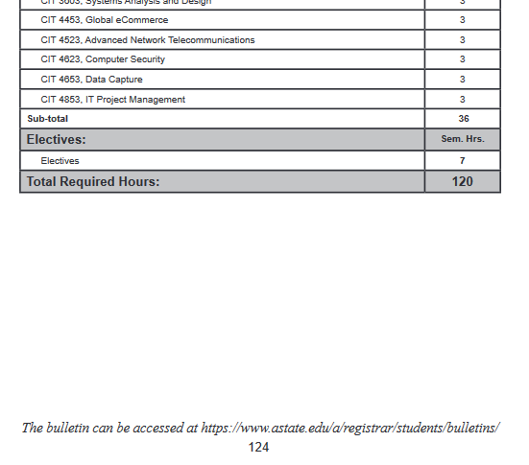

PAGE 127
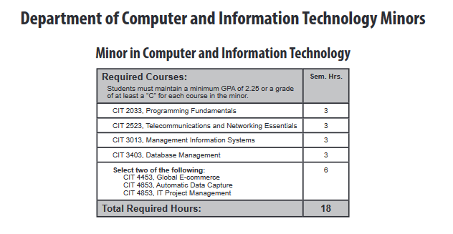

CIT 4653. IoT and Blockchain Business Strategies

Page 455
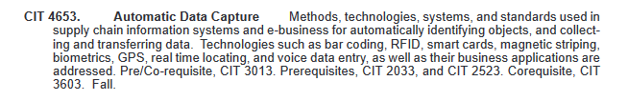
CIT 4653. IoT and Blockchain Business Strategies Empirical study of the Internet of Things (IoT) for automated, secure data sharing through Blockchain among smart connected assets equipped with RFID, sensors for integration with organizational and supply chain information systems for analysis to create enhanced, real-time business intelligence. Prerequisites, CIT 2033 and CIT 2523. Co-requisite CIT 3013 Fall.

