For Academic Affairs and Research Use Only
Proposal Number
CIP Code:
Degree Code:

Program Modification Form
[X] Undergraduate Curriculum Council
[ ] Graduate Council
Modification Type: [ ]Admissions, [ ]Curricular Sequence, or [ ]Other

Signed paper copies of proposals submitted for consideration are no longer required. Please type approver name and enter date of approval.

Melodie Philhours 9/25/2020  Department Curriculum Committee Chair | __________________ Enter date  COPE Chair (if applicable)
Sharon D. James 9/25/2020  Department Chair | __________________ Enter date  Head of Unit (if applicable)
Melodie Philhours 9/25/2020  College Curriculum Committee Chair | __________________ Enter date  Undergraduate Curriculum Council Chair
__________________ Enter date  Director of Assessment (only for changes impacting assessment) | __________________ Enter date  Graduate Curriculum Committee Chair
Melody Lo 9/25/2020  College Dean | __________________ Enter date  Vice Chancellor for Academic Affairs
__________________ | Enter date
General Education Committee Chair (if applicable)

- Contact Person (Name, Email Address, Phone Number)
Dr. Melodie Philhours, mphil@astate.edu, 870-680-8148

- Proposed Change (for undergraduate curricular changes please provide an 8-semester plan (appendix A), if applicable)
Replace MKTG 4253 Data Analytics and Visualization with CIT 3423 Data Visualization in the BS Marketing, Emphasis in Marketing Analytics, and the Marketing Analytics Certificate.

- Effective Date
Fall 2021

- Justification – Please provide details as to why this change is necessary.
Use of the same course in the marketing analytics program as in the data analytics program maximizes efficiencies within the college.

Bulletin Changes

Instructions
Please visit http://www.astate.edu/a/registrar/students/bulletins/index.dot and select the most recent version of the bulletin. Copy and paste all bulletin pages this proposal affects below. Please include a before (with changed areas highlighted) and after of all affected sections.

*Please note: Courses are often listed in multiple sections of the bulletin. To ensure that all affected sections have been located, please search the bulletin (ctrl+F) for the appropriate courses before submission of this form.

p. 148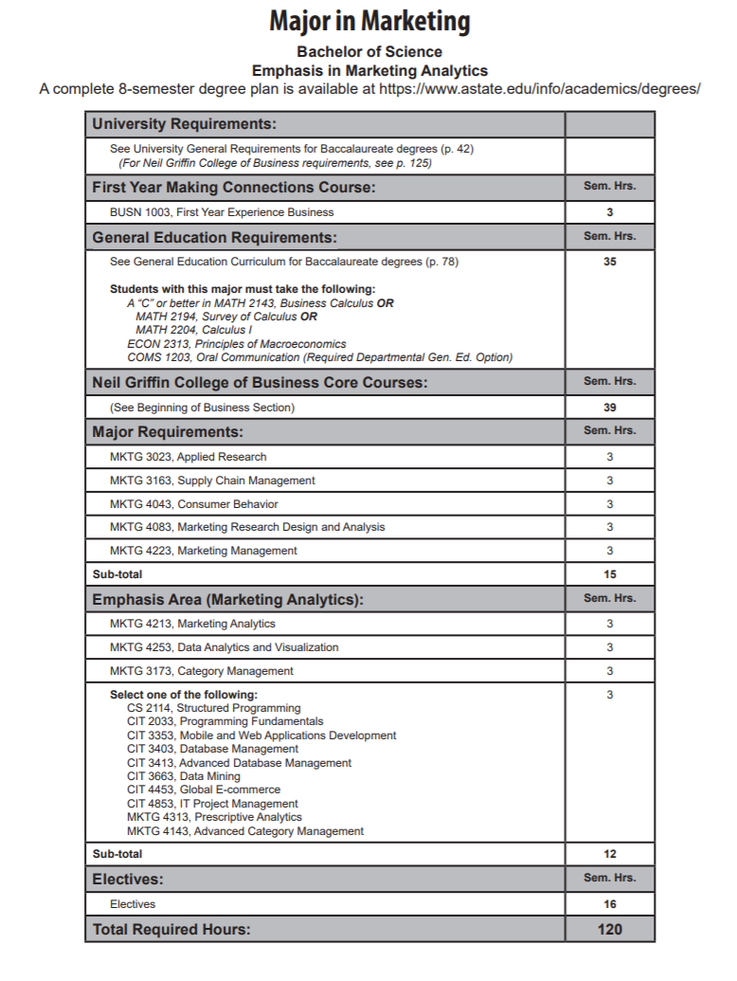
CIT 3423 Data Visualization

p. 153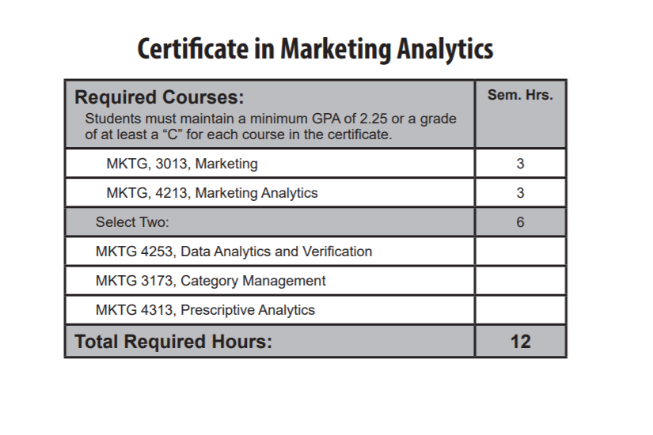
CIT 3423 Data Visualization

p. 146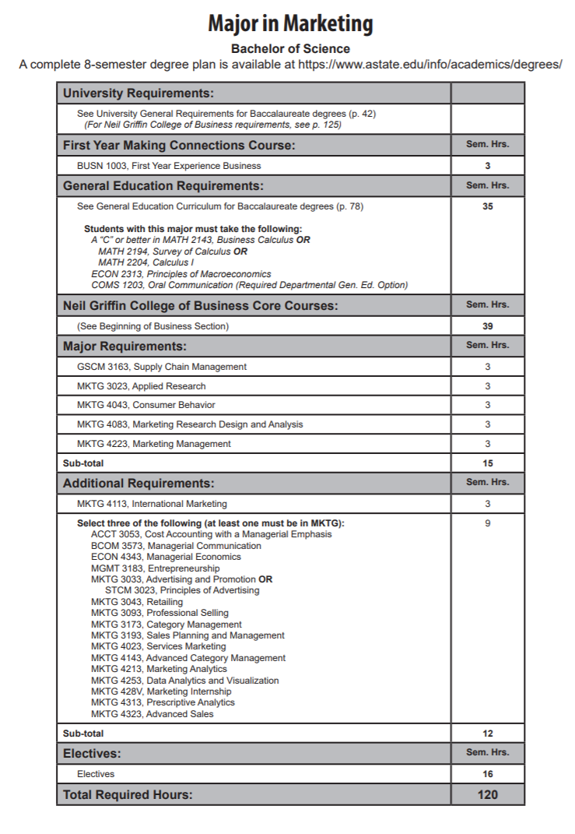
CIT 3423 Data Visualization
p. 150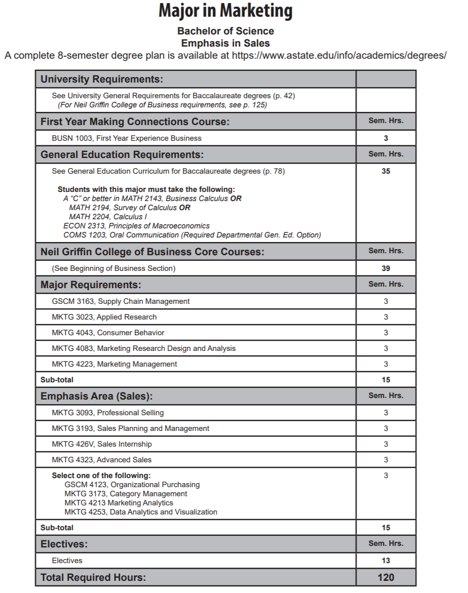
CIT 3423 Data Visualization
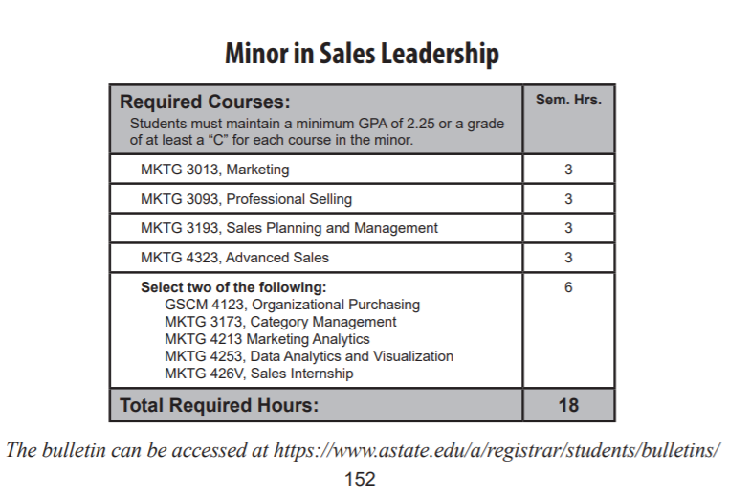
CIT 3423 Data Visualization

Appendix A, 8-Semester Plan
(Referenced in #2 - Undergraduate Proposals Only)
Instructions: Please identify new courses in italics.
Arkansas State University-Jonesboro
Degree:
Major:
Year:

Students requiring developmental course work based on low entrance exam scores (ACT, SAT, ASSET, COMPASS) may not be able to complete this program of study in eight (8) semesters. Developmental courses do not count toward total degree hours. Students having completed college level courses prior to enrollment will be assisted by their advisor in making appropriate substitutions. In most cases, general education courses may be interchanged between semesters. A minimum of 45 hours of upper division credit (3000-4000 level) is required for this degree.
Year 1 |  |  |  |  | Year 1
Fall Semester |  |  |  |  | Spring Semester
Course No. | Course Name | Hrs | Gen Ed |  | Course No. | Course Name | Hrs | Gen Ed
Total Hours |  |  |  |  | Total Hours
Year 2 |  |  |  |  | Year 2
Fall Semester |  |  |  |  | Spring Semester
Course No. | Course Name | Hrs | Gen Ed |  | Course No. | Course Name | Hrs | Gen Ed
Total Hours |  |  |  |  | Total Hours
Year 3 |  |  |  |  | Year 3
Fall Semester |  |  |  |  | Spring Semester
Course No. | Course Name | Hrs | Gen Ed |  | Course No. | Course Name | Hrs | Gen Ed
Total Hours |  |  |  |  | Total Hours
Year 4 |  |  |  |  | Year 4
Fall Semester |  |  |  |  | Spring Semester
Course No. | Course Name | Hrs | Gen Ed |  | Course No. | Course Name | Hrs | Gen Ed
Total Hours |  |  |  |  | Total Hours
Total Jr/Sr Hours ___ Total Degree Hours ___
Graduation Requirements:
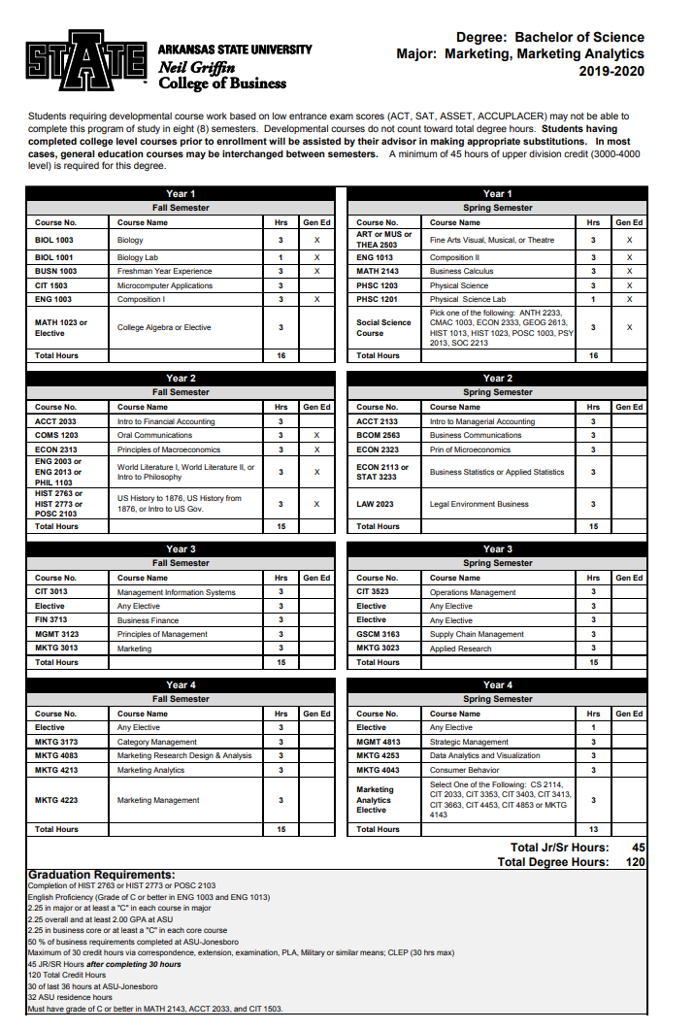
CIT 3423 Data Visualization
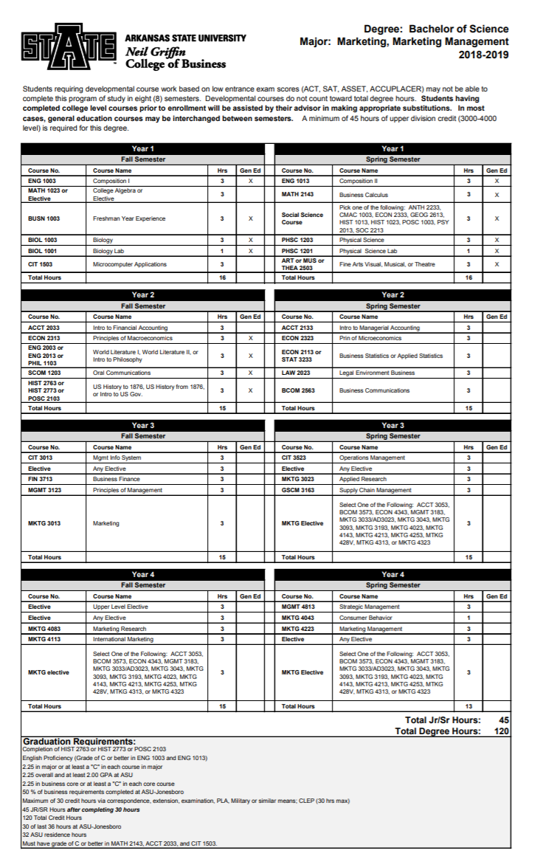
CIT 3423
CIT 3423
CIT 3423
BS Marketing, Sales Emphasis 8-Semester Plan:
MKTG 4253 Data Analytics and Visualization is listed as “Select One - See Degree Plan” so no modification needed for this change in this 8-semester plan.

