For Academic Affairs and Research Use Only
CIP Code:
Degree Code:

Course Revision Proposal Form
[x] Undergraduate Curriculum Council
[ ] Graduate Council
Signed paper copies of proposals submitted for consideration are no longer required. Please type approver name and enter date of approval.
Email completed proposals to curriculum@astate.edu for inclusion in curriculum committee agenda.
Sharon D. James 3/20/2018  Department Curriculum Committee Chair | ___________________ Enter date…  COPE Chair (if applicable)
Melodie Philhours 3/21/2018  Department Chair: | ___________________ Enter date…  Head of Unit (If applicable)
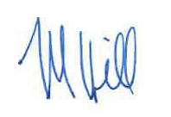 3/26/2018  College Curriculum Committee Chair (M. Hill) | ___________________ Enter date…  Undergraduate Curriculum Council Chair
Jim Washam 3/27/2018  College Dean | ___________________ Enter date…  Graduate Curriculum Committee Chair
__________________ Enter date  General Education Committee Chair (If applicable) | ___________________ Enter date…  Vice Chancellor for Academic Affairs

1. Contact Person (Name, Email Address, Phone Number)
Dr. Melodie Philhours, mphil@astate.edu, 870-680-8148

2. Proposed Starting Term and Bulletin Year for Change to Take Effect
Fall 2018

3. Current Course Prefix and Number
IB 3013
3.1 – [Yes / No] NO Request for Course Prefix and Number change
If yes, include new course Prefix and Number below. (Confirm that number chosen has not been used before. For variable credit courses, indicate variable range. Proposed number for experimental course is 9. )
Enter text...
3.2 – Yes / No If yes, has it been confirmed that this course number is available for use?
If no: Contact Registrar’s Office for assistance.

4. Current Course Title
Global Leadership Experience
4.1 – [Yes / No] YES Request for Course Title Change
If yes, include new Course Title Below.
Global Experience
- If title is more than 30 characters (including spaces), provide short title to be used on transcripts. Title cannot have any symbols (e.g. slash, colon, semi-colon, apostrophe, dash, and parenthesis).
Enter text...
- Please indicate if this course will have variable titles (e.g. independent study, thesis, special topics).
Enter text...

5. – [Yes / No ] YES Request for Course Description Change.
If yes, please include brief course description (40 words or fewer) as it should appear in the bulletin.
On-site examination of organizations, agencies, or locales in a region of the world involving the application of methods and techniques of investigation in International Business.

6. – [Yes / No ] NO Request for prerequisites and major restrictions change.
(If yes, indicate all prerequisites. If this course is restricted to a specific major, which major. If a student does not have the prerequisites or does not have the appropriate major, the student will not be allowed to register).
- Yes / No NO Are there any prerequisites?
  - If yes, which ones?
Enter text...
  - Why or why not?
Enter text...

- Yes / No NO Is this course restricted to a specific major?
  - If yes, which major? Enter text...

7. – [Yes / No ] NO Request for Course Frequency Change (e.g. Fall, Spring, Summer). Not applicable to Graduate courses.
a. If yes, please indicate current and new frequency:
Enter text...

8. – [Yes / No ] Request for Class Mode Change
If yes, indicate if this course will be lecture only, lab only, lecture and lab, activity, dissertation, experiential learning, independent study, internship, performance, practicum, recitation, seminar, special problems, special topics, studio, student exchange, occupational learning credit, or course for fee purpose only (e.g. an exam)? Please indicate the current and choose one.
NO

9. – [Yes / No ] Request for grade type change
If yes, what is the current and the new grade type (i.e. standard letter, credit/no credit, pass/fail, no grade, developmental, or other [please elaborate])
NO

10. Yes / No Is this course dual listed (undergraduate/graduate)?
a. If yes, indicate course prefix, number and title of dual listed course.
NO

11. Yes / No Is this course cross listed?
(If it is, all course entries must be identical including course descriptions. Submit appropriate documentation for requested changes. It is important to check the course description of an existing course when adding a new cross listed course.)

11.1 – If yes, please list the prefix and course number of cross listed course.
NO
11.2 – Yes / No Are these courses offered for equivalent credit?
Please explain. Enter text...

12. Yes / No Is this course change in support of a new program?
a. If yes, what program?
NO

13. Yes / No Does this course replace a course being deleted?
a. If yes, what course?
NO

14. Yes / No Will this course be equivalent to a deleted course or the previous version of the course?
a. If yes, which course?
NO

15. Yes / No Does this course affect another program?
If yes, provide confirmation of acceptance/approval of changes from the Dean, Department Head, and/or Program Director whose area this affects.
NO

16. Does this course require course fees? NO
If yes: Please attach the New Program Tuition and Fees form, which is available from the UCC website.

Revision Details

17. Please outline the proposed revisions to the course.
Include information as to any changes to course outline, special features, required resources, or in academic rationale and goals for the course.

No changes will be made to the structure of the course. This changes makes the course more inclusive and not restricted to the 10-day project as originally designed.

18. Please provide justification to the proposed changes to the course.

This course was specifically designed to accommodate a “trip-based” project that is no longer viable. The change allows the course to be more flexible and accommodate a number of travel opportunities offered by the College of Business, other Colleges, and the University Study Abroad program.

19. Yes / No Do these revisions result in a change to the assessment plan? NO

*If yes: Please complete the Assessment section of the proposal on the next page.
*If no: Skip to Bulletin Changes section of the proposal.
*See question 19 before completing the Assessment portion of this proposal.
Assessment

Relationship with Current Program-Level Assessment Process
20. What is/are the intended program-level learning outcome/s for students enrolled in this course? Where will this course fit into an already existing program assessment process?
Enter text...

21. Considering the indicated program-level learning outcome/s (from question #23), please fill out the following table to show how and where this course fits into the program’s continuous improvement assessment process.

For further assistance, please see the ‘Expanded Instructions’ document available on the UCC - Forms website for guidance, or contact the Office of Assessment at 870-972-2989.

Program-Level Outcome 1 (from question #23) | Type outcome here. What do you want students to think, know, or do when they have completed the course?
Assessment Measure | Please include direct and indirect assessment measure for outcome.
Assessment  Timetable | What semesters, and how often, is the outcome assessed?
Who is responsible for assessing and reporting on the results? | Who (person, position title, or internal committee) is responsible for assessing, evaluating, and analyzing results, and developing action plans?
(Repeat if this new course will support additional program-level outcomes)

Course-Level Outcomes
22. What are the course-level outcomes for students enrolled in this course and the associated assessment measures?

Outcome 1 | Type outcome here. What do you want students to think, know, or do when they have completed the course?
Which learning activities are responsible for this outcome? | List learning activities.
Assessment Measure | What will be your assessment measure for this outcome?
(Repeat if needed for additional outcomes)

Bulletin Changes

Instructions
Please visit http://www.astate.edu/a/registrar/students/bulletins/index.dot and select the most recent version of the bulletin. Copy and paste all bulletin pages this proposal affects below. Follow the following guidelines for indicating necessary changes.

*Please note: Courses are often listed in multiple sections of the bulletin. To ensure that all affected sections have been located, please search the bulletin (ctrl+F) for the appropriate courses before submission of this form.

- Deleted courses/credit hours should be marked with a red strike-through (red strikethrough)
- New credit hours and text changes should be listed in blue using enlarged font (blue using enlarged font).
- Any new courses should be listed in blue bold italics using enlarged font (blue bold italics using enlarged font)

You can easily apply any of these changes by selecting the example text in the instructions above, double-clicking the ‘format painter’ icon , and selecting the text you would like to apply the change to.
Please visit https://youtu.be/yjdL2n4lZm4 for more detailed instructions.

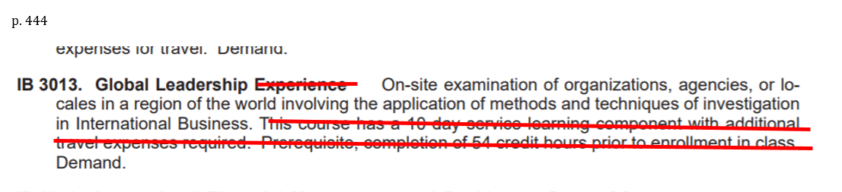

Paste bulletin pages here...

