Release to the News Media:
November 11, 2008

ASU - Jonesboro:

Beck PRIDE Center Receives Grant From Wal-Mart Foundation

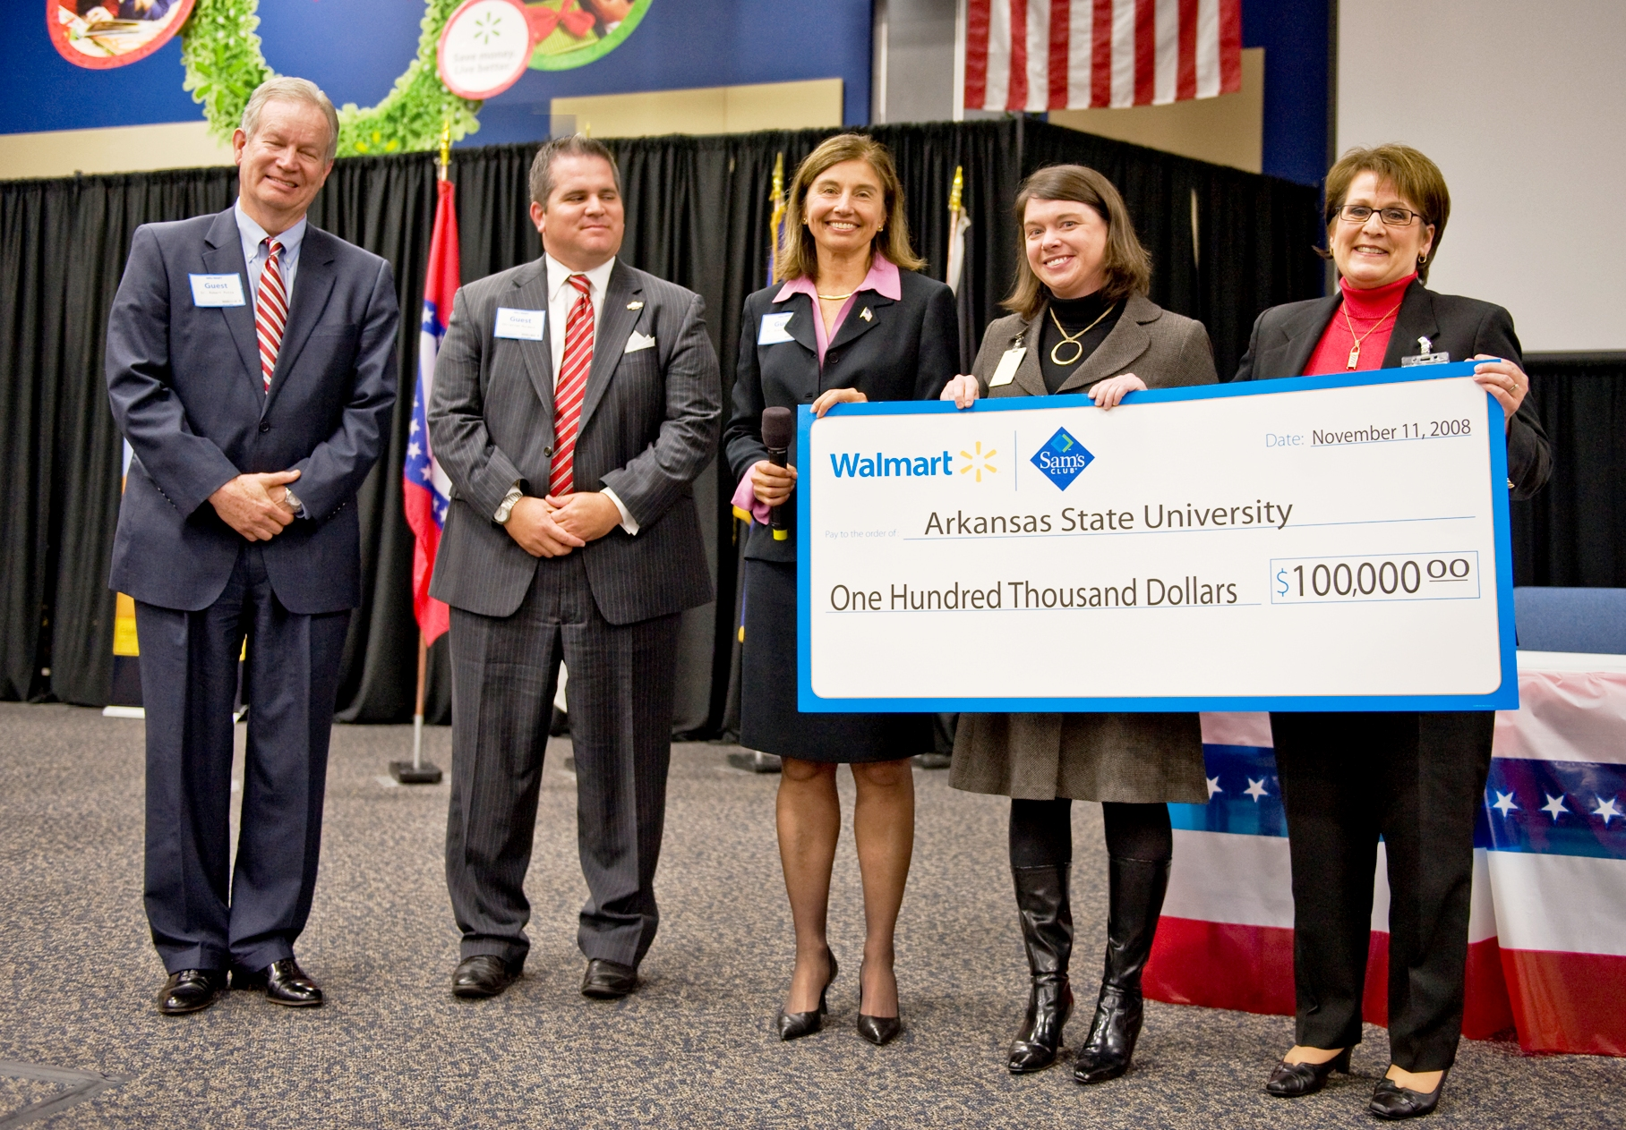
Arkansas State University’s Beck PRIDE Center for America’s wounded veterans received a $100,000 grant from the Wal-Mart Foundation Tuesday morning to aid in building programs and developing resources to support veterans with access to higher education and help in completing their degrees. The grant was presented to ASU officials in Bentonville.
The grant is part of a total $3.6 million package awarded by the Wal-Mart Foundation to 10 colleges and universities with $100,000 grants to each. The American Council on Education (ACE) also received a $2.5 million grant to support successful veteran educational assistance programs in 16 institutions of higher education.
“Arkansas State University-Jonesboro is thrilled to have been awarded a $100,000 grant for its Beck PRIDE Center for injured veterans as one of 10 grants to higher education institutions in the United States that currently have successful veteran educational assistance programs,” said Dr. Robert Potts, chancellor at Arkansas State.
“We are deeply grateful to the Wal-Mart Foundation for choosing Arkansas State for one of these grants and to the American Council on Education for its part in the awarding of the grant. The more than 50 veterans and their families currently being assisted in their rehabilitation and educational endeavors by the Beck PRIDE Center who will benefit from this generosity will be deeply grateful for this support for a wonderful program.”
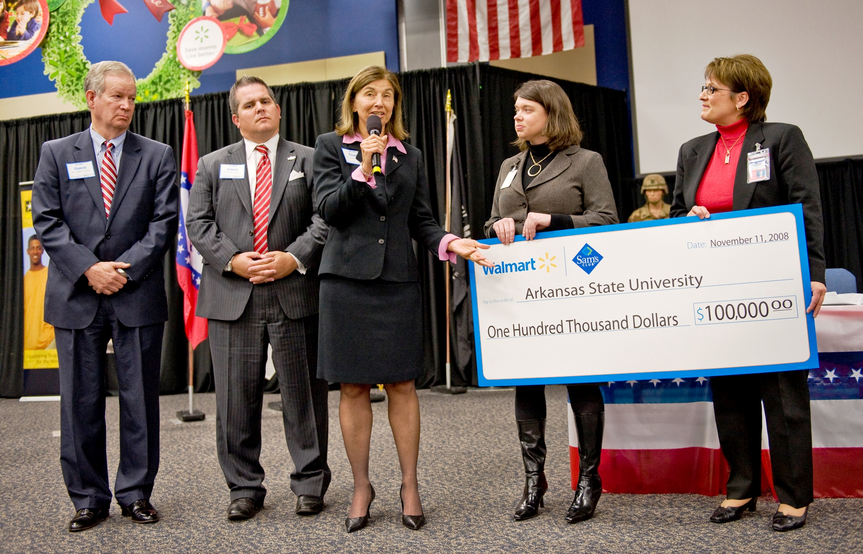
ASU is one of 10 higher education institutions that currently have successful veteran educational assistance programs. The grants will support the development of new and existing programs and provide resources to assist veterans with access to education, adjustment to civilian life and success in completing their degrees. Following are the institutions that received a grant: Arkansas State University, Cleveland State University, San Diego State University, University of Minnesota, Mississippi State, University of Incarnate Word (Texas), Montgomery College (Md.), Citrus College (Calif.), Florida Community College, and San Diego Community College.
"The generosity of the Wal-Mart Foundation to enable and enhance veterans support programs nationwide comes at an opportune time in the lives of our soldiers,” said Dr. Susan Hanrahan, dean of the ASU College of Nursing and Health Professions. “We are extremely pleased the Beck PRIDE Center was selected for this gift and are grateful to the Foundation for this investment. What a tribute to our soldiers on this Veterans Day!"
It is estimated that the number of veterans in the United States will rise to more than 375,000 in 2009.
"At the Beck PRIDE Center for America's Wounded Veterans, we have the privilege of seeing how the kind deeds of organizations like the Wal-Mart Foundation can change lives for military service members with combat injuries. We pledge to do our best to use these resources towards our mission,” said Susan Tonymon, program director of the Beck PRIDE Center. “Our mission is: ‘To provide combat wounded veterans with first class educational programs and services at Arkansas State University. These include, but are not limited to: resources to access to the higher education experience, resources for counseling, personal rehabilitation, advocacy, and financial assistance. Our efforts are directed at helping these individuals to achieve their post-military service goals.’"
“The men and women who serve our country are our nation’s heroes,” said Margaret McKenna, president of the Wal-Mart Foundation. “Wal-Mart is proud to support programs that help our veterans get the resources they need to succeed in their education and their transition back to civilian life.”

