For Release to the News Media:
August 12, 2008

ASU - Jonesboro: Tonymon selected to Governor Beebe’s Yellow Ribbon Task Force

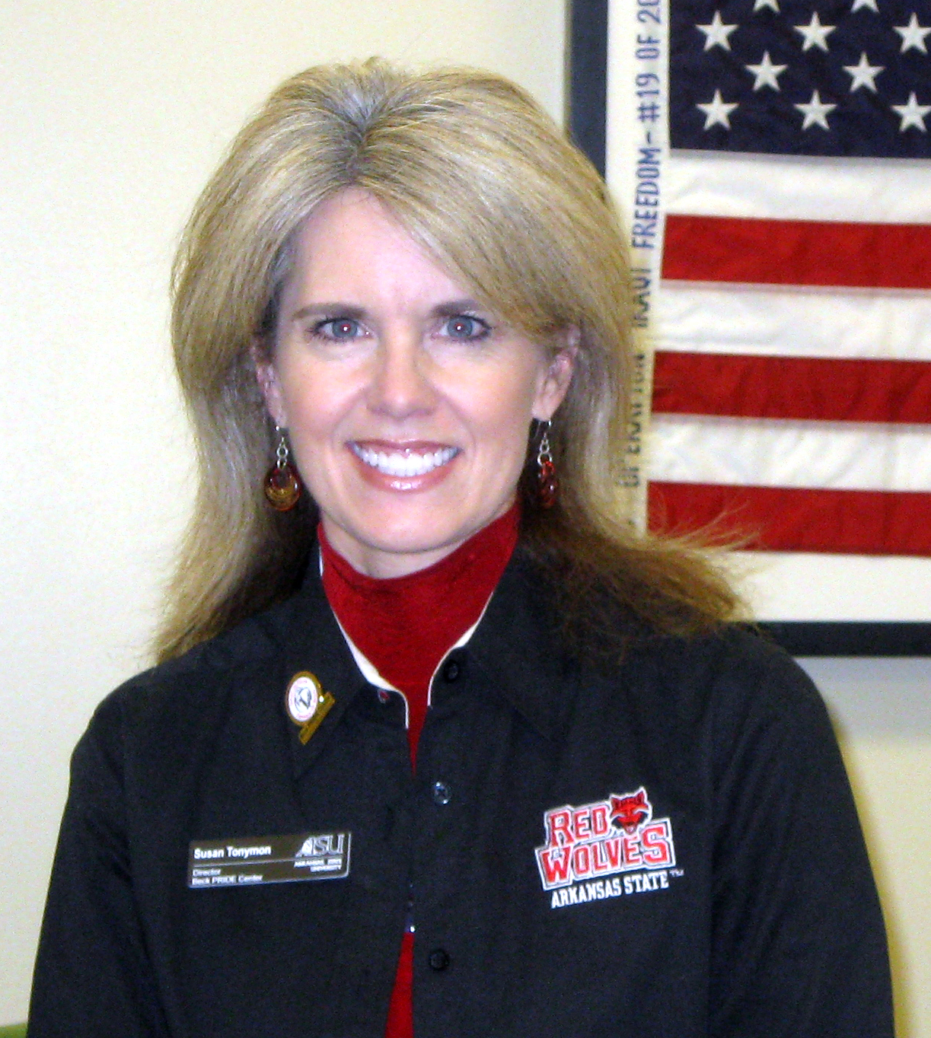
Susan Tonymon, program director for the Beck PRIDE Center for America's Wounded Veterans at Arkansas State University, has been selected by Arkansas Governor Mike Beebe as part of the Arkansas Yellow Ribbon Task Force. Tonymon is one of 20 task force members.
Dr. Robert Potts, chancellor at ASU, has been asked to serve on the task force in an ex-officio role.
“I am very pleased with Susan Tonymon’s appointment to the Yellow Ribbon Task Force,” said Dr. Potts. “As executive director of our Beck PRIDE Center, she is an ideal choice to make contributions to the force because of the strong development of this program.”
The task force focuses on issues faced by returning veterans from overseas deployment as well as senior veterans with increasing health needs. The purpose of the Task Force is to create a set of guidelines which will aid Arkansas military members of any branch in receiving necessary support, benefit, protection and opportunity.
“I am proud to accept Governor Mike Beebe’s appointment to the Arkansas Yellow Ribbon Task Force and applaud his efforts to improve benefits and services for Arkansas veterans,” said Tonymon. “I am proud to have the opportunity to share what I learn about the needs of the returning injured warriors and their families who are helped through the Beck PRIDE Center for America’s Wounded Veterans.
“I hope to be able to offer insight and assistance in the areas of personal rehabilitation, mental health counseling, education, social services, advocacy and vocational resources that we are developing in northeast Arkansas for returning combat injured veterans,” Tonymon continued. The task force, as a statewide combined effort, should result in Arkansas combat veterans and their families having enhanced coordination of services and benefits."
The first meeting by the task force was held July 29 at the Arkansas State Capitol Building in Little Rock. Tonymon, who was chosen to serve on Healthcare/Disabilities and Public/Private Partnerships and Community Resources committees, delivered a 15-minute PowerPoint presentation to the attendees about the PRIDE Center.
“These volunteers recognize that while we’ve gotten better at coordinating the services our men and women in uniform need, there is still more to be done,” said Governor Beebe. “By sitting down together, members of this task force will share their specialties and ideas to identify ways that we can better serve all our veterans.”
Governor Beebe’s office is working with Congressman John Boozman’s office in developing the Arkansas Yellow Ribbon Task Force to coordinate services and outreach groups to assist Arkansas military personnel. Representatives from Arkansas state agencies and higher-education institutions are also working with the task force.
The members of the Arkansas Yellow Ribbon Task Force are as follows:
--George Westmoreland (chairman), Rogers, civilian aide to the Secretary of the Army --Susan Tonymon, Jonesboro, program director, Beck PRIDE Center for America’s Wounded Veterans --Senator David Bisbee, Rogers, veteran
--- Bob Burns, Magnolia, Farmer Bank and Trust, veteran
--- Representative David Cook, Williford, veteran
--- Kim Dixon, Prairie Grove, military wife
--- David Fletcher, Monette, director of the Arkansas Department of Veterans Affairs
--- Janet Huckabee, North Little Rock, American Red Cross Arkansas program manager for Services to Military Families
--- Theotis King, Little Rock, elder, McAlmont Church of Christ, veteran
--- Dr. Joann Kirchner, Heber Springs, South Central Mental Illness Research, Education and Clinical Center
--- Colonel Nate McGee (Ret.), Hensley, former Army National Guard Deputy Chief of Logistics
--- Major General Don Morrow (Ret.), Little Rock, executive director of Employer Support for Guard and Reserve
--- Representative Bobby Pierce, Sheridan, former Arkansas National Guardsman
--- Cheryl Rawls, North Little Rock, director of VA Regional Office
--- Andrea Rockefeller-Hobbs, Little Rock, Arkansas Chapter president of Operation Homefront

--- Paige Smith, Fayetteville, president of Families Readiness Group – 142nd Fires Brigade
--- Representative Randy Stewart, Kirby, veteran
--- Chris Sultemeier, Rogers, Wal-Mart, veteran
--- Mike Winn, Bryant, director of the Little Rock VA Medical Center
--- Major General William Wofford, Conway, The Adjutant General, Arkansas National Guard

