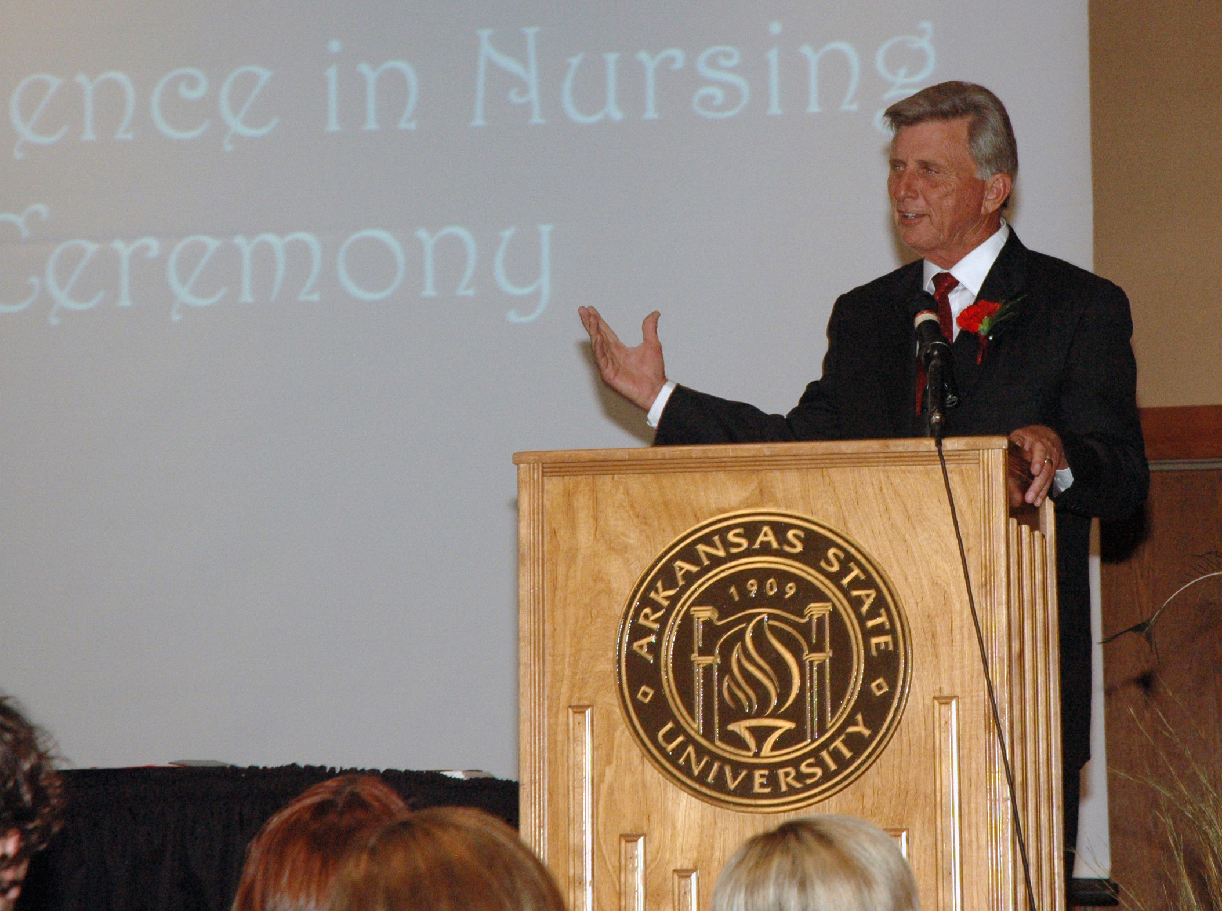
Gov. Beebe to speak at College of Nursing and Health Professions pinning May 9th
May 7, 2008 -- Arkansas State University’s College of Nursing and Health Professions will hold its Bachelor of Science in Nursing pinning ceremony Friday, May 9, from 7-9 p.m. in Centennial Hall, Reng Student Services Center/Student Union, 101 N. Caraway Road, Jonesboro. Arkansas Governor Mike Beebe will be the guest speaker at the ceremony.
According to Dr. Sue McLarry, department chair and associate professor of Nursing, the pinning ceremony is a deeply traditional nursing school rite of passage, marking the transition from nursing student to graduated nurse. “You have to be a graduate of a given school to wear its pin,” says McLarry. “Even though I’m faculty here, I can’t wear an ASU pin, because I didn’t graduate from here. Now that nurses rarely, if ever, wear caps, the pin has acquired the significance of the cap as well, really becoming the badge of being a trained and qualified nurse. Today, our graduates have to pass licensing exams before they can practice, but the pinning ceremony signifies that they have acquired the knowledge and skills they need to practice.”
The ASU College of Nursing and Health Professions pinning ceremony is traditionally planned by students, McLarry notes, and faculty of the college are invited to attend by the students. The Nightingale Pledge will also be used in the ASU ceremony, harkening, as McLarry observes, to the 1850s when Florence Nightingale began to elevate and to further nursing as a profession.
The ceremony will begin with a welcome from Latoya Webb, a graduating senior in the Bachelor of Science in Nursing program. Webb, a traditional student graduating in four years, is 22 years old, married, and is a native of Bono. She has been active in the Student Nurses Association in both her junior and senior years, serving as the class representative both years. After graduation, she plans to work at St. Bernards Regional Medical Center, Jonesboro, in the Intensive Care Unit.
Emily Odem will conduct the ceremony’s opening prayer, assistant professor of nursing Debbie Shelton will give an instructor’s-eye view of nursing, and Dr. Susan Hanrahan, Dean of the College of Nursing and Health Professions, will introduce Governor Mike Beebe as the guest speaker.
After Governor Beebe’s remarks, a member of the faculty will present student awards, Lauren Houser will present instructor awards, and associate nursing professor Annette Stacy, director of the Bachelor of Science in Nursing program, and associate nursing professor Julie Isaacson will conduct the pinning of the students. A slideshow presentation will follow, and the closing and special thanks and acknowledgements will be given by Brian Coleman, a graduating senior in the Bachelor of Science in Nursing program. Coleman, who also planned and orchestrated the pinning ceremony, is a non-traditional student and single father of two who returned to school at age 28 and is graduating at age 32, all while working full time. Coleman, who lives in Paragould, has been active in the Student Nurses Association both on the local chapter level and the state level, serving as president for the local chapter for two years. Coleman currently serves as the president for Arkansas Nursing Students Association (ANSA). He passed his LPN boards last summer and has been working as a nurse in the emergency room at St. Bernards since June 2007.
Of special note are the Governor’s recent appointees from ASU’s College of Nursing and Health Professions. Donna Caldwell, assistant professor of Radiologic Sciences, was recently reappointed to the Medical Ionizing Radiation Licensure Committee. Caldwell is also winner of this year’s Board of Trustees Faculty Achievement Award for Service. Becky Keith, assistant professor of Physical Therapy, was appointed to the Traumatic Brain Injury Taskforce, and Dean Hanrahan was recently appointed to the Arkansas Governor's Health Care Roundtable.

