Code # Enter text…
Bulletin / Banner Change Transmittal Form
[x] Undergraduate Curriculum Council
[ ] Graduate Council
Signed paper copies of proposals submitted for consideration are no longer required. Please type approver name and enter date of approval.
Email completed proposals to curriculum@astate.edu for inclusion in curriculum committee agenda.
Sharon James 1/9/2017  Department Curriculum Committee Chair | __________________ Enter date  COPE Chair (if applicable)
Melodie Philhours 1/11/2017  Department Chair: | __________________ Enter date  Head of Unit (If applicable)
John Seydel 2/3/2017  College Curriculum Committee Chair | __________________ Enter date  Undergraduate Curriculum Council Chair
C. Shane Hunt 2/21/2017  College Dean | __________________ Enter date  Graduate Curriculum Committee Chair
__________________ Enter date  General Education Committee Chair (If applicable) | __________________ Enter date  Vice Chancellor for Academic Affairs

1.Contact Person (Name, Email Address, Phone Number)
Dr. Melodie Philhours
mphil@astate.edu
870-680-8148

2.Proposed Change
Refine the selection of courses for the “Select Two of the Following Courses” section of the degree plan. “Select Two” changes to “Select Three.”

3.Effective Date
Fall 2017

4.Justification – Please provide details as to why this change is necessary.
The courses listed in the current degree plan include some that are less relevant to the major and some that are also rarely offered. This change clarifies the degree plan making it easier for advisors and students alike in terms of planning for graduation. The list of “select two” courses has been changed to “select three” and the course listing has been refined to remove those specifically related to the Global Supply Chain Management major and those rarely offered so that the student has a relevant and realistic list of courses from which to choose.

Bulletin Changes

Instructions
Please visit http://www.astate.edu/a/registrar/students/bulletins/index.dot and select the most recent version of the bulletin. Copy and paste all bulletin pages this proposal affects below. Follow the following guidelines for indicating necessary changes.

*Please note: Courses are often listed in multiple sections of the bulletin. To ensure that all affected sections have been located, please search the bulletin (ctrl+F) for the appropriate courses before submission of this form.

- Deleted courses/credit hours should be marked with a red strike-through (red strikethrough)
- New credit hours and text changes should be listed in blue using enlarged font (blue using enlarged font).
- Any new courses should be listed in blue bold italics using enlarged font (blue bold italics using enlarged font)

You can easily apply any of these changes by selecting the example text in the instructions above, double-clicking the ‘format painter’ icon , and selecting the text you would like to apply the change to.
Please visit https://youtu.be/yjdL2n4lZm4 for more detailed instructions.

Paste bulletin pages here...

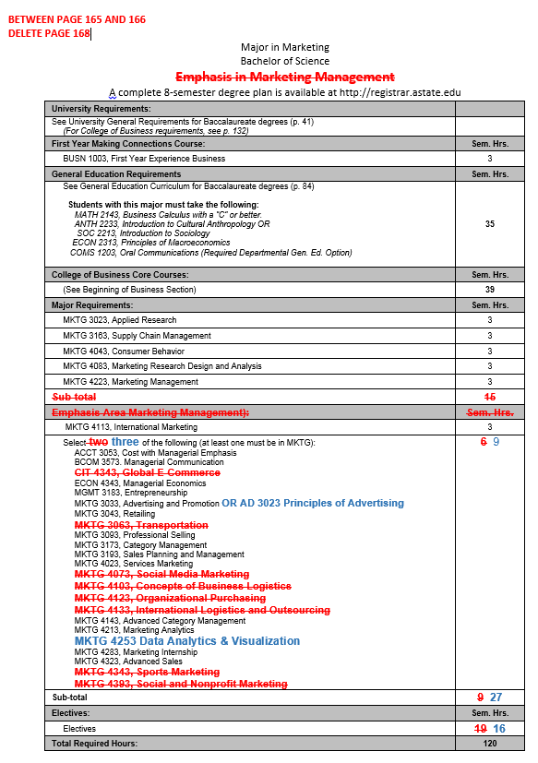
Page 168
Emphasis in Marketing Management

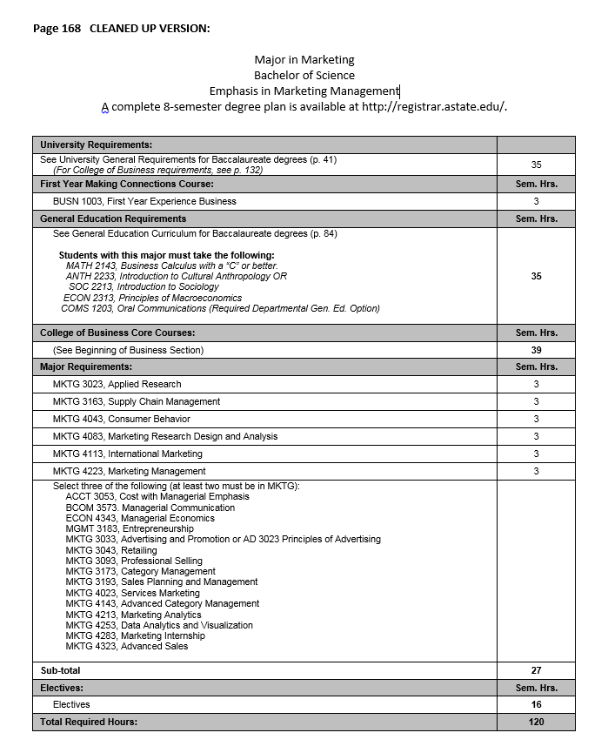
Ultimately, this page will look like this. . .

