Step one: Go to https://www.ebenefits.va.gov/ebenefits/vonapp. Click on No, Create a VONAPP Account.
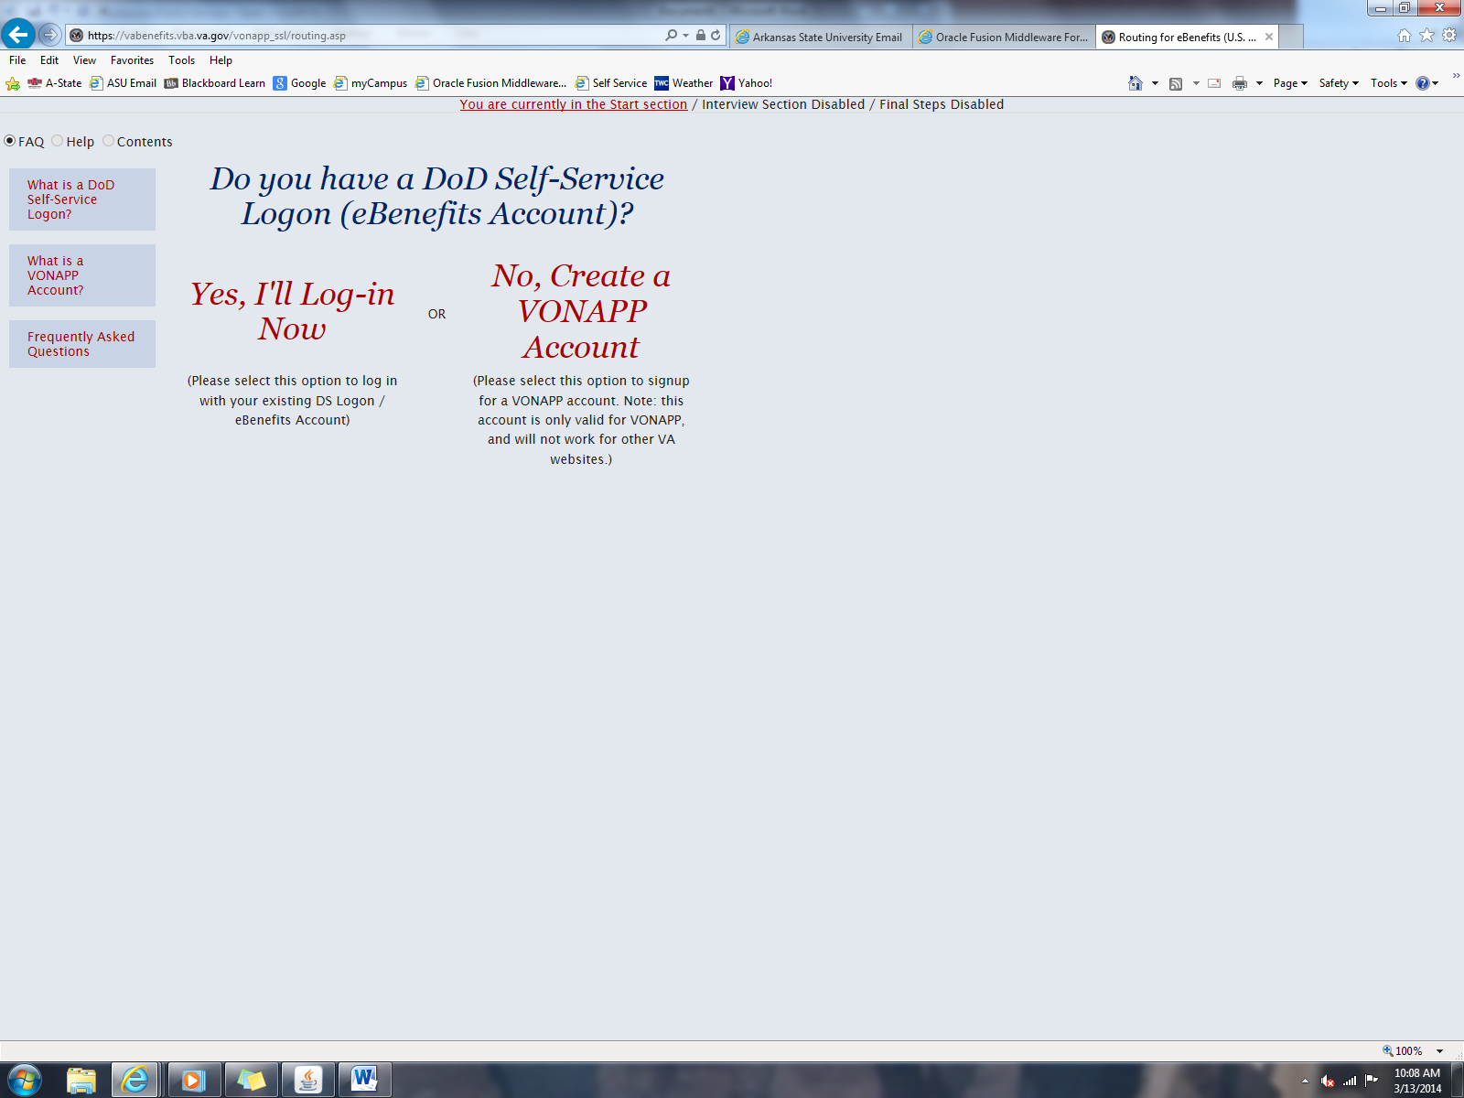

Step two: Create login. Read instructions on how to do so.
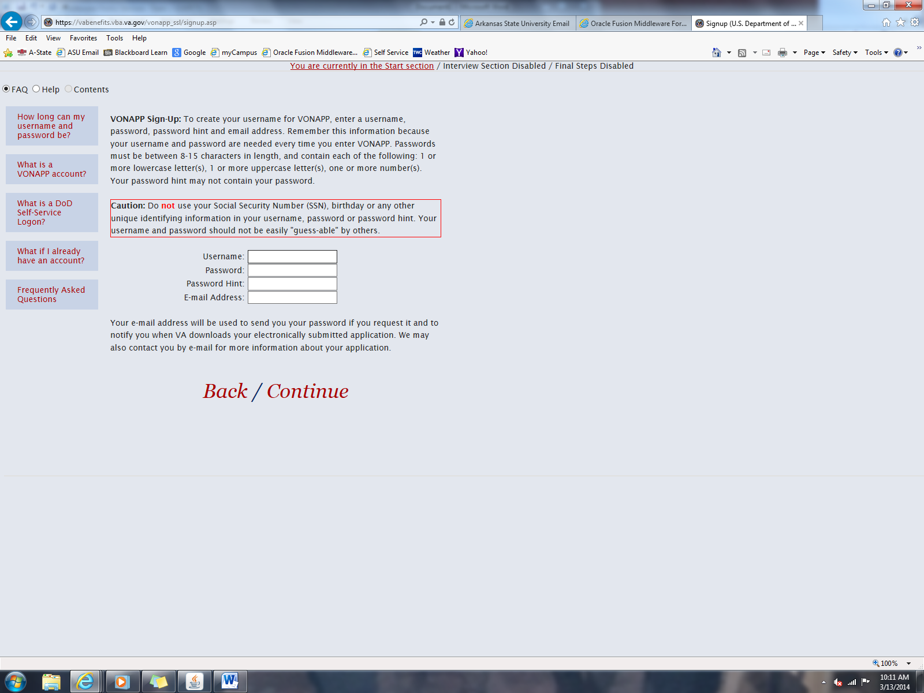

What you will need:
- Your routing and account number for direct deposit.

Forms:
- Form 22-1990
- Form 22-1990E
- Form 22-1995
- Form 22-5490
- Form 22-5495

Arkansas State Mailing Address:
- P.O. Box 1570
State University, AR 72467

What chapter are you?
- Chapter 30-Active Duty (Marines, Air Force, Navy, and Coast Guard)
- Chapter 33- 9/11 Deployments
- Chapter 1606-National Guard-Reserves
- Chapter 1607 (REAP)-National Guard and Reserves-Deployed
- Chapter 35-Spouses and Dependents of Veterans

