For Release to the News Media:
April 7, 2009

ASU - Jonesboro: Faculty Honors Convocation, retirement recognition, held April 7

The Faculty Honors Convocation at Arkansas State University-Jonesboro took place Tuesday, April 7, in Centennial Hall, in the Reng Student Services Center/Student Union. A reception for retiring faculty began at 3:30, and the recognition of these emeriti faculty, along with the presentation of the Arkansas State University Board of Trustees Faculty Achievement Awards and the Outstanding Academic Advising Award took place at 4 p.m.
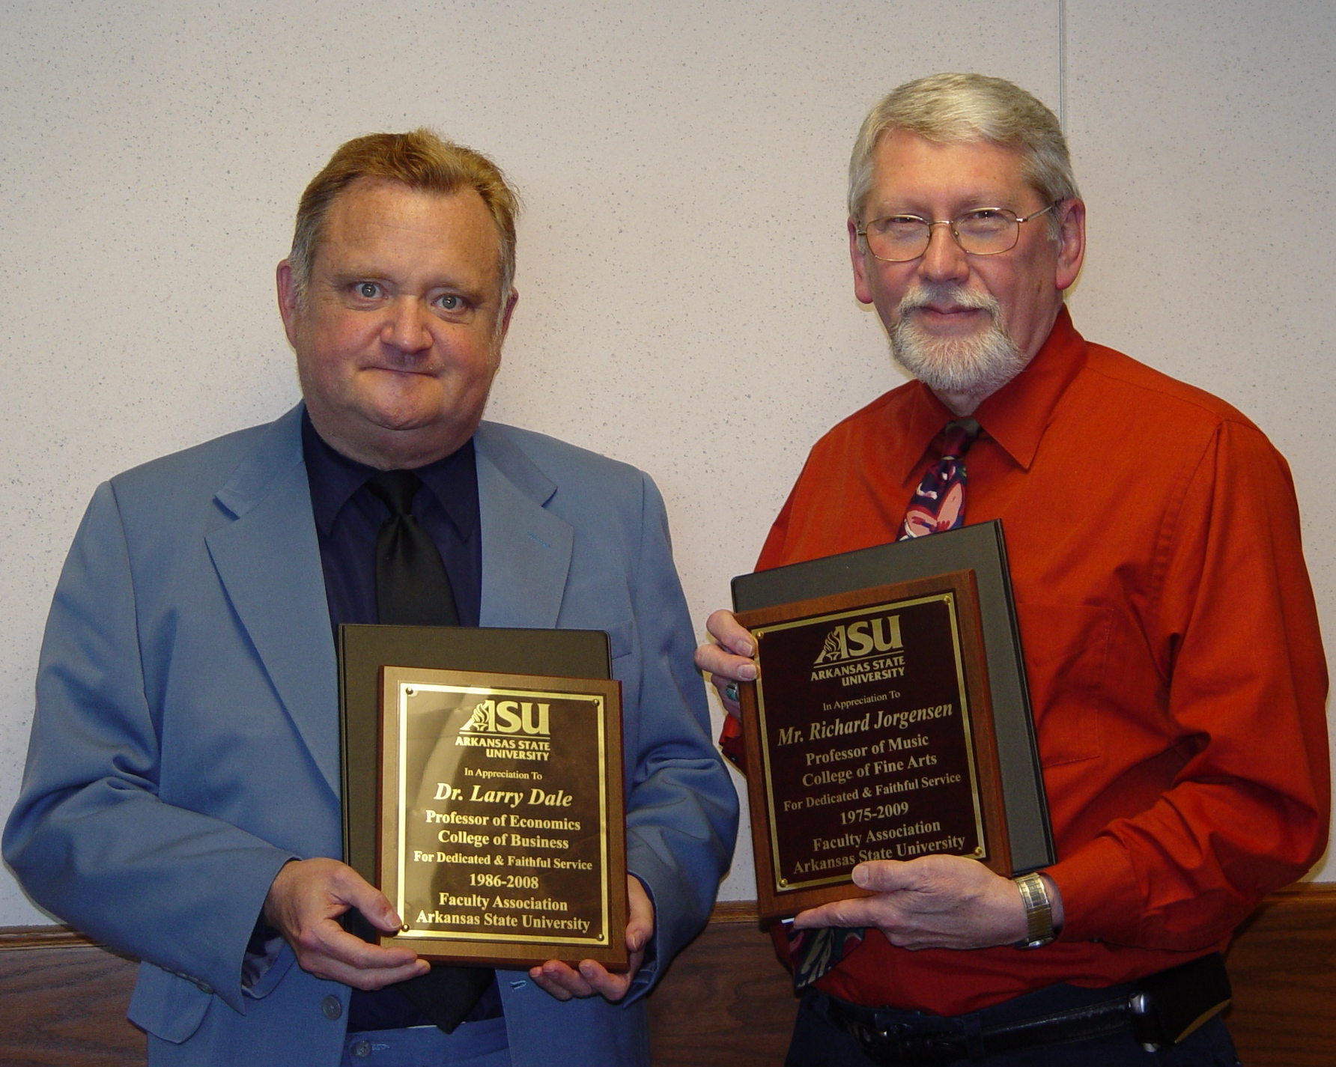
Dr. G. Daniel Howard, vice chancellor for Academic Affairs and Research, formally recognized the retiring faculty members, Dr. Larry Dale, professor of economics, Department of Economics and Finance, College of Business; Mr. Richard Jorgensen, professor of music, Department of Music, College of Fine Arts; Dr. Whitney Williams, chair and associate professor of Clinical Laboratory Sciences, College of Nursing and Health Professions; and Dr. William Wyatt, professor of Chemistry, Department of Chemistry and Physics, College of Sciences and Mathematics. The deans of the retirees’ colleges also made remarks, as did ASU chancellor, Dr. Robert Potts. Dr. Louella Moore, professor of accounting and president of ASU’s Faculty Senate/Faculty Association, presented plaques to the retiring faculty.
ASU Retiring Faculty--(left)Dr. Larry Dale, Professor of Economics; Mr. Richard Jorgensen, Professor of Music. (Not pictured: Dr. Whitney Williams, chair and associate professor of Clinical Laboratory Sciences; and Dr. William Wyatt, professor of Chemistry).
The Outstanding Academic Advising Award and the ASU Board of Trustees Faculty Achievement Awards for Teaching, Professional Service, and Scholarship, are presented each spring to four faculty members who have demonstrated unusually significant and meritorious achievement in advising, teaching, professional service, and scholarship.
The Outstanding Academic Advising Award recipient was Dr. Richard K. Freer, associate professor of Social Work, College of Nursing and Health Professions. This award was presented by Melissa Jackson, advisor, Office of Advisement Services, and Dr. Lynita Cooksey, associate vice chancellor for Academic Services and dean of University College. The Outstanding Academic Advising Award is based upon a faculty member’s demonstration of strong interpersonal ability, availability, and a caring, helpful attitude toward advisees, faculty, and staff, as well as a mastery of institutional regulations, policies, and procedures.
Following the presentation of the Outstanding Academic Advisement Award, Dr. G. Daniel Howard presented the Faculty Achievement Awards for teaching, professional service, and scholarship.
The Faculty Achievement Award for Teaching recipient was Dr. Catherine Reese, associate professor of Public Administration, Department of Political Science, College of Humanities and Social Sciences. This award for excellence in teaching is based upon unusual effort devoted to ensuring the quality of the students’ classroom learning experience; possession of high scholarly standards for both the rigor and the currency of course content and for the level of student performance with respect for these standards; and measurement of the faculty member’s direct impact on and involvement with students.
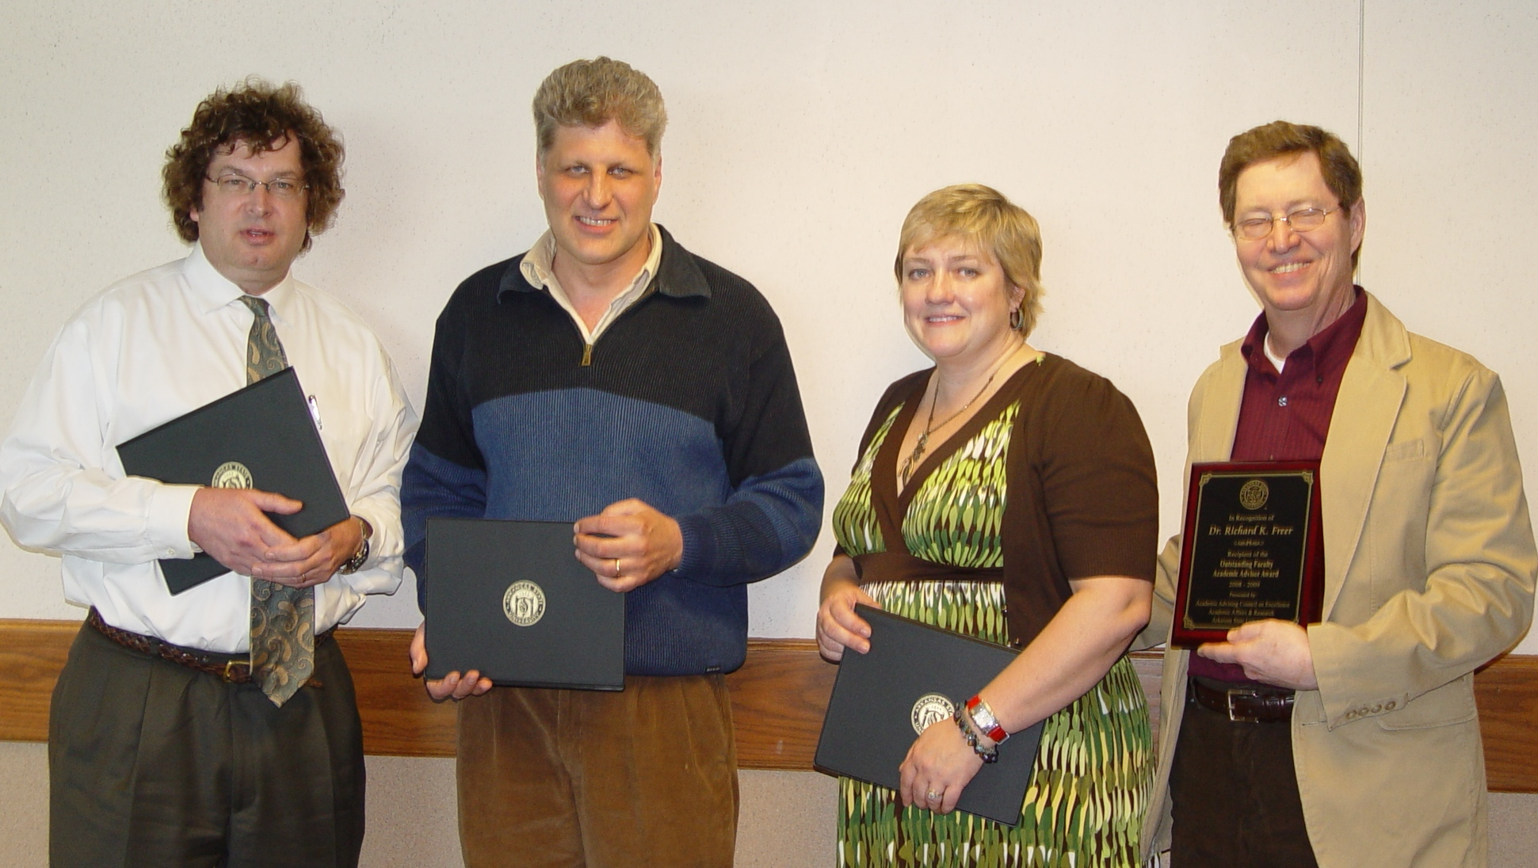
The Faculty Achievement Award for Professional Service recipient was Dr. Gregory Hansen, associate professor of English and Folklore, Department of English and Philosophy, College of Humanities and Social Sciences. This award for excellence in professional service is based upon contributions of exceptional merit and importance to department, college, and university committees, undertakings, projects, programs, student organizations, and services; contributions of exceptional merit and importance to academic and professional organizations as evidenced by offices held, editorships, reports, committee assignments completed, and other organizational responsibilities and roles; and contributions of professional expertise to individuals, groups, organizations and corporations through workshops, services, consulting, in-service training, and other activities.
Faculty Award Winners-- (left) Dr. Chris Brown, professor of Economics (Faculty Achievement Award for Scholarship); Dr. Gregory Hansen, associate professor of English and Folklore, (Faculty Achievement Award for Professional Service); Dr. Catherine Reese, associate professor of Public Administration, (Faculty Achievement Award for Teaching); Dr. Richard Freer, associate professor of Social Work, (Outstanding Academic Advising Award).
The Faculty Achievement Award for Scholarship recipient was Dr. Christopher Brown, professor of Economics, Department of Economics and Finance, College of Business. This award for excellence in scholarship is based upon the publication (or conditional acceptance) of one or more particularly high-quality, original, and scholarly contributions by a nationally recognized, refereed professional/academic journal, juried exhibition, or other professional outlet; additional evidence of scholarly merit, including refereed scholarly activities of lesser stature such as presentations in regional journals or exhibits, or refereed papers read to professional organizations; and the potential significance of these contributions to enhance the effectiveness of the subject content in the classroom.

