Arkansas State University
Jonesboro, Arkansas

Student Handbook
2014-1015
Doctor of Education Degree (Ed.D.)
In Educational Leadership

Revised September 3, 2014

The College of Education
is accredited by:

National Council for Accreditation of Teacher Education (NCATE)
and
Higher Learning Commission (HLC)

It is the policy of Arkansas State University to provide equal employment opportunity to all qualified persons; to prohibit discrimination against any employee or applicant for employment because of race, color, ancestry, religion, gender, age, disability, genetic information, national origin, status as a veteran or other status protected by law; and to promote the full realization of equal employment opportunity through a positive continuing program of affirmative action.

Any questions regarding this policy should be addressed to the Affirmative Action Program Coordinator at Arkansas State University,
P.O. Box 1500, State University, AR 72467.

Center for Excellence in Education telephone: 870.972.3943.
(7/29/14)

TABLE OF CONTENTS

Introduction …………………………………………………..................... | iii
Overview ………………………………………………………………... | iii
Mission Statement ………………………………………………………. | 1
The Academic Program .......................................................................................... | 1
Research and Development ................................................................................... | 2
Admission Procedures...…………………………………………................ | 3
Financial Assistance ………………………………………….................... | 5
Graduate Assistantships …………………………………………………. | 5
Dr. Eugene W. Smith Research Fellowship …………………………….... | 7
Doctoral Program …………………………………………………........... | 8
Conceptual Framework ……………………………………….. | 8
Program of Study ………………………………………............. | 9
Class Schedules……………………………………....................... | 10
Conceptual Framework ……………….………………………... | 10
Doctoral Program Checklist …………………………................. | 11
Doctoral Program Graphic .……………………………............. | 12
Transfer and Extension Credit ………………………………………….. | 13
Other Requirements
Program Advisory Committee ………………………………… | 13
Continuous Enrollment ……………………………………….. | 14
Time To Degree ………………………………………….......... | 14
Comprehensive Examinations
Comprehensive Examination Structure ………………………... | 15
Cohort Project ….............………………………………… | 15
Individual Written Exam .………………………………… | 18
Capstone Narrative….…………………………………….. | 20
Presentation/Publication/Grant …………………………. | 21
Dissertation and Proposal
Dissertation Committee ……………………………………….. | 22
Proposal ………………………………………………………. | 23
Human Subjects Research - Review Guidelines ............................... | 24
Policies Related To Dissertation Proposal ……………………... | 24
Dissertation …………………………………………………… | 25
Oral Dissertation Defense …….........………………………….. | 26
Guidelines To Pursuing A Doctorate ………………………….................. | 27
Declaration of Intent ............................................................................. | 27
The Doctoral Program Advisory Committee ................................... | 27
Request for a Program of Study Revision ........................................ | 27
Comprehensive Examination .............................................................. | 27
Dissertation Registration ....................................................................... | 27
Doctoral Dissertation Proposal Approval ......................................... | 27
Report of Results of Ed. D. Degree Oral Dissertation Defense... | 28
Intent to Graduate ……......................................................................... | 28
Preparation For Graduation ……………………………………………... | 28
Submission for Approved Dissertation for publication ………………….. | 29
Appendices: | 30
- Declaration of Intent………………………………………….. | 31
- Program of Study & Advisory-Examining Committee………… | 32
- Request For a Program of Study Revision……………………... | 34
- Report of Results of Comprehensive Examination……………. | 35
- Dissertation Proposal Approval………………………………... | 36
- Report of Results of Final Dissertation Defense………………. | 37
- Intent To Graduate Card……………………………………… | 38
- Dissertation Committee Form ………………………………… | 39
Contact Information ……………………………............................................ | 40

INTRODUCTION

The purpose of this handbook is to provide information concerning center policies and procedures required to obtain a Doctor of Education (Ed. D.) degree in Educational Leadership. This handbook is designed to be used in conjunction with the Arkansas State University Graduate web page, which has the most up-to-date information and is available online at http://www.astate.edu/college/graduate-school. Please consult this valuable resource for comprehensive information regarding graduation requirements and dissertation formatting and submission.
For any questions, please feel free to call the Center for Excellence in Education at 870.972.3943 or check us out on the web at http://www.astate.edu/education/cee.

OVERVIEW

The Doctor of Education degree in Educational Leadership provides the highest professional degree available in the field of education to students who aspire to administrative careers. Although the degree requirements include a prescribed curriculum of required and elective courses, the doctoral degree is not only awarded on the basis of coursework completion. In addition, each doctoral student is expected to complete the comprehensive examination requirement and conduct a major research project resulting in the presentation and oral defense of a dissertation.

MISSION STATEMENT

Arkansas State University established the Center for Excellence in Education in 1992.
The Center for Excellence in Education provides the following services:
- An academic program for educational leaders to serve in local, state, regional, or national organizations that have education as an integral component;
- Research and development inclusive of evaluative and consultative services to secondary, postsecondary, and other educational agencies.

THE ACADEMIC PROGRAM

Educational leadership has become increasingly professional in its demands. Accordingly, it is recognized that leadership requires professional preparation. In the Center’s administrative, academic, and collegial relationship with the Department of Educational Leadership, Curriculum, and Special Education, the Center offers an academic program for potential leaders. The academic program’s mission is accomplished through graduates who:

- Apply the program's academic knowledge base in bringing about creative changes and innovations within organizations;
- Understand human behavior within the organization as well as the transactional relationship between the organization and its external environment;
- Exercise effective leadership in the context of complex cultural, economic, and political diversity;
- Utilize appropriate research principles to resolve problems and conflicts;
- Discover and utilize insight about one's self to increase effectiveness in leading and working with others;
- Function as risk-takers and change agents in facilitating organizational vision and sound planning;
- Utilize the evolving professional knowledge base concerning learning
- theories, knowledge acquisition, and the nature of the educational environment in promoting sound educational practices;
- Create an organizational ethic committed to the equitable treatment of all people.

RESEARCH AND DEVELOPMENT

The Center for Excellence in Education has adapted its mission and role to keep pace with changes in society. The Research and Development components of the Center's activities have a special functional research emphasis in the following areas of inquiry:
- The Center will extend its leadership preparation role to include research development activities directed toward the improvement of educational practice in the service region of the university. Particular emphasis will be on educational issues unique to the schools in the Mississippi Delta, but Center-directed activities may also extend to other institutions.
- Activities may include sponsored research, evaluation, and technical service projects having the purpose of contributing new knowledge, addressing a particular problem, or developing the capacities of institutions and people to achieve their goals. Technical service may include grant writing, collaborative consultation, professional development, or direct assistance where needs arise and resources permit.
- Structural arrangements for carrying out such activities may include coalitions or consortia of educational agencies in collaboration with the university, the research and service unit of the Center as a point of origin, research and development partnerships, third party independent consultants under contract, or faculty working individually and in groups under the direction of the Center.
- Extended activities of the Center should be motivated by a combination of purposes: to create opportunities for faculty development, to focus energies on the improvement of professional practice in schools and colleges, and to enhance the image of the university as a source of leadership. To the extent feasible and appropriate, Center activities will support doctoral student research.

ADMISSION PROCEDURES

Residence Information
To be classified as an "in-state" student for tuition and fee purposes, a student must be a bona fide domiciliary of Arkansas and must have resided in that status for at least six consecutive months prior to the beginning of the term or semester for which the fees are to be paid.
Students from neighboring states may be treated as residents in certain circumstances. The Graduate School should be contacted to determine how these conditions may be met. A student outside Arkansas shall have the burden of establishing in-state status for tuition and fee purposes. Evidence to that effect must be presented in writing and verified under oath by the student.
International Students
A citizen of any foreign nation or graduate of any international institution of higher learning will be considered for admission to the Educational Leadership program if he/she can submit satisfactory credentials indicating the following:
- The ability to use the English language, if English is not the native language, as evidenced by one of the following: a score of 550 or higher on the paper-based TOEFL, 213 or higher on the computer-based TOEFL, or 79 or higher on the internet-based TOEFL; or completion of ASU’s ESL program with a minimum grade of 90%; or graduation from a university in the USA, UK, Canada, Australia, or New Zealand (minimum 2 years attendance); or a minimum 65% in English at X and XII in Certificate in India and Pakistan; or completion of required level of a CEA Accredited ESL program; or Academic 6.0 on the IELTS; or English as Official Language according to the CIA World Fact Book;
- Completion of an appropriate program of study that is equal to a master's degree in an appropriate area from a college or university in the U.S. with a GPA that meets the requirements of the Graduate School;
- The obtainment and continuation of adequate medical insurance and documentation to the international student advisor of a signed authorization for emergency medical treatment; and evidence of financial ability to support the student's stay in the U.S. during the period of study.
- Approximately $19,500 in U.S. currency will be needed to finance the nine-month academic year plus the required five-week summer session.

For additional admissions requirements for international students, please email International Programs at international@astate.edu or visit their website at www.astate.edu/info/admissions/international.

Admission Criteria:
Full admission to the doctoral program is predicated on the following criteria: (1) academic ability, (2) scholarship, and (3) professional promise. These criteria provide both the Center and the applicant with an indication of probable success in the program. In addition, the applicant must hold an earned master's degree.

Requirements for Admission Consideration:
- A completed application form accompanied with a $50 non-refundable fee. (See http://www.astate.edu/college/graduate-school)
- One set of official transcripts of all undergraduate and graduate work
completed, mailed directly to the Center from all institutions attended. (See address on back cover.)
Official report of scores for the Miller Analogies Test or the Graduate Record Examination less than five years old. Arrangements for testing can be made by contacting the Testing Center at 870.972.2038 or http://www.astate.edu/a/testing.
Letters of appraisal and recommendation should be mailed to the Center from four (4) persons: a supervisor, a central office administrator, and two college professors. (Any reference should be qualified to speak with authority on the applicant's perceived strengths and weaknesses as a candidate for the doctoral program.)
- Successful completion of the writing requirement such as a master's thesis, research paper, journal article, term paper, or field study.
- A personal statement including reasons for pursuing advanced graduate education, career goals, how the program in educational leadership would help to meet these goals, and prior experiences which relate to your interest in and aptitude for the graduate program.
- An interview with the Center for Excellence in Education Committee on Admissions may be required.

- Mail all documents to: Mail the $50.00 application fee to:
Director ASU Treasurer’s Office
Center for Excellence in Education P.O. Box 2640
Arkansas State University State University, AR 72467
P.O. Box 1270 *Note “Ed.D. Application fee” on your check*
State University, AR 72467

- After acceptance into the program, each doctoral applicant is required to pay a $500 non-refundable deposit to reserve a place in the designated cohort. Students who do not respond by the stipulated date will have their positions assigned to other applicants. Upon student’s completion of their first semester of the program, the deposit will be applied to the student’s tuition payment the following spring semester. Forfeited fees will revert to the Center for Excellence in Education and be used to support graduate student activities such as expenses related to the presentation of a scholarly paper, publication costs, or in support of research projects germane to the field of educational leadership.

FINANCIAL ASSISTANCE
Loans are available to graduate students from a number of sources. These include the following: Federal National Direct Student Loan, Federal Unsubsidized Stafford Student Loan, and Federal Supplemental Loan for Students. Interested applicants should contact the Financial Aid Office, P. O. Box 1620, State University, AR 72467 or 870.972.2310 for application instructions.

GRADUATE ASSISTANTSHIPS
Graduate Assistantships are available to a limited number of qualified applicants. Assistantships are available for both regular semesters and summer school. Application for an assistantship must be made through the Director of the Center for Excellence in Education. No application for assistantship will be considered unless the applicant has also applied for admission to the Graduate School. To be eligible for an assistantship, a graduate student must have unconditional admission or conditional admission with an overall undergraduate grade point average (G.P.A.) of at least 2.50 and either a 2.75 average on the last sixty hours of the undergraduate work, or a 3.00 average on the undergraduate work in the major field of study.

Graduate School Policies Concerning Graduate Assistantships
- The appointee must complete at least nine semester hours of graduate work and no more than twelve hours of both graduate and undergraduate work each semester during the academic year and six total semester hours of graduate work over the two summer terms to remain a Graduate Assistant (G. A.).
- Each G. A. should have a definite schedule of duties and responsibilities assigned by the Dean of the College of Education and the Director of the Center of Excellence in Education.
- G. A.s are not considered to be a part of the faculty of the university, are not entitled to faculty privileges, and will not be included in the Group Life and Hospital Insurance Program sponsored by the university.
- The appointee should attend regular staff meetings of the college and department, as well as the general staff meetings of the university. The
appointee should also attend the faculty workshop at the beginning of the academic year.
- If a student is unable to complete a semester's work due to circumstances beyond his or her control, this semester will not be counted as one of the semesters included in the maximum amount of time for which he or she may hold the assistantship. In those instances, the Graduate School must be notified immediately of any such situations warranting consideration of this policy by the department and the student. Final authority for granting an exemption from counting the semester as part of time for holding the assistantship rests with the Graduate School.
- The assistantship will normally be awarded on an academic year or summer term(s) basis. Re-application is necessary for the student to be considered for reappointment each period. There is no automatic renewal.
- The appointee must maintain a grade point average of 3.00 or better on all graduate work completed in order to remain eligible for the assistantship.
- The assistantship at the Doctoral level will have a maximum time limit of eight semesters.
- Graduate assistants are expected to work 20 hours each week during scheduled semesters only.
- Graduate assistants may not be employed elsewhere on campus.
- Doctoral graduate assistants will have tuition waived for the qualifying semesters; fees will continue to be paid by the G. A.

Dr. Eugene W. Smith
RESEARCH FELLOWSHIP
Application Guidelines
All application materials should be submitted to:
Eugene W. Smith Fellowship Center for Excellence in Education
Arkansas State University
PO Box 1270
State University, AR 72467
CRITERIA FOR THE FELLOWSHIP
The Foundation shall designate and identify the endowment fund as the Dr. Eugene W. Smith Research Fellowship at Arkansas State University with the purpose of the fund being to assist deserving students who are pursuing a doctoral degree in educational leadership at Arkansas State University.

APPLICATION PROCESS
- Students may apply for the scholarship upon completion of the dissertation proposal. Any doctoral student who has completed the proposal but has not finished the dissertation is eligible for this fellowship.
- For consideration, the student must submit:
  - a copy of his or her accepted dissertation proposal complete with signatures of the committee members;
  - a written rationale/justification for requesting the fellowship;
  - an itemized budget detailing expenses related to the research; and
  - a description of the methodology which includes: 1) intermediate steps and 2) time lines leading to the completion of the dissertation.

CONDITIONS
- The deadline for submitting is March 1. The final selection is made by April 1 of each year.
- The selection of the recipient(s) is made through the collective judgment of the Center faculty using a formalized rating process to estimate the chances for completion.
- The amount of award is up to $2000 per academic year, payable in June. If two recipients are chosen, the annual award is divided between them at a rate of up to $1000 each.
- The ASU Foundation will issue a check directly to the student(s) selected for this award. Federal law requires that a 1099 be issued the following year for tax purposes.
- The Eugene W. Smith Research Fellowship is a one-time award. Students who have previously received a stipend from this Fellowship are not eligible for a second round of funding.

THE DOCTORAL PROGRAM (Ed. D.)

The Ed.D. is the terminal degree in educational leadership. The purposes of the doctoral degree are to increase the knowledge and skill base in educational administration, enhance research skills, and provide the necessary credentials for those desiring to pursue a career in higher education or in the public school setting.
The conceptual framework of the doctoral program is described below and on the next page. This model is built on four themes which include: self, change, organization, and leadership. The following definitions of each strand were developed and accepted by the Center faculty.

SELF
Conceptual Framework:

Self is an evolving synthesis of values and traits existing in a transactional

relationship with an environment external to itself. This self is capable of examining its life by asking questions such as:
  - What are my personal values and purpose?
  - What are the next logical steps progressing toward personal and professional maturity?
For programmatic purposes, this definition facilitates the motto "You are your own project." The program proposes to facilitate the student's exploration of self, specifically in terms of values, beliefs, knowledge, and skills pertaining to leadership in educational organizations facing inevitable change.

CHANGE
Change may be evolutionary, incremental or instantaneous, may emerge out of chaos or be planned, and may be goal free or goal driven, but, change is an inevitable process in which new, discernable patterns of action develop in the culture or behavior of people and organizations.

ORGANIZATION
Organization is an assemblage of persons with a purpose that is continuously created by the dynamic interaction of their values, needs, expectations, and accomplishments.

LEADERSHIP
Leadership is the act of encouraging interaction and inspiring vision to facilitate a process of organizational change that results in the attainment of desired institutional goals through the empowerment of people while performing as an ethical example. The courses required in each component and their sequence is listed on the following pages.
The doctor of education program contains six components:
- Doctoral Knowledge Core;
- Research Foundations;
- Socio-Cultural Foundations;
- Psycho-Behavioral Foundations;
- Leadership Foundations;
- Cognate Area/Leadership Electives.

PROGRAM OF STUDY

Each student will complete a detailed program of study (see Appendix B) in consultation with his/her advisor. This form should be submitted to the Graduate School prior to the completion of 12 doctoral semester credit hours. The program of study will be designed to ensure breadth of professional knowledge and an appropriate specialization in educational leadership. In consultation with the student's advisor, revisions can be made to the program of study.
All revisions must have the approval of the student's program advisor, the Center Director, and the Dean of the College of Education (see Appendix C). At least 99 semester hours are required beyond the bachelor's degree, inclusive of applicable master's and specialist degree credit. This minimum number of semester hours must include 45 credits from the Doctoral Knowledge Core.

The Ed. D. program consists of a minimum of 99 credits beyond the bachelor's degree.
Students who have not completed the master's degree will be encouraged to do so prior to pursuing admission to the doctoral degree. Although all appropriate graduate credits from the master's and beyond will be transferred to the Ed. D., students must complete the doctoral block and dissertation, which total 45 credits, plus the necessary prerequisites.

CLASS SCHEDULES

The student should always consult the final class schedule and his/her advisor prior to enrolling each semester. The current course schedule can be found at ASU Student Self Service at the following address: https://asups1.astate.edu:4443/prod/bwckschd.p_disp_dyn_sched about two months prior to the semester start date. Students should consult their advisors and the Ed. D. checklist on page 15 of this Student Handbook to correctly select the next courses for their semester’s registration. If students have difficulty registering for a course, they should contact the CEE office (870.972.3943) for assistance.

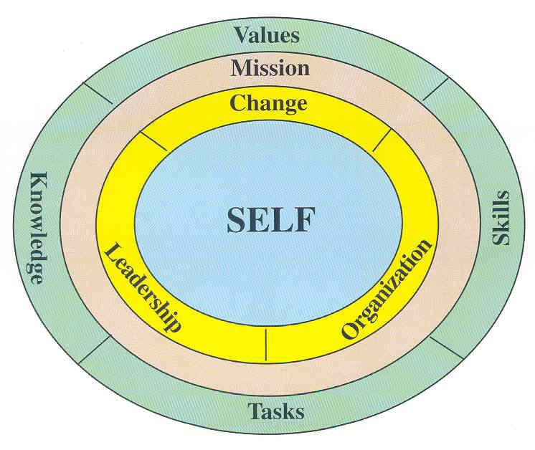

Ed. D in Educational Leadership
Conceptual Framework
Arkansas State University

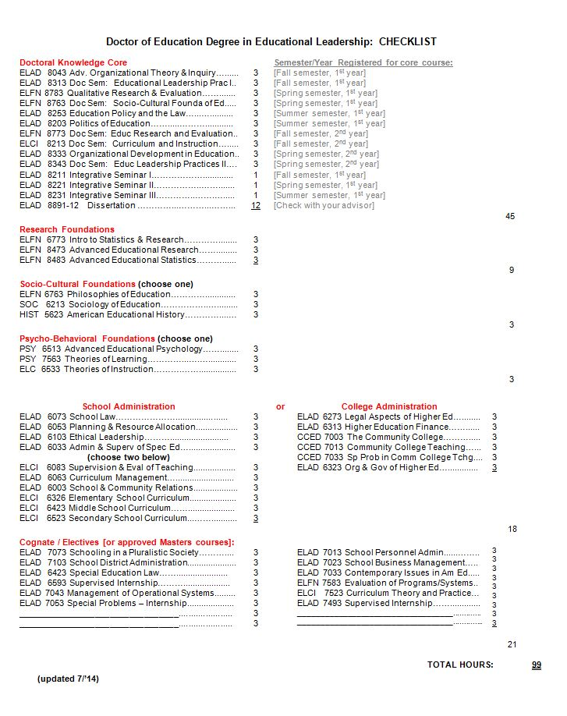
Arkansas State University
Center for Excellence in Education

Doctoral Program
Theory Practice

Fall Spring Summer Fall Spring

ELCI 8213
Curriculum and Instruction
ELAD 8211
Integrative Seminar I
ELFN 8763
Socio-Cultural Foundations
ELAD 8253
Policy and Law
ELAD 8221 Integrative Seminar II
ELAD 8203
Politics
ELAD 8343
Comparative Education
ELAD 8231 Integrative Seminar III
ELFN 8783
Qualitative Research
ELFN 8773
Research Seminar
ELAD 8333
Organizational Development
ELAD 8043
Organizational Theory
ELAD 8313
Education Leadership
Masters & Educational Specialist
Dissertation
Comprehensive

TRANSFER AND EXTENSION CREDIT

A student beginning doctoral study at ASU should bear in mind that transfer credits to the doctoral program are not allowed until all requirements governing admission have been met. Transfer credit will in all cases be individually evaluated by the student's program advisory committee, recommended by the Center, and approved by the Graduate Dean. The rule governing the time limit for doctoral credit applies also to transfer credits. No transfer credits will be allowed for courses completed with a grade less than B, and the applicant must have a B average at the transfer institution. (Note: B- grades are considered less than B.)

The number of courses required in addition to the 45 credit Doctoral Knowledge Core that constitutes a student's program of study will depend on any deficiencies found in each component of the doctoral program. The initial program of study will be developed by the student and advisor, but final approval is given by the program advisory committee. Students enrolled in the Ed. D. program who receive six credit hours with a grade of “C” or lower in the Doctoral Knowledge Core will be dismissed from the program.

OTHER REQUIREMENTS
Program Advisory Committee:
The student's program advisory committee will consist of no fewer than five members: three will possess expertise in the student's major area of concentration and will be selected by the student in consultation with his/her advisor and the Director of the Center for Excellence in Education. The remaining two committee members will be appointed, one each by the Dean of Graduate School and the Dean of the College of Education. The Education Dean's appointee will possess expertise in professional education and will represent the interests of the graduate faculty in the College of Education. The Graduate Dean's appointee will be chosen from graduate faculty outside of the field of professional education but from a field related to the student's research interest and will represent the interests of the university graduate faculty at large. No committee is considered constituted without the final written approval of the dean of the Graduate School.
Membership of the program advisory committee may be changed if either the candidate or a member of the advisory committee feels that such a change is appropriate and if the requested change is subsequently approved by the Director of the Center for Excellence in Education and the Graduate Dean. Such a change will not be approved except in clearly unusual circumstances. If approval is given, the student will be notified in writing by the Graduate School.

Continuous Enrollment:
Doctoral students must maintain continuous enrollment subsequent to completion of all coursework, beginning the summer after coursework ends. Once doctoral students have enrolled for dissertation credit, they must maintain continuous enrollment at a minimum of one semester hour of dissertation credit during each regular semester, including at least one summer term each year, until the dissertation has been accepted by the Graduate Dean. Students completing the dissertation with less than the specified 12-hour credit limit should enroll in ELAD 8891-12 to complete the twelve hour requirement during the graduation semester. This enrollment process is done through the CEE office.
Time to Degree:
The policy as stated in the Graduate Bulletin is as follows:
- All requirements for the doctoral degree must be completed within a period of four (4) years from the date of successful completion of the comprehensive examination (Dec. 1). Time limits are strictly monitored. Students exceeding the time limit may be required to repeat the comprehensive examination, replace out- of-date credits with up-to-date work, and/or show other evidence of being current in their major and minor fields.
- Students anticipating that they will exceed the time limit should apply for an extension. Holding a full-time job is not in itself considered sufficient grounds for requesting an extension. Time spent in obligated military service of the United States will not be considered in computing these time limits. However, career members of the armed forces should consult the Graduate Dean concerning credit given to work completed before entering active service.
The faculty approved the following procedure to operationalize the “Time to Degree” policy:
- Students who have not completed the dissertation four years after successfully fulfilling the comprehensive requirement have two options to extend the time to degree.
  - Doctoral students who have completed a dissertation proposal that has been accepted by the committee prior to the expiration date will be granted a one year extension upon committee approval.
  - For those individuals who have not had a proposal approved by their committee, a two year extension may be granted contingent upon committee approval with the completion of additional prescribed course work and a retake of the written comprehensive_examination.

Four years is the designated time for completion of the dissertation after advancement to candidacy. Beginning August 2009, all doctoral students who have not completed the dissertation within the allotted time period, and who have been granted an extension, are required to enroll in 6 credit hours each semester (Fall, Spring, and Summer I or II semesters) until the dissertation is finished or the extension has expired.

COMPREHENSIVE EXAMINATIONS

The Center will devise and monitor the comprehensive examination. The purpose of the examination will be to assess the candidate's knowledge in the field, skill in problem solving, ability to organize material, and effectiveness of written expression. Students must complete all portions of the comprehensive examination by December 1 following the last semester in which the student completes the Doctoral Knowledge Core.

Comprehensive Exam Structure: (Students choose three)
The comprehensive examination for the Ed. D. has multiple parts:
- Cohort Project
- Individual Written Exam
- Capstone Narrative
- Presentation/Publication/Grant
* students are encouraged to contact their advisor for information about comprehensive exams

Cohort Project

Introduction
A “group project” is one of four options for completing the comprehensive exam requirement. The other three are: scholarly presentation/publication, portfolio, and traditional written exam.

Expectations
The faculty expect to see group members working together to create a product larger and more comprehensive than one individual could do working alone. In the process of learning about self-organizing systems and group dynamics, group members are expected to demonstrate competency in shared leadership responsibility for carrying out a challenging, truly “group” undertaking (not the default division-of-labor syndrome). This means collaborative decision-making from initial organization to a product that clearly documents an outcome greater than the sum of the parts (i.e., synergy).

The faculty also expects students to assess themselves, the group process, and one another in terms of effective and ineffective leadership interventions. The group will be expected to address any internal conflict issues that might arise pertaining to an unbalanced share of the work load. While the project is a component of the comprehensive exam, it is also a learning exercise and leadership laboratory for sharpening skills to transfer into “back home” teamwork settings.
The focus for the group project is initiated by the group and is fairly wide open, but a proposal does have to be approved by the faculty by May 1 of the first year of study. Examples of project possibilities are: (1) a field project with specific learning objectives involving travel within or outside the United States (e.g., model program, professional conference), (2) a consulting project with a school or college (or sub-component thereof), (3) an advisory role to an educational agency, and (4) a critical analysis of a major educational reform issue with problem identification, background research, methodology, discussion, conclusions, and recommendations culminating in a “white paper” monograph.

Procedures and Timeline
In the spring term of the first year of the cohort’s existence, students will identify themselves as wanting to pursue the “group project” option. Member self- identification takes place before any topics are floated. Group composition can range from a minimum of three cohort members to all cohort members. There can be only one group project per cohort, and no student who wishes to participate in a group project will be excluded.
- An organization meeting will then be set up at a time convenient to group members and a faculty process observer. At the organization meeting, steps will be initiated to develop a project proposal.
- Subsequent meetings may be necessary to deliver a proposal to the faculty by April 1 of the first year of study. The month of April may be needed to hold negotiations between the group members and the faculty in order to have an approved project in place by May 1st.
The proposal or group charter has the following components (center headings and side headings):
  - Title page signed by all group members
  - Purpose (overall, general statement)
  - Goals (more specific)
  - Rationale (why this project was chosen and why it is significant)
  - Roles
    - Individual responsibility assignments or roles
    - Time commitments
    - Timelines
    - Self-assessment role (and instrument)
    - Peer-assessment role (and instrument)
  - Procedures
    - Group Meetings
    - Ground Rules
    - Communication Guidelines (norms)
    - Decision Making Guidelines
    - Handling Conflict Guidelines
    - Handling Accountability Issues (e.g., free riders, slackers, Dropouts)
  - Product and timeline of completion
The group project is initiated in the spring term of the first year of study and is expected to be completed and accepted by the faculty by May 1 of the second year of study. This gives the group members one full year to carry out the study to completion. If a proposal is not approved by May 1 of the first year, students would need to complete the remaining three comprehensive options. This would also be the case if the final product is not approved by the faculty by May 1 of the second year.
The group project is a totally student-driven enterprise from conception through completion. While faculty have evaluation responsibilities for the proposal and the final product, the faculty will not direct how and when the group goes about its business. However, faculty are interested in facilitating learning as a result of group process interactions.

Faculty Process Observer
Please plan to invite a faculty process observer to each group meeting. The process observer’s role is to help the group debrief group dynamics at the end of each working session – for the purpose of enhancing team building skills. Please schedule meeting times and locations convenient to a faculty process observer.

Authorship/Ownership
Each member of the group is an equal owner of the intellectual property of the project. That means that any paper, poster, presentation, etc. that might arise from the work must list every member as an author. Even if a group member adapts the deliverables long after the project has ended to present at a meeting or submit for a paper, every group member should be listed as an author.

Deliverables
The major deliverables for the group project are:
  - A proposal
  - An extensive final written report
    - Problem statement
    - Background research and literature review
    - Methodology
    - Findings
    - Discussion
    - Conclusions
    - Recommendations
    - References
  - A four page summary of the project
  - An oral presentation (to faculty and invited guests)
    - Thirty minute overview
    - Thirty minute question and answer session
An accepted proposal is due by May 1 of the first year of study. All other deliverables are due by May 1 of the second year of study.
Evaluation: What will it look like when we are successful?
The faculty will evaluate the final project according the following criteria:
  - Group members self-organized, planned, and implemented a significant investigation from beginning through completion
  - The group accomplished its purpose and goals
  - The group demonstrated creative and critical thinking
  - The group practiced leadership skills learned during the program
  - The group engaged in a mutual peer assessment exercise connected to learning how to function more effectively in group settings
  - The group produced a scholarly, well-organized, and well-written professional document (with potential for presentation and/or publication)

Individual Written Exam
A student choosing the individual-written-exam option will address comprehensive exam questions focusing on the programmatic themes of self, leadership, organization, and change. The exam must be passed between the conclusion of the coursework in May and December 1 of the same year. The date scheduled prior to December 1 will be determined by the Center Director, and student – dependent on facility availability. The student must re-take any failed portion of the exam. The date will be determined by the Center Director and student.

The following policies apply to the comprehensive examination. Students should consult the Graduate Catalog and their advisors if additional information or clarification is needed:
- The comprehensive examinations will be program oriented rather than course driven.
- The student is responsible for the content in the total program of study.
- The Center faculty will devise and monitor the written comprehensives.
- The Center faculty will be responsible for designing, preparing, and scoring the examination. Faculty members from cognate fields related to the program of study may be consulted. No advanced clues or hints will be distributed and no copies of previous examinations will be provided.

The faculty will use the following rating scale:
5 Extremely strong response, considerably above average, likely to be attained by only a small minority of examinees.
4 Above average, somewhat above what one would expect of an examinee.
3 Adequate and reflects an average level of performance commensurate with the expectations of the Center. (This is equal to a minimum pass.)
2 Below the quality expected but has some positive indicators.
1 Substandard and totally fails to reflect the quality one expects of an applicant for the doctoral degree.
Any failed portion may be repeated once, but the student may be directed by the program advisory committee to take additional coursework. If the examination or any portion thereof is failed a second time, the student will be dismissed from the program. The re-examination or any portion failed must be successfully passed within the next consecutive full semester. Failure to pass the comprehensive examination the second time terminates the degree program and the student will be dismissed from the program.

Capstone Narrative
As you know, the doctoral program is organized around four themes: Self, Leadership, Change Process, and Organizations. In a culminating reflective essay, tell the faculty how you have grown over your two years in the program and how the four themes have contributed to your growth as a “change agent.” Describe in detail how you are different after the coursework compared to when you entered.
In preparation for writing the essay, please review all the notes you took, reflections you made, projects you contributed to, and papers you submitted. Also review any feedback you received from your professors and/or fellow cohort members. In essence, relive the program journey. Select one special artifact for each theme. Pick quality artifacts – representatives of your best work. The four artifacts will comprise the appendix of your essay.
Compose a 12 to 16 page essay around the four themes and a conclusion. Introduce each theme section with a narrative that tells the reader what artifact was chosen and why. Tell how the artifact contributed to your development. Conclude each theme section with a summary statement of your personal and professional growth over the duration of your doctoral coursework – related to each theme. When you do these summaries, put some deep thought into them. Give specific examples. Write about what has heart and meaning for you as you reflect over the doctoral journey.
After you have handled each theme separately, provide a closing, “integrative statement” (a conclusion) that pulls everything together into an overall summary of your growth. Paint the faculty a before and after picture of who you were when you entered the program and who you are now almost two years later.
Each faculty member should get a copy of your essay and appendix material prior to the required oral defense of your doctoral journey presented to faculty. These can be sent electronically. The oral presentation is an opportunity to talk about the impact of the program. The faculty will ask questions about what has happened to you during the doctoral experience. This is a time to celebrate the joys and pains of learning and growing. The capstone narrative must be submitted and orally defended before December 1 following the last semester in which the student completes the block.
Assessment Criteria
    - Artifacts represent your best efforts regarding worthy problems or questions of importance
    - Artifacts address programmatic themes and personal/professional growth
    - Essay documents written communication skills reflecting the proficiency level of a doctoral candidate
    - Oral presentation documents clarity of thought and oral communication skills reflecting the proficiency level of a doctoral candidate

Presentation/Publication/Grant
The student who elects this as an option will make a presentation, submit an article for publication, or write a grant application.

  - Presentation: The student may elect to make a formal presentation to a state, regional, national, or international educational association. The presentation may be completed at any time between the time the student begins the doctoral block and December 1, following the last semester in which the student completes the block. Documentation of completion will be the association's program in which the student's presentation announcement appears.
  - Publication: The student may elect to author an article for publication in a professional journal. The article does not have to be actually accepted for publication by a journal, but the article must be of publishable quality and actually be submitted for publication to a journal. The submission may occur any time during the student's course work between the time the student begins the doctoral block and December 1 following the last semester in which the student completes the block. Documentation of completion will be the acceptance notification coming from the Advisory Committee and hopefully an acceptance letter from a journal editor.
  - Grant Application: The student may elect to write a grant in response to a Request for Proposal (RFP) issued by the federal government or a private foundation (such as Danforth, Mott, or Rockefeller). Grants for flow-through money such as title programs as well as those which are part of the student's normal job duties are not acceptable. The grant application may be completed at any time during the student's course work between the time the student begins the doctoral block and December 1 following the last semester in which the student completes the block. Documentation of completion will be the acceptance notification coming from the Advisory Committee and hopefully an acceptance notification from the funding agency.

DISSERTATION AND PROPOSAL
Dissertation Committee:
The student in consultation with the dissertation chair will recommend committee appointments to the Center Director, the Dean of the College of Education, and the Dean of Graduate School for approval.
The dissertation committee consists of five members:
    - Dissertation chair
    - Center faculty member
    - Center faculty member
    - College of Education member appointed by Dean of Education
    - Graduate faculty at large appointed by Dean of Graduate School
Overview:
Educational Leadership students are required to enroll in 12 credit hours of Dissertation.
There is no fixed length for the dissertation. Rather than concentrating on the size of the document, students are advised to consider the following purposes of a dissertation:
- to demonstrate technical mastery of the student's field,
- to originate new knowledge or to advance or modify the present knowledge base in educational leadership, and
- to demonstrate the ability to conceptualize and complete a project of focused inquiry. The dissertation typically follows a five chapter format. The most recent edition of the Publication Manual of the American Psychological Association will serve as the official style guide. The committee may approve another style should that format better suit the needs of organizing and presenting the research. In either case, the dissertation is evidence that the student is an expert in the chosen topic area. Students are requested to work closely with the advisor in determining the topic and in formulating the research design.

In order to ensure a quality product, a proposal consisting of the first three chapters of the dissertation is developed and presented to the dissertation committee for approval (see Appendix E). Once the proposal is accepted, the student will begin the actual research. Students are encouraged to work closely with the advisor while writing the dissertation.

Proposal:
Specifically, the proposal is a detailed plan for conducting the investigation and should communicate to the dissertation committee precisely what the student plans to do, as well as why, how, when, and where the student plans to do it.

The proposal is significant in that it becomes a contract between the student and committee. Any significant changes or deviation in the proposal will require committee approval.
The more accurate, complete, and detailed the proposal, the easier it will be to complete the dissertation. The format that is typically followed for an empirical research problem contains five parts and is represented below:

Chapter I: Chapter I contains a clear and concise statement of the problem (what is to be studied), justification for the study (why it is important to investigate this particular problem), the conceptual or theoretical perspective from which the problem will be investigated, the objectives and hypothesis to be tested or the questions to be pursued, and a definition of terms.

Chapter II: Chapter II focuses on a complete critical review of the literature related to the problem statement and conceptual framework.

Chapter III: Chapter III describes how the study will be produced (i.e., procedures). Included in this section is a detailed description of how the hypothesis will be tested or questions answered, a description of the population and sample, the instrument(s) used to gather data, and the treatment or analysis of the data. If the study involves human subjects, requirements for Human Subjects Review will be satisfied.

Appendix: The Appendix will contain questionnaires or other instruments used to gather data for the purpose of carrying out the research.

References: All sources cited in the proposal will be included in the reference list.

Research problems of the historical, philosophical, theoretical, or ethnographic type typically lead to a proposal somewhat different in structure from the example provided above. In such a situation, it is expected that the student confer with his/her advisor, relevant literature, and the dissertation committee to establish understandings about format.

HUMAN SUBJECTS RESEARCH - REVIEW GUIDELINES
Do you plan to interview people? Do you plan to look up people’s records or read their diaries? Do you plan to collect medical or dental specimens? Do you plan to give out surveys? Do you plan to collect information about people in any way? If you answered yes to any of these questions, the message below is important to you.
Any researcher at Arkansas State University (ASU) who collects data on human subjects must follow the ethical guidelines for human-subjects research established in accordance with Federal law by the Institutional Review Board (IRB).
How do you know if you need IRB review? The best place to start is the ASU webpage and type in http://www.astate.edu/a/ortt/research-compliance/compliance-committees/ institutional-review-board which gives access to the documents and the Federal guidelines, as well as access to “downloadable” files of our forms. A quick checklist is also given at the top of the IRB website which will help tell you what kind of review you will need. However, if you are someone who conducts research on human subjects, it is important that you read the complete document. You can obtain copies of the ASU IRB documents at: http:// researchoffice.astate.edu/IRB/training.htm. The IRB chair or members also can help you navigate your way through the guidelines.

To whom do you submit your proposal?
Submit your proposal electronically by going to this web site: http://www.astate.edu/a/ortt/research-compliance/compliance-committees/institutional-review-board. Jenny Estes, Director of Research Compliance, reviews applications every Friday.
Paper applications have a tendency to end up at the bottom of a stack of papers. Electronic applications keep everything together including your approval letter and any comments. Everything is accessible to you online immediately if you need it. Follow all of the steps located on this site. If you have any questions, contact the ASU Research Office through the link on this site.

Policies Related to Dissertation Proposal:
The proposal defense seminar will only be open to the student’s five-member dissertation committee.
- The Center will schedule the required oral defense. The dissertation committee will receive the proposal at least two weeks in advance of the defense. Data collection may proceed only with unanimous approval of the five- member dissertation committee.
- Two copies of the proposal and a signed signature page of approval must be on file in the Center office; in addition, one copy should be submitted to the Graduate School prior to beginning the dissertation. One copy and the signature page will be placed in the student's file. A second proposal copy is for a library of sample proposals.

The student is responsible for complying with the Human Subjects Review.
- The student must complete or enroll in ELFN 8773 (Doctoral Seminar: Educational Research and Evaluation) before the proposal can be defended.
Since this course will focus on advanced research methods and proposal development, it is anticipated that knowledge derived from ELFN 8773 will be incorporated into the proposal. The student is reminded that successful completion of ELFN 8773 does not necessarily result in a dissertation proposal acceptable to the student's advisor and committee.
- The student may complete the proposal defense prior to the successful completion of the written comprehensive exam. The student may take the written comprehensive exam either while in the last term of coursework or after completing all coursework in the program of study. A proposal dissertation defense will be difficult to schedule during the summer terms. It is highly recommended that students schedule defenses during the fall or spring semesters when more faculty members are available.
- After the candidate has successfully defended the dissertation proposal, it is assumed that he/she will develop, with the supervision of the committee, this proposed problem into a completed dissertation. The candidate will be notified in writing of the committee's approval.

Dissertation:
Once approved by the committee, the proposal becomes the framework for the first three chapters of the dissertation. The student proceeds to gather data and reports the results in Chapter 4, with the summary, discussion, and recommendations comprising Chapter 5.

A student must be continuously enrolled for dissertation credit for a minimum of one credit per term, including at least one summer session, starting with the semester following successful completion of coursework. Doctoral students must maintain continuous enrollment subsequent to passing the comprehensive examination until the dissertation is completed. To register for dissertation hours, students should go to Self-Service Banner on the ASU website at https://asups1.astate.edu:4443/prod/. Students completing the dissertation with less than the specified 12-hour credit limit should enroll in ELAD 8891-12 to complete the twelve hour requirement during the graduation semester. This enrollment process is done through the CEE office.
Four years is the designated time for completion of the dissertation after advancement to candidacy. As of August 2009, all doctoral students who have not completed the dissertation within the allotted time period, and who have been granted an extension, are required to enroll in 6 credit hours each semester (Fall, Spring, and Summer I or II semesters) until the dissertation is finished or the extension has expired. The following suggested dates will be helpful to students and faculty in planning completion of the dissertation project:

Deadlines for Graduation:
* Submission of Chapters 1-5 to Dissertation  Committee: | ** Latest Month for  Defense: | Turn Finished Project in to Graduate Dean: | Graduate:
March 15 | April | See Graduate Catalog | May
June 15 | ** July | See Graduate Catalog | August
October 1 | November | See Graduate Catalog | December

* Chapters can be submitted to the dissertation committee earlier, but this is the deadline for turning in the last chapter(s) in near perfect form in order to have a chance of making the targeted graduation goal.
** Dissertation defenses should be avoided in the summer.

Oral Dissertation Defense:
Copies of the dissertation should be given to each member of the dissertation committee at least three (3) weeks prior to the defense. After the completed dissertation has been reviewed by the committee, a final oral defense of the dissertation and related topics is conducted. Arrangements for this oral defense will be made by the Center and announced to the university community through the Graduate School. The committee will either approve the dissertation as a successfully completed research project or require any needed revisions prior to final approval.
Plans for a doctoral candidate's dissertation defense must be submitted to the Graduate Dean's office at least one week prior to the date of the defense so that the Graduate School can issue the announcement (See Appendix F). The defense will be open to students and faculty.

GUIDELINES TO PURSUING A DOCTORATE IN EDUCATIONAL LEADERSHIP

Declaration of Intent:
Prospective students must file a statement of intent to begin pursuing the doctoral degree with the Dean of the Graduate School upon registering for the first semester of graduate work beyond the master's degree. No requirements for the doctoral degree can be fulfilled until the Declaration of Intent has been filed with the Graduate Dean. (See Appendix A.)

The Doctoral Program Advisory Committee:
The Doctoral Program Advisory Committee form should be submitted in quadruplicate to the Graduate School immediately following admission to the program. (See Appendix B.)

Request for a Program of Study Revision:
This form must be approved and signed by a student’s advisor, the Center Director, and the Dean of the College. It is then submitted to the Graduate School. (See Appendix C.)

Comprehensive Examination:
A comprehensive examination must be passed before completing all other requirements for the degree. The Graduate Dean's Office must be notified when the student has achieved candidacy and the examination must be filed in the Graduate School. (See Appendix D.)

Dissertation Registration:
Each doctoral candidate must register for a minimum of 12 hours of dissertation. After passing the comprehensive examination, the student must continuously register for at least one hour of coursework or dissertation credit each semester (including summer) until the degree is completed.

Doctoral Dissertation Proposal Approval:
The Doctoral Dissertation Proposal Approval Form should be submitted to the Graduate Dean's Office prior to beginning the dissertation. (See Appendix E.) The Dissertation Committee will consist of a dissertation director and at least four other members of the graduate faculty. The Guide to Thesis and Dissertation is available from the Graduate School office or online at http://www.astate.edu/college/graduate-school/thesis.
Arrangements for this examination will be made by the Center and announced to the University community through the Graduate School after the dissertation is reviewed by the Dissertation Committee. (See Appendix F.)

Report of Results of Ed. D. Degree Final Dissertation Defense:
Shortly after the dissertation defense, the doctoral candidate will receive a written report of the findings of the Dissertation Committee. (See Appendix G.)
.
Intent to Graduate:
An online Intent to Graduate form must be filed for the student to be placed on the graduation list. The Intent to Graduate online form is obtained through the Graduate School or and filed online with the Graduate School (at http:// www.astate.edu/college/graduate-school/graduation) early in the semester in which the student expects to receive the degree. Exact deadline dates are available on the Graduate School’s webpage. Additional information concerning the Intent to Graduate Online Form can be found at http://registrar.astate.edu/intent-instructions.pdf (See Appendix H.)

PREPARATION FOR GRADUATION
During registration for the semester of intended graduation the following tasks must be completed:
- File the Intent to Graduate Form online with the Graduate School by the end of the first full week of school (first summer session for August graduation).
- Pay Graduation Fee ($125.00) at the beginning of the semester you intend to graduate. Pay this fee at the Cashier’s Window or use ASU Banner Self- Service and pay on-line. Call the Cashier’s Window at 870.972.3847 if you have questions.
- Call the Center at 870.972.3943 to register for all remaining dissertation hours (minimum of 12 dissertation hours are required).
- Once your fee is paid, the Graduate School will contact you via email about the graduation fair and information where to order your regalia online. The $125.00 graduation fee includes gown and tam rental. You may purchase your regalia for an additional cost. Brown's Graduation Supply and Awards will be on campus during the semester for gown fittings and you may choose to purchase at this time.

SUBMISSION OF DISSERTATION
According to Graduate School requirements, doctoral candidates must follow these steps to submit their dissertations electronically:

- Create an account on the UMI submission site http://www.etdadmin.com/astate).
- Convert the dissertation document to a PDF file (You can use the UMI submission site converter up to five times. This converter can convert Word or RTF files up to 100 MB. If converted properly, the conversion to PDF format should not affect the quality of the original document.)
- Agree to the ProQuest/UMI publishing agreement.
- Upload the PDF file and any supplemental files (Acceptable file formats for supplemental files can be found on the UMI requirements page. Although the UMI submission site discusses mailing in documents with very large supplementary files on a CD-ROM, ASU will not accept submissions in this manner).
- Choose whether or not UMI should file a personal copyright for the dissertation. Keep in mind that there is a charge to copyright.
- The Graduate School has a standing order with UMI for four hardcover 8 X 11 copies, but this does not include a copy for the student. The CEE requests that students order five copies (Library, Graduate School, advisor, department, and student). The books will be delivered to the Graduate School and the advisor will be notified that the books are ready to be picked up. Students’ copies are mailed to them directly.

Fees for Publishing Services
Traditional publishing* | no cost
Open-access publishing* | $95
Copyright service | $55
Student copies | $56
Four required copies | $172
* Choosing between Open Access and Traditional Publishing
Open Access: Freely available through ProQuest/UMI for viewing or downloading by anyone with access to the internet.
Traditional Publishing: The author contracts with the publisher (ProQuest/UMI) to reproduce, distribute, and sell copies of the work; the publisher pays the author a certain portion of the revenue (royalty).

APPENDICES

APPENDIX A

Graduate School DECLARATION OF INTENT
Arkansas State University (Ed.D. Degree)

TO: Dean of the Graduate School

I hereby declare my intention to begin pursuing the Doctor of Education degree as a member

of cohort: XXIII (Fall 2014)___________________________________________

with a program in: Educational Leadership________

EXAMPLE

_________________________ ______
Name of Student (please print) Signature of Student

____________________________________
Student Identification # Date

____________________________________
Center Director

____________________________________
Date

APPENDIX B
Graduate School PROGRAM OF STUDY &
Arkansas State University ADVISORY-EXAMINING COMMITTEE
(Ed.D. Degree)

NAME: |  | Student ID #:

MAJOR AREA OF CONCENTRATION: Educational Leadership Cohort # 23

This program of study is a listing of all courses and credits constituting the requirements for the Ed.D. degree. It must be filed with and approved by the dean of the Graduate School immediately following admission to the program. The program of study is not considered final until the signatures of all members of the student's advisory committee and all required approval signatures are affixed to this appointment document. List courses in chronological order by date of completion.

¹Identify course number and institution of all credits transferred. ²Identify courses taken off-campus.
³Identify numbering system in effect prior to 1990.
COURSE # | COURSE TITLE | CRS | GRADE | SEM/YR
ELAD 8043  ELAD 8313  ELCI 8213  ELFN 8763  ELAD 8253  ELAD 8203  ELFN 8783  ELAD 8343  ELFN 8773  ELAD 8333  ELAD 8211  ELAD 8221  ELAD 8231  ELAD 8893  ELAD 8893  ELAD 8893  ELAD 8893  ELFN 6773  ELFN 7773  ELFN 7783 | KNOWLEDGE CORE:  Advanced Organizational Theory and Inquiry  Educational Leadership Practices I  Curriculum and Instruction  Socio-Cultural Foundations of Education  Education Policy and the Law  Politics of Education  Qualitative Research and Evaluation  Comparative Education  Educational Research and Evaluation  Organization Development in Education  Integrative Seminar I  EXAMPLE  Integrative Seminar II  Integrative Seminar III  Dissertation  Dissertation  Dissertation  Dissertation  RESEARCH FOUNDATIONS:  Introduction to Statistics and Research  Advanced Educational Research  Advanced Educational Statistics | 3  3  3  3  3  3  3  3  3  3  1  1  1  3  3  3  3  3  3  3 |  | F 14  F 14  Sp 15  Sp 15  Su 15  Su 15  F 15  F 15  Sp 16  Sp 16  Su 16  Su 16  Su 16
Page 1 of 2

32

PROGRAM OF STUDY & ADVISORY-EXAMINING COMMITTEE (Continued)

NAME: |  | Student ID #:

COURSE # | COURSE TITLE | CRS | GRADE | SEM/YR
EXAMPLE | SOCIO-CULTURAL FOUNDATIONS:  PSYCHO-BEHAVIORAL  FOUNDATIONS:  LEADERSHIP FOUNDATIONS:  COGNATE / ELECTIVES:
ADVISORY-EXAMINING COMMITTEE APPROVAL: (Type each name under signature)

____________________________________________ _________________________________________________ Student Date Dean, College of Education Date

_____________________________________________ _________________________________________________
Chair, Committee Date Dean, Graduate School Date Dean, College of Education Date

_____________________________________________
Director, Center for Excellence Date

---------------------------------------------------------------------------------------------------------------------------------------------------

______________________________________________ _________________________________________________
Member, Major Area Date Member, Outside College/Department Date

______________________________________________ _________________________________________________
Member, Major Area Date Member, Education Date

Page 2 of 2

33

APPENDIX C

Graduate School REQUEST FOR A PROGRAM
Arkansas State University OF STUDY REVISION
(Ed.D. Degree)

Date: ____________ Student Identification #: ______________________ ____

Student's Name: _____________________________________________

Home Address: _______________________________________________________________

Degree Sought: Ed.D.______________ __________

Major: Educational Leadership_____ __________

Add:
EXAMPLE
______________________________________________________________________________________

___________________________________________________________________________________________

_________________________________________________________________________________ _________

_________________________________________________________________________________________________

Delete:

___________________________________________________ ____________________

__________________________________________________________________________________ _______________

______________

______________

Signature of Student: ______________________________________________

Signature of Adviser: _______________________________________________

Signature of Center Director: _______________________________________

Signature of Dean of the College: _____________________________________

Copy submitted to Graduate School

34

APPENDIX D

Graduate School REPORT OF RESULTS OF
Arkansas State University COMPREHENSIVE EXAMINATION
AND RECOMMENDATION FOR
ADVANCEMENT TO CANDIDACY
(Ed.D. DEGREE)

Student's Name ______________________________ Date ______________

ASU Student Identification # ____________________ Cohort # __________

Major/Area of Concentration: EDUCATIONAL LEADERSHIP

Comprehensive Options: (Must choose three of these four)
Date of Acceptance Adviser’s Initials

Capstone Narrative, and ______________ ______________

Presentation/publication/grant ______________ ______________

Individual written exam ______________ ______________

Cohort project ______________ ______________
EXAMPLE

Signature of Faculty Member (Indicates approval/consent)

_________________________________ ________________________________

As acknowledged by the signatures of the faculty of the Center for Excellence in Education, this student
has successfully completed the comprehensive examination and is hereby recommended for advancement
to candidacy status for the Ed.D. degree in Educational Leadership.

Stipulations (if any): _________________________________________________________________

_____________________________________________________________________________________

REQUIRED APPROVAL SIGNATURES:

Center Director Date _______________________

College Dean Date________________________

Copy submitted to Graduate School

35
APPENDIX E
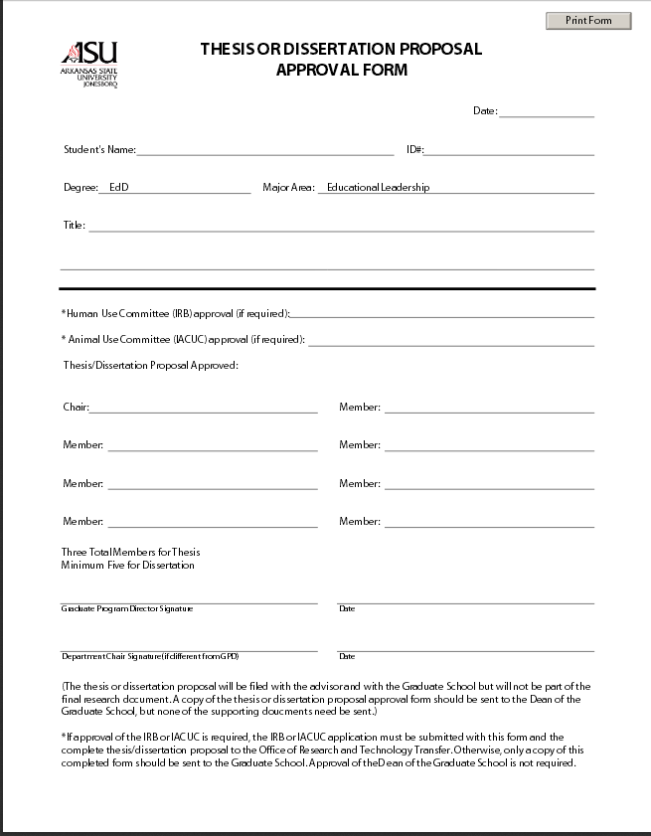
EXAMPLE
EXAMPLE
36

APPENDIX F

Report of Results Of Ed. D. Degree
Final Dissertation Defense
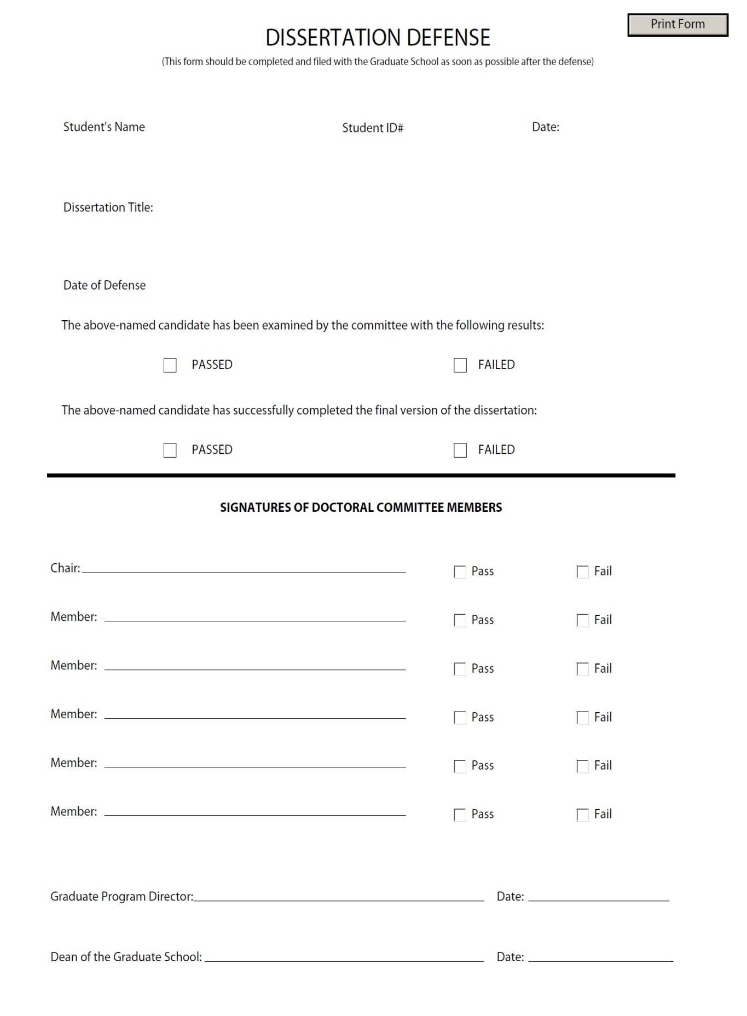
EXAMPLE

37

APPENDIX G

Online Intent to Graduate

On the Graduate School website http://www.astate.edu/college/graduate-school/ graduation look under the heading of "Online Application to Graduate-Intent to Graduate" and click here. Then follow the steps shown.

38
APPENDIX H

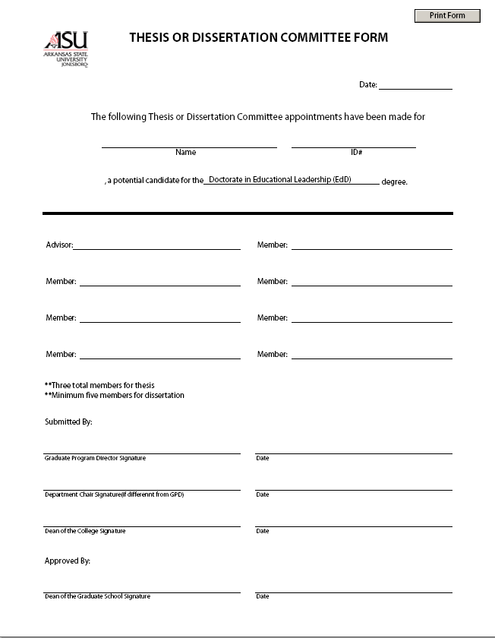
EXAMPLE
39
For assistance call:

CENTER FOR EXCELLENCE IN EDUCATION
Director of the Center
Telephone: 870.972.3943
Fax: 870.972.3945
http://www.astate.edu/education/cee

GRADUATE SCHOOL
Dean of Graduate School
Telephone: 870.972.3029
Toll Free: 877.278.4723
Fax: 870.972.3857
E-Mail: gradsch@astate.edu
http://www.astate.edu/college/graduate-school

FINANCIAL AID
Director of Financial Aid
Telephone: 870.972.2310
Fax: .870.972.2794
http://www.astate.edu/a/finaid

RESIDENCE LIFE
Director of Residence Life
Telephone: 870.972.2042
Fax: 870.972.2561
http://www.astate.edu/a/residence-life

TESTING CENTER
Director of Testing
Telephone: 870.972.2009 Fax:
870.972.3898
http://www.astate.edu/a/testing

40

