For Academic Affairs and Research Use Only
CIP Code:
Degree Code:

New Course Proposal Form
[ ] Undergraduate Curriculum Council
[X] Graduate Council
[X] New Course or [ ]Experimental Course (1-time offering) (Check one box)
Signed paper copies of proposals submitted for consideration are no longer required. Please type approver name and enter date of approval.
Email completed proposals to curriculum@astate.edu for inclusion in curriculum committee agenda.
Dr. Mark Foster 11/5/2019  Department Curriculum Committee Chair | ___________________ Enter date…  COPE Chair (if applicable)
Dr. Mark Foster 11/5/2019  Department Chair: | ___________________ Enter date…  Head of Unit (If applicable)
Shanon Brantley 11/5/2019  College Curriculum Committee Chair | ___________________ Enter date…  Undergraduate Curriculum Council Chair
Susan Hanrahan 11/5/2019  College Dean | ___________________ Enter date…  Graduate Curriculum Committee Chair
__________________ Enter date  General Education Committee Chair (If applicable) | ___________________ Enter date…  Vice Chancellor for Academic Affairs

1. Contact Person (Name, Email Address, Phone Number)
Name: Lark E. Montgomery, Assistant Professor of Nursing for the College of Nursing and Health Professions
Name of Institution: Arkansas State University- Jonesboro
Address: College of Nursing and Health Professions
P.O. BOX 910
State University, AR 72467
E-mail Address: lmontgomery@astate.edu
Phone Number: Office 870-972-2668/ Cell 870-761-6731

2. Proposed Starting Term and Bulletin Year
Spring 2022
2021-2022 Academic Year

3. Proposed Course Prefix and Number (Confirm that number chosen has not been used before. For variable credit courses, indicate variable range. Proposed number for experimental course is 9. )
NURS 6483

4. Course Title – if title is more than 30 characters (including spaces), provide short title to be used on transcripts. Title cannot have any symbols (e.g. slash, colon, semi-colon, apostrophe, dash, and parenthesis). Please indicate if this course will have variable titles (e.g. independent study, thesis, special topics).
NURS 6483 Adult Gerontology Acute Care Nurse Practitioner Seminar III

5. Brief course description (40 words or fewer) as it should appear in the bulletin.
Focuses on research based complex care for specialization of Adult/Gerontology Acute Care Nurse Practitioner. Particular attention given to health care economics, palliative or end of life care, emergency therapeutics, and disaster management strategies.

6. Prerequisites and major restrictions. (Indicate all prerequisites. If this course is restricted to a specific major, which major. If a student does not have the prerequisites or does not have the appropriate major, the student will not be allowed to register).
- Yes / No Are there any prerequisites? YES
  - If yes, which ones?
NURS 6402 Role Development in Advanced Nursing
NURS 6203 Theory Development in Nursing
NURS 6303 Health Care Issues and Policy
NURS 6023 Advanced Assessment and Diagnostic Evaluation
NURS 6013 Advanced Clinical Pharmacology
NURS 6003 Advanced Clinical Physiology
NURS 6103 Research Design and Methodology
NURS 6213 AG ACNP Seminar I
NURS 6214 AG ACNP Practicum I
NURS 6363 AG ACNP Seminar II
NURS 6364 AG ACNP Practicum II
NURS 6484 AG ACNP Practicum III (Co-Requisite)

  - Why or why not?
Pre-requisites will provide foundation needed for starting and progressing through the seminar/practicum course work within the student’s specialty area of focus. Many of the pre-requisites are currently required as “core” classes in other specialty options within the masters of science in nursing program.

- Yes / No Is this course restricted to a specific major? YES
  - If yes, which major? MSN (Adult Gerontology Acute Care Nurse Practitioner program option)

7. Course frequency (e.g. Fall, Spring, Summer). Not applicable to Graduate courses.
N/A

8. Will this course be lecture only, lab only, lecture and lab, activity, dissertation, experiential learning, independent study, internship, performance, practicum, recitation, seminar, special problems, special topics, studio, student exchange, occupational learning credit, or course for fee purpose only (e.g. an exam)? Please choose one.
Lecture

9. What is the grade type (i.e. standard letter, credit/no credit, pass/fail, no grade, developmental, or other [please elaborate])
Standard Letter

10. Yes / No Is this course dual listed (undergraduate/graduate)? NO

11. Yes / No Is this course cross listed? NO
(If it is, all course entries must be identical including course descriptions. Submit appropriate documentation for requested changes. It is important to check the course description of an existing course when adding a new cross listed course.)

11.1 – If yes, please list the prefix and course number of cross listed course.
N/A
11.2 – Yes / No Are these courses offered for equivalent credit?
Please explain. N/A

12. Yes / No Is this course in support of a new program? YES
a. If yes, what program?
Adult Gerontology Acute Care Nurse Practitioner Program

13. Yes / No Does this course replace a course being deleted? NO
a. If yes, what course?
N/A
14. Yes / No Will this course be equivalent to a deleted course? NO
a. If yes, which course?
N/A

15. Yes / No Has it been confirmed that this course number is available for use? YES
If no: Contact Registrar’s Office for assistance.

16. Yes / No Does this course affect another program? NO
If yes, provide confirmation of acceptance/approval of changes from the Dean, Department Head, and/or Program Director whose area this affects.
N/A

Course Details

17. Outline (The course outline should be topical by weeks and should be sufficient in detail to allow for judgment of the content of the course.)
Week | Content | Assignment
1 | Course Orientation | Discussion Board
2 | Neurological Disorders (CVA, Structural Abnormalities, Peripheral Abnormalities)
3 | Neurological Disorders (CNS Disorders, Seizure Disorders, Dementia, Multiple Sclerosis, Parkinson’s, Amyotrophic Lateral Sclerosis)  Psychological Problems in Acute Care
4 |  | Discussion Board
5 |  | Exam 1
6 | Hematologic Disorders (Anemias, Sickle Cell, Coagulopathies)
7 | Oncologic Disorders (Leukemias, Lymphoma, other common cancers)
8 |  | Discussion Board
9 |  | Exam 2
10 | Immunologic Disorders (HIV/AIDS, opportunistic infection among older adults, autoimmune diseases)
11 | Trauma (Neurological, Chest, abdominal, eye)  Disaster Preparedness
12 | Poisoning and Drug Toxicities  Palliative Care
13 |  | Discussion Board  CV Due
14 |  | Exam 3
15 | Review for Final Examination | DRT
16 |  | Final Exam

18. Special features (e.g. labs, exhibits, site visitations, etc.)
-Co-requisite to practicum course

19. Department staffing and classroom/lab resources
- Will this require additional faculty, supplies, etc.?
NO

20. Yes / No Does this course require course fees? YES (please see the attached form at the end of this document)
If yes: please attach the New Program Tuition and Fees form, which is available from the UCC website.

Course Justification
21. Justification for course being included in program. Must include:
a. Academic rationale and goals for the course (skills or level of knowledge students can be expected to attain)

- Describes challenges to optimal complex care created by the competing priorities of patients, payers, providers, and suppliers. (MPO 7)
- Identifies processes, principles and regulations related to payer systems used in the planning and delivery of complex health care services. (MPO 10)
- Uses pharmacologic and non-pharmacologic management strategies to ameliorate physical and behavioral symptoms in individuals who has mental health and substance misuse disorders. (MPO 1, 3)
- Diagnoses common behavioral and mental health and substance use or addictive disorder/disease, in the context of complex acute, critical, and chronic illness. (MPO 1, 3)
- Manages geriatric syndromes and changing conditions using evidenced base practice guidelines. (MPO 1, 3)
- Implements interventions to support the patient with a rapidly deteriorating physiologic condition based on Advanced Care Life Support and Fundamentals of Critical Care Support. (MPO 1, 3)

b. How does the course fit with the mission established by the department for the curriculum? If course is mandated by an accrediting or certifying agency, include the directive.

This course will serve as a specialty course with the new program option intended to provide quality education to the graduate student population in order to prepare them to serve in the role of an Adult Gerontological Acute Care Nurse Practitioner.

This course aligns with Master’s and Post Master’s Certificate curriculum standards and criteria set forth by the Accreditation Commission for Education in Nursing. (Please see ACEN Standard 4 at the end of this document)

Course curriculum is also in alignment with competencies of the Adult-Gerontology Acute Care Nurse Practitioner as set forth by the American Association of Colleges of Nursing. A PDF file of these competencies may be found at https://www.aacnnursing.org/Portals/42/AcademicNursing/pdf/Adult-Gero-NP-Comp-2016.pdf

c. Student population served.
Graduate

d. Rationale for the level of the course (lower, upper, or graduate).
Course will serve as a “specialty” course for Adult Gerontology Acute Care Nurse Practitioner option within the Masters of Science in Nursing program.

Assessment

Relationship with Current Program-Level Assessment Process
22. What is/are the intended program-level learning outcome/s for students enrolled in this course? Where will this course fit into an already existing program assessment process?

1. Integrate theories and concepts from nursing and related disciplines in the implementation of the advanced practice role.
2. Propose culturally appropriate solutions for complex health care situations presented by individuals, families and populations using processes and knowledge from nursing and related disciplines to foster quality improvement.
3. Demonstrate evidence based clinical practice and decision-making in providing nursing care to individuals, families and populations in states of wellness or illness
4. Analyze learning needs of patients, families, populations and care providers in establishing educational programs to foster an environment conducive to achieving an optimal level of health.
5. Critique research in nursing and related disciplines as a basis for application to advanced nursing care.
6. Initiate cooperative and collaborative relationships to implement evidence based practice to foster improved individual, families and population health outcomes.
7. Synthesis knowledge of policy issues in managing and delivering health care to individuals, families and populations as applied to research, education, and administration.
8. Assume leadership and consultation roles in the planning, providing, and managing of services and in influencing policy for the health care of individuals, families, and populations.
9. Propose strategies that contribute to the advancement of nursing as a practice discipline and as a social force.
10. Utilize information systems and technology to evaluate programs of care, outcomes of care and care systems.

23. Considering the indicated program-level learning outcome/s (from question #23), please fill out the following table to show how and where this course fits into the program’s continuous improvement assessment process.

For further assistance, please see the ‘Expanded Instructions’ document available on the UCC - Forms website for guidance, or contact the Office of Assessment at 870-972-2989.

Program-Level Outcome 1 (from question #23) | Integrate theories and concepts from nursing and related disciplines in the implementation of the advanced practice role.
Assessment Measure | -Examinations
Assessment  Timetable | Annually
Who is responsible for assessing and reporting on the results? | -Program Director  -Internal Committee

Program-Level Outcome 3 (from question #23) | Demonstrate evidence based clinical practice and decision-making in providing nursing care to individuals, families and populations in states of wellness or illness
Assessment Measure | -Examinations
Assessment  Timetable | Annually
Who is responsible for assessing and reporting on the results? | -Program Director  -Internal Committee

Program-Level Outcome 7 (from question #23) | Synthesis knowledge of policy issues in managing and delivering health care to individuals, families and populations as applied to research, education, and administration.
Assessment Measure | -Discussion Boards
Assessment  Timetable | Annually
Who is responsible for assessing and reporting on the results? | -Program Director  -Internal Committee

Program-Level Outcome 10 (from question #23) | Utilize information systems and technology to evaluate programs of care, outcomes of care and care systems.
Assessment Measure | -Discussion Boards
Assessment  Timetable | Annually
Who is responsible for assessing and reporting on the results? | -Program Director  -Internal Committee

Course-Level Outcomes
24. What are the course-level outcomes for students enrolled in this course and the associated assessment measures?

Outcome 1 | Describes challenges to optimal complex care created by the competing priorities of patients, payers, providers, and suppliers.
Which learning activities are responsible for this outcome? | -Assigned Reading  -Online Resources  -Peer Learning  -Written Assignment
Assessment Measure | -Discussion Board

Outcome 2 | Identifies processes, principles and regulations related to payer systems used in the planning and delivery of complex health care services.
Which learning activities are responsible for this outcome? | -Assigned Reading  -Online Resources  -Peer Learning  -Written Assignment
Assessment Measure | -Discussion Board

Outcome 3 | Uses pharmacologic and non-pharmacologic management strategies to ameliorate physical and behavioral symptoms in individuals who has mental health and substance misuse disorders.
Which learning activities are responsible for this outcome? | -Assigned Reading  -Lecture
Assessment Measure | -Examinations

Outcome 4 | Diagnoses common behavioral and mental health and substance use or addictive disorder/disease, in the context of complex acute, critical, and chronic illness.
Which learning activities are responsible for this outcome? | -Assigned Reading  -Lecture
Assessment Measure | -Examinations

Outcome 5 | Manages geriatric syndromes and changing conditions using evidenced base practice guidelines.
Which learning activities are responsible for this outcome? | -Assigned Reading  -Lecture
Assessment Measure | -Examinations

Outcome 6 | Implements interventions to support the patient with a rapidly deteriorating physiologic condition based on Advanced Care Life Support and Fundamentals of Critical Care Support.
Which learning activities are responsible for this outcome? | -Assigned Reading  -Lecture
Assessment Measure | -Examinations

Bulletin Changes

Instructions
Please visit http://www.astate.edu/a/registrar/students/bulletins/index.dot and select the most recent version of the bulletin. Copy and paste all bulletin pages this proposal affects below. Follow the following guidelines for indicating necessary changes.

*Please note: Courses are often listed in multiple sections of the bulletin. To ensure that all affected sections have been located, please search the bulletin (ctrl+F) for the appropriate courses before submission of this form.

- Deleted courses/credit hours should be marked with a red strike-through (red strikethrough)
- New credit hours and text changes should be listed in blue using enlarged font (blue using enlarged font).
- Any new courses should be listed in blue bold italics using enlarged font (blue bold italics using enlarged font)

You can easily apply any of these changes by selecting the example text in the instructions above, double-clicking the ‘format painter’ icon , and selecting the text you would like to apply the change to.
Please visit https://youtu.be/yjdL2n4lZm4 for more detailed instructions.

P. 233
- Family Nurse Practitioner/Adult Gerontology Acute Care Nurse Practitioner
The Family Nurse Practitioner (FNP) and Adult Gerontology Acute Care Nurse Practitioner (AG ACNP) Concentrations prepares nurses with the complex practice skills and theoretical knowledge necessary for roles in advanced nursing and leadership in the contemporary health care system. Graduate study in nursing is the basis for professional growth in advanced practice roles and the foundation for doctoral study.

P. 234
Add “Adult Gerontology Acute Care Nurse Practitioner Option” & Table
University Requirements
See Graduate Degree Policies for additional information (p. 39)
Core Courses: | Sem. Hrs.
NURS 6103, Research Design and Methodology | 3
NURS 6203, Theory Development in Nursing | 3
NURS 6303, Health Care Issues and Policy | 3
NURS 6402, Professional Role Development in Advanced Nursing | 2
Sub-total | 11
Support Courses: | Sem. Hrs.
NURS 6003, Advanced Clinical Physiology | 3
NURS 6013, Advanced Clinical Pharmacology | 3
NURS 6023, Advanced Assessment and Diagnostic Evaluation | 3
Sub-total | 9-15
Advanced Practice Courses: | Sem. Hrs.
NURS 6213, AG ACNP Seminar I | 3
NURS 6214, AG ACNP Practicum I | 4
NURS 6363, AG ACNP Seminar II | 3
NURS 6364, AG ACNP Practicum II | 4
NURS 6483, AG ACNP Seminar III | 3
NURS 6484, AG ACNP Practicum III | 4
Sub-total | 21
Total Required Hours: | 41

P. 364
NURS 6473. Advanced Adult-Gerontology Nursing Clinical Synthesis Culminating clinical course for implementation of clinical nurse specialist role in an area of emphasis. Pre-requisites: NURS 6443, NURS 6453, completion of required clinical hours in NURS 646(1-6).

NURS 6483 AG ACNP Seminar III Focuses on research based complex care for specialization of Adult/Gerontology Acute Care Nurse Practitioner. Particular attention given to health care economics, palliative or end of life care, emergency therapeutics, and disaster management strategies. Prerequisites: NURS 6203, NURS 6303, NURS 6402, NURS 6003, NURS 6013, NURS 6023, NURS 6103, NURS 6214, NURS 6363, NURS 6364. Co-requisite NURS 6484.

NURS 6513. FNP Clinical Management I Study of theoretical and clinical bases for management of clients and families who are well or have minor health problems. Application of principles through case studies of clients across the lifespan. Prerequisites: NURS 6003, NURS 6013, NURS 6023, NURS 6203; acceptance to FNP track. Pre- or corequisite: NURS 6103, NURS 6402. Co-requisite: NURS 6514.
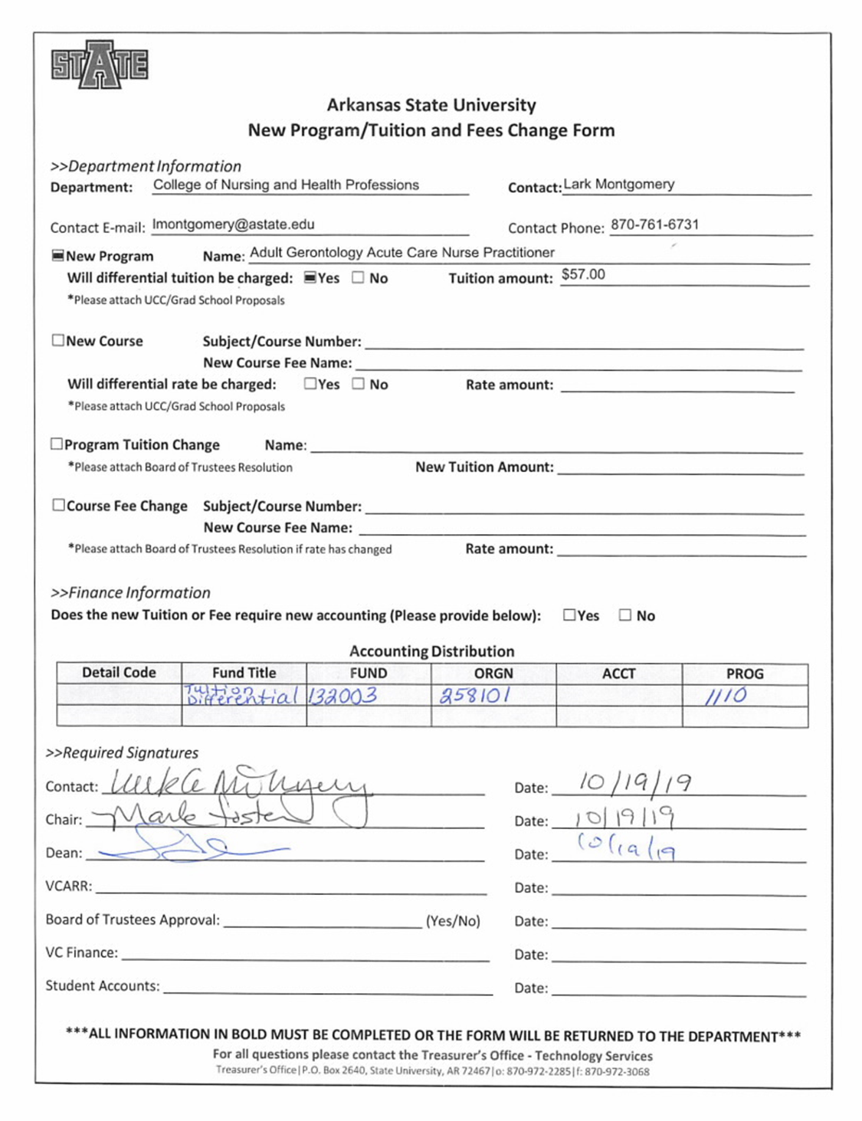
ACEN 2017 STANDARDS AND CRITERIA
MASTER’S and POST-MASTER’S CERTIFICATE

STANDARD 4
Curriculum
The curriculum supports the achievement of the end-of-program student learning outcomes and
program outcomes and is consistent with safe practice in contemporary healthcare environments.

4.1 Consistent with contemporary practice, the curriculum is congruent with established
standards for master's/post-master's programs, including appropriate advanced nursing
practice competencies, role-specific professional standards and guidelines, and certification
requirements, and has clearly articulated end-of-program student learning outcomes.

4.2 The end-of-program student learning outcomes are used to organize the curriculum, guide
The delivery of instruction, and direct learning activities.

4.3 The curriculum is developed by the faculty and regularly reviewed to ensure integrity,
rigor, and currency.

4.4 The curriculum is designed to prepare graduates to be information-literate and to practice
from an evidence-based approach in their direct and indirect advanced nursing roles.

4.5 The curriculum is designed so that graduates of the program are able to practice in a
culturally and ethnically diverse global society.

4.6 The curriculum and instructional processes reflect educational theory, interprofessional
collaboration, research, and current standards of practice.

4.7 Evaluation methodologies are varied, reflect established professional and practice
competencies, and measure the achievement of the end-of-program student learning
outcomes.

4.8 The total number of credit/quarter hours required to complete the defined nursing
program of study is congruent with the attainment of the identified end-of-program
student learning outcomes and program outcomes, and is consistent with the policies of
the governing organization, the state, and the governing organization's accrediting agency.

4.9 Student clinical experiences and practice learning environments are evidence-based;
reflect contemporary practice and nationally established patient health and safety goals;
and support the achievement of the end-of-program student learning outcomes.

4.10 Written agreements for clinical practice agencies are current, specify expectations for all
parties, and ensure the protection of students.

4.11 Learning activities, instructional materials, and evaluation methods are appropriate for all
delivery formats and consistent with the end-of-program student learning outcomes.

All programs with APRN options are also expected to adhere to the current National Task Force Guidelines for Evaluation of
Nurse Practitioner Programs as well as other requirements of the specialty organizations as they apply to the current ACEN
Standards and Criteria. See crosswalk between ACEN Standards and Criteria and 2016 National Task Force Guidelines for
Evaluation of Nurse Practitioner Programs.

