Code # Enter text…

**New Minor Proposal Form**

**[X] Undergraduate Curriculum Council**

Signed paper copies of proposals submitted for consideration are no longer required. Please type approver name and enter date of approval.

Email completed proposals to [curriculum@astate.edu](mailto:curriculum@astate.edu) for inclusion in curriculum committee agenda.

|  |  |  |  |  |  |
| --- | --- | --- | --- | --- | --- |
| |  |  | | --- | --- | | Dr. Gabriel Tait | 8/25/2017 |   **Department Curriculum Committee Chair** | |  |  | | --- | --- | | __________________ | Enter date |   **COPE Chair (if applicable)** |
| |  |  | | --- | --- | | Dr. Osa Amienyi | 8/25/2017 |   **Department Chair:** | |  |  | | --- | --- | | __________________ | Enter date |   **Head of Unit (If applicable)** |
| |  |  | | --- | --- | | Warren Johnson | 9/22/2017 |   **College Curriculum Committee Chair** | |  |  | | --- | --- | | __________________ | Enter date |   **Undergraduate Curriculum Council Chair** |
| |  |  | | --- | --- | | Gina Hogue | 9/28/2017 |   **College Dean** | |  |  | | --- | --- | | __________________ | Enter date |   **Graduate Curriculum Committee Chair** |
| |  |  | | --- | --- | | __________________ | Enter date |   **General Education Committee Chair (If applicable)** | |  |  | | --- | --- | | __________________ | Enter date |   **Vice Chancellor for Academic Affairs** |

**i. Proposed Program Title**

Minor in Graphic Communication

**ii. Contact Person** (Name, Email Address, Phone Number)

Pradeep Mishra, Instructor of Creative Media Production

[pmishra@astate.edu](mailto:pmishra@astate.edu)

(870) 972-3114

**iii. Proposed Starting Date**

Fall 2018

**Minor Justification**

1. Justification for introduction of new minor:

The creation of this minor will allow students in other programs to obtain valuable hands-on experience that would provide them a second career option or improve their capability/productability in their own fields.

2. New minor objectives:

* + 1. Students will learn to apply the tools and technologies required in the field of the Graphic Communication industry.
    2. Students will learn effective Adobe Creative Suite techniques.
    3. Students will learn to think critically, creatively, and independently as they create Graphic Communication related products.
    4. Students will learn about developing entrepreneurial characteristics and apply those in Graphic Communication settings.

3. Provide the following:

a. Curriculum outline - List of required courses

|  |  |  |
| --- | --- | --- |
| **Course Number** | **Course Title** | **Credit Hours** |
| GCOM 1813 | Introduction to Digital Publishing | 3 |
| GCOM 2673 | Digital Prepress Workflow | 3 |
| GCOM 3603 | Graphic Production System | 3 |
| GCOM 3673 | Desktop Publishing and Publication Design | 3 |
| MDIA 4363 | Multimedia Storytelling | 3 |
| GCOM 4643 | Graphic Communications Management Seminar | 3 |

b. New course descriptions

No new courses

4. Will the new minor be offered via distance delivery?

No

5. Mode of delivery to be used:

Class-room delivery (traditional)

6. Specify the amount of the additional costs required, the source of funds, and how funds will be used.

No additional resources needed.Students in the minor will use existing equipment and instruction.

**NEW MINOR ASSESSMENT**

**University Goals**

1. Please indicate the university-level student learning outcomes for which this new minor will contribute. Check all that apply.

|  |  |  |
| --- | --- | --- |
| * 1. **[X]** Global Awareness | * 1. **[X]** Thinking Critically | * 1. **[X]** Information Literacy |

**MINOR Goals**

2. Justification for the introduction of the new emphasis. Must include:

1. Academic rationale (how will this minor fit into the mission established by the department for the curriculum?)  
   The creation of this minor will allow students in other programs to obtain valuable hands-on experience that would provide them a second career option or improve their productivity in their own fields.
2. List goals for the minor (faculty, enrollment and/or curricular goals.)

1. Students will learn to apply the tools and technologies require in the field of Graphic Communication industry
2. Students will learn effective Adobe Creative Suite techniques.
3. Students will learn to think critically, creatively, and independently as they create Graphic Communication related products.
4. Students will learn about developing entrepreneurial characteristics and apply those in Graphic Communication settings.
5. Student population served.

Many majors on campus, especially Advertising, Public Relations, Marketing, and Sports Management.

**MINOR Student Learning Outcomes**

3. Please fill out the following table to develop a continuous improvement assessment process for this minor.

*For further assistance, please see the ‘Expanded Instructions’ document available on the UCC - Forms website for guidance, or contact the Office of Assessment at 870-972-2989.*

***Note: Best practices suggest 4-7 outcomes per program; minors would have 1 to 4 outcomes.***

|  |  |
| --- | --- |
| **Outcome 1** | Students will perform the traditional role of page layout creator for cross media platform usages. |
| Assessment Procedure Criterion | Direct: Students will create a portfolio according to minor requirements Indirect: External review of portfolio websites conducted by advisory board |
| Which courses are responsible for this outcome? | GCOM 1813, GCOM 2673, GCOM 3603 and GCOM 3673 |
| Assessment  Timetable | Students are assessed in the final upper level course taken in the final semester within the minor |
| Who is responsible for assessing and reporting on the results? | Instructors and Department Chair |

*Please repeat as necessary.*

**Bulletin Changes**

|  |
| --- |
| **Instructions** |
| **Please visit** [**http://www.astate.edu/a/registrar/students/bulletins/index.dot**](http://www.astate.edu/a/registrar/students/bulletins/index.dot) **and select the most recent version of the bulletin. Copy and paste all bulletin pages this proposal affects below. Follow the following guidelines for indicating necessary changes.**  **\*Please note: Courses are often listed in multiple sections of the bulletin. To ensure that all affected sections have been located, please search the bulletin (ctrl+F) for the appropriate courses before submission of this form.**  - Deleted courses/credit hours should be marked with a red strike-through (~~red strikethrough~~)  - New credit hours and text changes should be listed in blue using enlarged font (blue using enlarged font).  - Any new courses should be listed in blue bold italics using enlarged font (***blue bold italics using enlarged font***)  *You can easily apply any of these changes by selecting the example text in the instructions above, double-clicking the ‘format painter’ icon 🡪 , and selecting the text you would like to apply the change to.*  *Please visit* [*https://youtu.be/yjdL2n4lZm4*](https://youtu.be/yjdL2n4lZm4) *for more detailed instructions.* |

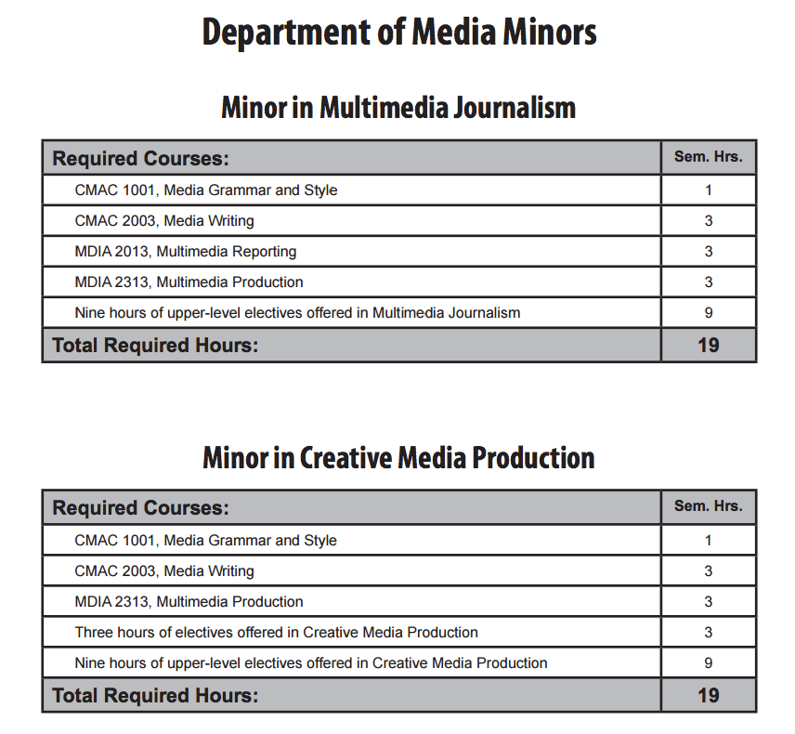

**Minor in Graphic Communication**

|  |  |  |
| --- | --- | --- |
| **Course Number** | **Required Courses** | **Sem. Hours** |
| GCOM 1813 | Introduction to Digital Publishing | 3 |
| GCOM 2673 | Digital Prepress Workflow | 3 |
| GCOM 3603 | Graphic Production Systems | 3 |
| GCOM 3673 | Desktop Publishing and Publication Design | 3 |
| MDIA 4363 | Multimedia Storytelling | 3 |
| GCOM 4643 | Graphic Communications Management Seminar | 3 |

**LETTER OF NOTIFICATION   
New Minor**

1. Institution submitting request:

Arkansas State University

2. Contact person/title:

Mr. Pradeep Mishra, Instructor of Creative Media Production

3. Phone number/e-mail address:

(870) 972-3114, [pmishra@astate.edu](mailto:ccpillow@astate.edu)

4. Proposed effective date:

Fall 2018

5. Title of degree program: (Indicate if the degree listed above is approved for distance delivery)

BS in Creative Media Production

6. CIP Code:

Enter text...

7. Degree Code:

Enter text...

8. Proposed name of new minor:

Graphic Communication Minor

9. Reason for proposed action:

The creation of this minor will allow students in other programs to obtain valuable hands-on experience

that would provide them a second career option or improve their capability/productability in their own fields.

10. New minor objective:

1. Students will learn to apply the tools and technologies require in the field of Graphic Communication industry.   
 2. Students will learn effective Adobe Creative Suite techniques.   
 3. Students will learn to think critically, creatively, and independently as they create Graphic Communication related products.   
 4. Students will learn about developing entrepreneurial characteristics and apply those in Graphic Communication settings.

11. Provide the following:

* 1. Curriculum outline - List of courses in new minor – Underline required courses

|  |  |  |
| --- | --- | --- |
| **Course Number** | **Course Title** | **Credit Hours** |
| GCOM 1813 | Introduction to Digital Publishing | 3 |
| GCOM 2673 | Digital Prepress Workflow | 3 |
| GCOM 3603 | Graphic Production System | 3 |
| GCOM 3673 | Desktop Publishing and Publication Design | 3 |
| MDIA 4363 | Multimedia Storytelling | 3 |
| GCOM 4643 | Graphic Communications Management Seminar | 3 |

* 1. Total semester credit hours required for minor

18

* 1. New courses and new course descriptions

None

* 1. Goals and objectives of minor

Our program is accredited by the ACEJMC body. We strive to prepare our students to possess 12 core competencies. They are:

1. understand and apply the principles and laws of freedom of speech and press for the country in which the institution that invites ACEJMC is located, as well as receive instruction in and understand the range of systems of freedom of expression around the world, including the right to dissent, to monitor and criticize power, and to assemble and petition for redress of grievances
2. demonstrate an understanding of the history and role of professionals and institutions in shaping communications;
3. demonstrate an understanding of gender, race ethnicity, sexual orientation and, as appropriate, other forms of diversity in domestic society in relation to mass communications;
4. demonstrate an understanding of the diversity of peoples and cultures and of the significance and impact of mass communications in a global society;
5. understand concepts and apply theories in the use and presentation of images and information;
6. demonstrate an understanding of professional ethical principles and work ethically in pursuit of truth, accuracy, fairness and diversity
7. think critically, creatively and independently;
8. conduct research and evaluate information by methods appropriate to the communications professions in which they work;
9. write correctly and clearly in forms and styles appropriate for the communications professions, audiences and purposes they serve
10. critically evaluate their own work and that of others for accuracy and fairness, clarity, appropriate style and grammatical correctness;
11. apply basic numerical and statistical concepts;
12. apply tools and technologies appropriate for the communications professions in which they work.

* 1. Expected student learning outcomes

1. Students will perform the traditional role of page layout creator for cross media platform usages.
2. Students will understand the ethical dilemmas faced by graphic communication industry, and how those challenges should be handled.
3. Students will demonstrate knowledge of the contributions of women and minorities in graphic communication industry.
4. Students will learn the basic principles elements of design.
5. Students will learn how to handle raster and vector graphics along with the various appropriate file formats.
6. Students will demonstrate knowledge of the concepts and apply color theory and color modes in the production workflow.

* 1. Documentation that minor meets employer needs

Graphic communication is a multifaceted industry, with a wide range of career opportunities in fields such as print production, digital publishing and design, and web-based media. This highly technical industry employs men and women working as prepress/premedia specialists, researchers, press operators, technicians, sales people, customer service representatives, photographers, package engineers, quality control specialists, production supervisors and managers. The Graphic Communications program prepares students about the concepts, terminology and tools used in the GCOM field, along with the fundamentals of design, critical and conceptual thinking and visual communication theory. The program meets all industry standards and continuously evolves to keep up with ever-changing technology.

* 1. Student demand (projected enrollment) for minor

20 students per year

* 1. Name of institutions offering similar programs or and the institution(s) used as a model to develop the proposed program option

Cal Poly University – Graphic Communication   
Clemson University – Graphic Communication  
Millersville University – Graphic Communication  
Georgia Southern University – Graphic Communication

12. Institutional curriculum committee review/approval date:

13. Will the new minor be offered via distance delivery? No

If yes, indicate mode of distance delivery:

N/A

14. Explain in detail the distance delivery procedures to be used, if applicable:

N/A

15. Specify the amount of additional costs required for program implementation, the source of funds, and how funds will be used.

No additional costs are required to implement this proposed minor.

16. Provide additional program information if requested by ADHE staff.

President/Chancellor Approval Date: Click here to enter a date.

Board of Trustees Notification Date: Click here to enter a date.

Chief Academic officer: ___________________________________ Date: Enter date.

Name (printed): Click here to enter text.