For Academic Affairs and Research Use Only
CIP Code:
Degree Code:

Course Revision Proposal Form
[x] Undergraduate Curriculum Council
[ ] Graduate Council
Signed paper copies of proposals submitted for consideration are no longer required. Please type approver name and enter date of approval.
Email completed proposals to curriculum@astate.edu for inclusion in curriculum committee agenda.
Sharon D. James 3/20/2018  Department Curriculum Committee Chair | ___________________ Enter date…  COPE Chair (if applicable)
Melodie Philhours 3/21/2018  Department Chair: | ___________________ Enter date…  Head of Unit (If applicable)
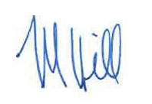 3/26/2018  College Curriculum Committee Chair (M. Hill) | ___________________ Enter date…  Undergraduate Curriculum Council Chair
Jim Washam 3/27/2018  College Dean | ___________________ Enter date…  Graduate Curriculum Committee Chair
__________________ Enter date  General Education Committee Chair (If applicable) | ___________________ Enter date…  Vice Chancellor for Academic Affairs

1. Contact Person (Name, Email Address, Phone Number)
Dr. Melodie Philhours, mphil@astate.edu, 870-680-8148

2. Proposed Starting Term and Bulletin Year for Change to Take Effect
Fall 2018

3. Current Course Prefix and Number
IB 3013
3.1 – [Yes / No] NO Request for Course Prefix and Number change
If yes, include new course Prefix and Number below. (Confirm that number chosen has not been used before. For variable credit courses, indicate variable range. Proposed number for experimental course is 9. )
Enter text...
3.2 – Yes / No If yes, has it been confirmed that this course number is available for use?
If no: Contact Registrar’s Office for assistance.

4. Current Course Title
Global Leadership Experience
4.1 – [Yes / No] YES Request for Course Title Change
If yes, include new Course Title Below.
Global Experience
- If title is more than 30 characters (including spaces), provide short title to be used on transcripts. Title cannot have any symbols (e.g. slash, colon, semi-colon, apostrophe, dash, and parenthesis).
Enter text...
- Please indicate if this course will have variable titles (e.g. independent study, thesis, special topics).
Enter text...

5. – [Yes / No ] YES Request for Course Description Change.
If yes, please include brief course description (40 words or fewer) as it should appear in the bulletin.
On-site examination of organizations, agencies, or locales in a region of the world involving the application of methods and techniques of investigation in International Business.

6. – [Yes / No ] NO Request for prerequisites and major restrictions change.
(If yes, indicate all prerequisites. If this course is restricted to a specific major, which major. If a student does not have the prerequisites or does not have the appropriate major, the student will not be allowed to register).
- Yes / No NO Are there any prerequisites?
  - If yes, which ones?
Enter text...
  - Why or why not?
Enter text...

- Yes / No NO Is this course restricted to a specific major?
  - If yes, which major? Enter text...

7. – [YES ] Request for Course Frequency Change (e.g. Fall, Spring, Summer). Not applicable to Graduate courses.
a. If yes, please indicate current and new frequency:
Fall, Spring, Summer

8. – [Yes / No ] Request for Class Mode Change
If yes, indicate if this course will be lecture only, lab only, lecture and lab, activity, dissertation, experiential learning, independent study, internship, performance, practicum, recitation, seminar, special problems, special topics, studio, student exchange, occupational learning credit, or course for fee purpose only (e.g. an exam)? Please indicate the current and choose one.
NO

9. – [Yes / No ] Request for grade type change
If yes, what is the current and the new grade type (i.e. standard letter, credit/no credit, pass/fail, no grade, developmental, or other [please elaborate])
NO

10. Yes / No Is this course dual listed (undergraduate/graduate)?
a. If yes, indicate course prefix, number and title of dual listed course.
NO

11. Yes / No Is this course cross listed?
(If it is, all course entries must be identical including course descriptions. Submit appropriate documentation for requested changes. It is important to check the course description of an existing course when adding a new cross listed course.)

11.1 – If yes, please list the prefix and course number of cross listed course.
NO
11.2 – Yes / No Are these courses offered for equivalent credit?
Please explain. Enter text...

12. Yes / No Is this course change in support of a new program?
a. If yes, what program?
NO

13. Yes / No Does this course replace a course being deleted?
a. If yes, what course?
NO

14. Yes / No Will this course be equivalent to a deleted course or the previous version of the course?
a. If yes, which course?
NO

15. Yes / No Does this course affect another program?
If yes, provide confirmation of acceptance/approval of changes from the Dean, Department Head, and/or Program Director whose area this affects.
NO

16. Does this course require course fees? NO
If yes: Please attach the New Program Tuition and Fees form, which is available from the UCC website.

Revision Details

17. Please outline the proposed revisions to the course.
Include information as to any changes to course outline, special features, required resources, or in academic rationale and goals for the course.

No changes will be made to the structure of the course. This changes makes the course more inclusive and not restricted to the 10-day project as originally designed.

18. Please provide justification to the proposed changes to the course.

This course was specifically designed to accommodate a “trip-based” project that is no longer viable. The change allows the course to be more flexible and accommodate a number of travel opportunities offered by the College of Business, other Colleges, and the University Study Abroad program.

19. Yes / No Do these revisions result in a change to the assessment plan? NO

*If yes: Please complete the Assessment section of the proposal on the next page.
*If no: Skip to Bulletin Changes section of the proposal.
*See question 19 before completing the Assessment portion of this proposal.
Assessment

Relationship with Current Program-Level Assessment Process
20. What is/are the intended program-level learning outcome/s for students enrolled in this course? Where will this course fit into an already existing program assessment process?
Enter text...

21. Considering the indicated program-level learning outcome/s (from question #23), please fill out the following table to show how and where this course fits into the program’s continuous improvement assessment process.

For further assistance, please see the ‘Expanded Instructions’ document available on the UCC - Forms website for guidance, or contact the Office of Assessment at 870-972-2989.

Program-Level Outcome 1 (from question #23) | Type outcome here. What do you want students to think, know, or do when they have completed the course?
Assessment Measure | Please include direct and indirect assessment measure for outcome.
Assessment  Timetable | What semesters, and how often, is the outcome assessed?
Who is responsible for assessing and reporting on the results? | Who (person, position title, or internal committee) is responsible for assessing, evaluating, and analyzing results, and developing action plans?
(Repeat if this new course will support additional program-level outcomes)

Course-Level Outcomes
22. What are the course-level outcomes for students enrolled in this course and the associated assessment measures?

Outcome 1 | Type outcome here. What do you want students to think, know, or do when they have completed the course?
Which learning activities are responsible for this outcome? | List learning activities.
Assessment Measure | What will be your assessment measure for this outcome?
(Repeat if needed for additional outcomes)

Bulletin Changes

Instructions
Please visit http://www.astate.edu/a/registrar/students/bulletins/index.dot and select the most recent version of the bulletin. Copy and paste all bulletin pages this proposal affects below. Follow the following guidelines for indicating necessary changes.

*Please note: Courses are often listed in multiple sections of the bulletin. To ensure that all affected sections have been located, please search the bulletin (ctrl+F) for the appropriate courses before submission of this form.

- Deleted courses/credit hours should be marked with a red strike-through (red strikethrough)
- New credit hours and text changes should be listed in blue using enlarged font (blue using enlarged font).
- Any new courses should be listed in blue bold italics using enlarged font (blue bold italics using enlarged font)

You can easily apply any of these changes by selecting the example text in the instructions above, double-clicking the ‘format painter’ icon , and selecting the text you would like to apply the change to.
Please visit https://youtu.be/yjdL2n4lZm4 for more detailed instructions.

Undergraduate Bulletin 2017-2018, p. 443

IB 3013. Global Leadership Experience On-site examination of organizations, agencies, or locales in a region of the world involving the application of methods and techniques of investigation in International Business. This course has a 10 day service learning component with additional travel expenses required. Prerequisite, completion of 54 credit hours prior to enrollment in class. Demand. Fall, Spring, Summer.

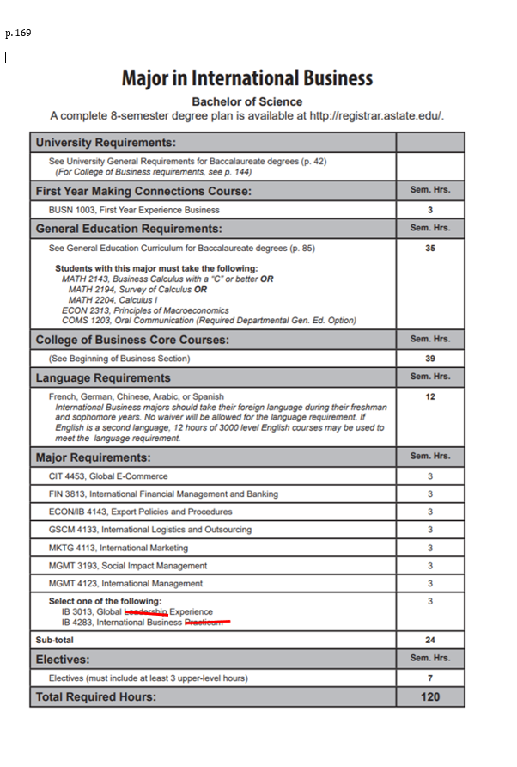

p. 172
Major in Management
Bachelor of Science
Emphasis in International Business
A complete 8-semester degree plan is available at http://registrar.astate.edu/.

University Requirements:
See University General Requirements for Baccalaureate degrees (p. 41)
(For College of Business requirements, see p. 143)
First Year Making Connections Course: | Sem. Hrs.
BUSN 1003, First Year Experience Business | 3
General Education Requirements: | Sem. Hrs.
See General Education Curriculum for Baccalaureate degrees (p. 84)  Students with this major must take the following:  MATH 2143, Business Calculus with a “C” or better OR  MATH 2194, Survey of Calculus OR  MATH 2204, Calculus I  ECON 2313, Principles of Macroeconomics  COMS 1203, Oral Communication (Required Departmental Gen. Ed. Option) | 35
College of Business Core Courses: | Sem. Hrs.
(See Beginning of Business Section) | 39
Major Requirements: | Sem. Hrs.
MGMT 3143, Human Resource Management | 3
MGMT 3153, Organizational Behavior | 3
MGMT 3613, Leadership | 3
MGMT 4163, Small Business Management | 3
MKTG 3023, Applied Research | 3
Sub-total | 15
Emphasis Area (International Business): | Sem. Hrs.
ECON/IB 4143, Export Policies & Procedures | 3
FIN 3813, International Financial Management and Banking | 3
GSCM 4133, International Logistics and Outsourcing | 3
MGMT 4123, International Management | 3
MKTG 4113, International Marketing | 3
Select one of the following:  CIT 4453, Global E-Commerce  ECON 4103, International Trade  ECON 4363, Global Environmental Policies  IB 3013, Global Leadership Experience  IB 4133, International Law  IB 4283, Internship in International Business Studies  MGMT 3193, Social Impact Management | 3
Sub-total | 18
Electives: | Sem. Hrs.
Electives | 10
Total Required Hours: | 120

p. 173
Major in Marketing
Bachelor of Science
Emphasis in International Business
A complete 8-semester degree plan is available at http://registrar.astate.edu/.

University Requirements:
See University General Requirements for Baccalaureate degrees (p. 41)
(For College of Business requirements, see p. 143)
First Year Making Connections Course: | Sem. Hrs.
BUSN 1003, First Year Experience Business | 3
General Education Requirements: | Sem. Hrs.
See General Education Curriculum for Baccalaureate degrees (p. 84)  Students with this major must take the following:  MATH 2143, Business Calculus with a “C” or better OR  MATH 2194, Survey of Calculus OR  MATH 2204, Calculus I  ECON 2313, Principles of Macroeconomics  COMS 1203, Oral Communication (Required Departmental Gen. Ed. Option) | 35
College of Business Core Courses: | Sem. Hrs.
(See Beginning of Business Section) | 39
Major Requirements: | Sem. Hrs.
GSCM 3163, Supply Chain Management | 3
MKTG 3023, Applied Research | 3
MKTG 4043, Consumer Behavior | 3
MKTG 4083, Marketing Research Design and Analysis | 3
MKTG 4223, Marketing Management | 3
Sub-total | 15
Emphasis Area (International Business): | Sem. Hrs.
ECON/IB 4143, Export Policies & Procedures | 3
FIN 3813, International Financial Management and Banking | 3
GSCM 4133, International Logistics and Outsourcing | 3
MGMT 4123, International Management | 3
MKTG 4113, International Marketing | 3
Select one of the following:  CIT 4453, Global E-Commerce  ECON 4103, International Trade  ECON 4363, Global Environmental Policies  IB 3013, Global Leadership Experience  IB 4133, International Law  IB 4283, Internship in International Business Studies  MGMT 3193, Social Impact Management | 3
Sub-total | 18
Electives: | Sem. Hrs.
Electives | 10
Total Required Hours: | 120

p. 298Minor in International Studies
The Minor in International Studies aims to provide students from across the campus the opportu- nity to understand better in an interdisciplinary context some of the complexities of our global society. Particularly suited for students in History, Political Science, English, World Languages, and Interna- tional Business, the minor draws on existing offerings in these and other departments, and also pro- vides a forum for interdisciplinary seminars and specialized courses that focus on international issues.
NOTE: Certain courses from this list may be offered infrequently. Consult the Chair of the relevant department if you have questions on when a course will be offered.
Required Courses:  Any student who completes the necessary courses may declare this minor and have it appear on the transcript. Each Department which offers a course included in the minor will determine for its own majors whether courses taken for a student’s minor can also count toward the major. | Sem. Hrs.
Select 12 hours from the following (no more than two courses may have the same prefix):
ARTH 3053, Medieval and Renaissance Art and Architecture ARTH 3063, Baroque and Rococo Art and Architecture ARTH 3073, Nineteenth Century Art and Architecture
ARTH 430V, Studies in Art History
COMS 4253, Intercultural Communication
ECON/IB 4103, International Trade
ENG 3453, World Literature
ENG 3473, Contemporary Literature
ENG 3613, Introduction to Folklore
FIN/IB 3813, International Financial Mgmt and Banking GEOG 3603, World Regional Geography
GEOG 3643, Introduction to Cultural Geography GEOG 3663, Geography of Africa
GEOG 3703, Political Geography
GEOG/SOC 4223, Urban Geography
HIST 3013, Civilizations of Africa
HIST 3123, Latin America, The Colonial Period
HIST 3133, Latin America, The National Period
HIST 3223, Renaissance and Reformation Europe
HIST 3253, Modern Europe, 1750-1870
HIST 3273, The Age of Crisis: Europe, 1870 To Present HIST 3283, Society and Thought in Europe
HIST 3303, The Modern History of the Middle East
HIST 4113, Imperial Russia
HIST 4123, Soviet Russia
HIST 4133, History of Ancient China
HIST 4143, The Rise of Modern China
HIST 4213, History of England 55 BC to AD 1689
HIST 4223, History of Great Britain, 1688 To 1982
HIST 4273, History of Mexico
HIST 4593, Special Topics in World History
IB 3013, Global Leadership Experience
IB 4133, International Law
IB 4273, Special Problems
INST 4503, Special Topics
INST 4803, Independent Study
MGMT 4123, International Management
MKTG 4113, International Marketing
PHIL 3623, Eastern Philosophy
POSC 3203, Introduction to Comparative Politics
POSC 3213, African Political Systems
POSC 3223, European Political Systems
POSC 3303, Introduction to International Policies
POSC 4223, Middle Eastern Political Systems
POSC 4313, International Organization
POSC 4323, Foreign Policy Analysis
PSY 3613, Cultural Psychology
SOC 4263, Terrorism as a Social Movement
SOC 4273, World Population and Society
Other courses approved by International Studies Advisor

