|  |  |
| --- | --- |
| For Academic Affairs and Research Use Only | |
| CIP Code: |  |
| Degree Code: |  |

**Reconfiguration of Existing Degree Program Proposal Form**

**Undergraduate Curriculum Council** -

**Graduate Council** -

Signed paper copies of proposals submitted for consideration are no longer required. Please type approver name and enter date of approval.

Email completed proposals to [curriculum@astate.edu](mailto:curriculum@astate.edu) for inclusion in curriculum committee agenda.

|  |  |
| --- | --- |
| Nikesha Nesbitt 3/30/2018 **Department Curriculum Committee Chair** | ___________________ Enter date…  **COPE Chair (if applicable)** |
| Nikesha Nesbitt 3/30/2018 **Department Chair:** | ___________________ Enter date…  **Head of Unit (If applicable)** |
| Jill Simons 3/30/2018 **College Curriculum Committee Chair** | ___________________ Enter date…  **Undergraduate Curriculum Council Chair** |
| Jill Simons 3/30/2018 **College Dean** | ___________________ Enter date…  **Graduate Curriculum Committee Chair** |
| |  |  | | --- | --- | | __________________ | Enter date |   **General Education Committee Chair (If applicable)** | Dr. Lynita Cooksey Enter date…  **Vice Chancellor for Academic Affairs** |

1. **Proposed Program Title**

Bachelor of Applied Science in Organizational Supervision

1. **Contact Person** (Name, Email Address, Phone Number)

Dr. Jill Simons, [jsimons@astate.edu](mailto:jsimons@astate.edu) 870-972-3574

1. **Proposed Starting Date**

Fall 2018

1. **Is there differential tuition requested?** *If yes, please fill out the New Program/Tuition and Fees Change Form.*

No

**Bulletin Changes**

|  |
| --- |
| **Instructions** |
| **Please visit** [**http://www.astate.edu/a/registrar/students/bulletins/index.dot**](http://www.astate.edu/a/registrar/students/bulletins/index.dot) **and select the most recent version of the bulletin. Copy and paste all bulletin pages this proposal affects below. Follow the following guidelines for indicating necessary changes.**  **\*Please note: Courses are often listed in multiple sections of the bulletin. To ensure that all affected sections have been located, please search the bulletin (ctrl+F) for the appropriate courses before submission of this form.**  - Deleted courses/credit hours should be marked with a red strike-through (~~red strikethrough~~)  - New credit hours and text changes should be listed in blue using enlarged font (blue using enlarged font).  - Any new courses should be listed in blue bold italics using enlarged font (***blue bold italics using enlarged font***)  *You can easily apply any of these changes by selecting the example text in the instructions above, double-clicking the ‘format painter’ icon 🡪 , and selecting the text you would like to apply the change to.*  *Please visit* [*https://youtu.be/yjdL2n4lZm4*](https://youtu.be/yjdL2n4lZm4) *for more detailed instructions.* |

***\*For new programs, please insert copy of all sections where this is referenced.\****

**On Page 70**

Bachelor of Applied Science (B.A.S.)

Bachelor of Applied Science

—Entrepreneurship

—Management

—Renewable Energy Technology

—Technology

Bachelor of Applied Science in Organizational Supervision

**On Page 142 Before the Technology Program Minors**

Bachelor of

Applied Science in Organizational Supervision

A complete 8-semester degree plan is available at http://registrar.astate.edu/.

University Requirements:

The BAS in Organizational Supervision program requires completion of the following program prerequisites:

1. Associate of Applied Science (AAS) or other recognized occupational-technical associate

degree from an accredited institution.

2. Minimum GPA of 2.00 on all transfer work.

3. Completion of the ASU admission application process with acceptance.

4. Completion of a total of 125 hours of which 45 hours are upper-level (3000-4000)

5. Minimum GPA of 2.00 on all coursework at ASU and a 2.00 average on all coursework presented for graduation.

AAS Degree:

Sem. Hrs.

60

General Education Requirements:

Sem. Hrs.

See General Education Curriculum for Baccalaureate degrees (p. 84)

Students with this major must take the following:

COMS 1203, Oral Communication

35

Core Requirements:

Sem. Hrs.

***COMS 4243, Interpersonal Communication***

***3***

***IDS 3013, Critical Thinking in the Profession***

***3***

***IDS 4013, Seminar in Professional Development***

***3***

***IDS 4023, Leadership in the Profession***

***3***

***MGMT 3123, Principles of Management***

***3***

***MGMT 3143 Human Resource Management***

***3***

***MGMT 3153, Organizational Behavior***

***3***

Sub-total

21

Professional Requirements:

Sem. Hrs.

In consultation with their advisor, students must select 24 hours from the courses below.

(General Supervision)

***COMS 4253, Intercultural Communication***

3

***COMS 4263, Organizational Communication***

3

***COMS 4373, Conflict Resolution***

3

***MGMT 3163, Labor Relations and Collective Bargaining***

3

***MGMT 3193, Social Impact Management***

3

***MGMT 3613, Leadership***

3

***MGMT 4143, Organizational Change and Development***

3

***MGMT 4173, Compensation Management***

3

(Health Supervision)

***HP 4443, Healthcare Management***

3

***HP 4543, Healthcare Service Delivery***

3

(Industrial Manufacturing)

***RET 3113, Fundamental Applications of Renewable Energy***

3

***TECH 3773, Statistics***

3

***TECH 3843, Manufacturing Materials and Processes***

3

***TECH 3863, Industrial Safety***

3

***TECH 4813, Operations Systems Research***

3

***TECH 4823, Quality Assurance***

3

***TECH 4883, Work Center Management***

3

24

Total Required Hours:

125

**LETTER OF NOTIFICATION – 11**

**RECONFIGURATION OF EXISTING DEGREE PROGRAMS**

**(Consolidation or Separation of Degrees to Create New Degree)**

*Please include the documents to be submitted found throughout this LON at the end of the form.

1. Institution submitting request: Arkansas State University
2. Contact person/title: Dr. Jill Simons, Associate Vice Chancellor
3. Title(s) of degree programs to be consolidated/reconfigured:

Bachelor of General Studies, Bachelor of Science in Management, Bachelor of Arts in Communication Studies, Bachelor of Science in Health Studies (Professional Track)

1. Current CIP Code(s)/Current Degree Code(s): 30.9999
2. Proposed title of consolidated/reconfigured program: Bachelor of Applied Science in Organizational Supervision
3. Proposed CIP Code for new program: 30.9999
4. Proposed Effective Date: Fall 2018
5. Reason for proposed program consolidation/reconfiguration:

*(Indicate student demand (projected enrollment) for the proposed program and document that the program meets employer needs)*

The BAS in Organizational Supervision was reconfigured to provide a seamless transition for students who have an associate in applied science degree in a technical field and wish to transfer to A-State to complete a bachelor’s degree. This interdisciplinary program is for students who desire to enhance their knowledge in supervision, communication, and leadership, as well as analytical abilities and critical thinking skills.  This degree offers enhancedopportunities for upward mobility within their field.

1. Provide current and proposed curriculum outline by semester.

The Bachelor of Applied Science (B.A.S.) in Organizational Supervision is designed for students who have graduated with an Associate of Applied Science degree. These students will transfer their 2-year A.A.S. degree to A-State. After transferring, students will take remaining required General Education courses, 21 hours of Core requirement courses, and 24 hours of Professional requirement courses. The Core requirement focuses on general organizational supervision principles and the Professional requirements add depth to organizational supervision in relation to specific fields of study.

**AAS Degree** – 60 hours

**General Ed Core –** Transferrable and A-State courses for a total of 35 hours

**Core Requirements** – 21 hours

* MGMT 3153 Organizational Behavior
* MGMT 3143 Human Resources Management
* MGMT 3123 Principles of Management
* COMS 4243 Interpersonal Communication
* IDS 3013 Critical Thinking in the Profession
* IDS 4013 Seminar in Professional Development
* IDS 4023 Leadership in the Profession

**Professional Requirements** – 24 hours (Choose 8 courses)

(Health Supervision)

* HP 4443 Healthcare Management
* HP 4543 Healthcare Service Delivery

(General Supervision)

* COMS 4373 Conflict Resolution
* COMS 4253 Intercultural Communication
* COMS 4263 Organization Communication
* MGMT 3163 Labor Relations and Collective Bargaining
* MGMT 3193 Social Impact Management
* MGMT 3613 Leadership
* MGMT 4143 Organizational Change and Development
* MGMT 4173 Compensation Management

(Industrial Manufacturing)

* RET 3113 Fundamental Applications of Renewable Energy
* TECH 3773 Statistics
* TECH 3843 Manufacturing Materials and Processes
* TECH 3863 Industrial Safety
* TECH 4813 Operations Systems Research
* TECH 4823 Quality Assurance
* TECH 4883 Work Center Management

**Total** – 125 hours

|  |  |  |  |  |  |  |  |  |  |
| --- | --- | --- | --- | --- | --- | --- | --- | --- | --- |
| **Arkansas State University-Jonesboro**  **Degree: Bachelor of Applied Science**  **Major: Organizational Supervision**  **Year: 2018-19** | | | | | | | | | |
| Students requiring developmental course work based on low entrance exam scores (ACT, SAT, ASSET, COMPASS) may not be able to complete this program of study in eight (8) semesters. Developmental courses do not count toward total degree hours. **Students having completed college level courses prior to enrollment will be assisted by their advisor in making appropriate substitutions. In most cases, general education courses may be interchanged between semesters.** A minimum of 45 hours of upper division credit (3000-4000 level) is required for this degree. | | | | | | | | | |
| **Year 3** | | | |  | **Year 3** | | | | |
| **Fall Semester** | | | |  | **Spring Semester** | | | | |
| **Course No.** | **Course Name** | **Hrs** | **Gen Ed** |  | **Course No.** | **Course Name** | **Hrs** | **Gen Ed** |
| COMS 4243 | Interpersonal Communication | 3 |  |  | IDS 4023 | Leadership in the Profession | 3 |  |
| IDS 3013 | Critical Thinking in the Profession | 3 |  |  | MGMT 3143 | Human Resources Management | 3 |  |
| MGMT 3123 | Principles of Management | 3 |  |  | Prof Req | Professional Requirement | 3 |  |
| Gen Ed | General Education | 3 | x |  | Gen Ed | General Education Science | 4 | X |
| Gen Ed | General Education Science | 4 | X |  | MGMT 3153 | Organizational Behavior | 3 |  |
|  |  |  |  |  |  |  |  |  |
| **Total Hours** |  | 16 |  |  | **Total Hours** |  | 16 |  |
| **Year 4** | | | |  | **Year 4** | | | | |
| **Fall Semester** | | | |  | **Spring Semester** | | | | |
| **Course No.** | **Course Name** | **Hrs** | **Gen Ed** |  | **Course No.** | **Course Name** | **Hrs** | **Gen Ed** |
| Prof Req | Professional Requirement | 3 |  |  | Prof Req | Professional Requirement | 3 |  |
| Prof Req | Professional Requirement | 3 |  |  | Prof Req | Professional Requirement | 3 |  |
| Prof Req | Professional Requirement | 3 |  |  | Prof Req | Professional Requirement | 3 |  |
| Gen Ed | General Education | 3 | X |  | Gen Ed | General Education | 3 | X |
| Gen Ed | General Education | 3 | X |  | Prof Req | Professional Requirement | 3 |  |
|  |  |  |  |  | IDS 4013 | Seminar in Professional Development | 3 |  |
| **Total Hours** |  | 15 |  |  | **Total Hours** |  | 18 |  |
| **Total Jr/Sr Hours _45__ Total Degree Hours _125__** | | | | | | | | | |
| **Students enrolled in this program would have completed an AAS degree (60 hours). Some of the general education courses required may vary depending upon the courses taken as part of the AAS degree.**  **Students will take 21 hours from Core Requirements (7 courses) listed below:**  **IDS 3013 Critical Thinking in the Profession IDS 4013 Seminar in Professional Development IDS 4023 Leadership in the Profession  COMS 4243 Interpersonal Communication MGMT 3123 Principles of Management MGMT 3143 Human Resource Management MGMT 3153 Organizational Behavior** | | | | | | | | | |
| **Students will choose 24 hours from Professional Requirements (8 courses) listed below:  HP 4443 Healthcare Management HP 4443 Healthcare Service Deliver**  **COMS 4253 Intercultural Communication COMS 4263 Organizational Communication**  **COMS 4373 Conflict Resolution**  **MGMT 3163 Labor Relations and Collective Bargaining  MGMT 3193 Social Impact Management MGMT 3613 Leadership MGMT 4143 Organizational Change and Development MGMT 4173 Compensation Management RET 3113 Fundamental Applications of Renewable Energy**  **TECH 3773 Statistics**  **TECH 3843 Manufacturing Materials and Processes**  **TECH 3863 Industrial Safety**  **TECH 4813 Operations Systems Research**  **TECH 4823 Quality Assurance**  **TECH 4883 Work Center Management**  **Red – Courses from Bachelor of General Studies**  **Purple – Courses from Bachelor of Arts in Communication Studies**  **Blue – Courses from Bachelor of Science in Management**  **Green – Courses from Bachelor of Science in Health Studies (Pre-professional Track)**  **Orange – Courses from Bachelor of Applied Science**  **Graduation Requirements:**  Completion of HIST 2763 or HIST 2773 or POSC 2103  English Proficiency (Grade of C or better in ENG 1003 and ENG 1013)  Grade C or better in all Technology Core Courses  2.00 GPA at ASU  2.00 GPA Overall  Maximum of 31 credit hours via correspondence, extension, examination, PLA, Military or similar means; CLEP (30 hrs max)  45 JR/SR Hours **after completing 30 hours**  120 Total Credit Hours  18 of last 24 hours must be ASU-Jonesboro courses  Minimum of 57 hours from 4-year institutions  32 Resident Hours if completing second degree and first degree was not from ASU-J | | | | | | | | | |

1. Provide program budget. Indicate amount of funds available for reallocation.

The program costs are currently embedded in existing programs. No funds will be reallocated.

1. Provide current and proposed organizational chart. *See end of document.*
2. Institutional curriculum committee review/approval date: April 13th 2018
3. Are the existing degrees offered off-campus or via distance delivery? Yes
4. Will the proposed degree be offered on-campus, off-campus, or via distance delivery?

On-campus and 100% Distance Delivery

1. Identify mode of distance delivery or the off-campus location for the proposed program.

Blackboard Learn

1. Provide documentation that proposed program has received full approval by licensure/certification entity, if required.

*(A program offered for teacher/education administrator licensure must be reviewed/approved by the Arkansas Department of Education prior to consideration by the Coordinating Board; therefore, the Education Protocol Form also must be submitted to ADHE along with the Letter of Notification).*N/A

1. Provide copy of e-mail notification to other institutions in the area of the proposed program and their responses; include your reply to the institutional responses. *See end of document.*
2. List institutions offering similar program and identify the institutions used as a model to develop the proposed program.

University of Arkansas Little Rock

University of Arkansas Fort Smith

Arkansas Tech University

1. Provide scheduled program review date (within 10 years of program implementation).

Fall 2028

1. Provide additional program information if requested by ADHE staff.

Enter text...

President/Chancellor Approval Date: Click here to enter a date.

Board of Trustees Notification Date: Click here to enter a date.

Chief Academic officer: ___________________________________ Date: Enter date.

Name (printed): Click here to enter text.

**Program Budget**

**(referenced in # 10)**

**Organizational Chart**

**(referenced in # 11)**

Provide current and proposed organizational chart. Include where the proposed program will be housed (department/college).

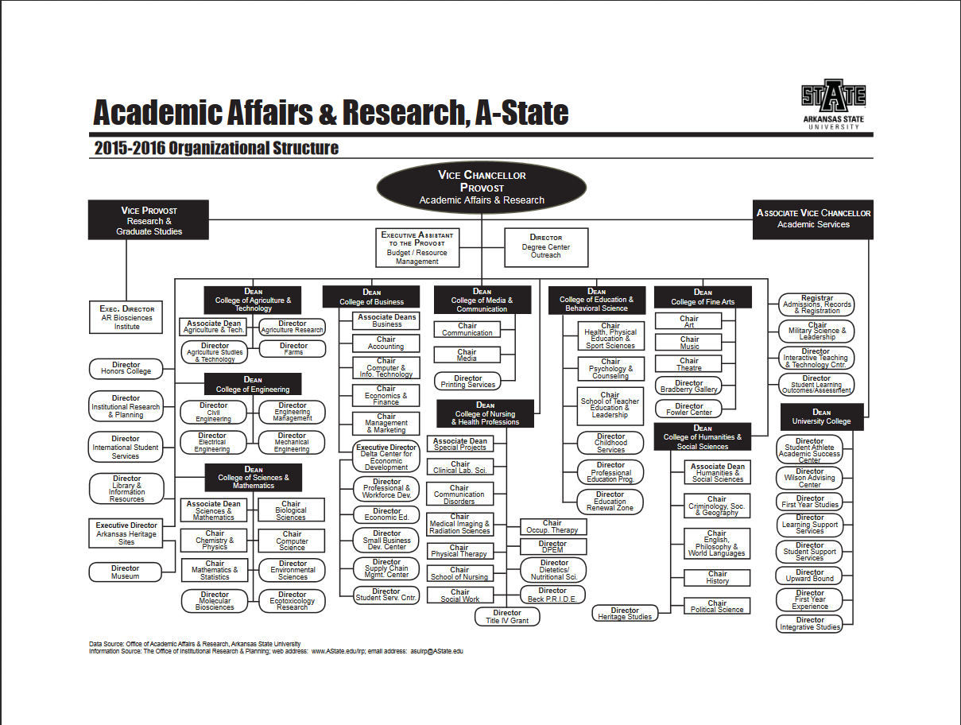

**Written Notification to Other Institutions**

**(referenced in # 17)**

This should include a copy of written notification to other institutions in area of proposed program and responses

Enter text...

**Student Learning Outcomes**

Provide outcomes that students will accomplish during or at completion of this reconfigured degree. Fill out the following table to develop a continuous improvement assessment process.

*For further assistance, please see the ‘Expanded Instructions’ document available on the UCC - Forms website for guidance, or contact the Office of Assessment at 870-972-2989.*

***Note: Best practices suggest 4-7 outcomes per program; minors would have 1 to 4 outcomes.***

|  |  |
| --- | --- |
| **Outcome 1** | BAS in Organizational Supervision graduates will demonstrate the ability to think critically and creatively. |
| Assessment Procedure Criterion | Research Project. Program level; Direct – Student Artifact. Students in the program will be responsible for constructing a research project through critical analysis to demonstrate an accomplishment of this outcome. Student will be assessed using a Critical Thinking Rubric. The results will be judged by a benchmark of 80% proficiency. |
| Which courses are responsible for this outcome? | IDS 3013 Critical Thinking in the Profession |
| Assessment  Timetable | It will be assessed at the end of the Spring semester; once per year. |
| Who is responsible for assessing and reporting on the results? | The Associate Vice Chancellor and Assessment Coordinator for University College and the Program Director of Integrative Studies will be responsible for assessing, evaluating, and analyzing results. The Program Director will, additionally, be responsible for reporting results and closing the loop. |

|  |  |
| --- | --- |
| **Outcome 2** | BAS in Organizational Supervision students will develop a practical and professional skillset including reading, writing, communicating, and basic computer proficiency. |
| Assessment Procedure Criterion | Professional Portfolio. Program level: Direct – Portfolio. Students in the program will construct a comprehensive professional portfolio with practical documents indicative of professional or graduate-level academic readiness. Students will be assessed using a project-based rubric. The results will be judged by a benchmark of 75% proficiency. |
| Which courses are responsible for this outcome? | IDS 4013 Seminar in Professional Development |
| Assessment  Timetable | It will be assessed at the end of the Spring semester; once every two years. |
| Who is responsible for assessing and reporting on the results? | The Associate Vice Chancellor of Undergraduate Studies and the Program Director of Integrative Studies will be responsible for assessing, evaluating, and analyzing results. The Program Director will, additionally, be responsible for reporting results and closing the loop. |

|  |  |
| --- | --- |
| **Outcome 3** | BAS in Organizational Supervision students will prepare for career readiness by gaining an understanding of workplace dynamics in relation to professional settings, organizational roles, etiquette, leadership strategies, and decision processes. |
| Assessment Procedure Criterion | Independent Study: Leadership Research Project. Program level: Direct-Student Artifact. Students in this program will be responsible for constructing a research paper that demonstrates practical knowledge about a leadership concept or theory, a community service project, on the job project, or internship experience. Students will be assessed using a project rubric. The results will be judge by a benchmark of 80% proficiency. |
| Which courses are responsible for this outcome? | IDS 4023 Leadership in the Profession |
| Assessment  Timetable | It will be assessed at the end of the Spring semester, once every two years. |
| Who is responsible for assessing and reporting on the results? | The Associate Vice Chancellor of Undergraduate Studies and the Program Director of Integrative Studies will be responsible for assessing, evaluating, and analyzing results. The Program Director will, additionally, be responsible for reporting results and closing the loop. |

|  |  |
| --- | --- |
| **Outcome 4** | Prepare students for professional, graduate, or workforce placement through the certificate and baccalaureate-level degrees. |
| Assessment Procedure Criterion | Job Placement. Other level: Direct – Other. Integrative Studies will provide interdisciplinary education and academic research skills to prepare students for the graduate level. 60T of graduates in the BAS Organizational Supervision program will successfully attend graduate/professional degree programs or gain employment. |
| Which courses are responsible for this outcome? | IDS 4013 Seminar in Professional Development |
| Assessment  Timetable | Implementation Plan: 2018-2019 |
| Who is responsible for assessing and reporting on the results? | IDS 4013 Faculty, Alumni Relations Staff, Graduate Admission Staff |

*Please repeat as necessary.*