For Academic Affairs and Research Use Only
CIP Code:
Degree Code:

Reconfiguration of Existing Degree Program Proposal Form
[ ] Undergraduate Curriculum Council
[X] Graduate Council
Signed paper copies of proposals submitted for consideration are no longer required. Please type approver name and enter date of approval.
Email completed proposals to curriculum@astate.edu for inclusion in curriculum committee agenda.
Edward Hammerand 9/27/2017  Department Curriculum Committee Chair | __________________ Enter date  COPE Chair (if applicable)
Hung-Chi Su 9/27/2017  Department Chair: | __________________ Enter date  Head of Unit (If applicable)
David F. Gilmore 10/6/2017  College Curriculum Committee Chair | __________________ Enter date  Undergraduate Curriculum Council Chair
Anne A. Grippo 10/6/2017  College Dean | __________________ Enter date  Graduate Curriculum Committee Chair
__________________ Enter date  General Education Committee Chair (If applicable) | __________________ Enter date  Vice Chancellor for Academic Affairs

- Proposed Program Title
Graduate Certificate in Data Science

- Contact Person (Name, Email Address, Phone Number)
Dr. Hung-Chi Su, suh@astate.edu, 870-680-8119

- Proposed Starting Date
Spring 2018

- Is there differential tuition requested? If yes, please fill out the New Program/Tuition and Fees Change Form.
No
Bulletin Changes

Instructions
Please visit http://www.astate.edu/a/registrar/students/bulletins/index.dot and select the most recent version of the bulletin. Copy and paste all bulletin pages this proposal affects below. Follow the following guidelines for indicating necessary changes.

*Please note: Courses are often listed in multiple sections of the bulletin. To ensure that all affected sections have been located, please search the bulletin (ctrl+F) for the appropriate courses before submission of this form.

- Deleted courses/credit hours should be marked with a red strike-through (red strikethrough)
- New credit hours and text changes should be listed in blue using enlarged font (blue using enlarged font).
- Any new courses should be listed in blue bold italics using enlarged font (blue bold italics using enlarged font)

You can easily apply any of these changes by selecting the example text in the instructions above, double-clicking the ‘format painter’ icon , and selecting the text you would like to apply the change to.
Please visit https://youtu.be/yjdL2n4lZm4 for more detailed instructions.

*For new programs, please insert copy of all sections where this is referenced.*
Insert Page 52 of 2017-18 Graduate Bulletin under Graduate Certificates:

Educational Leadership
—Building Level Administration
—Curriculum Director
—Gifted, Talented and Creative Director
—Instructional Specialist - Gifted, Talented
and Creative
—K-12 Special Education
—Special Education Director
Dyslexia Therapy
History
Health Care Management
Health Communication
Healthcare Emergency Management
Health Sciences Education
Clinical Mental Health Counseling
Nurse Educator
Play Therapy
Data Science

Insert Page 244 of 2017-18 Graduate Bulletin:

The College of Sciences and Mathematics offers work leading to the Master of Arts degree in biology; to the Master of Science degree with majors in biology, chemistry, computer science, environmental sciences, and mathematics; to the Master of Science in molecular biosciences; to the Master of Science in Education degree with majors in biology, chemistry, and mathematics; and to the Graduate Certificate in Data Science.

Insert Page 262 of 2017-2018 Graduate Bulletin after Program of Study for Computer Science but before Program of Study for Mathematics:

University Requirements:
See Graduate School Degree Policies for additional information (p. 35)

Program Requirements: Sem. Hrs.
CS 5543, Database Systems 3
CS 5623, Fundamentals of Data Science 3
CS 6523, Data Mining Techniques 3

Electives: 6
Select six hours from the following:
CS 6443, Machine Learning
CS 6543, Advanced Database Systems
STAT 6433, Time Series Analysis
STAT 6643, Multivariate Analysis
STAT 6653, Data Analysis I: Regression Analysis
STAT 6663, Data Analysis II: Analysis of Variance (ANOVA)

Total Required Hours: 15

LETTER OF NOTIFICATION – 11
RECONFIGURATION OF EXISTING DEGREE PROGRAMS
(Consolidation or Separation of Degrees to Create New Degree)
*Please include the documents to be submitted found throughout this LON at the end of the form.

- Institution submitting request: Arkansas State University

- Contact person/title: Dr. Hung-Chi Su, Chair of Computer Science Department

- Title(s) of degree programs to be consolidated/reconfigured:
Master of Science in Computer Science

- Current CIP Code(s)/Current Degree Code(s): 11.0101

- Proposed title of consolidated/reconfigured program: Graduate Certificate in Data Science

- Proposed CIP Code for new program: 11.0301

- Proposed Effective Date: Spring 2018

- Reason for proposed program consolidation/reconfiguration:
(Indicate student demand (projected enrollment) for the proposed program and document that the program meets employer needs)

Reconfiguring the M.S. in Computer Science degree to create a graduate certificate in Data Science for students in the computer science program as well as non-degree seeking students. The courses will be pulled from the MS Computer Science Elective courses.

There is a rising demand for students who have expertise in data science from corporations, nonprofit companies, agencies and educational institutions. The projected enrollment will be 35 students per section.
https://www.forbes.com/sites/emsi/2016/11/16/want-to-become-a-data-scientist-where-the-jobs-are-and-what-employers-are-looking-for/#5b0628ce5760
There were on average 2009 unique job postings active per month for data scientists over the past 9 years
https://www.forbes.com/sites/louiscolumbus/2017/05/13/ibm-predicts-demand-for-data-scientists-will-soar-28-by-2020/#29aa079b7e3b
Annual demand for the fast-growing new roles of data scientists, data developers, and data engineers will reach nearly 700,000 openings by 2020.
http://www.computerscienceonline.org/degree-programs/data-science/
According to research from executive recruiting company Burtch Works, a majority of professional data scientists (92 percent) hold a graduate degree.
http://www.mastersindatascience.org/careers/data-scientist/

- Provide current and proposed curriculum outline by semester.
For undergraduate programs, please also fill out 8-semester plan at end of document.
Indicate total semester credit hours required for the proposed program. Underline new courses and provide new course descriptions. (If existing courses have been modified to create new courses, provide the course name/description for the current/existing courses and indicate the related new/modified courses.) Identify required general education core courses with an asterisk.
Current M.S. in Computer Science Curriculum
M.S. Computer Science
Course Number | Course Title | Credit Hours
CS 5713 | Analysis of Algorithms | 3
Select One of the Following
CS 5133 | Compiler | 3
CS 5723 | Automata Theory
Select One of the Following
CS 5313 | Computer Networks | 3
CS 6213 | Parallel Processing
CS 6243  (pre fall 2017 #s were 6233 & 6823) | Distributed Systems
CS 6253  (pre fall 2017 #s were 6223 & 6823) | Heterogeneous Computing  (pre fall 2017 name was High Performance Computing)
Computer Science Electives (Choose 18 hours)
 | including CS courses such as:  CS 5543 Database Systems  CS 5623 Fundamentals of Data Science  CS 6443 Machine Learning  CS 6523 Data Mining Techniques  CS 6543 Advanced Database Systems | 18
CS/MATH/STAT Electives (Choose 6 hours)
 | including CS/MATH/STAT courses such as:  STAT 6433 Time Series Analysis  STAT 6643 Multivariate Analysis  STAT 6653 Data Analysis I: Regression Analysis  STAT 6663 Data Analysis II: Analysis of Variance (ANOVA) | 6

Proposed Graduate Certificate in Data Science

Course Number | Course Title | Credit Hours
Semester 1
CS 5543 | Database Systems | 3
Semester 2
CS 5623 | Fundamentals of Data Science | 3
Semester 3
CS 6523 | Data Mining Techniques | 3
Semester 4
Choose Two Electives (6 hours)
CS 6443 | Machine Learning | 6
CS 6543 | Advanced Database Systems
STAT 6433 | Time Series Analysis
STAT 6643 | Multivariate Analysis
STAT 6653 | Data Analysis I: Regression Analysis
STAT 6663 | Data Analysis II: Analysis of Variance (ANOVA)
Total Credit Hours |  | 15

New/modified courses:
- CS 5623, Fundamentals of Data Science
Study of the practices and techniques associated with data science, including programming for data analytics, modern technologies for data access in distributed and parallel systems, and an overview of machine learning models.
- CS 6523, Data Mining Techniques (offered to date as a special topics subject, CS6823)
Exploration of the algorithms and methodologies in knowledge discovery and data mining used to find information or knowledge of interest in large data sets efficiently.
- CS 6443, Machine Learning (offered to date as a special topics subject, CS6823)
The theory and practice of machine learning from a variety of perspectives. Topics include supervised learning (classification, regression); unsupervised learning (clustering, dimensionality reduction); reinforcement learning; and computational learning theory.

- CS 6543, Advanced Database Systems (offered to date as a special topics subject, CS6823)
A study of the internals of database systems as a basis for system implementation and performance tuning. Topics include database system architecture, transactions and serializability, recovery from errors, query optimization, and new technologies in database systems.
- STAT 6433, Time Series Analysis (offered to date as a seminar subject, MATH 669V)
Topics include stochastic processes, stationarity, autocovariance and autocorrelation, filtering and smoothing, ARMA processes, and spectral analysis.

- Provide program budget. Indicate amount of funds available for reallocation.
See end of document.

- Provide current and proposed organizational chart. See end of document.

- Institutional curriculum committee review/approval date: Enter text...

- Are the existing degrees offered off-campus or via distance delivery? No

- Will the proposed degree be offered on-campus, off-campus, or via distance delivery?
On-campus

- Identify mode of distance delivery or the off-campus location for the proposed program.
N/A

- Provide documentation that proposed program has received full approval by licensure/certification entity, if required.
(A program offered for teacher/education administrator licensure must be reviewed/approved by the Arkansas Department of Education prior to consideration by the Coordinating Board; therefore, the Education Protocol Form also must be submitted to ADHE along with the Letter of Notification).

N/A, program does not lead to licensure/certification

- Provide copy of e-mail notification to other institutions in the area of the proposed program and their responses; include your reply to the institutional responses. See end of document.

- List institutions offering similar program and identify the institutions used as a model to develop the proposed program.

University of Arkansas at Little Rock – Graduate Certificate in Data Science
University of Memphis – Graduate Certificate in Data Science
University of Missouri – Graduate Certificate in Data Science

Model used to develop program was the A-State M.S. in Computer Science program

- Provide scheduled program review date (within 10 years of program implementation).
Spring 2028

- Provide additional program information if requested by ADHE staff.
Enter text...

President/Chancellor Approval Date: Click here to enter a date.
Board of Trustees Notification Date: Click here to enter a date.

Chief Academic officer: ___________________________________ Date: Enter date.
Name (printed): Click here to enter text.

8-Semester Plan
(referenced in #9 - Undergraduate Proposals Only)
Instructions: Please identify new courses in italics.
Arkansas State University-Jonesboro Degree:
Major:
Year:

Students requiring developmental course work based on low entrance exam scores (ACT, SAT, ASSET, COMPASS) may not be able to complete this program of study in eight (8) semesters. Developmental courses do not count toward total degree hours. Students having completed college level courses prior to enrollment will be assisted by their advisor in making appropriate substitutions. In most cases, general education courses may be interchanged between semesters. A minimum of 45 hours of upper division credit (3000-4000 level) is required for this degree.
Year 1 |  |  |  |  | Year 1
Fall Semester |  |  |  |  | Spring Semester
Course No. | Course Name | Hrs | Gen Ed |  | Course No. | Course Name | Hrs | Gen Ed
Total Hours |  |  |  |  | Total Hours
Year 2 |  |  |  |  | Year 2
Fall Semester |  |  |  |  | Spring Semester
Course No. | Course Name | Hrs | Gen Ed |  | Course No. | Course Name | Hrs | Gen Ed
Total Hours |  |  |  |  | Total Hours
Year 3 |  |  |  |  | Year 3
Fall Semester |  |  |  |  | Spring Semester
Course No. | Course Name | Hrs | Gen Ed |  | Course No. | Course Name | Hrs | Gen Ed
Total Hours |  |  |  |  | Total Hours
Year 4 |  |  |  |  | Year 4
Fall Semester |  |  |  |  | Spring Semester
Course No. | Course Name | Hrs | Gen Ed |  | Course No. | Course Name | Hrs | Gen Ed
Total Hours |  |  |  |  | Total Hours
Total Jr/Sr Hours ___ Total Degree Hours ___
Graduation Requirements:

Program Budget
(referenced in # 10)

Provide program budget. Indicate amount of funds available for reallocation.

All but one of the courses involved are already being taught as special topics; the rotation will be revised to provide an opening for the one new course. Consequently, there will be no extra funds required.

Organizational Chart
(referenced in # 11)

Provide current and proposed organizational chart. Include where the proposed program will be housed (department/college).

Organizational Chart will remain the same.

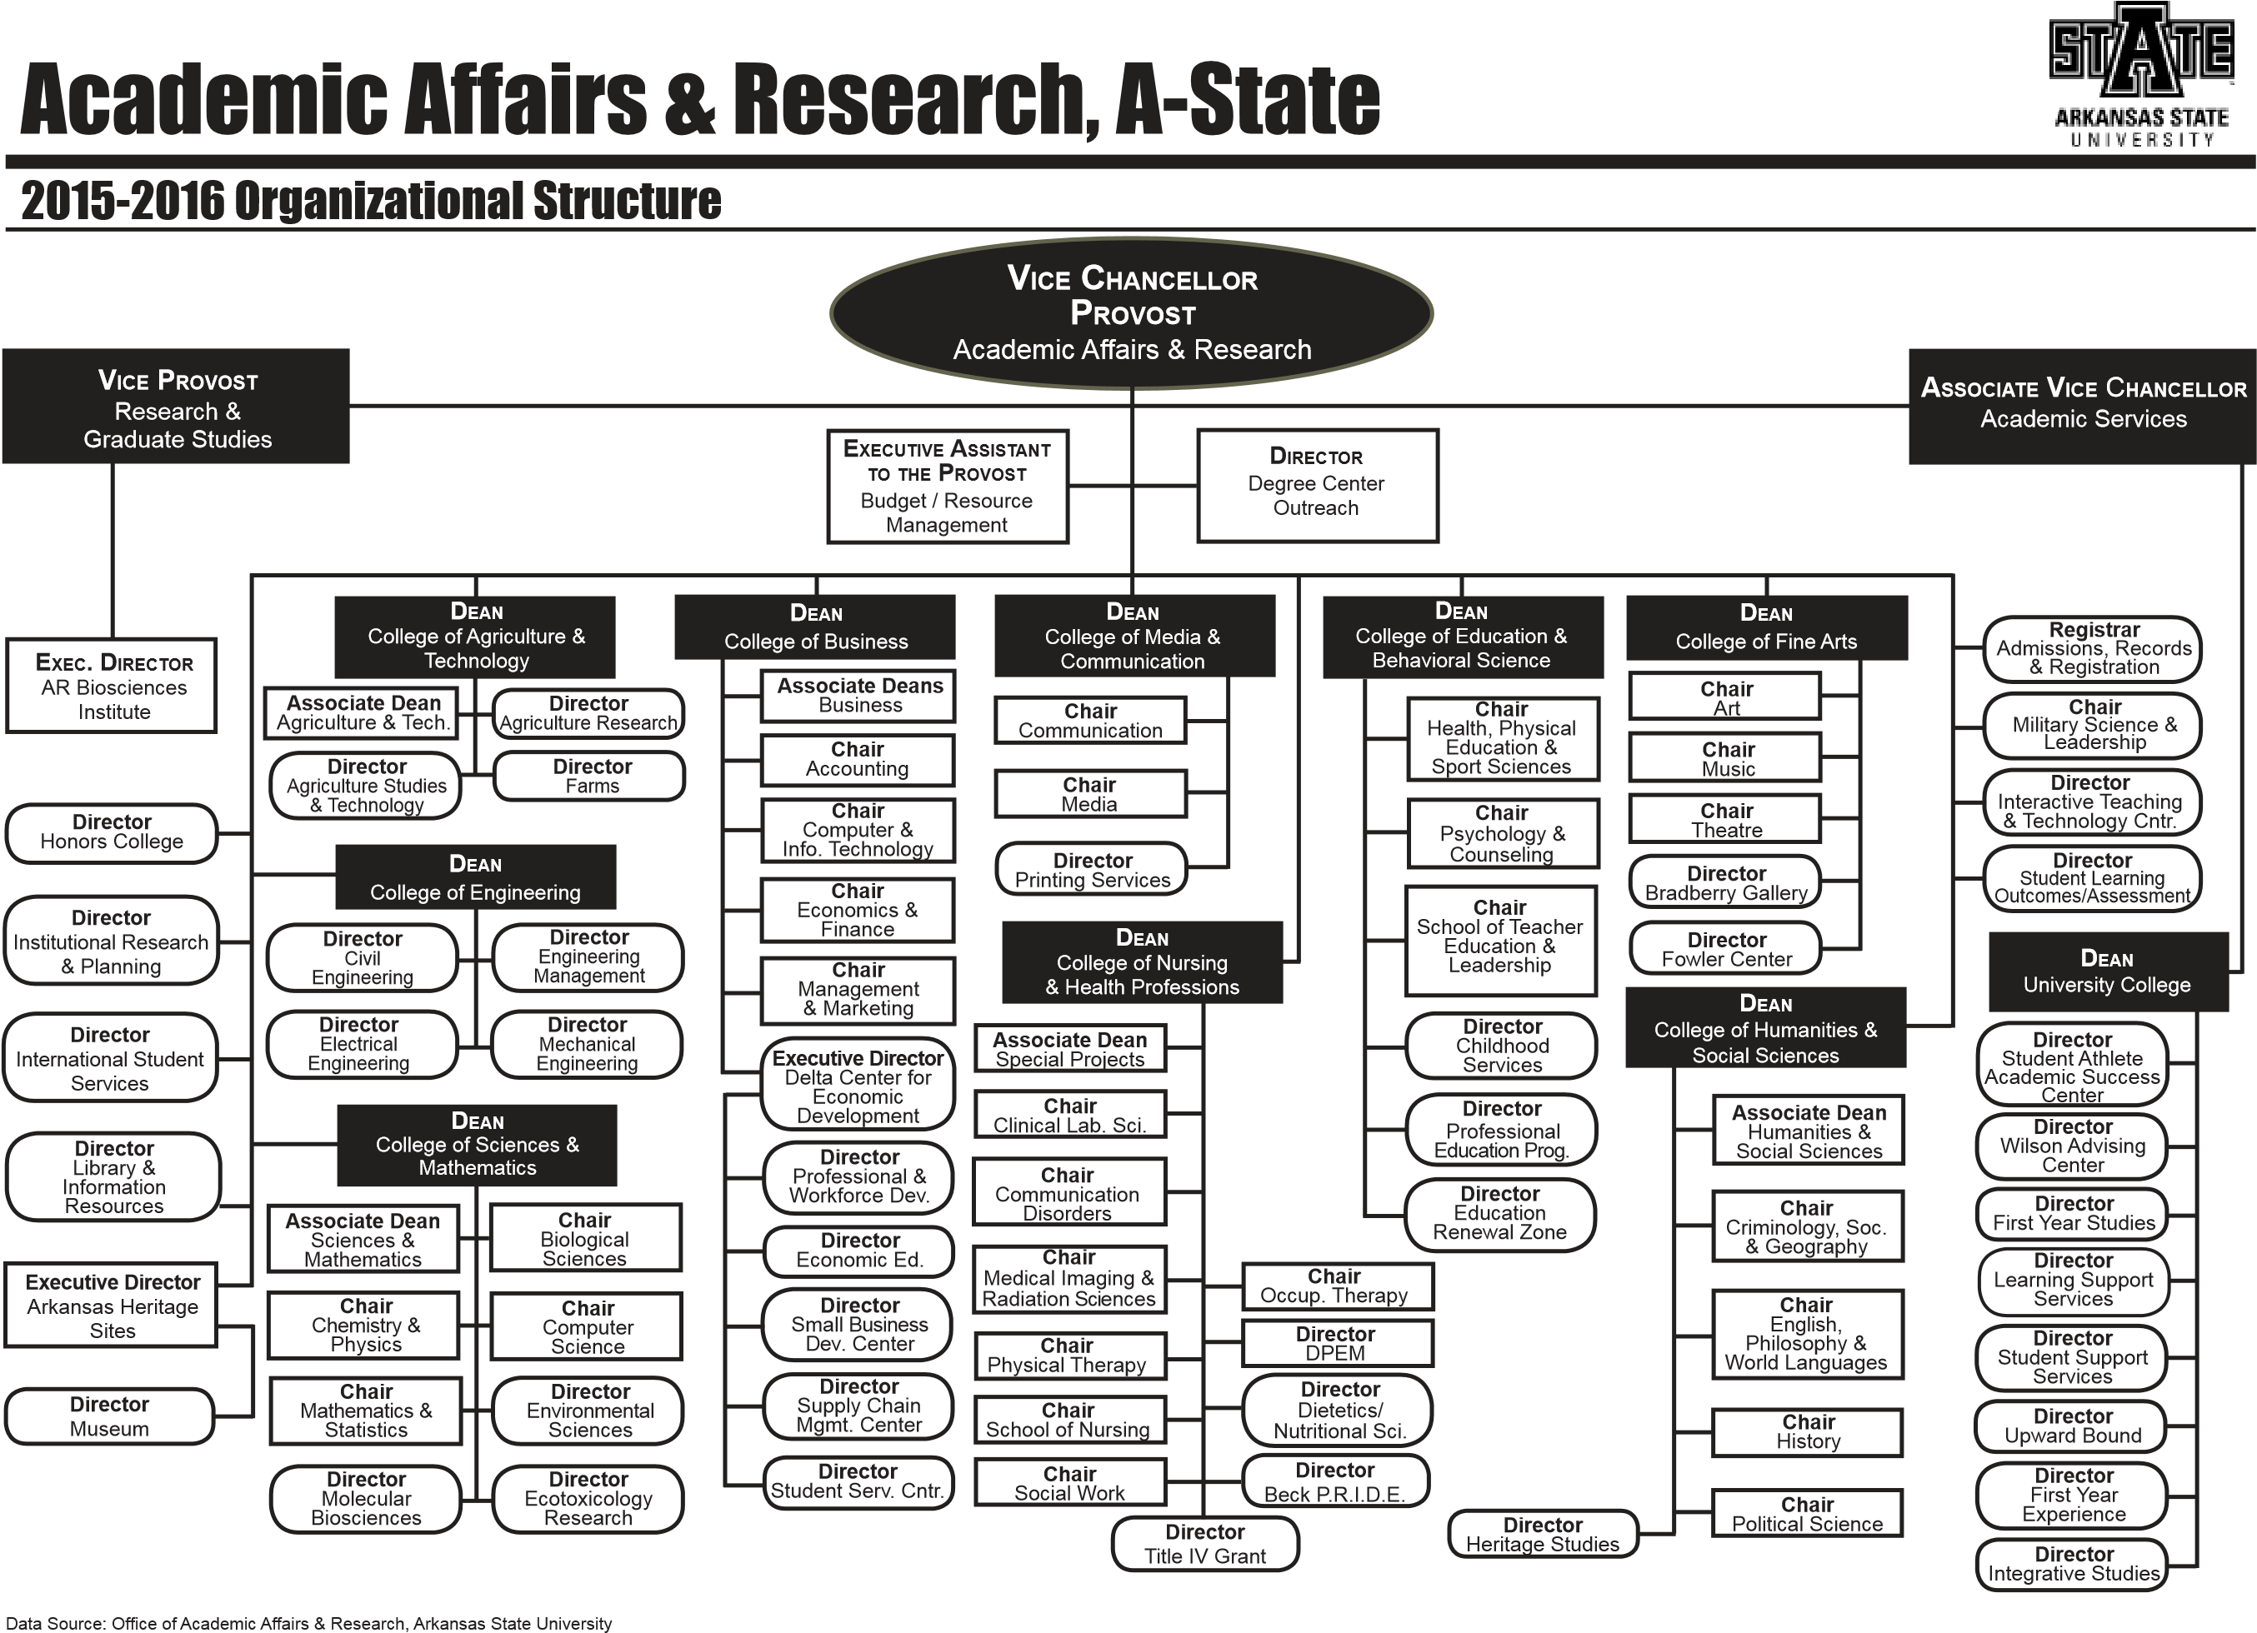

Written Notification to Other Institutions
(referenced in # 17)

This should include a copy of written notification to other institutions in area of proposed program and responses

According to the office of Vice Chancellor for Academic Affairs, this is not required for this certificate

Student Learning Outcomes
Provide outcomes that students will accomplish during or at completion of this reconfigured degree. Fill out the following table to develop a continuous improvement assessment process.
For further assistance, please see the ‘Expanded Instructions’ document available on the UCC - Forms website for guidance, or contact the Office of Assessment at 870-972-2989.
Note: Best practices suggest 4-7 outcomes per program; minors would have 1 to 4 outcomes.
Outcome 1 | A deeper understanding of the theory and application of data science algorithms and processes.
Assessment Procedure Criterion | Comprehensive examinations and employer surveys
Which courses are responsible for this outcome? | CS 5543, Database Systems  CS 5623, Fundamentals of Data Science  CS 6523, Data Mining Techniques  CS 6443, Machine Learning  CS 6543, Advanced Database Systems
Assessment  Timetable | Comprehensive exams will be conducted each semester, reviewed annually, and reported on every three years; employer surveys will be conducted each fall and reported on every four years.
Who is responsible for assessing and reporting on the results? | Department assessment committee

Outcome 2 | The ability to apply data science analysis techniques to problem identification.
Assessment Procedure Criterion | Comprehensive examinations and employer surveys
Which courses are responsible for this outcome? | CS 5543, Database Systems  CS 5623, Fundamentals of Data Science  CS 6523, Data Mining Techniques  CS 6443, Machine Learning  CS 6543, Advanced Database Systems  STAT 6433, Time Series Analysis  STAT 6643, Multivariate Analysis  STAT 6653, Data Analysis I: Regression Analysis  STAT 6663, Data Analysis II: Analysis of Variance
Assessment  Timetable | Comprehensive exams will be conducted each semester, reviewed annually, and reported on every three years; employer surveys will be conducted each fall and reported on every four years.
Who is responsible for assessing and reporting on the results? | Department assessment committee

Outcome 3 | The ability to apply data science implementation techniques to problem solution.
Assessment Procedure Criterion | Comprehensive examinations and employer surveys
Which courses are responsible for this outcome? | CS 5543, Database Systems  CS 5623, Fundamentals of Data Science  CS 6523, Data Mining Techniques  CS 6443, Machine Learning  CS 6543, Advanced Database Systems
Assessment  Timetable | Comprehensive exams will be conducted each semester, reviewed annually, and reported on every three years; employer surveys will be conducted each fall and reported on every four years.
Who is responsible for assessing and reporting on the results? | Department assessment committee

Please repeat as necessary.

