For Academic Affairs and Research Use Only
CIP Code:
Degree Code:

Letter of Notifications
[x] Undergraduate Curriculum Council
[ ] Graduate Council
Signed paper copies of proposals submitted for consideration are no longer required. Please type approver name and enter date of approval.
Email completed proposals to curriculum@astate.edu for inclusion in curriculum committee agenda.
Sharon D. James 3/20/2018  Department Curriculum Committee Chair | __________________ Enter date  COPE Chair (if applicable)
Melodie Philhours 3/21/2018  Department Chair: | __________________ Enter date  Head of Unit (If applicable)
3/27/2018  College Curriculum Committee Chair | __________________ Enter date  Undergraduate Curriculum Council Chair
Jim Washam 3/27/2018  College Dean | __________________ Enter date  Graduate Curriculum Committee Chair
__________________ Enter date  General Education Committee Chair (If applicable) | __________________ Enter date  Vice Chancellor for Academic Affairs

If you require to fill out a Letter of Notification, please email curriculum@astate.edu or contact Academic Affairs and Research at (870) 972-2030 for guidance PRIOR TO submitting these through the curricular process.

1.Contact Person (Name, Email Address, Phone Number)

Dr. Melodie Philhours, mphil@astate.edu, 870-680-8148

Bulletin Changes

Instructions
Please visit http://www.astate.edu/a/registrar/students/bulletins/index.dot and select the most recent version of the bulletin. Copy and paste all bulletin pages this proposal affects below. Follow the following guidelines for indicating necessary changes.

*Please note: Courses are often listed in multiple sections of the bulletin. To ensure that all affected sections have been located, please search the bulletin (ctrl+F) for the appropriate courses before submission of this form.

- Deleted courses/credit hours should be marked with a red strike-through (red strikethrough)
- New credit hours and text changes should be listed in blue using enlarged font (blue using enlarged font).
- Any new courses should be listed in blue bold italics using enlarged font (blue bold italics using enlarged font)

You can easily apply any of these changes by selecting the example text in the instructions above, double-clicking the ‘format painter’ icon , and selecting the text you would like to apply the change to.
Please visit https://youtu.be/yjdL2n4lZm4 for more detailed instructions.

Paste bulletin pages here...

LETTER OF NOTIFICATION – 1

NAME CHANGE OF EXISTING CERTIFICATE, DEGREE, MAJOR, OPTION
OR ORGANIZATIONAL UNIT
(No change in program curriculum, option/emphasis/concentration or organizational structure)

  - Institution submitting request: Arkansas State University

  - Contact person/title: Dr. Melodie Philhours, Chair, Department of Management and Marketing

  - Phone number/e-mail address: 870-680-8148 mphil@astate.edu

  - Proposed effective date: Fall 2018

  - Current title of degree/certificate program: B.S. Marketing, Emphasis in Marketing Management

  - Current title of major or option/emphasis/concentration: Marketing Management

  - Current title of organizational unit:

  - Proposed name of certificate/degree: B.S. Marketing

  - Proposed name of major or option/emphasis/concentration:

  - Proposed name of organizational unit:
  - Program CIP Code:

  - Degree/Department Code:

  - Reason for proposed action: This degree is a general marketing degree incorporating the marketing core courses with a selection of various marketing courses. Rather than have an emphasis in marketing management, simply Marketing is a clearer and more descriptive title for the degree. This is consistent with other universities’ marketing programs.

  - Semester credit hours for proposed major or option/emphasis/concentration: 120

  - Provide the curriculum/credit hours for the certificate/degree/major/option/emphasis/concentration listed above.
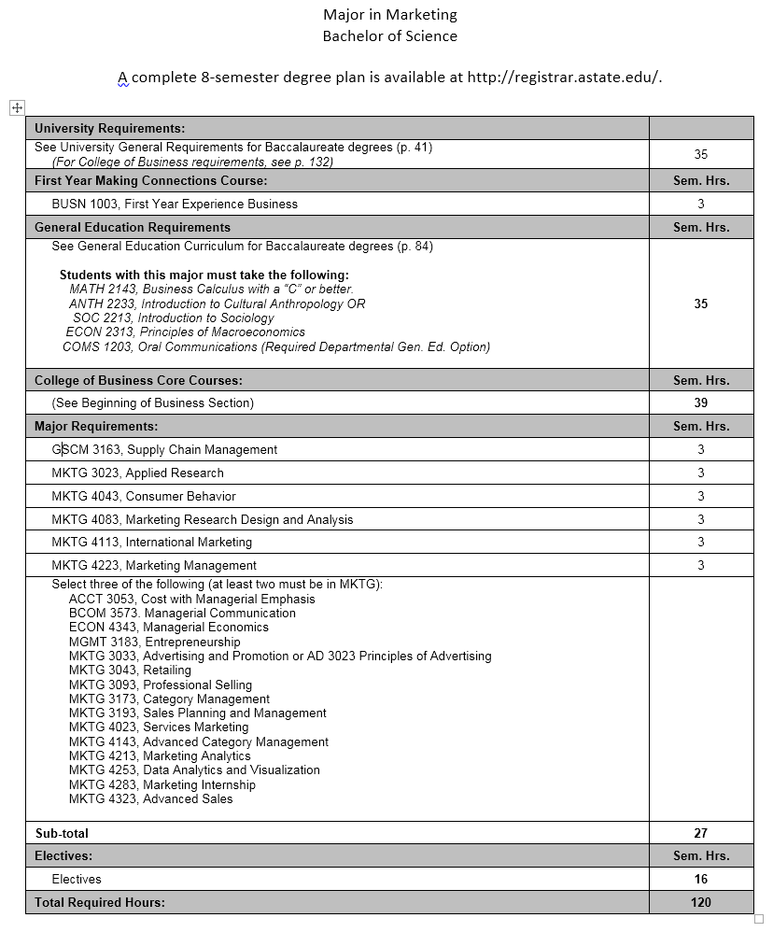
  - Provide additional program information if requested by ADHE staff.

President/Chancellor Approval Date:

Board of Trustees Notification Date:

Chief Academic Officer: Date:

