If you log into Banner and receive the following error, use the steps below to resolve the issue.

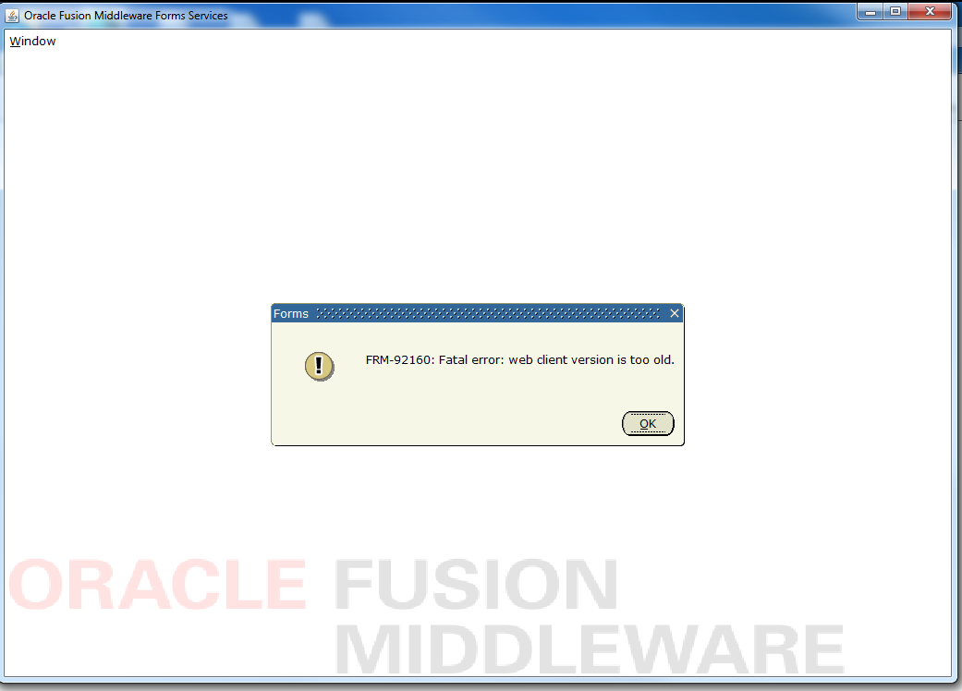

Close all your browser windows, not just the one open for INB. Then go to control panels and click on java. This screen will appear.

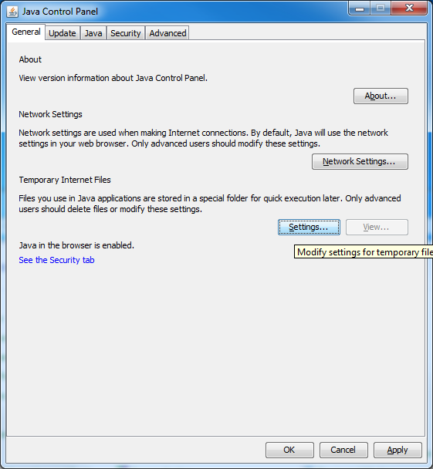

Click on “Settings…” and another screen will appear.

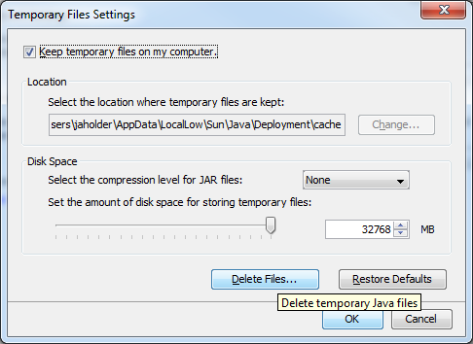

Click on “Delete Files…” and make sure all the boxes are checked.

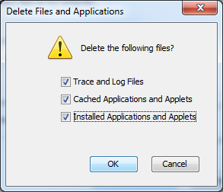

Click “OK” and then “Apply”. Now you should be able to restart your web browser and connect to INB. This will only have to be done this 1 time.

To use Java 8.x with Banner INB, the following steps will have to be completed.

* Uninstall previous versions of Java 7.x.
* Download the correct Java version from <http://www.astate.edu/a/its/>. The Java executable is in the center of the page under the “INB Fix after the Upgrade:” heading as shown below. It is <<Java 8 for Windows>>. There is also a version for MacOS. Make sure to download and install the correct version for your specific OS.

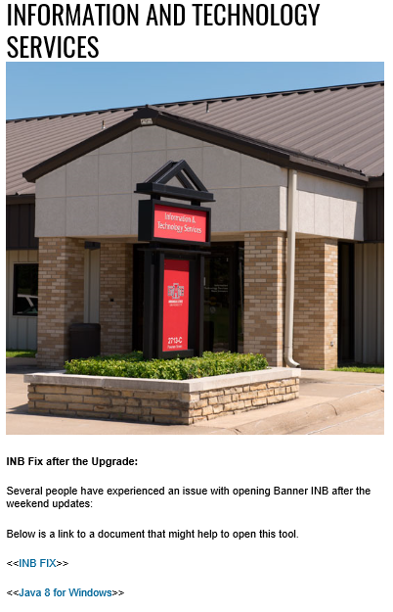

* Once you click on this link, the following box will appear. You will want to choose “Save File”. Once the file has downloaded, click it and follow the prompts.

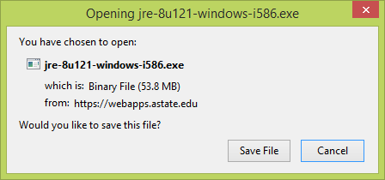

* Once Java has been installed, open the Java Console by going to Control Panels and clicking on the Java icon. This will open the following box.

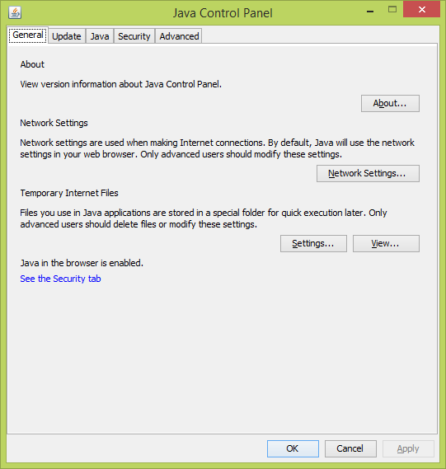

* Go to the Security tab. Under the “Exception Site List”, click the “Edit Site List” button to add exceptions. You will need to add the following exceptions.
  + For PROD INB, add this exception
    - https://asupi1.astate.edu:8890/forms/frmservlet?config=prod
  + For Discoverer, add this exception
    - https://asuodis.astate.edu:8890/discoverer/plus
  + For TEST INB, add any/all of the following
    - https://asuti1a.astate.edu:8890/forms/frmservlet?config=ract
    - https://asuti1vm.astate.edu:8890/forms/frmservlet?config=pprd
    - https://asuti1vm.astate.edu:8890/forms/frmservlet?config=tst1
    - https://asuti1vm.astate.edu:8890/forms/frmservlet?config=tst2

Once completed, the exception site list should look similar to the one below, depending on which of the links listed that you use. Click ok to save the changes.

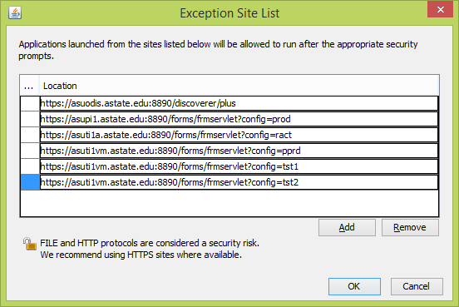

* Next, go to the Advanced tab within the Java console. You will need to go to the bottom of this, looking for the “Advanced Security Settings” grouping. Make sure “Use SSL 2.0 compatible ClientHello format”, “Use TLS1.0”, “Use TLS 1.1”, and “Use TLS 1.2” are all checked.

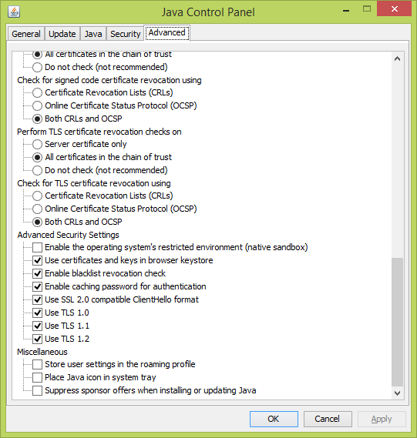

Once all these steps have been completed, Java 8 should be functional for INB. Do not update beyond Java 8 Update 121. There are issues with copy/paste with Java 8 Update 131. Java 9 will become available later this year. Do NOT upgrade to Java 9 as it is currently not supported by Ellucian for Banner.