Accessing Taleo
The Taleo platform performs better using Firefox or Chrome browers.
As a first time user, you will receive an email notification from jobs.astate.edu to create your password. Contact taleo-support@astate.edu if you didn’t receive this email notification.
After setting up your password, login to myCampus: https://mycampus.astate.edu.
- Click on the Employee folder in the QuickLaunch Navigation window
- Click on the Taleo Admin icon
Single sign-on is not enabled for Taleo, which means you will need to login again after accessing myCampus.
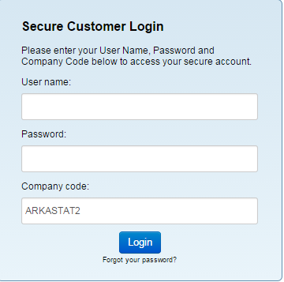
- Your User name is the same as your A-State user name or email address without @astate.edu.
- Company code ARKASTAT2.

Getting Started:
The home tab (is located in the upper left corner) and will allow you to see your tasks due and dashboard, make changes to your settings and set up your profile.
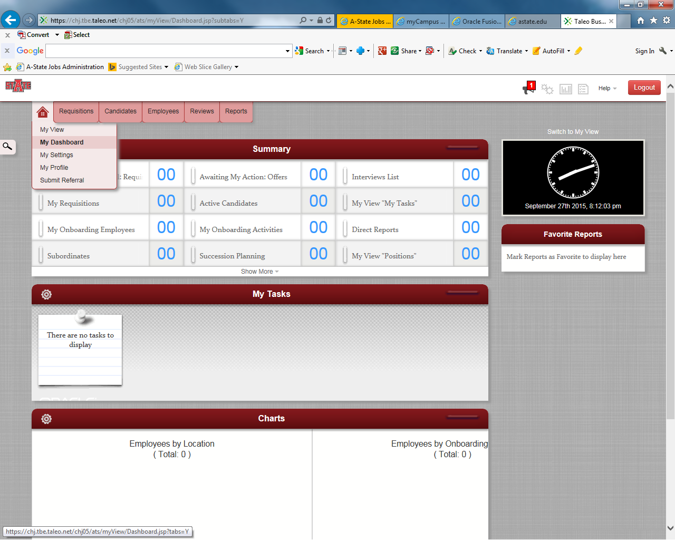

You have two options for establishing your page layout. Here is a brief description of each option:
1) My View - provides a list view summary of Taleo activities awaiting your action such as interviews, feedback, requisition’s, approvals, etc.
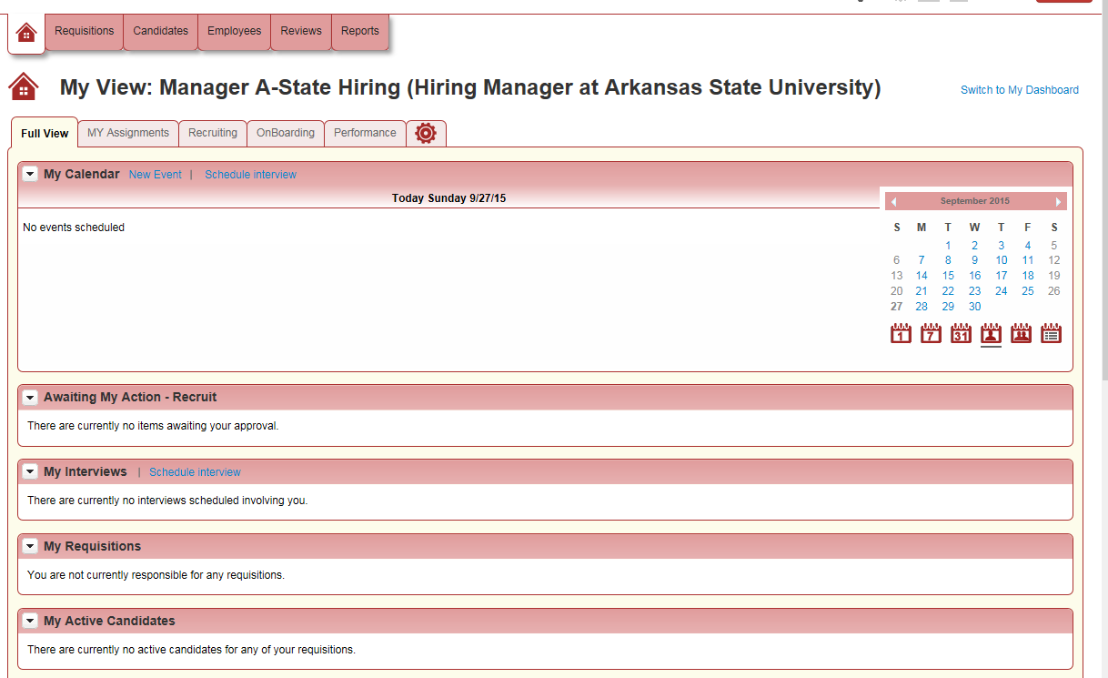
Provides the ability to establish and select items for display and layout. This page can be customized by selecting the Gear.
2) Dashboard – provides the same information as the My View option but in a dashboard format. This option is customizable.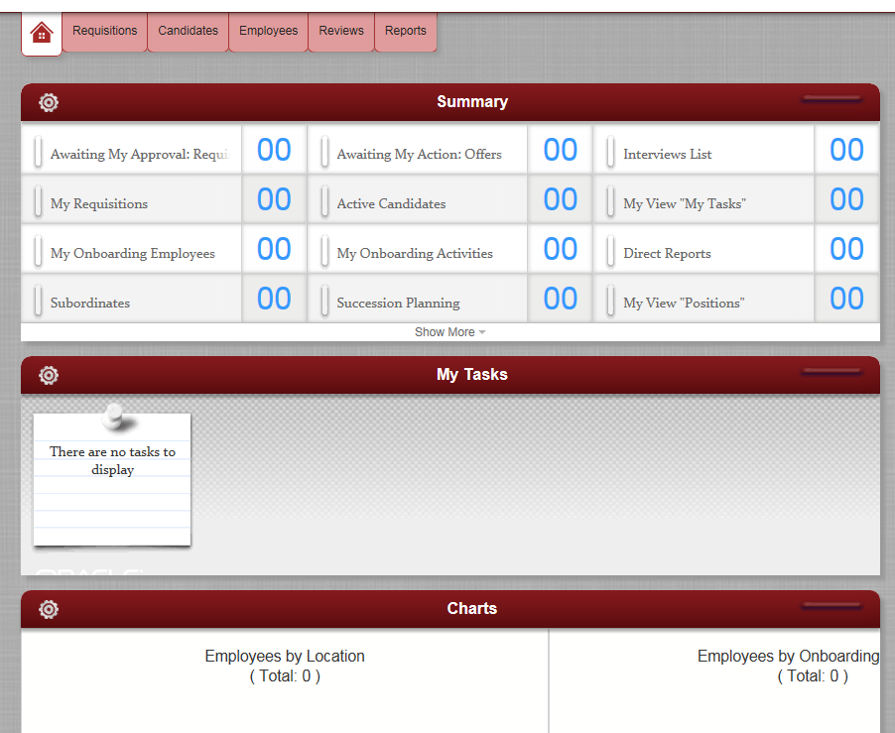
My Settings – provides the ability to personalize the settings, establish a proxy (someone that will approve on your behalf), set up email defaults and change your password. Be sure to check your Time Zone on this tab. If it is set incorrectly any scheduled interviews will not be saved at the appropriate time.
My Profile - provides the ability to load your resume, CV or other documentation you want to associate with your profile. You can also create a brief bio. It also stores the feedback you have provided for previous interviews.
Submit Referral – provides ability to refer candidates for general consideration or for a specific requisition.

